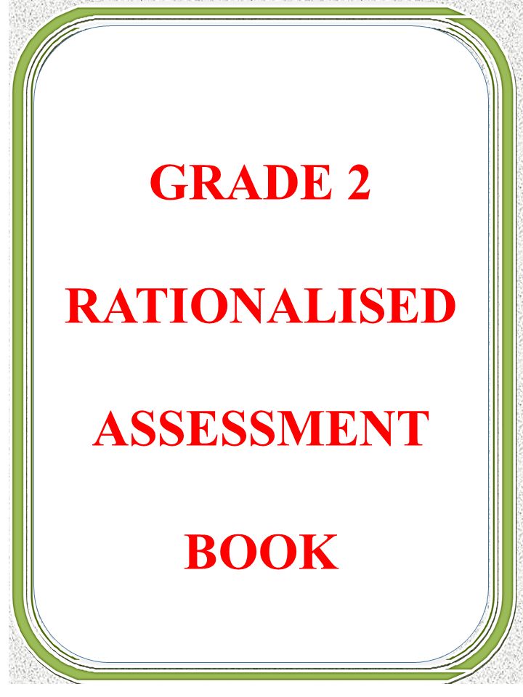

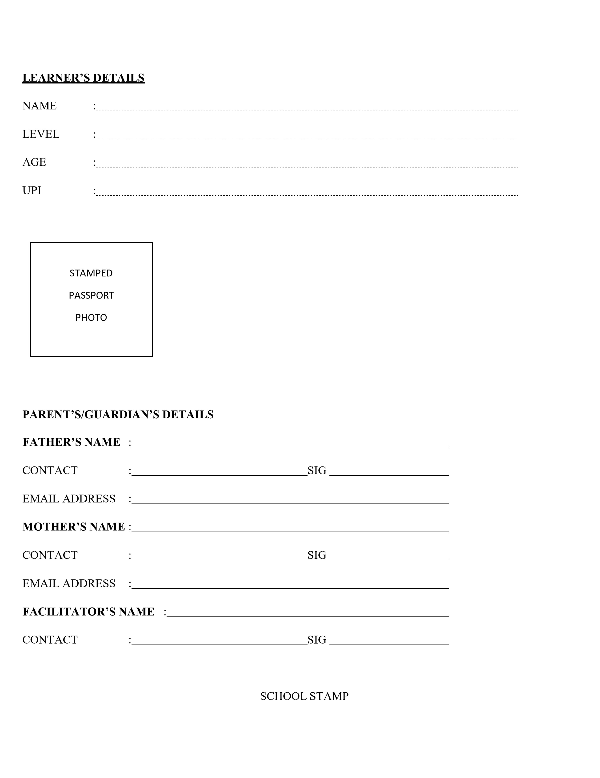
RATIONALISED ENVIRONMENTAL ACTIVITIES ASSESSMENT
KEY: EX- EXCEEDING EXPECTATION, MT- MEETING EXPECTATION, AP –APPROACHES EXPECTATIONS, BA – BELOW EXPECTATIONS
 | TERM ONE |  |  |  | TERM TWO |  |  |  | TERM THREE |  |  |  | SUMMATIVE ASSESSMENT
Tick appropriately | EX | MT | AP | BE | EX | MT | AP | BE | EX | MT | AP | BE | TERM 2 | TERM 2 | TERM 3
1.0 NUMBERS |  |  |  |  |  |  |  |  |  |  |  |  | ENTER SCORES FOR THE TERM IN THE BOX
Number concept
Whole numbers
Additions
Subtraction
Multiplication
Divisions
Fractions
2.0 MEASUREMENT
Length
Mass
Capacity
Time
Money
3.0 GEOMETRY
LINES
SHAPES

RATIONALIZED KISWAHILI ACTIVITIES ASSESSMENT
KEY: EX- EXCEEDING EXPECTATION, MT- MEETING EXPECTATION, AP –APPROACHES EXPECTATIONS, BA – BELOW EXPECTATIONS
 | TERM ONE |  |  |  | TERM TWO |  |  |  | TERM THREE |  |  |  | SUMMATIVE ASSESSMENT
Tick appropriately | EX | MT | AP | BE | EX | MT | AP | BE | EX | MT | AP | BE | TERM 2 | TERM 2 | TERM 3
1.0 KUSIKILIZA NA KUZUNGUMZA |  |  |  |  |  |  |  |  |  |  |  |  | ENTER SCORES FOR THE TERM IN THE BOX
Mamkuzi na maagano
Matamshi bora
Maneno ya Heshima na Adabu
Matamshi bora
Hadithi
Matamshi bora
Maagizo
Matamshi bora
Mazungumzo ya papo kwa hapo
Matamshi bora
2.0 KUSOMA
Kusoma ufahamu
Kusoma kwa ufasaha
Kusoma kwa ufahamu
Kusoma kwa ufasaha
Kusoma kwa ufahamu
Kusoma kwa ufasaha
Kusoma kwa ufahamu
Kusoma kwa ufasaha
Kusoma kwa ufahamu
Kusoma kwa ufasaha
3.0 KUANDIKA
Hati nadhifu: Sentensi
Hati nadhifu:herufi kubwa
Mpangilio wa herufi ndogo
Nafasi katika maandishi
Uakifishi: matumizi ya alama ya kiulizi
Tahajia Imla
uhariri
Tahajia
Kuandika kifungu
Maneno na sentensi
4.0 SARUFI
Matumizi ya wewe na nyinyi
Umoja na wingi wa vifungu
Matumizi ya huyo na hao
Umoja na wingi wa vifungu kwa maneno
Matumizi ya –ako na yenu
Matumizi ya –refu, kubwa na tamu
Ukanusho wa nafsi ya pili, umoja na wingi
Matumizi ya huu na hii
Matumizi ya vizuri na mbaya, pole pole na haraka
Vinyume vya vitendo

RATIONALISED INDIGENOUS LANGUAGE ACTIVITIES ASSESSMENT
KEY: EX- EXCEEDING EXPECTATION, MT- MEETING EXPECTATION, AP –APPROACHES EXPECTATIONS, BA – BELOW EXPECTATIONS
 | TERM ONE |  |  |  | TERM TWO |  |  |  | TERM THREE |  |  |  | SUMMATIVE ASSESSMENT
Tick appropriately | EX | MT | AP | BE | EX | MT | AP | BE | EX | MT | AP | BE | TERM 2 | TERM 2 | TERM 3
1.0 LISTENING AND SPEAKING |  |  |  |  |  |  |  |  |  |  |  |  | ENTER SCORES FOR THE TERM IN THE BOX
Listening to instructions
Reading : picture reading
Writing: writing names of items
2.0 LISTENING AND SPEAKING
Riddles
Reading : reading picture stories
Writing: writing simple sentences
3.0 LISTENING AND SPEAKING
Listening to stories
Reading: Loud reading
Writing : spelling words
4.0 LISTENING AND SPEAKING
Self-expression
Reading : loud reading
Writing: handwriting
5.0 LISTENING AND SPEAKING
Listening to instructions
Reading: reading simple text
Writing: creative writing

RATIONALISED ENVIRONMENTAL ACTIVITIES ASSESSMENT
KEY: EX- EXCEEDING EXPECTATION, MT- MEETING EXPECTATION, AP –APPROACHES EXPECTATIONS, BA – BELOW EXPECTATIONS
 | TERM ONE |  |  |  | TERM TWO |  |  |  | TERM THREE |  |  |  | SUMMATIVE ASSESSMENT
Tick appropriately | EX | MT | AP | BE | EX | MT | AP | BE | EX | MT | AP | BE | TERM 2 | TERM 2 | TERM 3
1.0 SOCIAL ENVIRONMENT |  |  |  |  |  |  |  |  |  |  |  |  | ENTER SCORES FOR THE TERM IN THE BOX
Our home
Family needs and wants
Our school
Our national flag
Our rights and responsibility
Our market
2.0 NATURAL ENVIRONMENT
Weather
Soil
Light
3.0 RESOURCES IN OUR ENVIRONMENT
Water
Plants
Animals

RATIONALISED ENGLISH LANGUAGE ACTIVITIES ASSESSMENT
KEY: EX- EXCEEDING EXPECTATION, MT- MEETING EXPECTATION, AP –APPROACHES EXPECTATIONS, BA – BELOW EXPECTATIONS
 | TERM ONE |  |  |  | TERM TWO |  |  |  | TERM THREE |  |  |  | SUMMATIVE ASSESSMENT
Tick appropriately | EX | MT | AP | BE | EX | MT | AP | BE | EX | MT | AP | BE | TERM 2 | TERM 2 | TERM 3
1.0 LISTENING AND SPEAKING |  |  |  |  |  |  |  |  |  |  |  |  | ENTER SCORES FOR THE TERM IN THE BOX
Pronunciations and Vocabularies
Reading: Fluency
Reading: comprehension
Use of language: the verb ‘ to be’
Writing : handwriting
2.0 LISTENING AND SPEAKING
Pronunciations and Vocabularies
Reading: Fluency
Reading: comprehension
Use of language: the verb ‘ to be’ (was, were)
Writing : handwriting
3.0 LISTENING AND SPEAKING
Pronunciations and Vocabularies
Reading: Fluency
Reading: comprehension
Language use: singular and plural objective pronounce
Writing : handwriting
4.0 LISTENING AND SPEAKING
Pronunciations and Vocabularies
Reading: Fluency
Reading: comprehension
Language use: Simple past tense
Handwriting
5.0 LISTENING AND SPEAKING
Pronunciations and Vocabularies
Reading: Fluency
Reading: comprehension
Language use: plurals of irregular nouns
Writing: spelling
6.0 LISTENING AND SPEAKING
Pronunciations and Vocabularies
Reading: Fluency
Reading: comprehension
Language use: past continuous tense
Writing: spelling
7.0 LISTENING AND SPEAKING
Pronunciations and Vocabularies
Reading: Fluency
Reading: comprehension
Use of conjunctions
Writing: spelling
8.0 LISTENING AND SPEAKING
Pronunciations and Vocabularies
Reading: Fluency
Reading: comprehension
Language use: cardinal and ordinary numbers; demonstratives (these and those
Writing: spelling
9.0 LISTENING AND SPEAKING
Pronunciations and Vocabularies
Reading: Fluency
Reading: comprehension
Language use: word set (gender set for animal and people)
Opposites
Writing: punctuation (the comma)
10.0 LISTENING AND SPEAKING
Pronunciations and Vocabularies
Reading: Fluency
Reading: comprehension
Language use: prepositions
Writing : punctuation (exclamation mark)
11.0 LISTENING AND SPEAKING
Pronunciations and Vocabularies
Reading: Fluency
Reading: comprehension
Language use: regular comparative and superlative adjectives
Writing: guide writing
12.0 LISTENING AND SPEAKING
Pronunciations and Vocabularies
Reading: Fluency
Reading: comprehension
Language use : possessive pronounce
Writing: guide writing
13.0 LISTENING AND SPEAKING
Pronunciations and Vocabularies
Reading: Fluency
Reading: comprehension
Language use : - wh questions
Writing: guide writing
14.0 LISTENING AND SPEAKING
Pronunciations and Vocabularies
Reading: Fluency
Reading: comprehension
Language use: adverb of time
Writing: guide writing
15.0 LISTENING AND SPEAKING
Pronunciations and Vocabularies
Reading: Fluency
Reading: comprehension
Language use: imperatives (commands) interjections of excitement/joy
Writing: guide writing

RATIONALISED CREATIVE ARTS ASSESSMENT
KEY: EX- EXCEEDING EXPECTATION, MT- MEETING EXPECTATION, AP –APPROACHES EXPECTATIONS, BA – BELOW EXPECTATIONS
 | TERM ONE |  |  |  | TERM TWO |  |  |  | TERM THREE |  |  |  | SUMMATIVE ASSESSMENT
Tick appropriately | EX | MT | AP | BE | EX | MT | AP | BE | EX | MT | AP | BE | TERM 2 | TERM 2 | TERM 3
1.0 CREATING AND EXPLORATION |  |  |  |  |  |  |  |  |  |  |  |  | ENTER SCORES FOR THE TERM IN THE BOX
Picture making
Rhythm
Melody
2.0 PERFOMING AND DISPLAY
Turning
African Style Singing game
Hoping
Kicking
Playing Musical instrument (winds)
Roles and balances
Water safety
3.0 APPRECIATION
African Style Singing game

RATIONALISED CHRISTIAN RELIGIOUS EDUCATION (CRE) ASSESSMENT
KEY: EX- EXCEEDING EXPECTATION, MT- MEETING EXPECTATION, AP –APPROACHES EXPECTATIONS, BA – BELOW EXPECTATIONS
 | TERM ONE |  |  |  | TERM TWO |  |  |  | TERM THREE |  |  |  | SUMMATIVE ASSESSMENT
Tick appropriately | EX | MT | AP | BE | EX | MT | AP | BE | EX | MT | AP | BE | TERM 2 | TERM 2 | TERM 3
1.0 CREATING |  |  |  |  |  |  |  |  |  |  |  |  | ENTER SCORES FOR THE TERM IN THE BOX
Self-awareness
My family
Creation of the sky, sun, moon and stars
2.0 THE BIBLE
The holy bible as a guide
Division of the bible
The bible story: call of samwel
The bible story: Daniel in the den of lion
The bible story: the widow of zarephath
3.0 THE EARLY LIFE OF JESUS CHRIST
The birth of Jesus Christ
Kindness of the wise men
Jesus calm the storm
Miraculous catch of fish
Healing the man with withered hand
The Esther
4.0 CHRISTIAN VALUES
Sharing
Obedience
Honesty
Thankfulness
Forgiveness
Responsibility
Work
5.0 THE CHURCH
Prayer
The holy spirit

RATIONALISED HINDU RELIGIOUS EDUCATION (HRE) ASSESSMENT

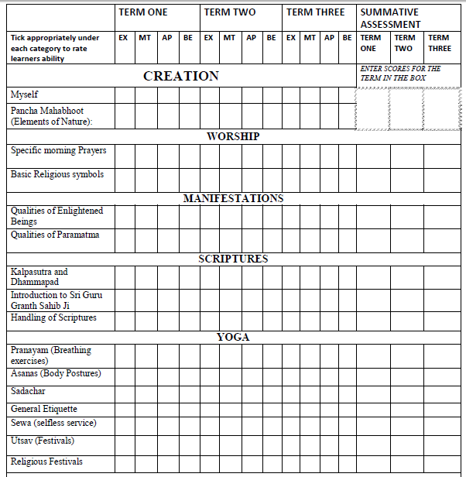

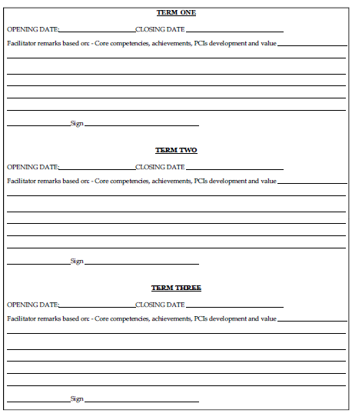

SUMMATIVE ASSESSMENT SUMMARY REPORT
 | ENTER SCORES FOR PARTICULAR TERM IN THE BOX PROVIDE BELOW
 | TERM ONE |  | TERM TWO |  | TERM THREE
SUBJEC | ASSESSMENT ONE | ASSESSMENT TWO | ASSESSMENT ONE | ASSESSMENT TWO | ASSESSMENT ONE | ASSESSMENT TWO
MATHEMATICS ACTIVITIES
INDIGENOUS LANGUAGE
KISWAHILI
ENGLISH ACTIVITIES
CREATIVE ARTS
ENVIRONMENTAL ACTIVITIES
CRE
HRE

