2023 GRADE 2 MATHEMATICS ACTIVITIES
TERM ONE SCHEME OF WORK
SCHOOL | GRADE | TEACHERS NAME | TIME | YEAR

WEEK | LSN | STRAND | SUB-STRAND | SPECIFIC LEARNING  OUTCOME | KEY INQUIRY QUESTIONS | LEARNING EXPERIENCE | LEARNING RESOURCES | ASSESSMENT METHOD | REFL
1 | 1 | NUMBERS | Number concept | By the end of the lesson, the learner should be to  - read number symbols up to 20.  - Play games on number representation using concrete objects  - Appreciate the importance of numbers in real life | How do you read number symbols? | 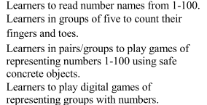 | Videos  Audios  Number cards  Number charts  Mathematics Activities pupil’s book 2 pg.3  Mathematics teachers guide grade 2 pg. 4 | Oral Questions  Written exercise  observation
 | 2 |  |  | By the end of the lesson, the learner should be to  - read number symbols up to 50.  - Play games on number representation using concrete objects  - Appreciate the importance of numbers in real life | How do you read number symbols? |  | Videos  Audios  Number cards  Number charts  Mathematics Activities pupil’s book 2 pg.3  Mathematics teachers guide grade 2 pg. 4 | Oral Questions  Written exercise  observation
 | 3 |  |  | By the end of the lesson, the learner should be to  - Represent numbers up to 20 using objects.  - Work out examples in their books  - Appreciate the role of numbers in real life | How do you represent numbers using objects? |  | Books  Pencils  Balls  Bottle tops  Mathematics Activities pupil’s book 2 pg.4  Mathematics teachers guide grade 2 pg. 5 | Oral Questions  Written exercise  observation
 | 4 |  |  | By the end of the lesson, the learner should be to  - Represent numbers up to 50 using objects.  - Play digital games of representing groups with numbers  - Appreciate the role of numbers in real life | How do you represent numbers using objects? |  | Marbles  Crayons  Bottle tops  Mathematics Activities pupil’s book 2 pg.6-7  Mathematics teachers guide grade 2 pg. 6 | Oral Questions  Written exercise  observation
 | 5 |  |  | By the end of the lesson, the learner should be to  - Count in 2s up to 20 forward and backward.  - Count their fingers and toes in 2’s  - Desire to count concrete objects in the environment | How do you count numbers forward and backward? | 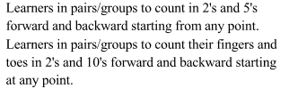 | Counter  Number line  Sticks, Straws  Stones, Seeds  Grains  Mathematics Activities pupil’s book 2 pg.8  Mathematics teachers guide grade 2 pg. 8 | Oral Questions  Written exercise  observation
2 | 1 |  |  | By the end of the lesson, the learner should be to  - Count in 2s up to 50 forward and backward.  - Count their fingers and toes in 2’s  - Desire to count concrete objects in the environment | How do you count numbers forward and backward? |  | Counter  Number line  Sticks  Straws, Stones  Seeds, Grains  Mathematics Activities pupil’s book 2 pg.9  Mathematics teachers guide grade 2 pg. 9 | Oral Questions  Written exercise  observation
 | 2 |  |  | By the end of the lesson, the learner should be to  - Identify place value of digits in numbers up to tens.  - Work out examples in the books  - Appreciate the importance of place value in real life | How do you identify the position of a digit in a number? | 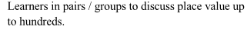 | Place value chart  Sticks  Straws  Mathematics Activities pupil’s book 2 pg.10  Mathematics teachers guide grade 2 pg. 10 | Oral Questions  Written exercise  observation
 | 3 |  |  | By the end of the lesson, the learner should be to  - read and write number symbols up to 20  - identify number symbols  - appreciate the importance of symbols | How do you read and write numbers? | Learners to read and write number symbols | Number chart  Number cards  Video clips  Mathematics Activities pupil’s book 2 pg.11  Mathematics teachers guide grade 2 pg. 11 | Oral Questions  Written exercise  observation
 | 4 |  |  | By the end of the lesson, the learner should be to  - read and write number symbols up to 50  - identify number symbols  - appreciate the importance of symbols | How do you read and write numbers in symbols? | Learners to read and write number symbols in their books | Number chart  Number cards  Video clips  Mathematics Activities pupil’s book 2 pg.12  Mathematics teachers guide grade 2 pg. 12 | Oral Questions  Written exercise  observation
 | 5 |  |  | By the end of the lesson, the learner should be to  - Read and write numbers up to 10 in words.  - identify number symbols  - appreciate the importance of symbols | How do you read and write numbers in words? | Learners to read and write number symbols in words in their books | Cards with numerals and words  Video clips  Mathematics Activities pupil’s book 2 pg.13  Mathematics teachers guide grade 2 pg. 13 | Oral Questions  Written exercise  observation
3 | 1 |  |  | By the end of the lesson, the learner should be  - identify missing number patterns  - Work out missing numbers in patterns up to 20 in 2’s.  - desire to complete various patterns | How do you complete a number pattern? | Learners dto identify missing number patterns  Complete various patterns in real life | Number cards  String  Rope  Video clips  Mathematics Activities pupil’s book 2 pg.14  Mathematics teachers guide grade 2 pg. 14 | Oral Questions  Written exercise  observation
 | 2 |  |  | By the end of the lesson, the learner should be  - work out missing numbers in patterns up to 50 in 5’s.  - Work out missing numbers in patterns up to 20 in 2’s.  - desire to complete various patterns | How do you complete a number pattern? | Learners dto identify missing number patterns  Complete various patterns in real life | Card with numerals  Video clips  Mathematics Activities pupil’s book 2 pg.15  Mathematics teachers guide grade 2 pg. 15 | Oral Questions  Written exercise  observation
 | 3 |  |  | By the end of the lesson, the learner should be able to  - Identify a half as part of a whole.  - Draw half as part of a whole  - Appreciate the role of fractions | How do you get two equal parts of a whole? | Learners to play digital games involving fractions  Draw half as part of a whole | Paper cut-outs  Manila papers  Mathematics Activities pupil’s book 2 pg.16  Mathematics teachers guide grade 2 pg. 17 | Oral Questions  Written exercise  observation
 | 4 |  | Fractions | By the end of the lesson, the learner should be able to  - Identify a half as part of a whole.  - Draw half as part of a whole  - Appreciate the role of fractions | How do you get two equal parts of a whole? | 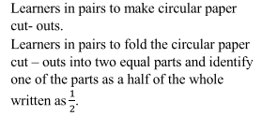 | Paper cut-outs  Manila papers  Mathematics Activities pupil’s book 2 pg.17  Mathematics teachers guide grade 2 pg. 18 | Oral Questions  Written exercise  observation
 | 5 |  |  | By the end of the lesson, the learner should be able to  - Write a half using symbols.  - Identify half using symbols  - Develop curiosity in explaining half as part of a whole | How do you write a half using numbers? |  | Paper cut-outs  Felt pens  Manila papers  Mathematics Activities pupil’s book 2 pg.18  Mathematics teachers guide grade 2 pg. 19 | Oral Questions  Written exercise  observation
4 | 1 |  |  | By the end of the lesson, the learner should be able to  - form a whole using halves  - identify halves used to form a whole  - appreciate the importance of fractions | How do you use parts to form a whole? |  | Paper cut-outs of different sizes  Felt pens  Manila papers  Mathematics Activities pupil’s book 2 pg.19  Mathematics teachers guide grade 2 pg. 20 | Oral Questions  Written exercise  observation
 | 2 |  | Addition | By the end of the lesson, the learner should be able to  - add a 2-digit number to a 1-digit number up to a sum of 50 horizontally and vertically  - come up with a two digit number and a 1-digit number  - appreciate adding numbers in real life | How do you add a 2-digit number to a 1-digit number? | 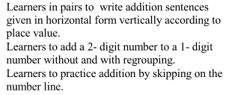 | Counters  Basic addition table  Mathematics Activities pupil’s book 2 pg.20  Mathematics teachers guide grade 2 pg. 22 | Oral Questions  Written exercise  observation
 | 3 |  |  | By the end of the lesson, the learner should be able to  - Add a 2-digit number to a 1-digit number up to a sum of 100 horizontally.  - come up with a two digit number and a 1-digit number  - appreciate adding numbers in real life | How do you add a 2-digit number to a 1-digit number? |  | Counters  Basic addition table  Mathematics Activities pupil’s book 2 pg.21  Mathematics teachers guide grade 2 pg. 23 | Oral Questions  Written exercise  observation
 | 4 |  |  | By the end of the lesson, the learner should be able to  - Add a 2-digit number to a 1-digit number without regrouping up to a sum of 100 vertically.  - come up with a two digit number and a 1-digit number  - appreciate adding numbers in real life | How do you add a 2-digit number to a 1-digit number? |  | Counters  Basic addition table  Place value apparatus  Mathematics Activities pupil’s book 2 pg.22  Mathematics teachers guide grade 2 pg. 24 | Oral Questions  Written exercise  observation
 | 5 |  |  | By the end of the lesson, the learner should be able to  - Add 3-single digit numbers.  - come up with a 3-single digit number  - appreciate adding numbers in real life | How do you add single digit numbers? | 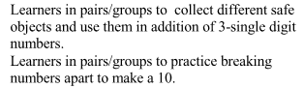 | Counters  Basic addition table  Mathematics Activities pupil’s book 2 pg.23  Mathematics teachers guide grade 2 pg. 25 | Oral Questions  Written exercise  observation
5 | 1 |  |  | By the end of the lesson, the learner should be able to  - add a 2-digit number to a 2-digit number without regrouping up to a sum of 50 horizontally.  - Work out examples in their books  - Appreciate addition of numbers in real life | How do you add a 2-digit number to a 2-digit number? | 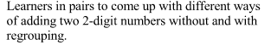 | Counters  Basic addition table  Place value apparatus  Mathematics Activities pupil’s book 2 pg.24  Mathematics teachers guide grade 2 pg. 26 | Oral Questions  Written exercise  observation
 | 2 |  |  | By the end of the lesson, the learner should be able to  - Add a 2-digit number to a 2-digit number without regrouping up to a sum of 50 vertically.  - Work out examples in their books  - Appreciate addition of numbers in real life | How do you add a 2-digit number to a 2-digit number? |  | Counters  Basic addition table  Place value apparatus  Mathematics Activities pupil’s book 2 pg.25  Mathematics teachers guide grade 2 pg. 27- 28 | Oral Questions  Written exercise  observation
 | 3 |  |  | By the end of the lesson, the learner should be able to  - work out missing numbers in patterns involving addition up to 20.  - Identify missing number in patterns  - Develop curiosity in completing missing number patterns | How do you work out missing numbers in patterns? | 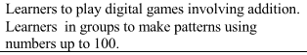 | Counters  Mathematics Activities pupil’s book 2 pg.26  Mathematics teachers guide grade 2 pg29 | Oral Questions  Written exercise  observation
 | 4 |  |  | By the end of the lesson, the learner should be able to  - work out missing numbers in patterns involving addition up to 20.  - Identify missing number in patterns  - Develop curiosity in completing missing number patterns | How do you work out missing numbers in patterns? |  | Counters  Mathematics Activities pupil’s book 2 pg.26  Mathematics teachers guide grade 2 pg29 | Oral Questions  Written exercise  observation
 | 5 |  | Subtraction | By the end of the lesson, the learner should be able to  - Subtract 2-single digit numbers horizontally.  - Work subtraction sums in their books  - Appreciate the importance of subtraction | How do you subtract single digit numbers? | 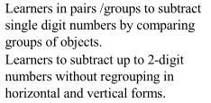 | Counters  Mathematics Activities pupil’s book 2 pg.27  Mathematics teachers guide grade 2 pg31 | Oral Questions  Written exercise  observation
6 | 1 |  |  | By the end of the lesson, the learner should be able to  - subtract 2-single digit numbers vertically  - Work subtraction sums in their books  - Appreciate the importance of subtraction | How do you subtract single digit numbers? |  | Counters  Mathematics Activities pupil’s book 2 pg.28  Mathematics teachers guide grade 2 pg32-33 | Oral Questions  Written exercise  observation
 | 2 |  |  | By the end of the lesson, the learner should be able to  - Subtract a 1-digit number from a 2-single digit number horizontally.  - Work subtraction sums in their books  - Appreciate the importance of subtraction | How do you subtract a 1-digit number from a 2-digit number? |  | Counters  Mathematics Activities pupil’s book 2 pg.29  Mathematics teachers guide grade 2 pg. 34 | Oral Questions  Written exercise  observation
 | 3 |  |  | By the end of the lesson, the learner should be able to  - Subtract a 2-single using the relationship between addition and subtraction.  - Work subtraction sums in their books  - Appreciate the importance of subtraction | How do you work out subtraction using the relationship between addition and subtraction? |  | Counters  Mathematics Activities pupil’s book 2 pg.31  Mathematics teachers guide grade 2 pg. 37 | Oral Questions  Written exercise  observation
 | 4 |  |  | By the end of the lesson, the learner should be able to  - Work out missing numbers in subtraction of single digit numbers.  - Identify missing number patterns  - Develop curiosity in completing number patterns | How do you work out missing numbers in subtraction? | 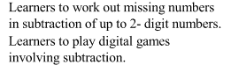 | Counters  Mathematics Activities pupil’s book 2 pg.32  Mathematics teachers guide grade 2 pg. 38 | Oral Questions  Written exercise  observation
 | 5 |  |  | By the end of the lesson, the learner should be able to  - Work out missing numbers in subtraction of single digit numbers.  - Identify missing number patterns  - Develop curiosity in completing number patterns | How do you work out missing numbers in subtraction? |  | Counters  Mathematics Activities pupil’s book 2 pg.33  Mathematics teachers guide grade 2 pg. 39 | Oral Questions  Written exercise  observation
7 | 1 |  |  | By the end of the lesson, the learner should be able to  - work out missing number in patterns involving subtraction from 1 up to 20.  - Identify missing number patterns  - Develop curiosity in completing number patterns | How do you work out missing numbers in patterns? |  | Counters  Mathematics Activities pupil’s book 2 pg.34  Mathematics teachers guide grade 2 pg. 40 | Oral Questions  Written exercise  observation
 | 2 |  | Multiplication | By the end of the lesson, the learner should be able to  - Model multiplication as repeated addition up to 2 times.  - Work out multiplication sums in their books  - Desire to explain the importance of multiplication | How do you get the total number of objects in two groups? | 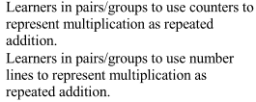 | Counters  Mathematics Activities pupil’s book 2 pg.35  Mathematics teachers guide grade 2 pg. 42 | Oral Questions  Written exercise  observation
 | 3 |  |  | By the end of the lesson, the learner should be able to  - Model multiplication as repeated addition up to 3 times.  - Work out multiplication sums in their books  - Desire to explain the importance of multiplication | How do you get the total number of objects in three groups? |  | Counters  Mathematics Activities pupil’s book 2 pg.36-37  Mathematics teachers guide grade 2 pg. 43 | Oral Questions  Written exercise  observation
 | 4 |  |  | By the end of the lesson, the learner should be able to  - Model multiplication as repeated addition up to 4 times.  - Work out multiplication sums in their books  - Desire to explain the importance of multiplication | How do you get the total number of objects in four groups? |  | Counters  Mathematics Activities pupil’s book 2 pg.38-39  Mathematics teachers guide grade 2 pg. 44 | Oral Questions  Written exercise  observation
 | 5 |  |  | By the end of the lesson, the learner should be able to  - Model multiplication as repeated addition up to 5 times.  - Work out multiplication sums in their books  - Desire to explain the importance of multiplication | How do you get the total number of objects in five groups? |  | Counters  Mathematics Activities pupil’s book 2 pg.40-41  Mathematics teachers guide grade 2 pg. 45-46 | Oral Questions  Written exercise  observation
8 | 1 |  |  | By the end of the lesson, the learner should be able to  - write repeated addition as multiplication, using the sign “x”  - Work out multiplication sums in their books  - Desire to explain the importance of multiplication | How do you write repeated addition as multiplication using the sign “x”?? | 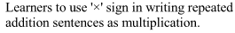 | Counters  Mathematics Activities pupil’s book 2 pg.42-43  Mathematics teachers guide grade 2 pg. 47 | Oral Questions  Written exercise  observation
 | 2 |  |  | By the end of the lesson, the learner should be able to  - Write multiplication sentences from repeated addition.  - Work out multiplication sums in their books  - Desire to explain the importance of multiplication | How do you write multiplication sentence from repeated addition? | 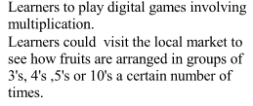 | Counters  Mathematics Activities pupil’s book 2 pg.44  Mathematics teachers guide grade 2 pg. 48-49 | Oral Questions  Written exercise  observation
 | 3 |  |  | By the end of the lesson, the learner should be able to  - multiply single digit numbers by 1  - Work out multiplication sums in their books  - Desire to explain the importance of multiplication | How do you multiply single digit numbers by 1? | 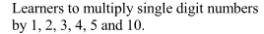 | Counters  Mathematics Activities pupil’s book 2 pg.45  Mathematics teachers guide grade 2 pg. 50 | Oral Questions  Written exercise  observation
 | 4 | MEASUREMENT | Length | By the end of the lesson, the learner should be able to  - Measure length using fixed units.  - Define the term length  - Appreciate the importance length in real life | How can you measure length? | 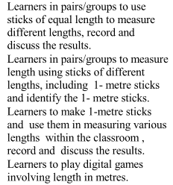 | Pencils of same length.  Mathematics Activities pupil’s book 2 pg.46  Mathematics teachers guide grade 2 pg. 52 | Oral Questions  Written exercise  observation
 | 5 |  |  | By the end of the lesson, the learner should be able to  - Measure length using fixed units.  - Define the term length  - Appreciate the importance length in real life | How can you measure length? |  | Stick  Classroom wall  Mathematics Activities pupil’s book 2 pg.47  Mathematics teachers guide grade 2 pg. 53 | Oral Questions  Written exercise  observation
9 | 1 |  | Mass | By the end of the lesson, the learner should be able to  - measure mass using fixed units  - play digital games involving mass in kilograms  - appreciate the importance of mass | How can you measure mass of an object? | 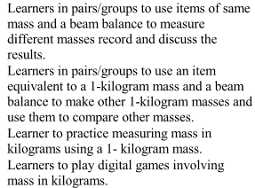 | Beam balance  Mathematics textbooks  Stones, bag, sand.  Mathematics Activities pupil’s book 2 pg.48  Mathematics teachers guide grade 2 pg. 55 | Oral Questions  Written exercise  observation
 | 2 |  |  | By the end of the lesson, the learner should be able to  - measure mass using fixed units  - play digital games involving mass in kilograms  - appreciate the importance of mass | How can you measure mass of an object? |  | Beam balance  Coin  Potato  Rubber, chalk stick  Mathematics Activities pupil’s book 2 pg.49  Mathematics teachers guide grade 2 pg. 56 | Oral Questions  Written exercise  observation
 | 3 |  | Capacity | By the end of the lesson, the learner should be able to  - measure capacity using fixed units  - play digital games involving capacity  - appreciate the importance of capacity | How can you measure the amount of water a container can hold? | 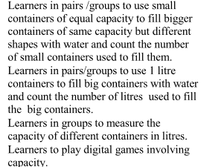 | Cup  Basin  Water  Bucket, jug, sufuria  Mathematics Activities pupil’s book 2 pg.50  Mathematics teachers guide grade 2 pg. 58 | Oral Questions  Written exercise  observation
 | 4-5 | HALF TERM
10 | 1 |  |  | By the end of the lesson, the learner should be able to  - measure capacity using fixed units  - play digital games involving capacity  - appreciate the importance of capacity | How can you measure the amount of water a container can hold? |  | Cup  Basin  Water  Bucket, jug, sufuria, jerricans  Mathematics Activities pupil’s book 2 pg.51  Mathematics teachers guide grade 2 pg. 59 | Oral Questions  Written exercise  observation
 | 2 |  |  | By the end of the lesson, the learner should be able to  - measure capacity using fixed units  - play digital games involving capacity  - appreciate the importance of capacity | How can you measure the amount of water a container can hold? |  | Cup  Basin  Water  Bucket, jug, sufuria, jerrycan  Mathematics Activities pupil’s book 2 pg.52  Mathematics teachers guide grade 2 pg. 60 | Oral Questions  Written exercise  observation
 | 3 |  | Time | By the end of the lesson, the learner should be able to  - Identify months of the year.  - Play digital games involving time  - Appreciate the importance of time | How can you identify the time of the year? | 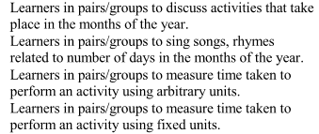 | Calendar  Digital devices  Mathematics Activities pupil’s book 2 pg.53  Mathematics teachers guide grade 2 pg. 62 | Oral Questions  Written exercise  observation
 | 4 |  |  | By the end of the lesson, the learner should be able to  - relate the months of the year with various activities  - Play digital games involving time  - Appreciate the importance of time | What activities take place in a year? |  | Calendar  Digital devices  Mathematics Activities pupil’s book 2 pg.54  Mathematics teachers guide grade 2 pg. 63 | Oral Questions  Written exercise  observation
 | 5 |  |  | By the end of the lesson, the learner should be able to  - Recite the number of days in each month of the year.  - Play digital games involving time  - Appreciate the importance of time | How do we tell the number of days in each month of the year? |  | Calendar  Mathematics Activities pupil’s book 2 pg.55  Mathematics teachers guide grade 2 pg. 64 | Oral Questions  Written exercise  observation
11 | 1 |  |  | By the end of the lesson, the learner should be able to  - Measure time using arbitrary units.  - Play digital games involving time  - Appreciate the importance of time | How can you tell how long an activity will take? |  | Chart of the National anthem.  Mathematics Activities pupil’s book 2 pg.56  Mathematics teachers guide grade 2 pg. 64 | Oral Questions  Written exercise  observation
 | 2 |  | Money | By the end of the lesson, the learner should be able to  - Identify Kenyan currency coins and notes up to sh. 100.  - Model or draw Kenyan currency  - Appreciate the importance of money in real life | How do you identify Kenyan currency? | 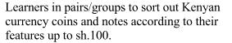 | Kenyan currency in coins and notes up to a hundred.  Mathematics Activities pupil’s book 2 pg.57  Mathematics teachers guide grade 2 pg. 67 | Oral Questions  Written exercise  observation
 | 3 | MEASUREMENT | Money | By the end of the lesson, the learner should be able to  - Sort Kenyan currency in coins and notes according to their value and features.  - Model or draw Kenyan currency  Appreciate the importance of money in real life | How do you identify Kenyan currency? | 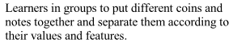 | Kenyan currency in coins and notes up to a hundred.  Mathematics Activities pupil’s book 2 pg.58  Mathematics teachers guide grade 2 pg. 68 | Oral Questions  Written exercise  observation
 | 4 |  |  | By the end of the lesson, the learner should be able to  - Count money in coins in values of sh.1, sh. 5, sh. 10, sh. 20, sh.40 and sh. 50 up to sh. 100.  - Model or draw Kenyan currency  Appreciate the importance of money in real life | How do you count money? | 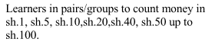 | Kenyan currency in coins up to a hundred.  Mathematics Activities pupil’s book 2 pg.59  Mathematics teachers guide grade 2 pg. 69 | Oral Questions  Written exercise  observation
 | 5 |  |  | By the end of the lesson, the learner should be able to  - count money in coins and notes in values of sh.1, sh. 5, sh. 10, sh. 20, sh.40 and sh. 50 up to sh. 100  - Model or draw Kenyan currency  Appreciate the importance of money in real life | How do you count money? |  | Kenyan currency in coins up to a hundred.  Mathematics Activities pupil’s book 2 pg.60  Mathematics teachers guide grade 2 pg. 70 | Oral Questions  Written exercise  observation
12 | 1 | GEOMETRY | Lines | By the end of the lesson, the learner should be able to  - Identify straight and curved lines.  - Model straight or curved lines  - Appreciate the Importance of lines | How do straight and curved lines look like? | 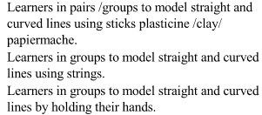 | Piece of rope  Pieces of sticks  Crayons  Chalk  Charcoal, materials with straight and curved edged.  Mathematics Activities pupil’s book 2 pg.61  Mathematics teachers guide grade 2 pg. 72 | Oral Questions  Written exercise  observation
 | 2 |  |  | By the end of the lesson, the learner should be able to  - Identify rectangles, circles and triangles.  - Model various shapes in the immediate environment  - Appreciate the Importance of shapes in the immediate environment | How does a rectangle, a circle and a triangle look like? | 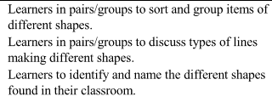 | Paper cut-outs of rectangles, triangles and circle  Mathematics Activities pupil’s book 2 pg.62-63  Mathematics teachers guide grade 2 pg. 74 | Oral Questions  Written exercise  observation
 | 3-5 | REVISION
13 | ASSESSMENT/CLOSING

