JUNIOR SCHOOL

24

AGRICULTURE AND NUTRITION

GRADE 8

STRAND 1-CONSERVING AGRICULTURAL ENVIRONMENT.
1.1-Soil Conservation Measures. Soil conservation measures refers to a combination of practices done or taken to prevent the loss of soil through soil erosion.

Reasons/Importance for Soil conservation.
- To keep top soil in its place.
- To maintain fertility in the soil.
- To maintain soil productivity.
- Helps to increase agricultural production promotes food security.

Methods of soil conservation in agricultural environment.
- Strip cropping.
- Grassed water ways.
- Stone lines.
- Trash lines.
- Soil bunds.

Strip cropping.
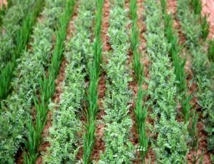

- It is the growing of crops in a way that crops that have little soil cover like maize are grown in alternating strips with those that have good ground cover such as sweet potatoes.
- Permanent vegetation such as grass can also be used as strips.
- The role of strip crop is it prevents loss of soil through surface runoff.

Grassed water ways.
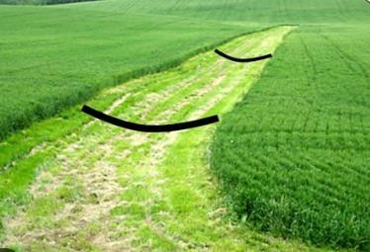
- Grassed waterways are natural or man-made shallow channels in which excess rain water flows.
- Grass and other vegetation are planted to grow in the channels.
- When surface run off is directed in the channels, the vegetation in the channels lower the speed of run off and also traps eroded soil.

Stone lines.
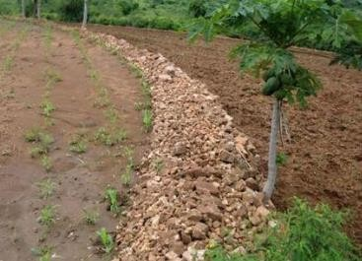
- These are stones (of different sizes) heaped in a line along the contour to prevent loss of soil down the slope through run off.
- Stone lines reduce speed of run off increasing water infiltration especially in semi-arid areas. Water infiltration is the downward entry of water into the soil from the surface.
- Stone lines are suitable in gently slopes.

Trash lines.
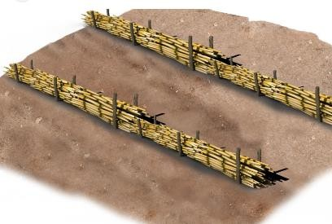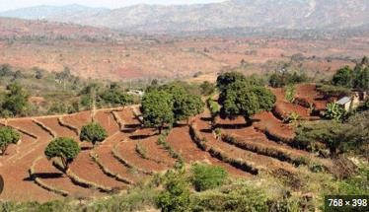

- Trash lines are plant materials or crop residues(remains) arranged along the contour in a cultivated field.
- Trash lines help to reduce runoff hence preventing loss of soil from land.
- They also increase water infiltration into the soil.
- Trash line should be 1 m wide and 0.5 m high.

Soil bunds.
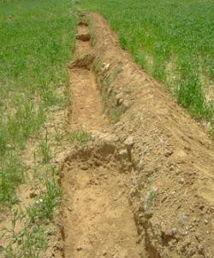
- A bund refers to a heap of compacted soil made along the contours.
- Grasses can be grown on top of the bunds to hold soil together firmly.
- Bunds help to reduce the volume of water flowing downwards in a cultivated field after rain fall.
- Bunds enhance water infiltration.

NOTE:
⭸ Most structures constructed to conserve the soil are made along the contour line.
Therefore, it is very important to establish the contour lines first before construction of the structures.
⭸ Contour lines are established to guide the position of the soil conservation measures.
⭸ Contour farming is the farming carried out across the slope rather than up and down.
Therefore, contour lines run across the slope and not up and down.

A model of the Farm Layout.
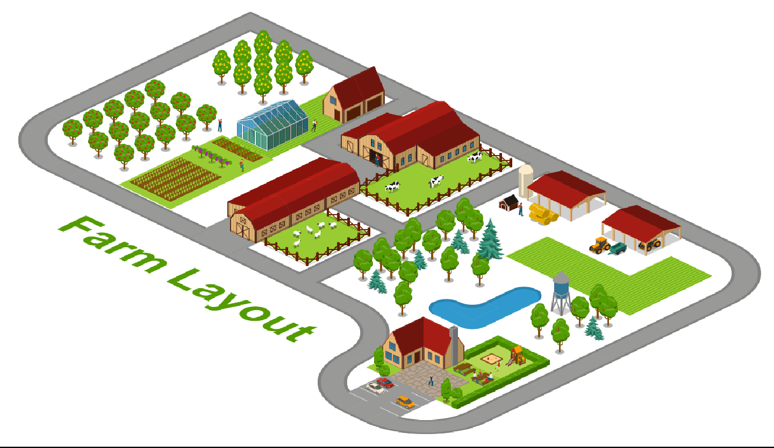
- A farm layout is a drawn plan that shows various farm enterprises and where they are placed in the farm.
- A farm layout is a plan of how various farm components (enterprises) are arranged and set up on the farm.
- A farm model guides the farmer to locate various farm activities and structures for convenience.

What is the importance of Farm layout?
- It helps in maximum utilization (use) of land.
- Farm enterprise are orderly arranged.

Local available material that can be used to make a farm model in school include:
- Cartons.
- Cardboards.
- Soil.
- Papier mache.
1.2-Water Harvesting and Storage
- In rainy season, a lot of water goes in waste.
- This water can be harvested and stored then used for farming purposes.

Methods of harvesting and storing water for farming purposes.
- There are various methods used to harvest and store water for farming purposes.
  - Use of rooftops.
  - Use of diversion channels. (directs water into water ponds and water tanks.)
  - Water ponds.
  - Shallow water pans.
  - Tanks.

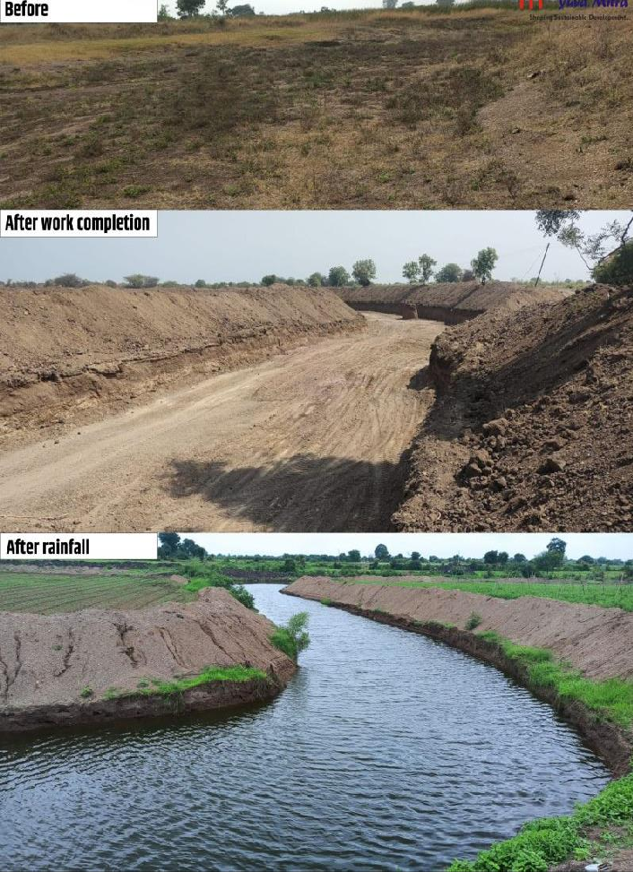
roof

Diversion channel constructed to direct water to storage areas

Shallow water pans
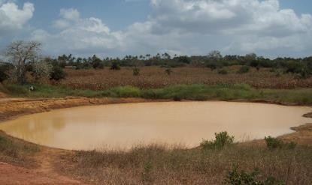

Water pond

Grass should be planted around the shallow water pan to:
- Control soil erosion.
- Control sedimentation.

Constructing Shallow water pan.
- Measure desired size of the structure.
- Dig out soil to the desired length and width with depth between 1 to 3 metres.
- Make conveyor or small channels that directs surface runoff to the structure.

Construction of a water pond.
  - Mark desired measurements on ground.
  - Dig out the soil.
  - Place a polythene liner evenly covering the sides and the base.
  - Reinforce the liner by placing soil in the upper part around the pond.
  - Plant grass around the pond to control erosion and sedimentation.
  - Make channels to transfer surface runoff.

Water tanks.
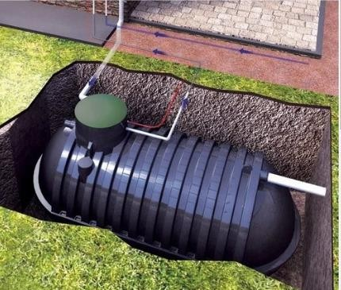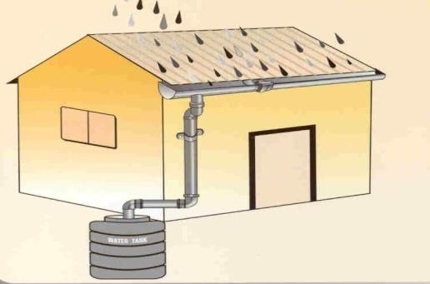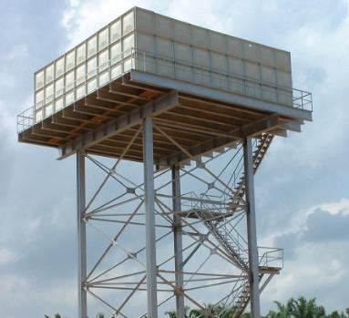
Gutter
Underground water tank Elevated water tank
  - Water tanks can be used to collect surface runoff or water from the rooftops.
  - Ensure water flow into the tank by removing any materials such as gravel, sediments from the sieve entrance of the tank.

  - Gutters should be fixed around the house to collect water when it rains and direct it to the tank through pipes for storage.

Factors to consider when setting up a water harvesting and storage unit at home or at school.
  - Location.
  - Accessibility.
  - Type of crop to be irrigated using water.
  - Size of the farm.
  - Dimension of the storage unit.
  - The slope of the land.
  - The cost of the work.

Importance of harvesting and storing water.
- Harvesting and storing water helps to supplement other sources of water.
- It provides water during shortage and in dry seasons.
- Water is available through out.
- Reduces cost of farming.
- Excess water from the rain is utilized.
- Helps to prevent destruction of infrastructures such as buildings and roads by surface runoff.

Maintenance of water harvesting and storage structures.
  - Plant grass around the water pans and water ponds to control soil erosion and sedimentation and to stabilize the embankments.
  - Remove foreign material in water found in water pans, ponds and tanks.
  - Structures such as water pans and water pons should be fenced.
  - Water tanks should be cleaned and foreign materials such as gravel, twigs, leaves sieved out during water entry.
  - Clean the gutters to remove accumulated materials.

Uses of water harvested and stored on the farm.
Watering/irrigating crops. Watering animals.
Domestic uses such as washing, cleaning items etc.

Types of water storage tanks.
- Water tanks can be:
  - Plastic.
  - Metallic.
  - Concrete.
- They can also be elevated (placed on top of the ground) or underground.

STRAND 2- FOOD PRODUCTION PROCESSES
2.1 Kitchen and Backyard Gardening.
✰ Food security is an important aspect of a healthy society.
✰ To promote food security, household should embrace kitchen gardens.
✰ A kitchen garden ensures regular and ready supply of fresh vegetables, fruits and herbs.
✰ Food security exists only when all people at all times have access to sufficient, safe and nutritious food that meets their dietary needs and food preference for healthy living.
✰ Kitchen garden is any convenient size of a plot, space or structure located in a home where a variety of crops are grown mainly for family consumption.

The role of a kitchen garden in food and nutrition security.
⮑ To produce safe, fresh food that is accessible to the family.
⮑ It is a reliable source of green leafy vegetables, herbs, fruits, legumes and cereals for home consumption.
⮑ Growing of both seasonal and off-season crops that ensures steady supply of nutritious food.
⮑ Help family to meet their nutritional needs and promotes healthier lifestyles.
⮑ Generates income from sale of surplus (excess) produce.
⮑ Helps to save family income direct towards purchase of vegetables, fruits and others.
⮑ Provide alternative when staple foods are not in stock.
⮑ Helps to increase food production.
⮑ Some form of kitchen gardening use recycled materials like plastics hence contributes to environmental conservation.

Innovative technologies for kitchen garden.
- Increase in population and urbanization has led to limited space that can be used to establish large gardens.
- Innovative technologies ensure proper use of the small available space for maximum production.
- The main aim of innovative gardening is to maximize the small available space with proper water conservation, measures in crop production.

Examples of innovative kitchen gardens include:
✰ Container.
✰ Wick.
✰ Hanging pots.
✰ Tyre.
✰ Multistore gardens.
✰ Simple drip.
✰ Organic sack garden.

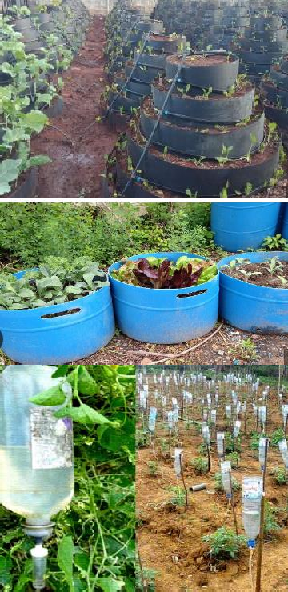
- Most of the kitchen gardens focus on vertical gardens which keeps the crops off the ground as compared to horizontal gardening.
Multi-storey garden | Involves filling a bag, sack or container with soil and manure the planting vegetables on the top or sides, it requires little space.
Container garden. | Done by planting crops in a container such as earthen pots, wooden boxes and plastic containers. The garden is not appropriate for deep rooted crops.
Simple drip garden | An innovative technology which involves use of plastic bottles and jerricans. It involves use of two containers, one filled with soil and manure in which crops are planted while the other is placed directly above the first container and filled with water, tiny holes are made at the bottom to allow water to drip.
Wick garden | A modern technology of using underground irrigation system. Crops are planted in a container which is placed on another container filled with water.  A wick connecting the bottom container with top container draws water up feeding the crops at the top. This technology is suitable for areas with little space | 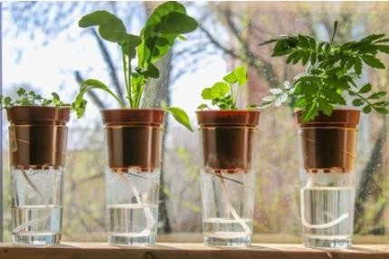

Benefits of innovative gardens.
 Use locally available materials.
 Requires little amount of water.
 Easy to manage because less labour is required.
 Makes good use of little space.
 Some are portable-can be moved from one area to another.
 High productivity or yields.
 Aesthetic value around the compound.
 Ideal for urban areas and congested homesteads.
2.2 Poultry Rearing in a Fold.
Poultry rearing is the keeping of domesticated birds such as chicken, ducks, turkeys, geese,
pigeons, guinea fowls and ostriches.
Poultry are kept for production of meat, eggs and other products.

Poultry folds. Structural appearance of a poultry fold.
A fold is a portable structure used for rearing poultry in an open piece of land where they can access sunlight, vegetation to supplement their feeds and can also exercise.
Feed and water troughs are placed inside the folds.
The fold can be moved from one place to another for the birds to eat fresh vegetation. Poultry folds are portable triangular shaped structures.
A fold has two sections, one is roofed and the other is left open but fitted wih wire mesh to secure the birds.
The fold has a door fitted on one side.
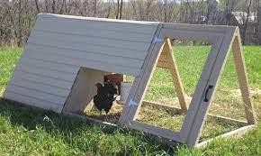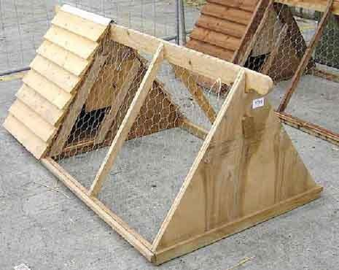

Materials used in the Construction of a poultry fold.
Poultry folds are constructed using locally available materials. This makes it cheap and easy to construct them.
Materials for constructing a poultry fold include:

⭸ Wire mesh.
⭸ Fencing staples
⭸ Reused and recycled wires.
⭸ Plastic materials.
⭸ Wood materials.
⭸ Nails.
⭸ Claw hammer.

NOTE:
Smaller folds have rollers and wheels that helps to move them from place to place.
Some folds structures have wire mesh at the base to allow droppings to pass through to the ground.
Fencing staples can be used instead of nails.
The size of the fold depends on the number and type of poultry reared.

Rearing practices of poultry in a fold.
There are various practices which are carried out when rearing poultry in a fold.

These rearing practices includes:
∼ Moving the fold to new sites regularly for the birds to feed on fresh vegetation.
∼ Ensure birds are provided with clean water.
∼ Ensure hygiene is maintained in the poultry fold.
∼ The fold should be strong enough to secure birds and kept in a safe place.
∼ The fold should be sheltered from the rain to avoid wetness. It should be placed in such a way that the open side is away from direct winds to avoid drought.

How to rear Poultry in a fold.
✗ Sitting. (where to place your fold) Ensure the fold is placed in an area:
∼ Protected from rain and direct wind.
∼ With enough security.
∼ That can be easily accessible.
∼ With enough vegetation.

✗ Stocking the folds.
∼ Place chicks into the fold carefully in the early hours of the day for them to familiarize with the environment.
∼ Place the right number of birds in the fold to avoid overcrowding which encourages diseases.

✗ Feeding.
∼ Provide enough feed depending on the stages of growth.
∼ Place feed in the feeding troughs.
∼ Move fold unit from one place to another to enable birds to eat fresh vegetation.

✗ Watering.
∼ Provide clean water in waterers.

✗ Sanitation.
∼ Maintain high standards of hygiene in the folds by cleaning the waterer, feed troughs and poultry folds.

✗ Vaccination.
∼ Provide poultry vaccinations to prevent poultry diseases. Ensure vaccines are provided at the correct time using the right means.
2.3 Crop Pests and Disease Control.

Vegetables crops attacked by pest and diseases.
Vegetables are usually attacked by various pests and diseases that eventually affects their growth and productivity.

Identification of vegetables crops attacked by pests.
We can identify various vegetables attacked by crop pests through the following:
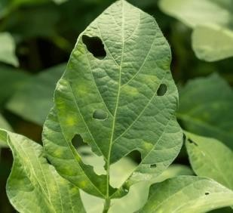
⭸ Punctured leaves – vegetables have leaves that are
damaged and have holes in them. This indicates the vegetables are attacked by pests.

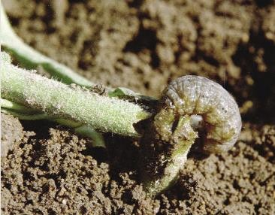
⭸ Cut-off seedlings – vegetables damaged by pests also have seedling that are cut off and fall.

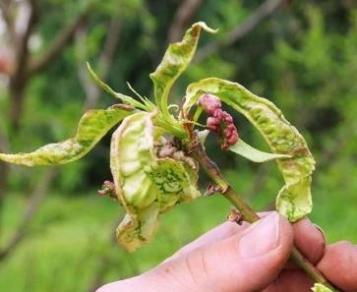
⭸ Curling leaves – leaves shrink and reduce in size because of pests sucking.

⭸ Holes made in vegetable fruits – pests bore holes in vegetable fruits such as tomatoes. This reduce quality and yields.
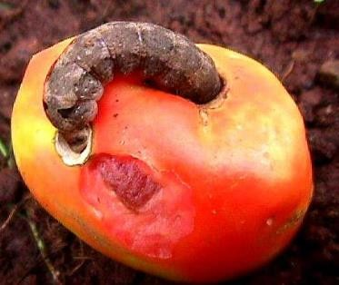

⭸ Fruits appear rotten and fall prematurely – vegetables attacked by pests also indicate rottenness in some areas such as fruits.
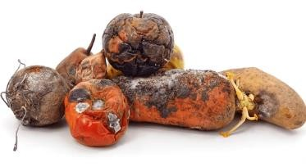
⭸ Presence of pests on vegetable parts- vegetables that are attacked by pest show presence of the pests on them
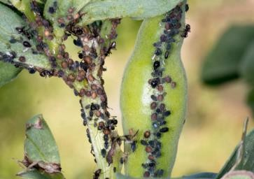

Identification of vegetables crops attacked by diseases.
We can identify various vegetables attacked by diseases through the following:
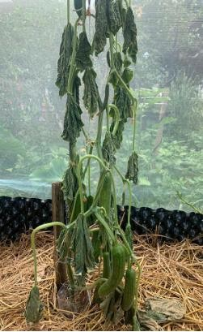
⭸ Wilting plants-plants appear to have lost water even in times of wet season.

Wilted plant- leaves appear to have lost water and droops down.

⭸ Presence of black and brown spots.
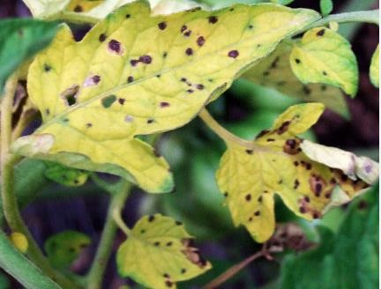

⭸ Rotting of plant parts
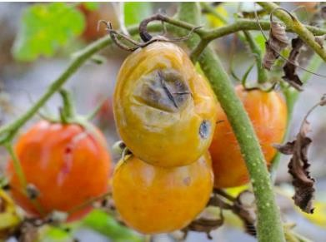

Control of pests and diseases on vegetables crops
The following can help to control pests in vegetable crops.
- Handpicking-pests are removed by hands.
- Removing affected plants parts-affected plant parts should be removed to prevent spread of pests to other plant parts.
- Uprooting heavily affected crops-uprooting heavily affected plants stops spread of pests in the farm.
- Applying natural pesticides such as ashes-some natural pesticide such as ashes help to prevent attack of pests.

The following can be done to control diseases in vegetable crops.
- Removing affected plant parts.
- Uproot heavily affected crops.

2.4 Preparation of Animal Products.
Animal products are materials derived from the body of animals which are consumed by
human beings.
Fish and poultry products require to be prepared to make them ready for human consumption.

How fresh fish is processed.
Fresh fish need to be processed immediately after being harvested from water to prevent spoilage.
Various processes are carried out to prepare fresh fish for transportation, storage and consumption.
⭸ Fish is prepared after harvesting by:
  - Scaling-removal of scales.
  - Gutting-removal of gut or the alimentary canal.
  - Cleaning-washing the fish with clean water.
⭸ These processes usually slow down the growth of micro-organisms and keep it fresh before use.

Procedure followed when processing fresh fish.
Specific methods of processing fish for consumption, storage and transportation are as follows:
Inspect and select fresh fish for processing. Start the process as follows.

a.) Scaling.
∼ Rinse fish to remove slime.
∼ Place fish on a chopping board or tray with absorbent paper.
∼ Hold fish firmly by the tail and use a fish scaling tool or back of a knife to scrape off the scales moving from the tail to head on both sides
∼ Rinse the fish in clean water to remove any loose scales.
∼ Run your fingers over the fish skin to make sure that all scales have been removed.
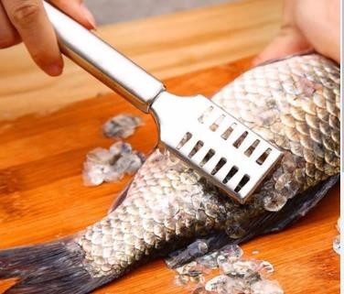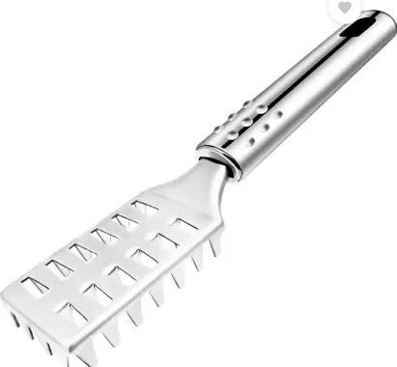

b.) Gutting.
∼ Lie the fish on its side on either a chopping board or a tray.
∼ Make a cut in the belly of the fish at the tail-end and cut through the skin to the head.
∼ Insert your fingers into the belly through the cut opening and remove internal organs by easily pulling them out.
∼ Place them on a separate plate or tray.
∼ Rinse the inside of the fish with cold water until the water becomes clear.
∼ Use a kitchen paper or towel to dry the fish.
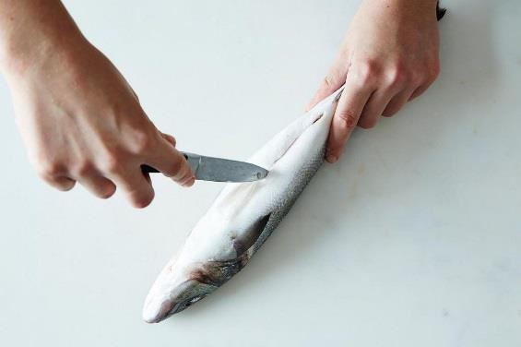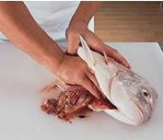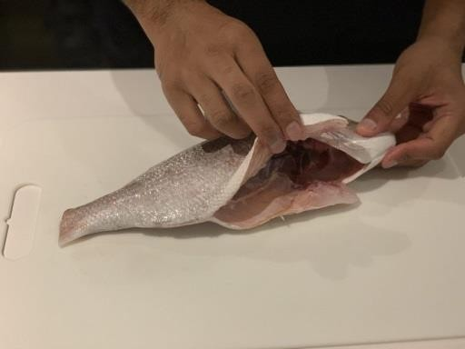

c.) Cleaning.
∼ Clean the fish thoroughly before and after gutting.
∼ Use cold water when cleaning fish.

d.) Salting.
∼ Use the fish that have been well prepared by scaling, gutting and properly cleaned.
∼ Place the fish on a flat clean surface or tray where they will remain after salting.
∼ Sprinkle layers of salt on all the parts of the fish.
∼ Leave the fish in layers of slat for at least 2 days.
∼ Keep the salted fish in a cool dry place.
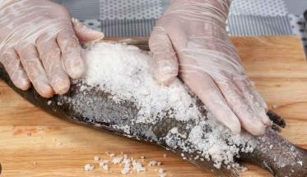

e.) Frying fish
∼ Select a clean well-prepared fish.
∼ Heat oil in a saucepan and dip the fish to cook for 4 to 5 minutes.
∼ Remove the fish from the oil using a draining spoon.
∼ Place the fish on a mesh tray to drain excess oil.
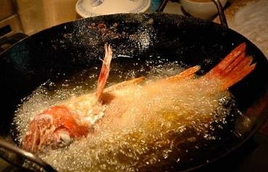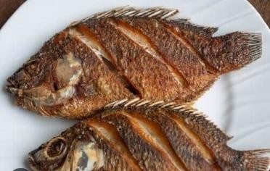
NOTE:
∼ Processing fish should be carried out in a hygienic environment to prevent contamination.
∼ Cold water should always be used when cleaning fish to remove all the blood. This prevents deterioration due to multiplication of bacteria.
∼ Gutting fish may sometimes include the complete removal of the gills and the fins.
∼ Salting draws water from the fish increasing its shelf life.

How to dress poultry carcass.
∼ Quality of poultry products can be linked to a variety of factors such as handling at slaughter.
∼ Poultry dressing procedures should be done in a hygienic manner in order to produce products fit for human consumption.
∼ When dressing poultry carcass, some parts can be detached and packed separately.
However, the whole carcass can be packed with the parts attached.
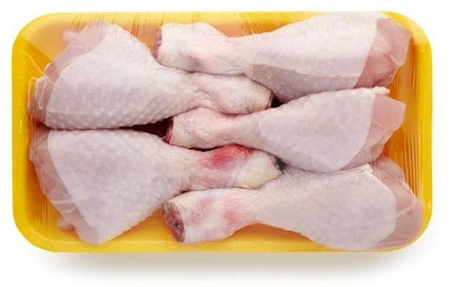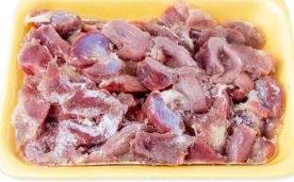
Poultry thighs poultry gizzards

Dressing a poultry carcass.
The following practices are carried out to dress the poultry carcass.
a.) Beheading-restrain the poultry well and cut the neck muscles with a sharp knife. b.) Defeathering-scald the bird into hot water of a temperature of 55⁰ C for about 2 minutes to loosen the feather. Remove and pluck off loose feathers completely.
c.) Singeing-hold the defeathered bird over a flame for a few minutes to burn the hair like structures left on the skin.
d.) Washing-wash the whole bird in clean cold water to remove the surface dirt.

Prepare the poultry carcass for various purposes as follows.
- Place the carcass on its back on a clean surface or chopping board. Remove oil gland with a knife.
- Remove the offals by:
⭸ Make a cut above the vent but avoid cutting too deep.
⭸ Press on the breast and insert fingers through the cut made on the vent.
⭸ Grab the visceral and pull them out avoiding too much pressures to prevent puncturing the gall bladder.
⭸ Slit the neck skin to remove the crop, trachea and Oesophagus.
⭸ Place the internal organs on a separate plate.

Cutting the carcass into various pieces.
⭸ Cut joints between thigh and the body and separate the thigh and the leg at the joint.
⭸ Cut the joint between the wings and the body and then separate the wings.
⭸ Cut the breast into two parts by separating the muscle in front of the keel.
⭸ Cut the backbone and neck strip into 3 pieces each.

Separate the gizzard, liver and the heart from the other internal organs.
⭸ Cut open the wall of the gizzard lengthwise to the lining to remove hard grit and then peel out the lining.
⭸ Wash these organs in cold water and then pack them.

- Pack all the pieces in clean storage bags as required.

NOTES:
∼ High hygiene standards should be maintained when handling raw poultry meat to avoid contamination which can lead to food poisoning.
∼ Complete bleeding of carcass prevents discolouration of the meat due to formation of clots in the muscles. The clots attract micro-organisms.
∼ Care should be taken not to burst gall bladder as this makes the meat bitter.
∼ Pieces from poultry carcass are packed separately and sold at different prices.

What is the importance of processing fresh fish and dressing poultry carcass?
~ It adds value to the meat.
~ Keeping quality of both fish and poultry products is increased hence prolonged shelf life.
~ Packing poultry pieces separately enables selling at a higher price than the whole carcass.
2.5 Preserving Meat and Milk.
Animals gives products such as milk, meat, eggs, honey, hides and skin.
Some of the products easily go bad, hence they should be preserved to increase their shelf- life.

Methods of preserving milk and meat in the locality.
- Milk and meat deteriorate in quality with time.
- They should be well preserved to prolong their shelf-life and availability.
- Food preservation is the process of preventing food from spoilage.
- There are various methods of preserving milk and meat.
- Methods used in preserving milk include:
 Boiling.
 Fermentation.

- Methods used to preserve meat include:
 Sun drying.
 Smoking.
 Salting.

Preservation of Milk and Meat at household level.

Common methods of preserving milk are:
a.) Fermentation-Fermentation of milk produces certain acid that preserves milk.
b.) Boiling or pasteurization of milk-boiling milk kills micro-organisms by exposing them to high temperatures at the milk boiling point. This method preserves fresh milk.

Common methods of preserving meat are:
a.) Sun drying-it removes moisture from meat making the action of micro-organism difficult. Meat is cut into small pieces, sundried and then packaged.
b.) Smoking-meat is covered with a layer of smoke which stops action of micro-organisms. c.) Salting-salt is applied on the surface of pieces of meat or dipped in a highly
concentrated salt solution know as brine. This salt solution dehydrates (removes water) the micro-organisms and stops their action on meat.

What is the importance of preserving milk and meat?
- It increases the shelf-life of both milk and meat.
- It makes the two products available for a longer period of time hence enhancing food security.

Strand 3 -HYGIENE PRACTICES.
3.1-Cleaning the Kitchen.

Methods of removing dirt from the kitchen surfaces.
Food should be prepared and cooked in a clean and orderly environment.
A dirty kitchen can be a breeding place for other harmful living things such as pests and flies which can lead to health hazards.
There are may ways of removing dirt from kitchen surface. The methods depend on types of dirt found on the surfaces.

Methods of removing dirt from kitchen surfaces. Sweeping-Done using a broom, brush and dustpan.

Dusting-it is done after sweeping a room. It ensures any dust that may have been blown in the air and deposited on the surface is removed.
Wiping -it is used to remove fixed dirt on the surfaces that can be damaged by scrubbing. Surfaces that are wiped include furniture, ornaments, walls and windows.
Scrubbing-this is where warm soapy water is used to together with a hard scrubbing brush. Vacuum cleaning-a vacuum cleaner is used to remove loose dirt from the surfaces which is sucked into a dirt bag attached to the vacuum cleaner and it is disposed of after cleaning.
Mopping-this is the removal of fixed dirt from a surface by using a mop, bucket, water and detergents.

State the reasons for cleaning the Kitchen.
A kitchen must be kept clean at all times.
Frequency of cleaning depends on type of fuel used and amount of cooking done. Therefore, cleaning the kitchen is necessary for the following reasons:
To preserve clean kitchen appearance.
to prolong life of a surface, dirt can destroy the surface if allowed to accumulate. Psychological satisfaction of the user.
To cut down cost of cleaning
Types of leaning for a kitchen.

Daily cleaning.
It is the removal of loose dirt from the kitchen surfaces on daily basis. It involves the following methods:
⮑ Sweeping.
⮑ Brushing.
⮑ Dusting.
⮑ Suction cleaning.

Weekly cleaning.
Involves the removal of both loose and fixed dirt. It involves:
⭸ Sweeping.
⭸ Dusting.
⭸ Scrubbing.
⭸ Wiping.

Special cleaning.
This is the thorough cleaning that is done occasionally when it is necessary. For example,
✰ Cleaning the chimney to remove soot,
✰ Painting the walls.

Cleaning different kitchen surfaces.

Area | Daily cleaning | Weekly cleaning | Special cleaning
Earthen floors | Close windows, sprinkle water on the floor  Sweep from farthest corner towards the door.  Collect loose dirt and dispose appropriately. | Close windows, sprinkle water on the floor  Sweep from farthest corner towards the door.  Collect loose dirt and dispose appropriately. | Close windows, sprinkle water on the floor Sweep from farthest  corner towards the door. Collect loose dirt and dispose appropriately.  Floor can be redone to cover holes and cracks.
Cemented floors | Sweep floor and collect to dispose off loose dirt.  Mop the floor.  Rinse with a mop wrung and dry the floor using a dry soft cloth | Seep the floor and dispose the waste.  Scrub the floor using soapy and warm water.
Wooden floors | Sweep.  Dispose loose dirt appropriately.  Mop and rinse. | Sweep. Mop.  Apply polish.
Tiled floors. | Sweeping.  Mopping and dry the floor
Terrazzo floors | Sweeping to dispose loose dirt.  Mopping.  Rinse and dry using a dry soft cloth or mop | Sweeping. Scrubbing.

Strand 4- PRODUCTION TECHNIQUES

SEAMS.
Terms used in clothing construction when making seams.
- Clothing construction is the process in which fabric is cut into pieces which are held together in position with stitches. This has to be done neatly and securely for the item to look presentable and to last long.
- A seam is any part of the garment or clothing article where two or more pieces of fabric are joined together using permanent stitches.
- Seam line is also referred to as the stitching line, construction line or fitting line. It is the line where permanent stitches are worked.
- Seam allowance is the distance between the seam line and the cutting line. It is usually 1.5cm wide.
- Seam turning is the amount of fabric between the cutting line and the seam line.

Types of Seams used in clothing construction.
There are many types of seams used in clothing construction.
The type of seam used depends on the desired outlook and stitching effects required.

- Open seam.
- Plain seam.
- Overlaid seam
- French seam.
- Machine fell seam (double stitched)
- Run and fell seam.

Factors to consider when choosing seams in clothing construction.
  - Type of garment-Frequent laundered garments are preferably made using a plain seam because the turnings of the plain seam are neatened together making it to remain closed during laundering.
  - Type of fabric- heavy fabrics require seams that are not bulky to prevent the seam from becoming too thick, for example, an open seam can be used for heavy fabrics because it is not bulky.
  - Position of the seam on the garment- some seams are more suitable for some areas of garment than others. For example, a plain seam is more suitable for the armhole seam as compared to open seam.
  - The effect desired-when a decorative effect is required, seams such as machine fell and overlaid seams that are constructed show on the right side of fabric when used.

Qualities of A well-made seam.
- A well-made seam should have some specific qualities as follows.
 Should be firmly stitched.
 Should be accurately stitched on the fitting line.
 Should be neatly stitched.
 Should be properly matched where two or ore seams meet.
 Should be of appropriate width.
 Should be well-pressed and flat.

MAKING SEAMS.
- The most commonly used seams in garment construction are the open and plain seam.
- They lie flat when finishing (pressed or ironed) and can be used in most types of articles.

Open Seam.
An open seam is a simple seam that has been stitched and pressed open.

STUDENT ACTIVITIES GUIDED BY THE TEACHER

Making an open seam. Requirements.
- 2 pieces of cloth (10 cm by 1o cm).
- A pair of scissors.
- Tape measure.
- Tailor’s chalk.
- Hand sewing needle.
- Sewing thread.
- Pins.
- A table and well threaded sewing machine.

Method.
  - Measure 1.5 cm seam allowance from the top edge of each fabric. Mark the stitching line.
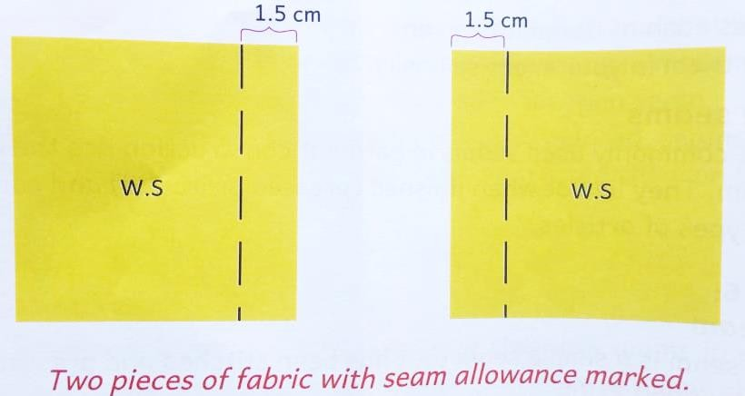
  - Place the two pieces right side facing each other.

  - Match the stitching lines and the raw edges.
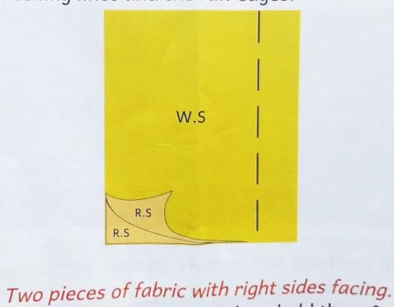

  - Pin the two pieces together at intervals to hold them firmly.
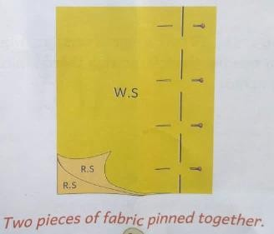
  - Take along the stitching lines.
  - Remove the pins.
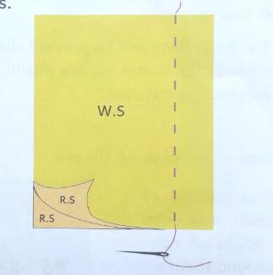
  - Machine stitch along the stitching line and remove the tackling stitches.

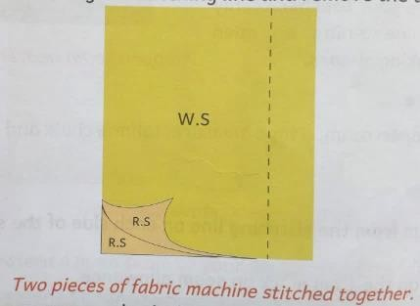

  - Press the seam open on both the wrong side and the right side.

Open Seams.
A plain seam is a simple seam that has been stitched and pressed to one side. Plain sea, is a flat seam which is used in most clothing and articles.
It is made the same way as an open seam but unlike the open seam which is neatened by opening and finishing each seam turning separately, the plain seam is neatened by stitching the edges of the seam turnings together.
Making a plain seam.

Requirements.
- 2 pieces of cloth (1ocm by 10cm)
- A pair of scissors.
- Tailor’s chalk.
- A tape measure.
- Hand sewing needle.
- Thimble.
- Sewing thread.
- Pins.
- A table.
- A well threaded sewing machine.

Method.
- Measure 1.5 cm seam allowance from the top edge of each fabric. Mark the seam line.
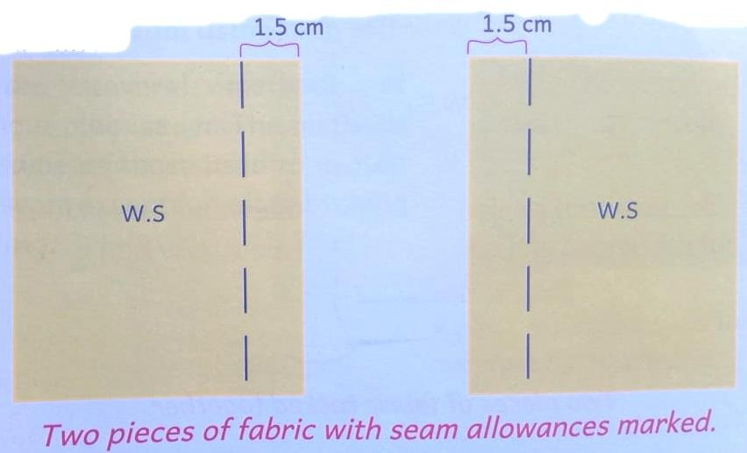

- Place the two pieces of fabric right sides facing.
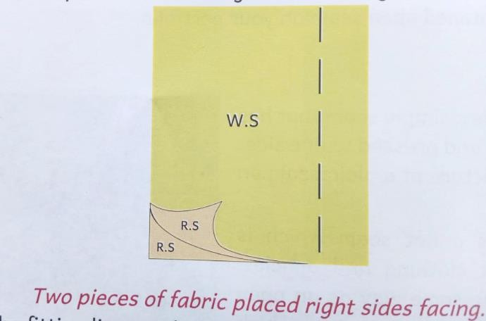

- Match the fitting lines and the raw edges.
- Pin the two pieces of fabric together at intervals along the seam line to hold them firmly.
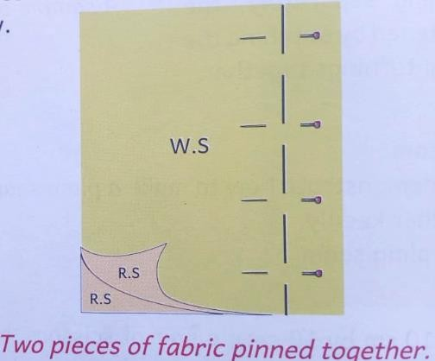
- Tack on the seam line and remove the pins.
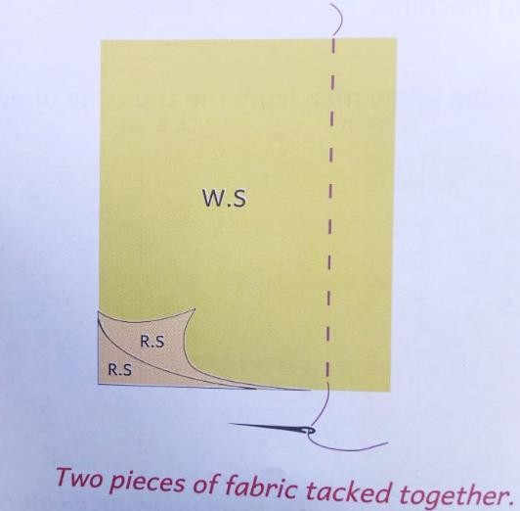

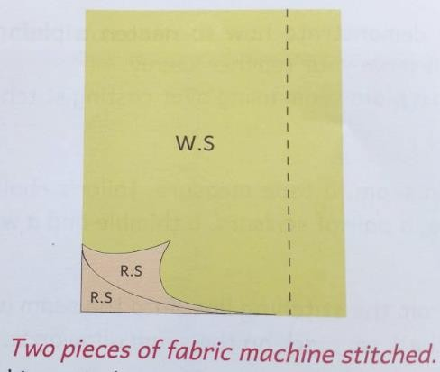

- Remove the tacking stitches.
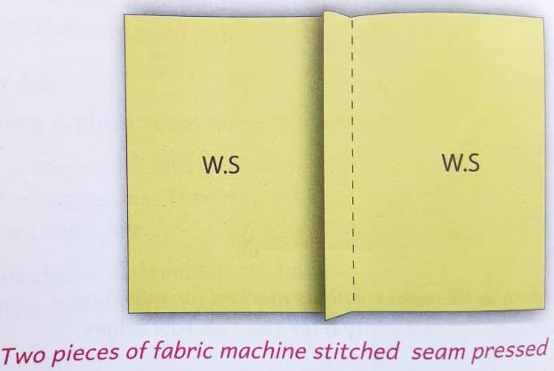
- Press the seam flat on the wrong side.

4.1 Innovative Waterer Project.
- Water is an essential requirement in animals just like in plants.
- Animals should drink clean and adequate water every day.
- Providing enough and clean water is a challenge for human beings and animals.
- Therefore, innovative economical ways of using available water to take care of domestic animals.

Types of animal waterer used by the community.
  - Domestic animals are provided water in containers called waterers.
  - Different domestic animals use different types of waterers.
  - Some waterers are left open for the animals to drink water directly while others are automatic.
  - The types of waterer used for watering animals in the community depends on the type of domestic animals kept.
  - Large animals such as cattle, camel. Donkeys, sheep, goat and pigs use open containers and troughs constructed as part of their houses.
  - Small animals such as rabbits and poultry use small containers cutout from jerrycans and hanged on the walls of their cages.

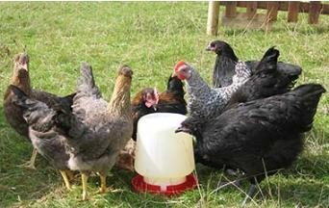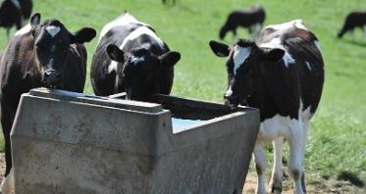

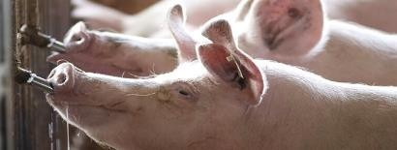

Challenges of the existing animal waterers used by domestic animals in the community.
  - Use of poorly constructed waterers-leads to inadequate water intake by the animals.
  - Lack of skills in handling the waters.
  - Poor placement of the waters.
  - Poor usage by the animals leading to spillage and contamination of water.
  - Provision of water to animals is a tiresome process discouraging community members from keeping domestic animals.
  - Provision of less spacious waterers for large number of animals.

Uses of innovative waterers.
An innovative waterer is an equipment that is designed to improve the ease and efficiency at which drinking water is provided to an animal.
It can be used to solve challenges of the existing waterer in the community.
The type of innovative waterer depends on the farmers preference and the skill to use the waterer.
The community household can be assisted to innovate and construct better waterer for their animals.
Waterer should be made with materials that are durable, easily available and affordable. Containers for any type of chemical should nor be used for waterers, unless they are cleaned thoroughly with detergent before use.

Innovative techniques for watering small domestic animals.
- An innovation means an idea generated in the mind and then created into reality.
- We can improve the existing waterer in the community to solve the challenges of watering animals or create new better waterer.
- Different groups can create their own innovations and select the innovation that has less cost.

Requirements for functionality of Waterers.
⮑ Should be workable.
⮑ Should be easy to use.
⮑ Should be easy to clean.
⮑ Should have efficient overflow control system to prevent spillage.
⮑ Should have a mechanism of adding water easily to avoid time wasting.
⮑ Should be heavy enough to prevent animals from toppling it off the ground.

Provision of Water to animals using the innovative waterer constructed.
- If waterer are placed at a higher point ,water remain clean for a long time.
- Waterer contaminated with feeds should be changed immediately.
- Accidental water spillage increases humid conditions in animals’ houses and should be controlled.

Importance of using innovative waterer in animal rearing.
  - Innovative waterer are made with locally available materials to suit needs of the farmer and of particular animals.
  - They are economical and affordable.
  - They are easy to operate and maintain.

4.3- ICT In Agricultural Support Services.
ICT stands for Information Communication and Technology.
ICT had become an important tool in agriculture when carrying out agricultural practices.
ICT devices such radio, televisions, phones, computer softwares are used together with other applications to improve agricultural activities by accessing important information.

Agricultural support services.
Farmers need agricultural services which supports farming operations. The services can be obtained from ICT.
Examples of agricultural support services that farmers can obtain from field officers, print media through the use of ICT devices include:
  - Weather forecasting-information on weather to help farmers make decisions related crop growth, irrigation, time of fertilizer application, pest and diseases control etc.

  - Input supply – ICT devices provide input and information on seeds, pesticides, soil testing, crop spraying, fertilisers and herbicides.

  - Extension services – use of radios, televisions, mobile phones and videos can help farmers access useful agricultural information instead of having to visit or visited by an extension officer.

  - Market information – farmers use ICT tools to access information on demand, supply and pricing of various agricultural commodities. ICT helps farmers to reach out to potential buyers who offer higher prices for their products.

  - Banking services – farmers can use ICT tools to compare various services offered by different financial institutions to make an informed decision on which to adopt.

Accessing Agricultural support services using ICT.
- Agricultural support services can be accessed using available ICT search engines.
- ICT tools such as radios, television, computers, mobile phones, data projectors, software programs, printers and scanners can be used to get agricultural support services.
- The internet plays a greater role in enabling farmers access such information.

Ethical and Security considerations in use of ICT platforms.
- ICT platforms should be used with precautions and responsibly. This ensures privacy personal data and information about companies involved.
- It also ensures ICT data is not erased or interfered with.
- When using ICT platforms, only concentrate on the target information to enhance efficiency in agricultural practices.
- The following are some of the ethical issues in ICT:

Personal privacy.
  - Refers to protection of personal data that is linked to other information about an individual causing emotional distress and harm such as physical, financial and professional to such an individual.

Access right.
  - Refers to permission granted to a user to perform a particular operation on a computer. Access rights restricts the user to specific operations only.

Harmful actions.
  - These are actions that can lead to loss of information, property and ownership. These damages cause security concerns to the user from the public.

Copyright issues.
  - Refers to legal rights given to investor for a fixed number of years to print, publish, perform, film or record literacy, artistic, or musical material. It allows inventors only to reproduce such work.

Piracy.
  - Refers to using unlicensed copies of software for operations by producing more copies than is licensed for.

Security Threats to ICT.
- Computer viruses-are malicious programs that interferes with normal functioning of the computer by causing damage to data soft-wares.
- Unauthorized access-gaining access without permission to a network, computer system, an application, data or other resources.
- Data loss-refers to intentional or unintentional destruction of information caused by a person or a process from within or outside the organization.
- Cyber-crime-refers to criminal activities carried out by means of computer or the internet.
- Examples include compromised ICT devices, stolen credit card information, hacking into government website, theft of user accounts etc.

OSCAR MWANGI O705443680

