STRAND 1 FOUNDATIONS OF CREATIVE ARTS.
WHAT IS CREATIVE ARTS
Introduction to Creative Arts and Sports.
Creative Arts is a description of various artistic activities that allow performers to use their imaginations, creativity, and express ideas through a variety of mediums to passage a message to the audience.
What is sports?
A sport is any activity involving physical or mental effort combined with skills in which an individual or a team or teams compete against another or others for entertainme
Roles of Creative arts and sports in the society.

Social roles of Creative arts & Sports.
- Creates a sense of identity-bring people together, creating shared experiences that help to foster a sense of community and collective identity.
- Creative arts and sports promote cohesion through teamwork.
- Through creative arts and sports culture is preserved-it ensures that our history and traditions are not forgotten, and that future generations can appreciate and learn from them.
- Creative arts and sports inspire creativity, talents and abilities.
- Creative arts and sports provide provides us with entertainment through components such as music, dance, drama, narratives, films and movies, various sports i.e., soccer, basketball, netball, volley ball.

Economic roles of Creative arts and Sports.
- Creative arts and sports provide employment opportunities such as artists, musicians, referees, sports coaches, sports doctors, choreographers. Trainers, teachers etc.
- One can earn income through activities related to creative arts and sports hence eradicating poetry.
- Through creative arts and sports, a country can earn or generate tax revenue. (boosts revenue collection)
- Creative arts and sports attract investments which in turn increases job opportunities.
- Creative arts and sports stimulate growth of economy through sectors such as tourism. (Encourages tourism)

1.2 | Components of Creative Arts and Sports.
Creative arts is made of the following components:
  - Visual arts -creative art forms appreciated through sense of sight such as;
    - Drawing.
    - Painting.
    - Sculpture.  Montage.
    - Collage

  - Play - a written work that tells a story through action and speech and is meant to be acted on a stage.

  - Music - Music is a collection of coordinated sound or sounds. Making music is the process of putting sounds and tones in an order, often combining them to create a unified composition
  - Dance – dance is the movement of the body in a rhythmic way, usually to music and within a given space, for the purpose of expressing an idea or emotion.

Principles of Visual arts.
There are two principles of visual arts namely:
- Principle of dominance.  Principle of proportion.

Principle of dominance in Visual Arts.
Dominance is when a single element is so large and/or different compared to the rest of the design that it dominates.
It grabs your attention.
Famous examples include the London Eye that dominates the skyline of London or the Ashoka Lions that dominate the Indian Passport and other official documents.
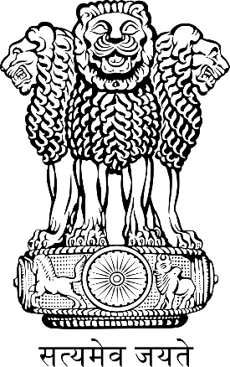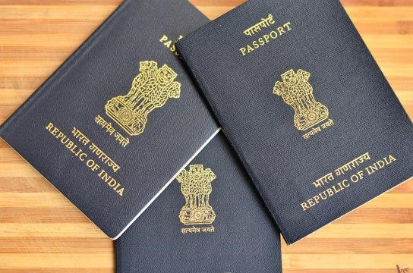

Principle of Proportion in Visual arts.
Proportion refers to the dimensions of a composition and relationships between height, width and depth. How proportion is used will affect how realistic or stylized. Proportion also describes how the sizes of different parts of a piece of art or design relate to each other.
Proportion in any art is the relative size of objects in relation to each other or corresponding to the other elements as a whole.

Basic Elements of a play.
- Theme - What is the meaning of theme in element of drama?
The theme refers to the message (meaning) that is intended to be expressed in the story. In other words, it is the main idea or the lesson to be learned from the story. Examples of themes in plays include: justice, loyalty. drugs, bullying, human rights etc.

- Character- this is a person or individual taking part in the play or drama that may have defined personal qualities and/or histories.

- Plot- A plot is a sequence of events within a play that tells a story. A plot is what makes a story. Five components make up a plot: exposition, rising action, climax, falling action, and resolution. Conflict and theme help drive the plot forward.

- Language- Language in drama is represented as spoken language or, in other words, as speech. In drama, language refers to the particular manner of verbal expression, the diction or style of writing, or the speech or phrasing that suggests a class or profession or type of character.

- Setting- The setting is the time and place in which the story takes place

Elements of Music in Creative Arts.
    - Sound-any tone with characteristics such as controlled pitch and timbre  Rhythm- Rhythm is the pattern of sound, silence, and emphasis in a song  Melody- a melody is a combination of pitch and rhythm.
    - Harmony-harmony, in music, the sound of two or more notes heard simultaneously.

Elements of Dance in Creative Arts.
- Body - In dance, the body is the mobile figure or shape, felt by the dancer, seen by others. The body is sometimes relatively still and sometimes changing as the dancer moves in place or travels through the dance area. The body is the mobile instrument of the dancer and helps inform us of what is moving.

- Action – This is what a dancer does, for example travelling, turning, elevation, gesture, stillness, use of body parts, floor-work and the transference of weight.

- Space – Space refers to the area through which the dancer's body moves.

- Time - It is an essential part of choreographing and performing dance. It helps us to stay together when we dance in unison, identify the beat and the rhythm of how we move and provide stimulus for choreography.

STRAND 2 CREATING & PERFORMING IN CREATIVE ARTS & SPORTS.
2.1 Composing Rhythm.
To understand and be able to write rhythmic patterns dictated, one needs to follow the following tips:
- Establish the beat of the rhythm patterns.
- Clap or tap the full rhythm before you start writing.
- Break down the rhythm into bars and write one bar at a time while clapping the whole rhythmic pattern.
- Clap through the rhythmic pattern you have written to check if it conforms to the rhythm dictated.

2.2 Athletics.
Middle distance races.
- Middle distance race starts with a standing start, athletes start from an upright, standing position the crouch forward with one foot about 18 inches behind the other.
- The leading foot and shoulder both point forward.
- The upper body should not be twisted.

Strategies applied by middle distance runners during a race:
 Pacing.  Stride length  Recovery.

Pacing – rate at which an athlete runs. An athlete knows how long it takes him or her to cover a certain distance.
Stride length – it is the uniform length of steps taken during running.

Recovery - It is a stop, walk or slow jog made after striding.
It helps an athlete to catch a breath and relax before striding again which helps in developing speed and running skills.
Photomontage.
Photomontage is the process and the result of making a composite photograph by cutting, gluing, rearranging and overlapping two or more photographs into a new image.
It is assembly of images that relate to each other in some way to create a single work or part of a work of art. photomontage is an image constructed from collaged photographs.
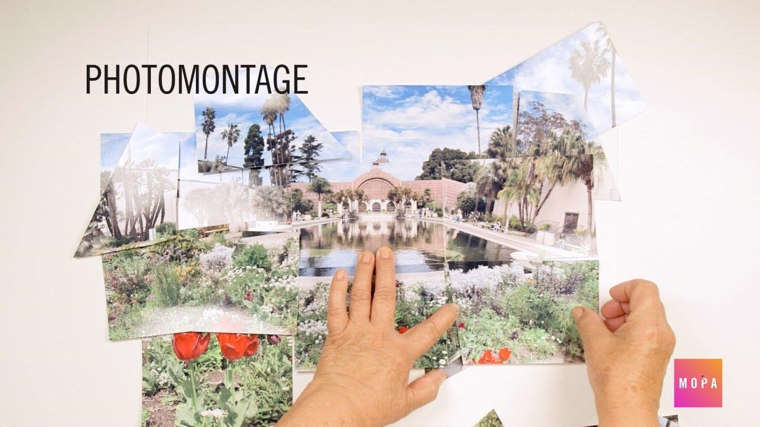

Characteristics shown in photomontage.
- Superimposition-combine two images to create something new.
- Use of pictures.
- Emphasis on shape.

  - Composing Melody.

  - Netball.
Chest pass in Net ball.
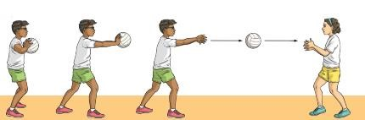
- Chest pass is a way of throwing the ball to a teammate where the ball is released and received at the chest level.
- The pass is usually used when the teammates are not far from each other.
Learning points for the chest pass.
1. Grip
· Spread your fingers out behind the ball to form a W formation, holding it at chest height with your elbows out in front of you.
2. Stance.
- Face the direction you want the ball to go in.
- Step forwards with your dominant foot as you begin to straighten your arms.
3. Execution of the pass.
- Push the ball away from your body at chest height by powerfully extending the arms forwards and flicking the wrists.
- Follow through with the arms, wrists, hands and fingers in the direction of the throw.

Chest pass drills
Dodging and marking in Netball.
Dodging is a technique used to counter the marking attempts. ⬇ It is applied by members of the team in control of the ball. ⬇ The player being marked attempts to get free from the marker and move into space to receive a pass.
- It may involve changing pace and use of deceptive body actions to put the marking player off balance.
- Deceptive means misleading or trickiness while off-balance means not steady or stable.
- Intercept means block a pass or prevent it from reaching destination or to block something from happening.

Body movements used by a player when dodging an opponent.
- Using bending or leaning movements with the body trunk to the left or right or left once or repeatedly.
- Sprinting off from the marker.
- Sprinting and stopping.
- Extending the left or right arm away from the opponent.

Marking is a technique used by a team that is not in possession of the ball to prevent an opponent from receiving a pass.
The intention is to obstruct passes made by the team in control of the ball.
A player can mark an opponent in possession of the ball or an opponent without the ball.
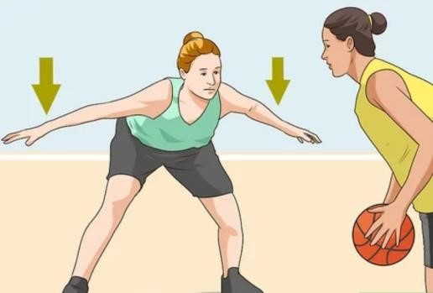 Marking opponent with the ball.
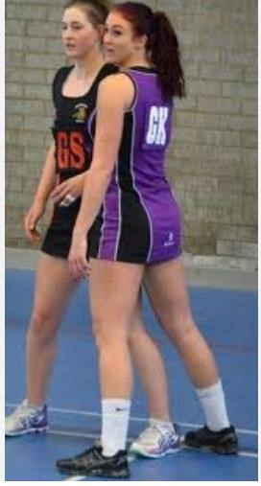Marking opponent without the ball.

Body movements used by a player when marking an opponent.
- Standing in front of the player being marked.
- Standing beside the player being marked.
- Raising hands up or to the side to reach the path of the ball.
- Stepping forward, or sideways while avoiding any obstruction.
Things to learn when dodging and marking stance.
Marking a player without the ball.
- Establish the basic stance for marking with body weight on your toes.
- Take a position slightly in front of the player you intend to mark.
- Be on your toes, with knees slightly bent, ready to catch the ball or move in the direction of the opponent.
- The hands should be on the side of the body.

- React quickly when the opponent being marked makes any movement, move in the direction of the opponent using short steps, shuffle sideways without crossing the feet.
- Focus on both the ball and the player and forth from one place to another.
Activity.
Guided by the teacher
Demonstrate
Basic stance for dodging, marking, body movement for dodging and marking.

Footwork in Netball.
Landing techniques.
In netball, the ball is played using hands.
During play, the players may:
    - Run to doge an opponent or to reach a ball.
    - Jump to catch a high ball or rebound from the ring.
    - Stop the running action suddenly to dodge an opponent or avoid getting to an offside position.
    - Land on the floor or the ground as dedicated by the laws of gravity in integrated science and as guided by the law of the game. However, players need to land safely for safety and healthy living.
There are two landing techniques in Netball:
 The double foot landing.
 Single foot landing.
Pivoting.
Pivoting is the act of turning with one foot on the ground while the other foot makes repeated short steps.
Picoting:
    - Helps the player develop balance after landing.
    - It helps the player turn away from the defender who may be marking.
    - Helps in locating teammates who may be well-positioned to receive the pass.
Things to learn in Pivoting.
    - Land one foot and maintain balance.
    - Maintain a firm grip of the ball.
    - Keep the landing foot grounded with knees slightly bent.
    - Keep the head up and the trunk upright.
    - Step with the non-landing foot and turn around.
    - Keep the ball close to the body.
2.5 Descant recorder or Any other western instrument.
Examples of western solo instruments.
 | Instruments |  | Playing technique |  | Fingering chart for the G scale.
 | Violin  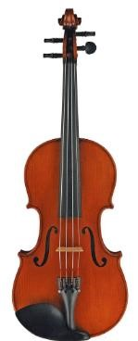 |  | Bowing on the strings
 | Guitar.  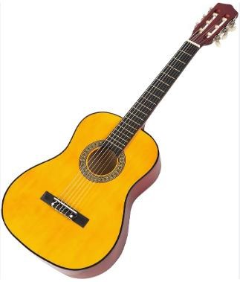 |  | Plucking the strings
 | Trumpet in B flat  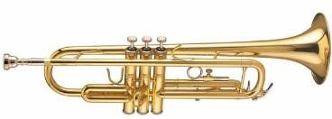 |  | Blowing air while producing a buzzing sound. Tones can be varied by pressing the valves.
 | Xylophone  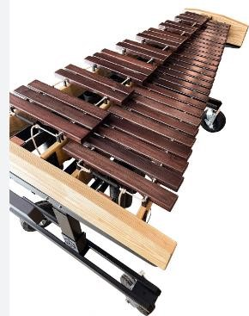 |  | Hitting the bars with a small mallet.  Each piece of wood is a different length so it produces different sounds when they are hit.
Piano  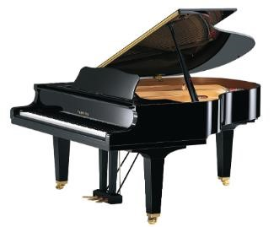 |  | Pressing on the keys.
Playing the recorder using appropriate techniques.
The following techniques are used to play descant recorder:
- Tonguing.
  - Gently say ‘tu’ when blowing air into the recorder.
- Embouchure.
  - This is how one places their mouth on the recorder’s mouthpiece to ensure that no air is lost when blowing into the instrument.
- Fingering.
  - Correct placement of the fingers on the recorder. As a rule, the left hand is always at the top part of the recorder. All the holes must be tightly covered to prevent leakage of air.
- Blowing.
  - Blow warm air into the recorder. Blowing gently gives a good sound. Blowing too hard generates unpleasant sounds.
- Slurring.
  - This is the technique of playing more than two notes in one breath. This involves only the movement of fingers while the airflow is constant.
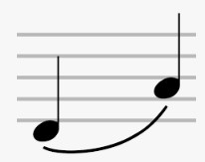

- Staccato.
  - Playing notes in a detached manner.
  - Notes to be played staccato have a dot above or below the note.
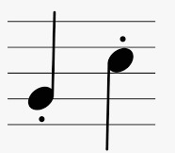

- Tone quality.
  - Listen carefully to the sound you produce when you blow into the recorder.
  - Blowing gently and having consistent air gives a good tone.
- Blend and balance.
  - Being able to listen to what the other in an ensemble are playing helps to blend and create a balanced sound.

Interpret performance directions when playing the descant recorder.
You should be able to play melodies on the descant recorder while observing the following directions: a.) Repeat.
Repeat signs are two dots that are placed before or after a double bar line.
Whey they are placed after a double bar line, it means it is the start of the repeat. However, when they are placed before a double line, it means the end of repeat.
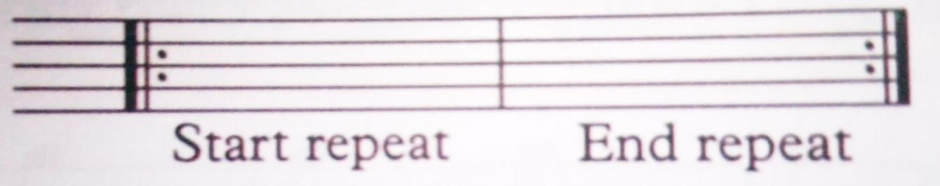

- 1st and 2nd ending
The two lines above the staff mean that one will avoid playing 1 notes when repeating. This applies where there is a repeat and the last part of the melody is different from the first one.
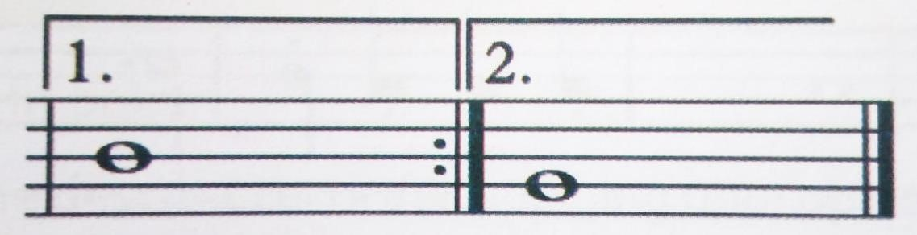

- Da capo al fine
It is often abbreviated as D.C al Fine.
It means one goes back to the beginning of the piece and plays to the point written.

- Dal segno al fine.
It is often abbreviated as D.S al fine.
It means you go back to a point in the piece of music with the sign and 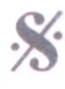 play or sing to the bar marked Fine (end) then stop.
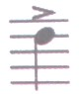
- Accent.
The note with sign is played with emphasis.
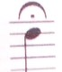
- Fermata.
This sign means that you can hold the note a little longer that its given time value or number of counts. g.) Dynamics.
This refers to how quietly or loudly a piece of music should be played.
Italian terms are used to indicate dynamics in the piece of music.

Dynamics | English meaning.
Pianissimo (pp) | Very soft
Piano (p) | Soft
Mezzo piano (mp) | Moderately soft
Mezzo forte (mf) | Moderately wide.
Forte (f) | Loud.
Fortissimo (ff) | Very loud.

h.) Tempo.
This term is used to refer to how fast or slow a piece of music can be played.
Italina terms are used to indicate what tempo the music is played
Tempo terms | English meaning.
Andante | At a walking pace (73-77 beats per minute)
Allegro | Fast (109-132 beats per minute)
Adagio | Slow (ss-65 beats per minute)
Lento | Slowly (40-45 beats per minute)

2.6 Volleyball.
Overarm and Jump serve in Volley.
Over arm serve.
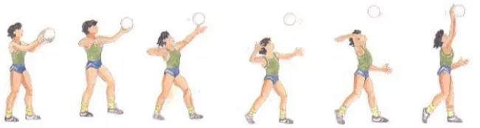
Over arm serve is where a player tosses the ball with one hand and strikes it in the air above their head with the other hand so that it crosses the net and lands into the opponents’ side.
Safety instructions.
- Ensure you perform thorough warm up activities.
- Avoid congestion by maintaining a safe distance from your peers.
- Follow instructions.

Jump serve in Volleyball.

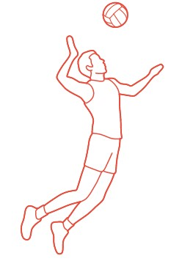

This is a type of serve where the serving player increases power and serve height by jumping to hit the ball when serving in volleyball.

Minor Games and basic rules.
Minor games are small sided games that help you practice skills learnt in volleyball while applying the rules of the games.

Safety precaution.
- Never fist hit the ball as you could hit someone’s face.
- Do not swing on the post.
- Do not go under the net, always walk around the nets.
- Do not throw the ball over the net, roll it under the net.

Diagram of human figures playing Volley.
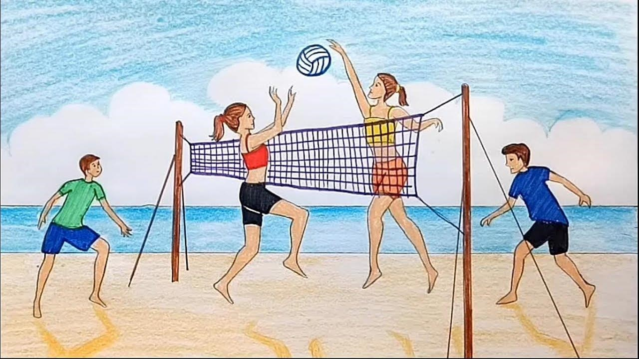

Student activities monitored and instructed by the teacher
 Draw human figures of players serving or volleying a ball.
      - Serve the ball using the jump serve over a net.
      - Perform the volley for skill acquisition,

  - Play.

  - Swimming.
Breast stroke in swimming.
Breast stroke is a stroke in which the arms are pushed forward and then swept back in a circular movement, while the legs are tucked in towards the bod and then kicked out in a sideways and backward movement.

Description of the prone body position.
- The body lies in a horizontal position in the water with the head in line, with the spine and the face in the water, eyes looking down.
- The arms are extended forward and the legs are held close together, toes pointed. The breast stroke begins with a forceful push from the poolside in order to generate some propulsion, which results in a glide.
The body moves in a smooth, continuous and effortless motion while lying on the stomach and glides in a horizontal position.
From the glide phase, the propulsive arm action takes place and then the leg action as the arms recover.
The body is then in a streamlined glide for a short moment in each before the next stroke begins.

Glide.
- For effective gliding in the water, the body should be well streamlined.
- This can be affected by the underwater recovery movements, as the propulsive force remain still and streamlined. For example, as the legs kick to provide propulsion, the arms should be extended forward to create the ideal streamlined body position at the front.
- Similarly, as the arms pull around, the legs should be in the glide phase to create the same streamlined body position at the back.
Gliding helps to make the breast stroke movement smooth and reduces the effort required by the arms to move forward, resulting on a more efficient swimming technique.
It is important to cultivate a glide so that the proper sequence of “arms-breath-leg - glide can be established.
The breast stroke starts with the arm pull, breathe, then the kick and finally the glide in a streamlined position.

Prone body postion and glide.
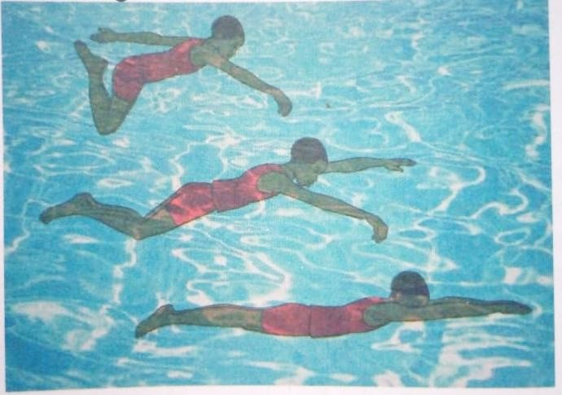
- Stand waist-deep in water, with knees bent or feet flat against the side of the pool.
You can hold onto the side of the pool with one hand for support.
- Breathe in and put your face in the water.
- Puch off the wall and glide to the prone body position.
- Lie flat, head facing down with your body in line with the water surface.
- Keep your face down and arms extended forward. Your eyes should look downwards and slightly forward to avoid straining the neck.
- Keep your shoulders, hips and legs horizontal as possible, and keep your hips as close as possible to the surface. Do not let your hips drop in the water.
- Stretch your legs behind with toes pointed but slope your body slightly to allow the legs to stay beneath the water.
- Keep your neck and shoulders as relaxed as possible to aid the arm action and reduce strain.
- Keep your body straight and streamlined to make swimming easier and enhance speed. The head movement should be kept to a minimum, and the shoulder should remain level throughout the stroke.

Arm action.
The arm pull technique is needed to assist the leg movement and also to keep the breast stroke streamlined and efficient.
Cath phase.
- Begin with the glide position, arms extended out in front of you, fingers and hands together, palms facing downwards.
- Pitch your hand outwards and downwards to an angle of about 45 degrees at the start of the catch phase.
- Pull your arms outwards and downwards until they are appropriately shoulderwidth apart. Your elbows should begin to bend, and your shoulders to roll inwards at the end of the catch phase.

Propulsive phase.
- Sweep your arms downwards and inwards, and let the hands pull to their deepest point. The elbows bend to 90⁰ and remain high.
- At the end of the down sweep, your hands, your hands should sweep inwards and slightly upwards.
- The elbow should tuck into the side as you pull your hand inwards towards the chest and the chin.

Recovery phase.
- Your hands should recover by stretching forward in a streamlined position.
- They should recover under, on, or over the water surface ready to restart the arm action.
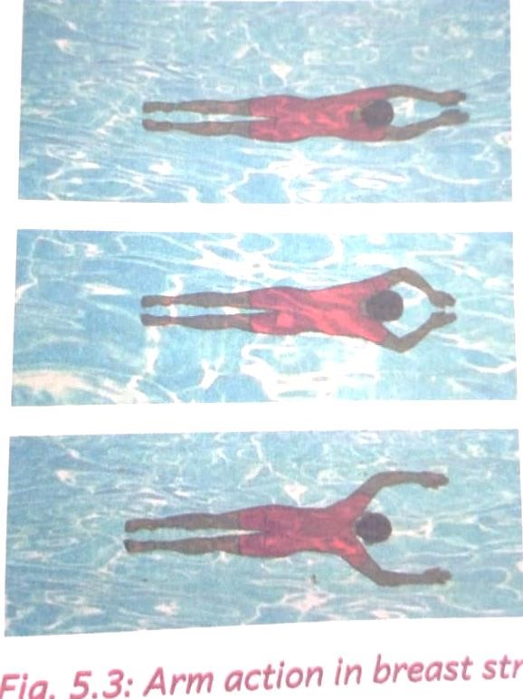
Leg action.
The legs are the powerhouse of the breast stroke, and the full leg kick should be a simultaneous and flowing action, resulting in a powerful boost that propels the whole stroke.
  - Start with your legs straight and together.
  - Bend your knees and bring the heels towards your seat with the sole of the feet facing outwards for the frog kick”.
  - Sweep the legs outwards and download in a flowing circular path. The heels and soles of your feet should drive around and back to provide power and propulsion to the stroke.
  - Squeeze legs together to come back together to the starting streamlined position with the toes pointed.
Breathing action.
- Breast stroke breathing occurs naturally as the breast technique has a body lift, which gives the ideal breathing point for each stroke.
    - Breathing in takes place every time your arms pull back to all the body to lift and the head to rise.
    - Lift your shoulders to bring your face out of the water to breath.
    - Don’t raise your head, let the head naturally rise with the shoulders so your chin is resting just above the water.

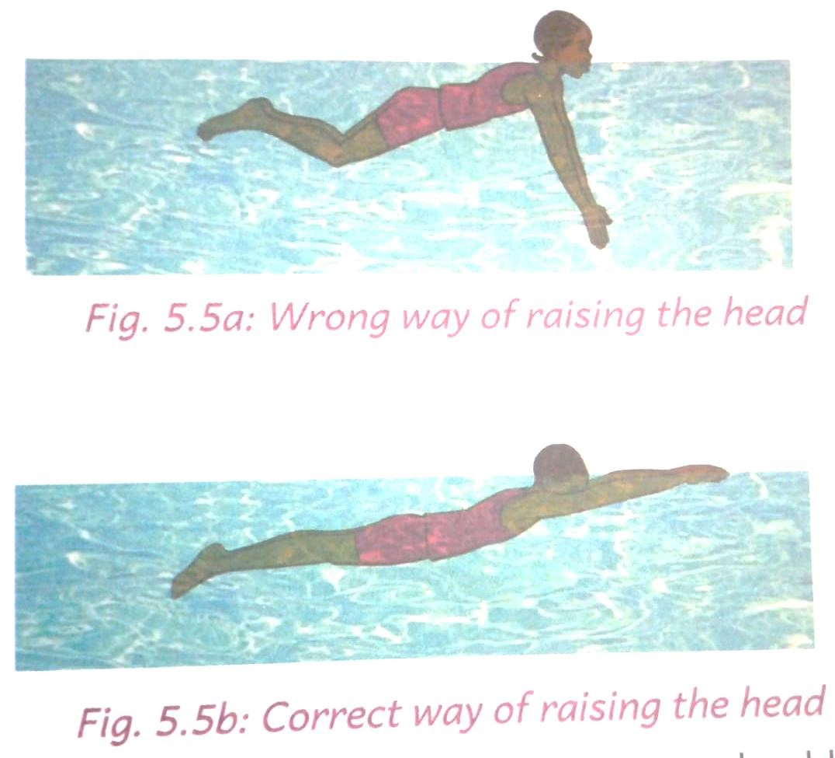

    - Inhale through your mouth before letting your shoulder drop as you sweep with your arms.
    - Breath out as your legs kick back and extend your arms forward.
    - The head returns to the water to exhale as the arms stretch forward to begin their recovery phase.
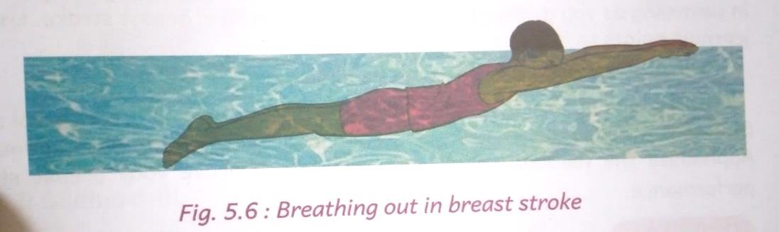
Timing.
A well-executed breast stroke timing sequence is key to achieving a smooth and efficient swimming stroke as you will effortlessly glide through the water.
- Try to time your arm action and leg kick so there is always something propelling you through water.
- The arms will be propulsive while the legs recover and the legs propulsive while the arms recover.
- To coordinate the leg kick, the arm strokes, and the breathing, think of the phrase
‘pull, breath, kick, glide’
- As your arms complete the power phase, take a breath, and then draw your feet toward the hips.
- When your arms are about halfway through the recovery phase, begin the leg action.
- Time the arm strokes and kick so that the arms and legs are both at their full length as the kick finishes.
- Rest in the phase position as your body glides through the water. Then the glide begins to slow down, it is time to start another stroke.

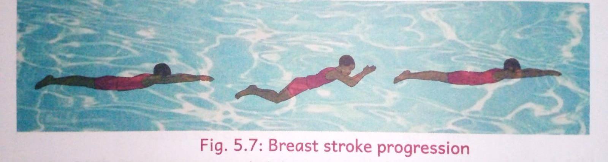

Water treading.
To maintain an upright position in deep water by moving the feet with a walking movement and the hands with a downward circular motion
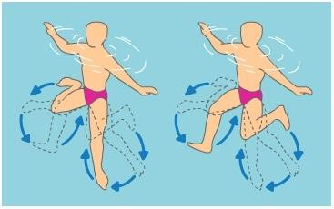

2.9
Kenyan Folk Dance

Classifying a folk song.

· African folk songs are classified according to the following.
- Their origin.
- Occasion.
- Function.
- Type.
a.) Community of origin.
- African songs can be classified according to their origin.
- The origin in this case means the community they are drawn from.
- Therefore, songs belong to a particular community such as luhya, luo, gikuyu, gusii. Kuria, Kamba, iteso, giriama, digo, Pokomo, gabra, nandi, Kipsigis, Marakwet, pokot, turkana and taita.
- These songs are passed on by oral tradition from one generation to the next.
- The music is related to the culture of a particular or region. For example, you can identify the culture od a particular community or region by their dressing, language used, musical instruments, props, body adornments, ornaments, body movements, vocal embellishments used to enrich music, style of sing and tone among others.
b.) Occasion.
- African folk songs can also be categorized according to occasions they are performed.
- For example:
  - naming folk songs.
  - Initiation folk songs.  Marriage folk songs.
  - War folk songs.
  - Funeral folk songs.
  - Worship folk songs among others.

c.) Function.
- Folk songs belong to the people with a common culture.
- Therefore, folk songs keep people connected to their cultures and heritage.
- They give history of the people and their culture.
- Folk songs usually pass important information, stories, messages and history from generation to generation.
- Folk songs are used to express emotions. They narrate stories of joy and sorrows in the simplest way.
- Folk songs are used as a means of unifying the community members when they come together to sing. This also creates positive outcomes or consequences if they do not watch their actions and intention.
- Some of the folk songs are purely for entertainment, enjoyment by performers and the audience.

d.) Type.
· African folk songs can also be classified according to the type such as:
- Lullabies.
- Dirges.
- Love songs.
- Protest songs.
- Children’s songs among others.

Creating improvised implements to use in performance of Folkdance songs.
Folk dances are performed by different participants who plays different roles as follows:
- Soloist-person who leads the rest of the participants in singing the melodies and dancing during the performance of the dance.
- Response group-they provide an answer to the soloist during the dance.
- instrumentalist-plays instruments to accompany a dance.
- Dancers- makes dance movements and formation in response to the songs and instruments.

Along side the participants, folk song dances also require other implements so help in identifying different cultures and diversities such as costumes, ornaments, body adornments, body make ups, props etc.

- During a folk-dance performance, participants wear specially designed cloths, hides or skins called costumes.
Costumes are made using locally available materials such as sisal fibre, sisal string, comb and pair of scissors.
- The participants also decorate their bodies using different paints to make patterns.
This is called body adornments.
Body adornments are made using the following materials:
    - Water paints.
    - Chalk powder.
    - Objects or items of different shapes and sizes like bottle tops, water bottles, combs, folk and other design shaped objects.
- Dancers also use beads, necklaces, bracelets and anklets during the dance performance. These are called ornaments.
Body ornaments are made using locally available materials such as:
    - Pieces of thread.
    - Pair of scissors.
    - Grains such as beans, maize (soaked in water to make them soft)  A needle.
- The costumes, body adornments and ornaments vary from one community to another expressing different cultures in Kenya.
The following are social importance of songs to the pastoralists:
  - Songs they sing accompany their journey to facilitate movements.
  - They songs are sung during their herding sessions to take away boredom.
  - They are a source of unity and collaboration among the community members.
  - They educate on the importance of the animals and other resources.
  - They tell the history of the community.
General uses of Folk songs.
- As a source of entertainment.
- As a source of cultural and national unity.
- In teaching subjects such as history, literature and geography among others.
- To educate.
- To rebuke.
- To advise.
- To worship.
- To encourage.
- To promote culture.
- To give moral teachings.

Economic importance of the songs.
Economic importance or economic significance of something refers to the monetary or trade value of an item.
Songs have economic importance to individuals, the cultural community and even the country.
General these are the economic importance of folk songs:
  - Performers can earn money or income by performing folk songs at private parties.
  - Folk song musicians also earn a living by offering singing lessons.
  - Some musicians are employed as singers or trainers of folk songs by some institutions such as cultural centres, universities and schools among others.
  - Folk songs musicians also earn the country foreign exchange when they perform outside the country.
  - Folk musicians also earn the country revenue when they pay taxes.
  - Folk musicians can be independent artists by recording and selling their music.

