GRADE 4 FRENCH
SCHEMES OF WORK TERM 2
Wee k | Ls n | Strand/Theme | Sub strand | Specific learning outcomes | Key inquiry Questions | Learning experiences | Learning Resources | Assessment methods | Refl
1 | 1 |  | Myself | By the end of the lesson leaners should be able to  - Contruct short and simple sentences about self and family  - Appreciate the uniqueness of individuals within the classrooms | - How do you introduce yourself to someone? | Learners to:  - Fill in details about self in forms  - Use capital and small letters correctly in writing  - Draw and name members of the family  - Record short dialogue on self-introduction (audio and visual.  - Sing songs on numbers for practice. | Charts, Video clips, Maps, Short stories, Real objects, pictures, Journal, Songs, Audio recordings | Word searches/puz zle, Filling missing words, reading aloud, spelling: oral and  written, rearranging
 | 2 |  | Myself | By the end of the lesson leaners should be able to  - Contruct short and simple sentences about self and family  - Appreciate the uniqueness of individuals within the classrooms | - How do you introduce yourself to someone? | Learners to:  - Fill in details about self in forms  - Use capital and small letters correctly in writing  - Draw and name members of the family  - Record short dialogue on self-introduction (audio and visual.  - Sing songs on numbers for practice. | Charts, Video clips, Maps, Short stories, Real objects, pictures, Journal, Songs, Audio recordings | Word searches/puz zle, Filling missing words, reading aloud, spelling: oral and written,  rearranging

2 | 1 |  | Interacting with others  :Etiquette | By the end of the sub strand , the learners should be able to;  - Use polite language to show courtesy  - Use appropriate non- verbal cues and tone when talking to others  - Read simple dialogue that demonstrate courtesy | - When do you use polite language?  - Which courtesy word do you know? | The learners:  - Engage in simple conversation that involved the use of polite language (excuse me, pardon,desole,merci, s’il vous plait, bienvenue  - Practice turn taking when talking to others | Charts, Video clips, Maps, Short stories, Real objects, pictures, Journal, Songs, Audio recordings | Word searches/puz zle, Filling missing words, reading aloud, spelling: oral and written, rearranging
 | 2 |  | Interacting with others  :Etiquette | By the end of the sub strand , the learners should be able to;  - Use polite language to show courtesy  - Use appropriate non- verbal cues and tone when talking to others  - Read simple dialogue that demonstrate courtesy | - When do you use polite language?  - Which courtesy word do you know? | The learners;  - Sing curtesy songs that demonstrate good manners e.g appreciation (merci)  - Fill in the missing leters in word courtesy learners  - Match courtesy words to the corresponding images on flashcards  - Read vocabularies on etiquettes on flash cards and chats | Charts, Video clips, Maps, Short stories, Real objects, pictures, Journal, Songs, Audio recordings | Word searches/puz zle, Filling missing words, reading aloud, spelling: oral and written, rearranging
3 | 1 |  | Interacting with others  :Etiquette | By the end of the sub strand , the learners should be able to;  - Write simple texts using courtesy words  - Appreciate that being courteous to others build cordial relationship | - When do you use polite language?  - Which courtesy word do you know? | Learners  - Recite simple poems on showing gratitude  - Watch video clips showing the practice of etiquette and courtesy  - Create word searches with vocabulary on etiquette in group or pairs | Charts, Video clips, Maps, Short stories, Real objects, pictures, Journal, Songs, Audio recordings | Word searches/puz zle, Filling missing words, reading  aloud, spelling: oral and written,  rearranging

 | 2 |  | Giving and responding to instructions | By the end of the sub strand , the learners should be able to;  - Give and respond to simple instructions in everyday situations  - Read simple instructions used in their immediate environment  - Complete texts using simple instructions  - Demonstrate a willingness to respond to simple instructions | 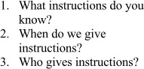 | 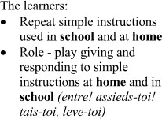 | Charts, Video clips, Maps, Short stories, Real objects, pictures, Journal, Songs, Audio recordings | Word searches/puz zle, Filling missing words, reading aloud, spelling: oral and  written, rearranging
4 | 1 |  | Giving and responding to instructions | By the end of the sub strand , the learners should be able to;  - Give and respond to simple instructions in everyday situations  - Read simple instructions used in their immediate environment  - Complete texts using simple instructions  - Demonstrate a willingness to respond to simple instructions |  |  | Charts, Video clips, Maps, Short stories, Real objects, pictures, Journal, Songs, Audio recordings | Word searches/puz zle, Filling missing words, reading aloud, spelling: oral and written,  rearranging
 | 2 |  | Giving and responding to instructions | By the end of the sub strand , the learners should be able to;  - Give and respond to simple instructions in everyday situations  - Read simple instructions used in their immediate environment  - Complete texts using simple instructions  - Demonstrate a willingness to respond to simple instructions |  | 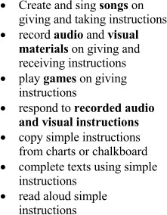 | Charts, Video clips, Maps, Short stories, Real objects, pictures, Journal, Songs, Audio recordings | Word searches/puz zle, Filling missing words, reading aloud, spelling: oral and written, rearranging

5 | 1 |  | Giving and responding to instructions | By the end of the sub strand , the learners should be able to;  - Give and respond to simple instructions in everyday situations  - Read simple instructions used in their immediate environment  - Complete texts using simple instructions  - Demonstrate a willingness to respond to simple instructions |  |  | Charts, Video clips, Maps, Short stories, Real objects, pictures, Journal, Songs, Audio recordings | Word searches/puz zle, Filling missing words, reading aloud, spelling: oral and written, rearranging
 | 2 |  | Expressing wishes | By the end of the sub strand , the learners should be able to;  - Express appropriate wishes used for different occasions  - Read simple dialogues fluently  - Use appropriate expressions to write wishes for different events  - Appreciate the important of expressing wishes | 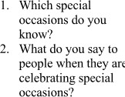 | 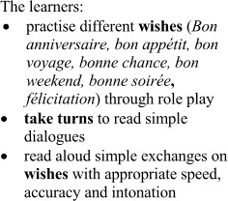 | Charts, Video clips, Maps, Short stories, Real objects, pictures, Journal, Songs, Audio recordings | Word searches/puz zle, Filling missing words, reading aloud, spelling: oral and written, rearranging

6 | 1 |  | Expressing wishes | By the end of the sub strand , the learners should be able to;  - Express appropriate wishes used for different occasions  - Read simple dialogues fluently  - Use appropriate expressions to write wishes for different events  - Appreciate the important of expressing wishes |  |  | Charts, Video clips, Maps, Short stories, Real objects, pictures, Journal, Songs, Audio recordings | Word searches/puz zle, Filling missing words, reading aloud, spelling: oral and written, rearranging
 | 2 |  | Expressing wishes | By the end of the sub strand , the learners should be able to;  - Express appropriate wishes used for different occasions  - Read simple dialogues fluently  - Use appropriate expressions to write wishes for different events  - Appreciate the important of expressing wishes |  | 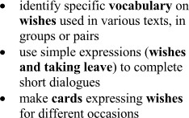 | Charts, Video clips, Maps, Short stories, Real objects, pictures, Journal, Songs, Audio recordings | Word searches/puz zle, Filling missing words, reading aloud, spelling: oral and written, rearranging
7 | 1 |  | Expressing wishes | By the end of the sub strand , the learners should be able to;  - Express appropriate wishes used for different occasions  - Read simple dialogues fluently  - Use appropriate expressions to write wishes for different events  - Appreciate the important of expressing wishes |  |  | Charts, Video clips, Maps, Short stories, Real objects, pictures, Journal, Songs, Audio recordings | Word searches/puz zle, Filling missing words, reading aloud, spelling: oral and written, rearranging

 | 2 |  | Expressing likes and dislikes | 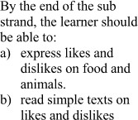 | 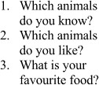 | 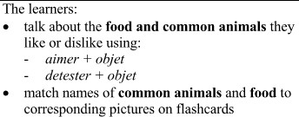 | Charts, Video clips, Maps, Short stories, Real objects, pictures, Journal, Songs, Audio recordings | Word searches/puz zle, Filling missing words, reading aloud, spelling: oral and 1written,  rearranging
8 | HALF TERM BREAK
9 | 1 |  | Expressing likes and dislikes |  |  |  | Charts, Video clips, Maps, Short stories, Real objects, pictures, Journal, Songs, Audio recordings | Word searches/puz zle, Filling missing words, reading aloud, spelling: oral and written,  rearranging
 | 2 |  | Expressing likes and dislikes |  |  | 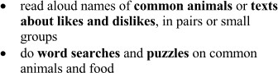 | Charts, Video clips, Maps, Short stories, Real objects, pictures, Journal, Songs, Audio recordings | Word searches/puz zle, Filling missing words, reading aloud, spelling: oral and  written, rearranging

10 | 1 |  | Expressing likes and dislikes | 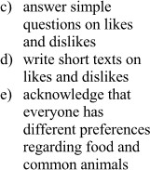 |  | 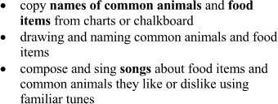 | Charts, Video clips, Maps, Short stories, Real objects, pictures, Journal, Songs, Audio recordings | Word searches/puz zle, Filling missing words, reading aloud, spelling: oral and written,  rearranging
 | 2 |  | Expressing likes and dislikes |  |  |  | Charts, Video clips, Maps, Short stories, Real objects, pictures, Journal, Songs, Audio recordings | Word searches/puz zle, Filling missing words, reading aloud, spelling: oral and written,  rearranging
11 | 1 |  | Moments of the day | 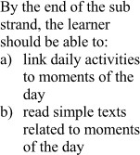 | 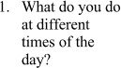 | 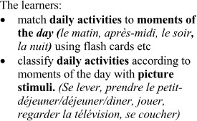 | Charts, Video clips, Maps, Short stories, Real objects, pictures, Journal, Songs, Audio recordings | Word searches/puz zle, Filling missing words, reading aloud, spelling: oral and  written, rearranging

 | 2 |  | Moments of the day |  |  |  | Charts, Video clips, Maps, Short stories, Real objects, pictures, Journal, Songs, Audio recordings | Word searches/puz zle, Filling missing words, reading aloud, spelling: oral and written,  rearranging
12 | 1 |  | Moments of the day | 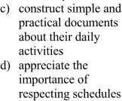 |  | 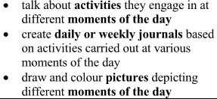 | Charts, Video clips, Maps, Short stories, Real objects, pictures, Journal, Songs, Audio recordings | Word searches/puz zle, Filling missing words, reading aloud, spelling: oral and written,  rearranging
 | 2 |  | Moments of the day |  |  |  | Charts, Video clips, Maps, Short stories, Real objects, pictures, Journal, Songs, Audio recordings | Word searches/puz zle, Filling missing words, reading aloud, spelling: oral and  written, rearranging
13 | ASSESSMENT AND CLOSSING

