GRADE 4 GERMAN LANGUAGE SCHEMES OF WORK TERM 3

Wee k | Ls n | Strand/Theme | Sub strand | Specific learning outcomes | Key inquiry Questions | Learning experiences | Learning Resources | Assessment methods | Refl
1 | 1 |  | Food stuff | 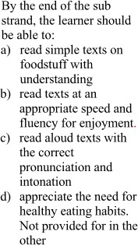 | 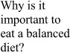 | 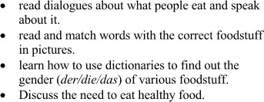 | Podcast, internet, maps, course books and workbooks, project, radio, newspaper | Observation, Discussion, Quizzes, Questionnair es, Exit/admit slips, Cloze test, Essays
 | 2 |  | Greetings and Introduction | 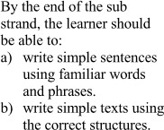 | 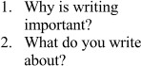 | 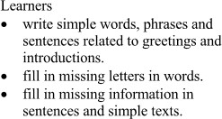 | Podcast, internet, maps, course books and workbooks, project, radio, newspaper | Observation, Discussion, Quizzes, Questionnair es, Exit/admit slips, Cloze test, Essays
2 | 1 |  |  |  |  |  |  | Observation, Discussion, Quizzes, Questionnair es, Exit/admit slips, Cloze test, Essays
 |  |  |  |  |  |  | Podcast,
 |  |  |  |  |  |  | internet, maps,
 |  |  | Greetings |  |  |  | course books
 |  |  | and |  |  |  | and
 |  |  | Introduction |  |  |  | workbooks,
 |  |  |  |  |  |  | project, radio,
 |  |  |  |  |  |  | newspaper
 | 2 |  |  | 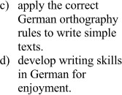 |  |  |  | Observation, Discussion, Quizzes, Questionnair es, Exit/admit slips, Cloze test, Essays
 |  |  |  |  |  |  | Podcast,
 |  |  |  |  |  |  | internet, maps,
 |  |  | Greetings |  |  |  | course books
 |  |  | and |  |  |  | and
 |  |  | Introduction |  |  |  | workbooks,
 |  |  |  |  |  |  | project, radio,
 |  |  |  |  |  |  | newspaper
3 | 1 |  |  |  |  |  |  | Observation,
 |  |  |  |  |  |  |  | Discussion,
 |  |  |  |  |  |  | Podcast, | Quizzes,
 |  |  |  |  |  |  | internet, maps, | Questionnair
 |  |  | Greetings |  |  |  | course books | es,
 |  |  | and |  |  |  | and | Exit/admit
 |  |  | Introduction |  |  |  | workbooks, | slips, Cloze
 |  |  |  |  |  |  | project, radio, | test, Essays
 |  |  |  |  |  |  | newspaper
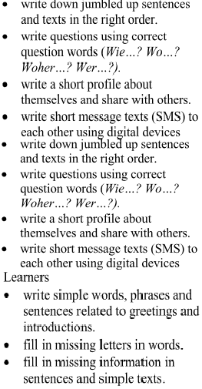

 | 2 |  | Numbers, days of the week | 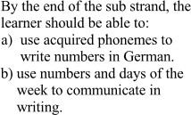 | 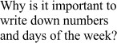 |  | Podcast, internet, maps, course books and workbooks, project, radio, newspaper | Observation, Discussion, Quizzes, Questionnair es, Exit/admit slips, Cloze test, Essays
4 | 1 | WRITING |  | 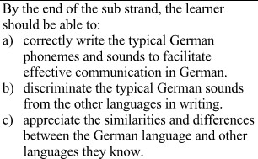 | 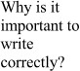 |  |  | Observation,
 |  |  |  |  |  |  |  | Discussion,
 |  |  |  |  |  |  |  | Quizzes,
 |  |  |  |  |  |  |  | Questionnair
 |  |  | Phonological awareness |  |  |  | Podcast, internet, maps, course books and workbooks, | es, Exit/admit slips, Cloze test, Essays
 |  |  |  |  |  |  | project, radio,
 |  |  |  |  |  |  | newspaper
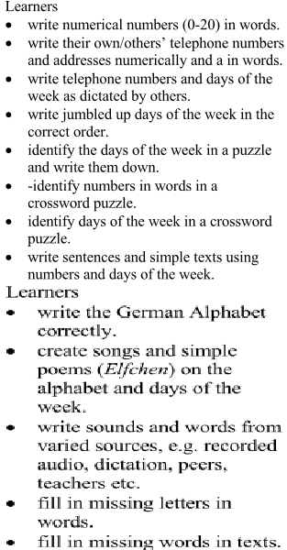

 | 2 |  | Describing objects, and people in the immediate environment | 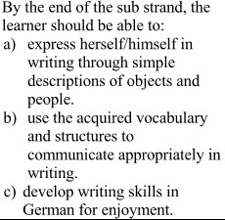 | 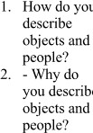 |  | Podcast, internet, maps, course books and workbooks, project, radio, newspaper | Observation, Discussion, Quizzes, Questionnair es, Exit/admit slips, Cloze test, Essays
5 | 1 |  | Describing objects, and people in the immediate environment |  |  |  | Podcast, internet, maps, course books and workbooks, project, radio, newspaper | Observation, Discussion, Quizzes, Questionnair es, Exit/admit slips, Cloze test, Essays
 | 2 |  | School |  | 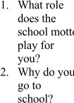 | 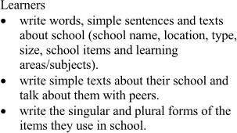 | Podcast, internet, maps, course books and workbooks, project, radio, newspaper | Observation, Discussion, Quizzes, Questionnair es, Exit/admit slips, Cloze test, Essays
6 | 1 |  | School |  |  | 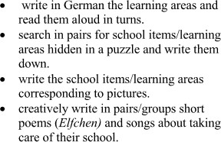 | Podcast, internet, maps, course books and workbooks, project, radio, newspaper | Observation, Discussion, Quizzes, Questionnair es, Exit/admit slips, Cloze test, Essays
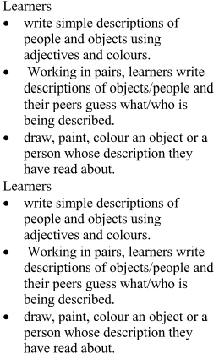
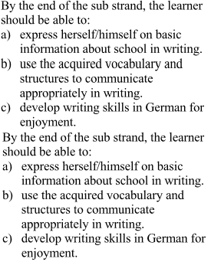

 | 2 |  | School | 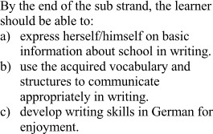 |  | 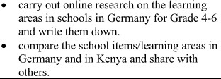 | Podcast, internet, maps, course books and workbooks, project, radio, newspaper | Observation, Discussion, Quizzes, Questionnair es, Exit/admit slips, Cloze test, Essays
7 | 1 |  | Leisure time activities |  | 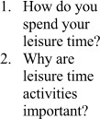 | 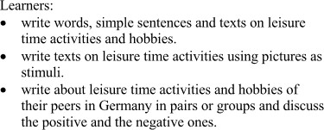 | Podcast, internet, maps, course books and workbooks, project, radio, newspaper | Observation, Discussion, Quizzes, Questionnair es, Exit/admit slips, Cloze test, Essays
 | 2 |  | Leisure time activities |  |  | 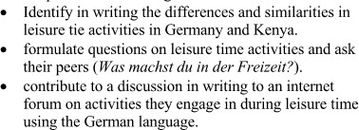 | Podcast, internet, maps, course books and workbooks, project, radio, newspaper | Observation, Discussion, Quizzes, Questionnair es, Exit/admit slips, Cloze test, Essays
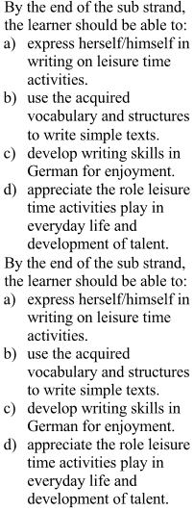

8 | 1 |  | Leisure time activities | 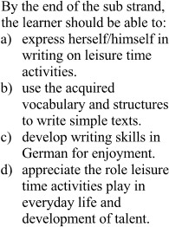 |  | 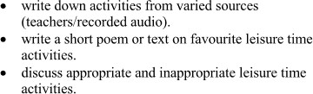 | Podcast, internet, maps, course books and workbooks, project, radio, newspaper | Observation, Discussion, Quizzes, Questionnair es, Exit/admit slips, Cloze test, Essays
 | 2 |  | Food stuff | 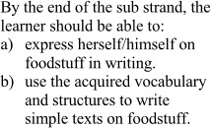 | 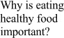 | 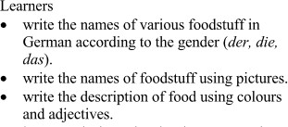 | Podcast, internet, maps, course books and workbooks, project, radio, newspaper | Observation, Discussion, Quizzes, Questionnair es, Exit/admit slips, Cloze  test, Essays
9 | 1 |  | Food stuff |  |  | 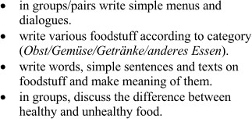 | Podcast, internet, maps, course books and workbooks, project, radio, newspaper | Observation, Discussion, Quizzes, Questionnair es, Exit/admit slips, Cloze  test, Essays
 | 2
10 |  | END YEAR/TERM EXAMS

