MADINGA COMPUTER SERVICES
P.O BOX 17-40222
OYUGIS
TELEPHONE NUMBER:
EMAIL:
NAME :
INSTITUTION:
INDEX NUMBER:
SUPERVISOR NAME:
SUBMITTED TO:

DECLARATION
I Ojanga Samuel proclaim that this is my personal work and has never been presented anywhere by anybody to the Kenya National Examination Council (KNEC) for the reward of certificate in Information and Communication Technology (ICT)
PRESENTER NAME:
SIGNATURE………………………………...

SUPERVISOR’S NAME:
SIGNATURE…………………………………

DEDICATION

I represent this business plan to my sister Winnie Odoyo for the wise decision she helped me to make and for her support as well

ACKNOWLADGEMENT
I appreciate the grace of Lord the Father for the gift of life up to now though it has not been smooth on my side. My acknowledgement also to the fraternity of Kenyaplex Institution for the conducive environment and quality education that one may desire to get in his/her life with an addition of abundance support throughout my study period.
Last but not least I pass my wholehearted recognition to my family members for their firmness and support towards my education.

EXECUTIVE SUMMARY

BUSINESS DESCRIPTION
The business owner will be Ojanga Samuel a Kenyan citizen by birth. He is 22 years of age undertaking certificate course in craft certificate in Information and Communication Technology (ICT)
The Business name will be Madinga Computer Services Which will be located in Homabay County, Oyugis Town. The business will operate as from 8.00 am up to 6.00 pm on daily basis except on Saturdays. Anyone will be given a chance to express his/her freedom of worship and will be allowed not to report to work on his/her worshipping day.
The business will major on offering cyber services like reproducing copies of documents, preparing any kind of publication like printing banners, T-shirts, Certificates, binding services, preparing schemes of work, KRA pin application. The enterprise will also help its customers in CRB clearance, web browsing at an affordable fee.
We shall also offer Installation and upgrading of computer software windows, availing storage mediums like hard disks, flash disks, memory cards and also peripheral devices like keyboards and mouse plus computer cables.

JUSTIFICATION OF THE BUSINESS
The owner of the business will be a sole proprietorship with a chief aim of rendering quality services to the customers

MARKETING PLAN
Madinga hopes to serve two main potential customers
- Institutional customers
- Individual customers – majorly the public
We expect to get more sales on Tuesdays and Fridays the well-known market days in Oyugis town.
Institutional customers expected are from Imbeke Training Centre, Agoro Sare Mixed Secondary and Kuoyo Oyugis. We shall employ qualified personnel, provide quality goods and services and be time conscious to stand any kind of stiff completion.
MANAGEMENT TEAM
The enterprise will comprise of the general manager, assistant manager, three customer attendants, cyclist and a cleaner
OPERATIONAL PLAN
Business will have machines like printer, T-shirt printing machine, plotter, motorcycle, two laptops and five desktop computers.
We shall also live to observe proper waste disposal for maximum environmental adherence. In addition we also plan to offer assistance to the elderly and the challenged in the society and to serve customers fairly and equally.

FINANCIAL PLAN
The business will require Ksh. 654,350 Capital to start the business with bank loans, Credit Institutions and Personal Savings as the source of capital. The capital required will be collected and followed by license acquisition before starting the business followed by advertisements

Contents
DECLARATION i
DEDICATION ii
ACKNOWLADGEMENT iii
EXECUTIVE SUMMARY iv
BUSINESS DESCRIPTION iv
JUSTIFICATION OF THE BUSINESS iv
MARKETING PLAN v
CHAPTER ONE 1
BUSINESS DESCRIPTION 1
JUSTIFICATION OF VENTURE 3
CHAPTER TWO 5
MARKETING PLAN 5
COPYING OUT WITH COMPETITION 7
CHAPTER THREE 9
ORGANIZATIONAL AND MANAGEMENT PLAN 9
REMUNERATION AND INCENTIVES 11
CHAPTER FOUR 12
OPERATIONAL PLAN 12
CHAPTER FIVE 14
FINANCIAL PLAN 14
REFERENCES 15
Endnotes 15
REFERENCES 15

CHAPTER ONE

BUSINESS DESCRIPTION
Background of the business
The owner of the business will be Ojanga Samuel from Homabay County, Mbita sub-county, Gembe ward pursuing Craft Certificate in Information and Communication Technology at Kenyaplex Institute of Technology
Form of Ownership
The business will be sole proprietorship under the name of Madinga Computer Services. The business is intended to offer all computer services to the institutions and public at an affordable price
Location and Address
The Business will be located along Kisii-Kisumu Highway next to Shivshakti hardware opposite KCB Oyugis Branch which is 850 M from Oyugis Police Station.
The reason for locating this business at this place is the high targeted number of customers visiting Kenya Commercial Bank (KCB) Oyugis branch and The Agatha Oyugis Bookshop and the stiff competition. Additionally there is enough security since police station is only twelve (12) minutes’ walk from the enterprise

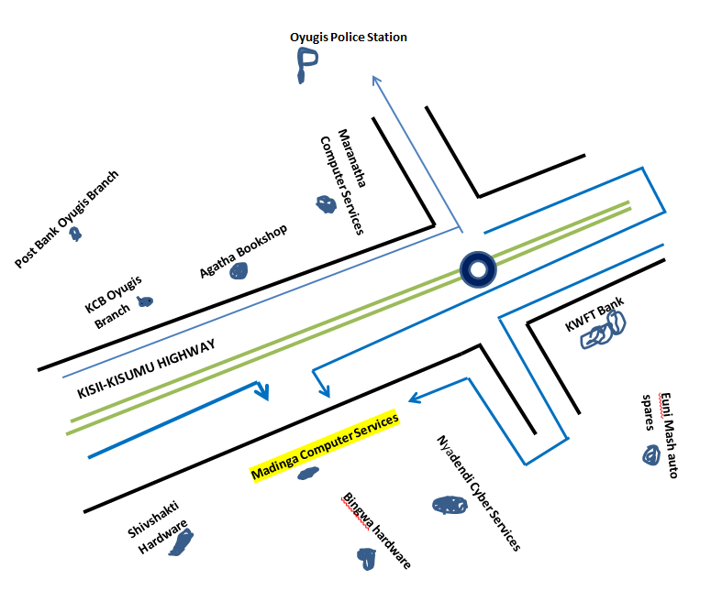

The Address
MADINGA COMPUTER SERVICES
P.O BOX 17-40222
OYUGIS-KENYA
Email:ojangaodoyo@gmail.com

JUSTIFICATION OF VENTURE
Following the vast entrepreneurship skills I acquired from Kenyaplex Institute of Technology, I am confident enough to operate and run my business
The Industry
My business will fall under Technology Industry due to the goods it will be dealing with and services it will render
Products and services
In this business there will be services like T-shirt printing, publication of banners, internet services, reproduction of documents, installation and upgrading of Pc software windows, availing storage devices and computer input devices like mouse and keyboards at an affordable price to all.

ENTRY AND GROWTH
The business will start up in 2024 after obtaining enough capital and management skills. It will need a basic capital of Ksh 654,350 to start up.

Sources of capital
Sources | Capital | Percentage
Bank loans | 400,000 | 61%
Personal Savings | 254,350 | 39%
TOTAL | 654,350 | 100%

The premise will have a 32-inch screen television that will entertain customers at the waiting bench waiting to be served

GROWTH STRATEGY
The owner will employ skilled employees in the business to help the business stand stiff competitions. The sources of capital to expand the business will come from
Sources | Capital | Percentage
Personal Savings | 35,000 | 70%
Plough back profit | 15,000 | 30%
Total | 50,000 | 100%

CHAPTER TWO

MARKETING PLAN
The premise is located in Oyugis town. I targeted to supply my products to supply my products to the area and the neighboring town where marketing department will be headed by the manager.
POTENTIAL CUSTOMERS
The potential customers for my business will be learning institutions like Imbeke Training Centre, Agoro Sare Mixed Secondary School and Kuoyo Oyugis Secondary.
OTHER CUSTOMERS
On the other hand I expect customers from the entire town who are familiar with the business operation and also the businesses like Shirikisho Library Services.
Depending with the level of competition in the locality of its operation we expect to serve 60 or more customers in a day and estimated total sales of 7000 per day
MARKET SHARE
Business description | Item sold | Percentage
Maranatha computer services | Reproduction of documents, Internet services and T-shirt printing | 15%
Nyadendi Cyber  Services | Availing storage devices, reproduction of documents and internet services | 20%
Madinga computer  services | T-shirt printing, publication of banner, reproduction of documents, Installation and upgrading of PC windows and  storage devices | 65%
Total |  | 100

I will have the largest share in the market since I will sell at fair price and avail quality goods
COMPETITION
POTENTIAL COMPETITORS
My potential competitor will be Nyadendi Cyber services which is located some 80m from my business and they will be disadvantageous to them following the quality of products they are rendering
OTHER COMPETITORS
Other competitors will be Maranatha Cyber located oppositely to my business some 200m away and Rehema Cyber and Computer services located 2 kilometers from town next to Brilliant Stars Academy
Competitors | Strength | Weakness
Nyadendi Cyber Services | Have qualified staff  Opens very early | Poor quality products  Does not offer discount
Rehema Cyber and Computer Services | Offers discount to customers  Have skilled and qualified staff | Difficult to access when it rains  Are time unconscious
Maranatha Cyber and Computer Services | Offers discount  Have skilled staff  Easy to access | Lack of business facilities  Time unconscious

COPYING OUT WITH COMPETITION
In order to withstand the stiff competition, my business will ensure
- Listen to customers’ complains and be closer to them
- Provide quality goods and services to customers
- Ask customers about the market trend
PRICING STRATEGY
Cost of production
My cost of production will be relatively low in order to access the customers. It will also offer credit facilities to its trustworthy customers and discount will be offered following the services and product purchased
Competitors’ price
My price will be cheap as compared to the competitors’ prices in order to have more sales
Government Policies
The business will adhere to government rules and regulations
Transport costs
The business will make sure low transport costs is reached as ordered goods will be supplied using the motorcycle

SALES TACTICS
My business will employ the use of direct selling method to our customers
MADINGA COMPUTER SERVICES
CUSTOMERS

PROMOTION AND ADVERTISEMENT
PROMOTION
My business will introduce services like free discount to attract more customers
ADVERTISEMENT
Posters
The business will introduce use of posters located at different strategic positions written in both Vernacular and English languages describing the nature of the business, Products and its location
Banner
The business will publish banner and locate it in front of the premise to create awareness such that it can be seen even from far
Social Media Posts
Being that social media is being accessed by many individuals every time, the business will be advertised through Facebook pages and WhatsApp groups with an aim of improving sales and reducing the advertisement costs
DISTRIBUTION STRATEGY
The products to be sold like Keyboards and mouse will be distributed directly from Madinga Computer Services to customers
Customers
Madinga Computers Services
This will ensure that quality goods from the business reach the intended customers in time and also customers not to purchase them at a higher cost as compared to when middlemen were there.

CHAPTER THREE

ORGANIZATIONAL AND MANAGEMENT PLAN
The management team of my business will consist of;
General Manager
Assistant manager
Accounts Clerk
Driver/Cyclist
Customer Attendants
ORGANIZATIONAL STRUCTURE
General Manager

Assistance Manager

Driver/Cyclist
Accounts Clerk

Customer Attendants

PERSONNEL
The key management personnel will be the General Manager. I will be responsible for smooth running of the premise
- General Manager
He an overall manager
Duties and Responsibilities
- Assigning duties to staff
- Recruiting new employees, promotes and sacks unproductive employees
- Funds the business

- The Assistant Manager
He is the assistant general manager administer of the business
Duties and Responsibilities
Performs all duties of the manager when the manager is absent
- The accounts Clerk
He/she is in charge of finance in the business
Duties and Responsibilities
- Will be in charge of all assets in the business
- Will keep good financial records of the business on goods sold on daily basis
- Will be responsible for sales promotions and advertisements
- Will ensure funds are kept in the bank for security
- Driver/Cyclist
Will be in charge of transport sector
Duties and Responsibilities
- Supplying ordered goods using the motorcycle
- Transport the newly purchased products by the business
- Customer attendants
They are the people who will operate the machines within premise
Duties and Responsibilities
- Attends to customers ‘needs
- Serve customers without discrimination

REMUNERATION AND INCENTIVES
This will be the amount of money paid to employees
Establishment | Number of Responsibilities | Basic  Salary | Medical  Allowance | Transport  Allowance | Gross Pay  Monthly
General Manager | 1 | 9,000 | 2,500 | 2,000 | 14,000
Assistant Manager | 1 | 5,500 | 3,000 | 2,000 | 12,500
Accounts Clerk | 1 | 6,000 | 2,500 | 3,000 | 11,000
Driver/Cyclist | 1 | 5,000 | 3,000 | 1,500 | 10,000
Customer Attendants | 3 | 5,500 | 3,000 | 1,000 | 9,500
Total | 7 | 31,000 | 14,000 | 9,500 | 57,000

GOVERNMENT REGULATION
License
Madinga Computer Services will obtain license of Ksh 3,000 from County Government of Homabay annually to enable it run smoothly
Insurance
The enterprise will ensure all its assets from theft and fire from The Jubilee Insurance Company of Kenya at an affordable cost of 3,000 monthly (36,000 annually)

CHAPTER FOUR

OPERATIONAL PLAN
The business will require some machines like computers, laptops and motorcycle to operate. The business will be under both Open Layout for the customer attendant’s chamber and Closed Office Layout for the senior ranks for privacy as well as to enhance tidy outlook. The store also will be under Closed Layout

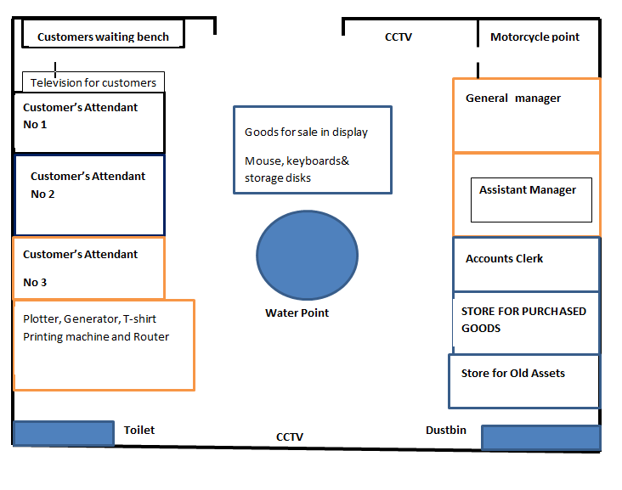

Computers
The premise will have 5 computers where 3 will be used/will be operated by customer attendants, 1 will be for keeping business related records and to be used by accounts clerk and 1 to be used by assistant manager for business related tasks
Laptops
The premise is planning to have at least two laptops to be used for management purposes to be under the use by the general manager and one to be used by the entire staff where portable work is needed
Motorcycle
This will be used for transportation of ordered goods form the premise to be delivered to customers and also purchased goods by the business
Health Regulation
Each worker within my premise will be under the cover of NHIF. We will also ensure that there is clean water for drinking and toilets also will be available for workers and customers
Safety Regulations
The business will install CCTV cameras for security purposes

CHAPTER FIVE

FINANCIAL PLAN
PRE-OPERATIONAL COST
ITEM | AMOUNT COSTS
Electricity | 3000
License | 3000
Advertising | 4000
Salaries | 57,000
Insurance | 36,000
Total | 103,000

WORKING CAPITAL
CURRENT ASSETS | AMOUNT
Cash in Hand | 250,000
Cash at Bank | 150,000
Debtors
TOTAL | 400,000
CURRENT LIABILITIES
Bank Loan | 254,350
Creditors
TOTAL | 254,350
WORKING CAPITAL ( Current Assets- Current Liabilities) | 400,000-254,350 = 145,650

REFERENCES

Endnotes
KRA ………. Kenya Revenue Authority
CRB……….. Credit Reference Bureau
KCB……… Kenya Commercial Bank
NHIF……… National Hospital Insurance Fund
CCTV……… Closed Circuit Television

REFERENCES


