NANDURII’S CYBER CAFE
P.O BOX 784 NJORO
NJORO
CELL:
E-MAIL: CYBERCAFE@GMAIL.COM
INSTITUTION:
PRESENTER :
CODE NUMBER: ………………………….......
SUPERVISOR NAME:
THIS BUSINESS PLAN IS SUBMITTED TO …………………….

DECLARATION
My name is …………… and I make declaration that the business plan am submitting has never appear in the Kenya National Examination body before for the award of certificate in craft certificate in information technology (cict)
PRESENTER NAME:
SIGNATURE …………………………………………..

SUPERVISOR’S NAME:
SIGNATURE……………………………………………

DEDICATION
I do dedicate this work of business plan to my sister Catherine Chebet Nandurii for the sacrifice she made and gives me a chance that made me be here. She has really be kind hearted and of great help in my life.

ACKNOWLEDGEMENT
I am so grateful to the Almighty God for the far He has brought me from and good health He has offered. My acknowledgement is to your institute for providing a conducive and friendly environment, and also being dedicated on passing on knowledge to me without getting tired in their work of tutoring.
Lastly I’ll pass my profound gratitude to the family members, friends and any other person who offered support, guidance, prayers and any other support in my life.

EXECUTIVE SUMMARY

The cyber café is going to offer lamination, printing, KRA application, scanning, and renewal of driving license, photocopying, games and all online services
It has come to my note that the nearing community and entire people of town have been getting challenges more so when their computer equipment develop problems. This is due to lack of qualified technician to offer them the services they need. The cyber-cafe is well managed with all modern computers, machines that will be able to handle customer’s needs.
Secondly, the cyber will be in a position of teaching illiterate students and any other person that will have interest for the fight of computer illiteracy in the community, this is because the generation we are now is world of technology.
Games will be also available so that the interested persons may come and have their leisure time there.
Also loading of flash and CDs will be part of our services so that the community within should be able to get the movies, songs, and any other kind of entertainment of their desire.

TABLE OF CONTENTS

Contents
DEDICATION iii
ACKNOWLEDGEMENT iv
EXECUTIVE SUMMARY v
TABLE OF CONTENTS vi
CHAPTER ONE 1
BACKGROUND INFORMATION 1
Background of the business 1
Form of business ownership 1
Business Name 1
Location and address 2
Location 2
BUSINESS ADDRESS 3
JUSTIFICATION OF VENTURES 3
The industry 3
ENTRY GROWTH STATEGIES 4
CHAPTER TWO 5
MARKETING PLAN 5
POTENTIAL CUSTOMERS 5
COMPETITION 5
POTENTIAL COMPETITORS 5
OTHER COMPETITORS 5
COPYING OUT WITH THE TECHNOLOGY 6
PRICING STRATAGES 7
Cost of production 7
Competitor’s price 7
Government policy 8
Transport cost 8
Cost of equipment’s to start the business 8
SALES TACTICS 8
PROMOTION AND ADVERTISEMENT 8
PROMOTION 9
ADVERTISEMENTS 9
Radio 9
Poster 9
Word of mouth 9
CHAPTER THREE 10
ORGANIZATION AND MANAGEMENT PLAN 10
ORGANIZATION STRUCTURE 11
PERSONNEL 12
KEY MANAGEMENT PERSONNEL 12
Director 12
Manager 12
Qualifications 12
Duties and Responsibilities 12
Cleaner 12
Qualifications 13
Duties 13
RECRUITMENT, TRAINING AND PROMOTION 13
Recruitment 13
Advertisement 13
Short listing 13
TRAINING 14
Promotion 14
SUPPORT SERVICES 14
GOVERNMENT REGULATIONS 14
CHAPTER FOUR 15
Operation plan 15
Production capacity and facility 15
Computers 15
Computers system tool box 15
Blower 15
Pick up 15
Production facility 16
Government Regulation 16
CHAPTER FIVE 18
Financial plan 18
REFERENCE 19

CHAPTER ONE

BACKGROUND INFORMATION

Background of the business
The owner of this business will be Gideon Nandurii from Nakuru County, Njoro Sub-county, Nessuit location and sub-location, taking certificate in information and communication technology.

Form of business ownership
The business will be a sole proprietorship under the name Nadurii’s Cyber cafe. It will be located at Nessuit town. The business is intended to offer all computer games and cyber services to all customers at a friendly price.

Business Name
The business name will be Gaming and cyber-cafe. It will be dealing with services like gaming, photocopying, scanning, printing and other products. The business will ensure that all services are offered to customers.

Location and address

Location
The business will be located at nessuit town opposite Hereto bookshop. The reason for locating at this place is that the place has conducive and friendly environment. The area also has many customers from the nearby bookshop and other businesses
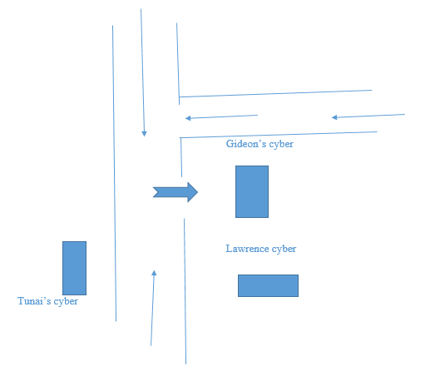

BUSINESS ADDRESS

NANDURII’S CYBER CAFE
P.O BOX 784
NJORO
CELL: 0724538193
EMAIL ADDRESS: cybercafe@gmail.com

JUSTIFICATION OF VENTURES
According to knowledge and skills of entrepreneurial acquired at Kenyaplex Institute of Technology, I am confident that the business will run smoothly. Gaming and cyber is the easiest type business to operate profitably since it has minimum losses compared to other types of business.

The industry
The business will fall under computer service industry. This is because the services offered include photocopying, scanning and printing and all other related equipment’s for customers in various parts of the country. It will use modern ways to ensure good services are offered to customers. The various ways include user of posters, banners, signboards and use of business websites.

ENTRY GROWTH STATEGIES
The business shall run up as from 12/04/2025 after acquiring adequate knowledge and skills to run and manage the business. The business will require a basic capital amounting to Ksh. 100, 000 to start. I will acquire the money from.
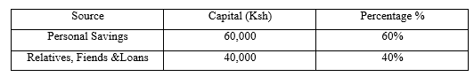

Since the business is at its initial stage, the entrepreneur will be the manager. The owner will employ staff according to their qualification in order to improve the quality of services offered to the customers. The owner will also purchase modern machines and equipment to make the job easy.

CHAPTER TWO

MARKETING PLAN
The business is located at Nessuit town. Am looking forward to offer services to customers’ within the town and entire nearing community. The marketing department will be headed by the manager who will be running marketing facilities, sales and market research.

POTENTIAL CUSTOMERS
The potential customers of the business will include learning institutions like Excel secondary, Cheptoroi secondary and among others within. This kind of customers include individuals operating in different types of business within Nessuit town. The business will be operating from 7:00am to 5:30pm week days and Saturdays is up to 1:00pm to ensure customers satisfaction.

COMPETITION
Competition is defined as the process of an enterprise or someone trying to win something or to be successful.

POTENTIAL COMPETITORS
The competitors who will challenge will be Kennedy Tunai’s cyber cafe. My competitors are not within less than 2 kilometer e in the town where most of the customers reside. This has made me to have more advantages than my competitors. This is because the customers are supposed to travel in order to reach their business and the transport cost is very high.

OTHER COMPETITORS
Other competitor is Lawrence’s cyber cafe but customers are complaining due to lack of modern machines and equipment.
Below is the table showing their strength and weaknesses;
Competitors | Strength | Weakness
- Gideon cyber café | - Time factor  - quality services  - computer classes  - Easy to access  - Offer discount | - Nill
- Lawrence cyber café | - Offer cheap services  - Have qualified staff | - Poor time management  - Difficult to access  - Do not offer discount
3.Tunais cyber café | -Open early  -Have skilled personnel | -Time unconscious  -Difficult to access  -Poor services

COPYING OUT WITH THE TECHNOLOGY
The business will ensure the following measures are followed
- Setting rules and regulations
- Employing skilled staff
- Offering better services
- Locating the business near the town

PRICING STRATAGES
The business will consider the following ways for better management. And to ensuring that the business shall not run shortage of resources and funds.

Cost of production
The cost of production will be low compare to other competitors in order to attract customers. The business will also be offering discounts to its customers.

Competitor’s price
My prices will be lower than that of other competitors for the services offered. I will make sure the business operates under good pricing.

Government policy
The business will make sure that it is operating under the legal conditions set by the government. This is by ensuring they follow rules and conditions given by the government during acquiring of license.

Transport cost
The owner will make sure that an appropriate cost is used in transportation of computer equipment’s from the market. Also the business will be offering a good transport to customers.

Cost of equipment’s to start the business
The owner will make sure that the business has enough equipment’s and tools to start.

SALES TACTICS
The business will use different ways to communicate and offer services to its customers.
The business will employ qualified staff. This will help in offering quality services customers hence attracting them. It will also offer discounts to the customers. The business will be motivating its staff from the work they’ve done.

PROMOTION AND ADVERTISEMENT
These include methods that promote my business and create awareness to customers that my business exists

PROMOTION
The business will offer free introducing services to customers. This includes attending the customers for free. It will also be offering discounts the customers to attract them.

ADVERTISEMENTS
The business will use the following means for advertisement

Radio
The business will use radio stations to prod cast and advertise its services especially radio Citizen and radio Jambo fm.

Poster
The business will use posters to advertise its services. The posters will contain the types of services offered, the price and the location of the business.

Word of mouth
This will include public Barraza’s and seminars.

CHAPTER THREE

ORGANIZATION AND MANAGEMENT PLAN
This chapter of my business plan will contain management plan, management structure, major personal and their duties, recruitment and employment,
The management team of my business will include the following;
- Director
- Manager
- Cleaner
- Watchman

ORGANIZATION STRUCTURE
The flow of organization structure is as follows;
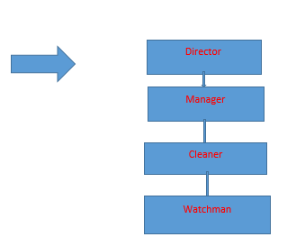
The people in the lower rank are cleaner, and watchman. They will be reporting their issues to the manager then the manager forward the issues to the director. The starting salary for a director will be ksh.19, 200. He will be in control of the other personnel. The manager will be earning ksh.11, 500. He will be assigning duties to the personnel in the lower ranks. Cleaner and watchman will be earning Ksh.4, 500 and Ksh.6000 respectively every month.

PERSONNEL

KEY MANAGEMENT PERSONNEL

Director
The director will be the owner of the business. I will ensure smooth running of the business. I will also ensure that the quality services are offered to customers.

Manager
-He/she will be the overall manager of the business.
-He or She will ensure that the work runs smoothly.

Qualifications
- Must have a minimum of diploma in business management.
- Must have two years’ experience
-Should have leadership skills.

Duties and Responsibilities
-Setting goals of the business.
-Employing and recruiting new employees.
-Assigning duties to the other staff.

Cleaner
He or she will take his or her responsibility to keep the working environment clean for both the staff and the customers.
He or She will also ensure that after working time machines are free from dust and any other unwanted that may cause things around machines like water.

Qualifications
-Must be able to communicate fluently in both English and Kiswahili.
-Must be courageous.

Duties
-Taking care of the business assets

RECRUITMENT, TRAINING AND PROMOTION

Recruitment
The selection of employees at Gaming cyber-shop will be only if the person has met the required qualification which are posted during job advertisement.

Advertisement
Gaming and cyber-shop services will be advertised through banners, posters and media where all new applications will be highlighted.

Short listing
This will be done after the application are over. The shortlisted candidates will be guided the procedure to follow

TRAINING
The business will be organizing seminars and workshops to provide training facilities to various group of workers. The training will be taking a period of 2 months.

Promotion
The firm will be promoting its employees depending on their experience and employ others to fill the gap which has been left after promotion.

SUPPORT SERVICES
- Management advices
This ensures smooth running of the business by finding solution to every problem for the success of the business and benefit to our customers

- Bank services
This help in providing security to the firm’s funds.

GOVERNMENT REGULATIONS
Gaming and cyber-shop will require a license which will enable it to run smoothly

  - License
This will be obtained from Nakuru county government and it will cost Ksh 4500.
b) Insurance
Gaming and cyber cafe will ensure assets from accident and theft and this will be from Monarch insurance company. This will cost Ksh 5500.

CHAPTER FOUR

Operation plan

This explains how the business will carry its operations for the satisfaction of its customer.
This will include various ways like;
- Charging customers fairly.
Providing services which are of better quality.

Production capacity and facility
The business will require the following machines and equipment before it start.

Computers
These will be used to keep all records of the business and of the customers.

Computers system tool box
This will be used in for storing tools and equipment’s that will be used to maintain machines

Blower
This will be used for blowing away dust from computers and other equipment’s. This will ensure safety in equipment’s like keyboards thus making work run smoothly.

Pick up
The vehicle will be used to carry computers and other equipment’s to and from the company.

Production facility
The business facility will include watchman, CCTV cameras, cleaner and manager.

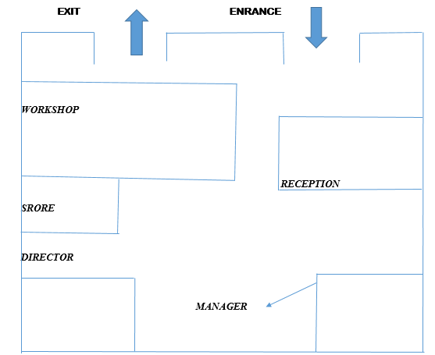

Government Regulation
The ventures will observe health regulation by ensuring the compound is clean for the safety of the workers and the customers.

CHAPTER FIVE

Financial plan
PRE-OPERATIONAL COST
ITEM | COST
Salary | 25,000
License | 1,500
Insurance | 3,000
Transport | 15,000
Electricity | 2,000
Advertising | 4,500
TOTAL | 51,000

WORKING CAPITAL
CURRENT ASSENTS | AMOUNT
Cash in hand | 100,000
Cash at bank | 70,000
Debtors | 50,000
TOTAL | 220,000
CURRENT LIABILITIES | AMOUNT
Creditors | 40,000
Bank loan | 50,000
TOTAL | 80,000
Working capital C.A-CL | 220,000-90,000=130,000

REFERENCE
- U.S Small Business Administration, “Business Plan Template”, accessed 27 December 2021
- Maranjian, Selena (November 1, 2003). ‘”South Park’s’ Investing Lesson”. The Motley Fool. Archived from the original on 2014-01-18. Retrieved 2008-11-10
- State of Louisiana, USA government agency operation plan.

