ALVO GAMING AND CYBER SHOP
P.O BOX 254
WEBUYE
TELRHONE NUMBER:
EMAIL ADDRESS: GAMINGCYBERSHOP@GMAIL.COM
INSTITUTION:
PRESENTER :
INDEX NUMBE:………………………….......
SUPERVISOR NAME:
THIS BUSINESS PLAN IS SUBMITTED TO THE KENYA NATIOL EXAMINATION COUNCIL FOR THE PARTIAL FULFILMENT FOR AWARD OF CRAFT CERTIFICATE IN INFORNMATION COMMUNICATION TECHNOLOGY.

DECLARATION
I Were Alvine declare that this is my initial work and has never been presented to the Kenya National Examination body for the award of certificate in craft certificate in information technology
PRESENTER NAME:

SIGNATURE …………………………………………..

SUPERVISOR’S NAME:

SIGNATURE……………………………………………

DEDICATION
I dedicate this business plan to beloved father Nebart Nauto for the support he has offered to me up to this point. He has been kind and of great help to me.

ACKNOWLEDGEMENT
I thank the Almighty God for the good life which He has given me to this far. My acknowledgement is to your institute name for providing a conducive environment and for their tireless support throughout my studies.
Finally I pass my profound gratitude to my beloved brothers and sisters for their guidance prayers and any support they have given unto me.

EXECUTIVE SUMMARY
The business will be offering printing, scanning, photocopying, games and all services offered to customers within and outside the town.
It is from my research that most of the people within and around the town have been getting challenges more so when their computer equipment develop problems. This is due to lack of qualified technician to offer them the services they need. Gaming and cyber-shop is well equipped with all modern techniques to handle all computer and other related equipment issues to customers’ satisfaction.

Table of Contents
CHAPTER ONE 1
BACKGROUND INFORMATION 1
Background of the business 1
Form of business ownership 1
Business Name 1
Location and address 1
Location 1
JUSTIFICATION OF VENTURES 3
The industry 3
ENTRY GROWTH STATEGIES 3
CHAPTER TWO 4
MARKETING PLAN 4
POTENTIAL CUSTOMERS 4
COMPETITION 4
POTENTIAL COMPETITORS 4
OTHER COMPETITORS 4
COPYING OUT WITH THE TECHNOLOGY 5
PRICING STRATAGES 5
Cost of production 5
Competitor’s price 5
Government policy 5
Transport cost 5
Cost of equipment’s to start the business 5
SALES TACTICS 5
PROMOTION AND ADVERTISEMENT 5
PROMOTION 5
ADVERTISEMENTS 6
Radio 6
Poster 6
Word of mouth 6
CHAPTER THREE 6
ORGANIZATION AND MANAGEMENT PLAN 6
ORGANIZATION STRUCTURE 7
PERSONNEL 7
KEY MANAGEMENT PERSONNEL 7
RECRUITMENT, TRAINING AND PROMOTION 8
SUPPORT SERVICES 9
GOVERNMENT REGULATIONS 9
CHAPTER FOUR 9
Operation plan 9
CHAPTER FIVE 11
Financial plan 11
REFERENCE 11

CHAPTER ONE

BACKGROUND INFORMATION

Background of the business

The owner of this business will be Were Alvine Nauto from Bungoma County, Bungoma East Sub-county, Maraka location and sub-location, pursuing craft certificate in information technology.

Form of business ownership
The business will be a sole proprietorship under the name Gaming and cyber-shop. It will be located at Webuye town along Bungoma Nairobi highway. The business is intended to offer all computer games and cyber services to all customers at an affordable price.

Business Name

The business name will be Gaming and cyber-shop. It will be dealing with equipment’s like gaming, photocopying, scanning, printing and other products. The business will ensure that all services are offered to customers.

Location and address

Location
The business will be located at Webuye town alongside Bungoma Nairobi highway. The reason for locating at this place is that the place has conducive and friendly environment. The area also has many customers from the nearby institutions.
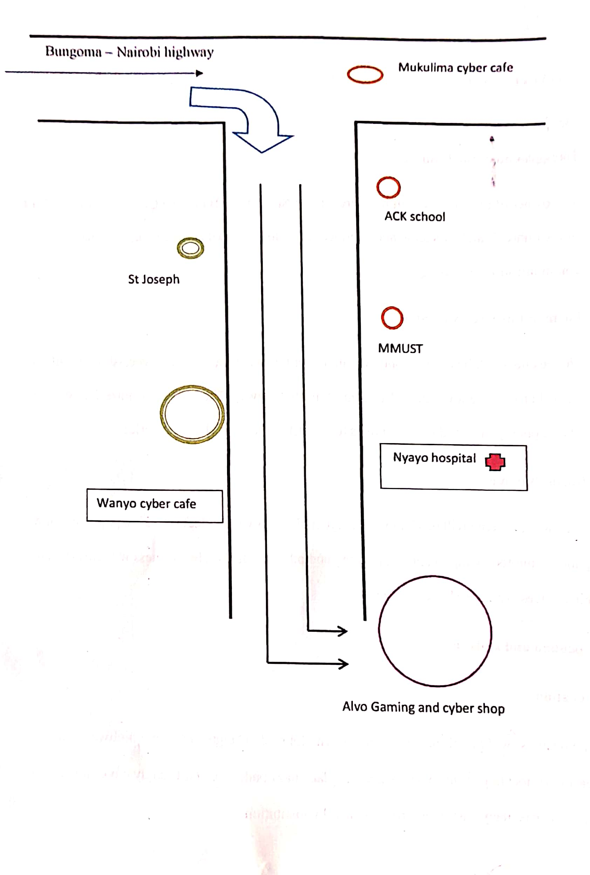BUSINESS ADDRESS
ALVO GAMING AND CYBER SHOP
P.O BOX 254
BUNGOMA
TELEPHONE NUMBER: 0795401213
EMAIL ADDRESS: Gamingcybershop@gmail.com

JUSTIFICATION OF VENTURES

Due to skills and entrepreneurial knowledge gained from Kenyaplex Institute of Technology, I am confident that the business will run smoothly. Gaming and cyber is the easiest type business to operate profitably since it has minimum losses compared to other types of business.

The industry
The business will fall under computer service industry. This is because the services offered include photocopying, scanning and printing and all other related equipment’s for customers in various parts of the country. It will use modern ways to ensure good services are offered to customers. The various ways include user of posters, banners, signboards and use of business websites.

ENTRY GROWTH STATEGIES
The business will start up on 1st July 2026 after acquiring adequate knowledge and skills to run and manage the business. The business will require a basic capital amounting to ksh 100, 000 to start. The money will come from the following sources.

Sources | Capital | Percentage
Personal savings | 50,000 | 50%
Relative and friends | 25,000 | 25%
Loans | 25,000 | 25%
Total | 100,000 | 100%

Since the business is at its initial stage, the entrepreneur will be the manager. The owner will employ staff according to their qualification in order to improve the quality of services offered to the customers. The owner will also purchase modern machine and equipment to make the job easy.

CHAPTER TWO

MARKETING PLAN
The business is located at Webuye town. I target to offer my services to customers in the town and the otherv towns around Bungoma. The marketing department will be headed by the manager who will be running marketing facilities, sales and market research.

POTENTIAL CUSTOMERS
Potential customers of the business will include learning institutions like A.C.K High School, and also Masinde Muliro University. This kind of customers include individuals operating in different types of business within Webuye town and its surrounding. The business will be operating from 7:00am to 10:00am daily since this is the when most of the customers are available. The estimated number of customers will be 100 customer daily.

COMPETITION
Competition is defined as the process of an enterprise or someone trying to win something or to be successful.

POTENTIAL COMPETITORS
My potential competitors will be wanyo cyber cafe. My competitors are 5kilometera away from the town where most of the customers reside. This has made me to have more advantages than my competitors. This is because the customers are supposed to travel in order to reach their business and the transport cost is very high.

OTHER COMPETITORS
Other competitors include Wanyo cyber cafe since and Mukulima cyber cafe are too far from the town.

The table below shows competitors, their strength band their weakness

Competitors | Strength | Weakness
- Gaming and cyber café | - Offer better services  - Skills personnel  - Easy to access  - Offer discount | - Time unconscious
- Mukulima cyber café | - Offer better services  - Have qualified staff | - Difficult to access  - Do not offer discount
- Wanyo cyber café | -Open early  -Have skilled personnel | -Time unconscious  -Difficult to access  -Poor services

COPYING OUT WITH THE TECHNOLOGY
The business will ensure the following measures are followed
- Setting rules and regulations
- Employing skilled staff
- Offering better services
- Locating the business near the town

PRICING STRATAGES
The business will consider the following ways for better management.

Cost of production
The cost of production will be low compare to other competitors in order to attract customers. The business will also be offering discounts to its customers.

Competitor’s price
My prices be lower than that of other competitors for the services offered. I will make sure the business operates under good pricing.

Government policy
The business will make sure that it is operating under the legal conditions set by the government.

Transport cost
The owner will make sure that an appropriate cost is used in transportation of computer equipment’s from the market. Also the business will be offering a good transport to customers.

Cost of equipment’s to start the business
The owner will make sure that the business has enough equipment’s and tools to start.

SALES TACTICS
The business will use different ways to communicate and offer services to its customers.
The business will employ qualified staff. This will help in offering quality services customers hence attracting them. It will also offer discounts to the customers. The business will be motivating its staff from the work they’ve done.

PROMOTION AND ADVERTISEMENT
These include methods that promote my business and create awareness to customers that my business exists

PROMOTION
The business will offer free introducing services to customers. This includes attending the customers for free. It will also be offering discounts the customers to attract them.

ADVERTISEMENTS
The business will use the following means for advertisement

Radio
The business will use radio stations to advertise its services especially radio Citizen and radio Jambo fm.

Poster
The business will use posters to advertise its services. The posters will contain the types of services offered, the price and the location of the business.

Word of mouth
This will include public Barraza’s and seminars.

CHAPTER THREE

ORGANIZATION AND MANAGEMENT PLAN
This chapter of my business plan will contain management plan, management structure, major personal and their duties, recruitment and employment,
The management team of my business will include the following;
- Director

- Manager

- Driver

- Cleaner

- Watchman

ORGANIZATION STRUCTURE
The flow of organization structure is as follows
Director
Manager
Driver

Cleaner
Watchman

The people in the lower rank are driver, cleaner, and watchman. They will be reporting their issues to the manager then the manager forward the issues to the director. The starting salary for a director will be ksh 10,000. He will be in control of the other personnel. The manager will be earning ksh 15,000. He will be assigning duties to the personnel in the lower rank. The driver will be earning ksh 6,000. He will be collecting computer equipment’s which need repair from customers who are far away from the business. Cleaner and watchman will be earning 4,500 every month.

PERSONNEL

KEY MANAGEMENT PERSONNEL
Director
The director will be the owner of the business. I will ensure smooth running of the business. I will also ensure that the quality services are offered to customers.
Manager
He/she will be the overall manager of the business.
Qualifications
- Must have a minimum of diploma in business management.
- Must have two years’ experience
-Should have leadership skills.
Duties and Responsibilities
-Setting goals of the business.
-Employing and recruiting new employees.
-Assigning duties to the other staff.
Driver
Qualifications
-should have a minimum D+ in KCSE.
-Should be above 18 years of age.
-Should have a valid driving license.
-Should have 2 years of experience.
Cleaner
He or she will be his or her responsibility to keep the working environment clean for both the staff and the customers.
Qualifications
-Must be able to communicate fluently in both English and Kiswahili.
-Must be courageous.
Duties
-Taking care of the business assets

RECRUITMENT, TRAINING AND PROMOTION
Recruitment
The selection of employees at Gaming cyber-shop will be only if the person has met the required qualification which are posted during job advertisement.
Advertisement
Gaming and cyber-shop services will be advertised through banners, posters and media where all new applications will be highlighted.
Short listing
This will be done after the application are over. The shortlisted candidates will be guided the procedure to follow
TRAINING
The business will be organizing seminars and workshops to provide training facilities to various group of workers. The training will be taking a period of 2 months.
Promotion
The firm will be promoting its employees depending on their experience and employ others to fill the gap which has been left after promotion.

SUPPORT SERVICES
- Management advices
This ensures smooth running of the business by finging solution to every problem for the success of the business and benefit to our customers

- Bank services
This help in providing security to the firm’s funds.

GOVERNMENT REGULATIONS
Gaming and cyber-shop will require a license which will enable it to run smoothly
(a)License
This will be obtained from Bungoma county government and it will cost Ksh 2500.
b) Insurance
Gaming and cyber-shop will ensure assets from accident and theft and this will be from Monarch insurance company. This will cost Ksh 4000.

CHAPTER FOUR

Operation plan

This explains how the business will carry its operations for the satisfaction of its customer.
This will include various ways like;
- Charging customers fairly.
Providing services which are of better quality.
Production capacity and facility
The business will require the following machines and equipment before it start.
Computers
These will be used to keep all records of the business and of the customers.
Computers system tool box
This will be used in cyber computer equipment’s.
Blower
This will be used for blowing away dust from computers and other equipment’s.
Pick up
The vehicle will be used to carry computers and other equipment’s to and from the company.
Production facility
The business facility will include watchman, CCTV cameras, driver, cleaner and manager.

Exit Entrance
Watchman
CCTV camera
Store
Service area
Manager

CC TV camera
Cleaner
Director
Driver

Government Regulation
The ventures will observe health regulation by ensuring the compound is clean for the safety of the workers and the customers.

CHAPTER FIVE

Financial plan
PRE-OPERATIONAL COST
ITEM | COST
Salary | 25,000
License | 1,500
Insurance | 3,000
Transport | 15,000
Electricity | 2,000
Advertising | 4,500
TOTAL | 51,000

WORKING CAPITAL
CURRENT ASSENTS | AMOUNT
Cash in hand | 100,000
Cash at bank | 70,000
Debtors | 50,000
TOTAL | 220,000
CURRENT LIABILITIES | AMOUNT
Creditors | 40,000
Bank loan | 50,000
TOTAL | 80,000
Working capital C.A-CL | 220,000-90,000=130,000

REFERENCE
- U.S Small Business Administration, “Business Plan Template”, accessed 27 December 2021
- Maranjian, Selena (November 1, 2003). ‘”South Park’s’ Investing Lesson”. The Motley Fool. Archived from the original on 2014-01-18. Retrieved 2008-11-10
- State of Louisiana, USA government agency operation plan.

