Institute logo

HOSPITAL MANAGEMENT SYSTEM
AUTHENTICATION
BY
Your name
SUPERVISED
BY
Supervisor name

This Report Presented to the Kenya National Examination Council for the fulfillment of requirement for Craft Certificate in Information Technology.

DECLARATION
I Celestine Awuor declare that this proposal project is my original work and has never been presented to Kenya National Examination Council [KNEC] or any examination body for the award of Craft Certificate in Information Technology.

PRESENTER NAME:
SIGNATURE…………………………………

SUPERVISOR NAME:
SIGNATURE…………………………....

ACKOWLEDGEMENT
I would first thank the Almighty God for the gift of life he has given me to date.
My acknowledgement to institute name for providing conducive and friendly environment for my studies and materials for the project much thanks.
I also offer special thanks to my project supervisor Mr. STEPHEN MBITHI for the help and support throughout this project. Lastly my gratitude to my beloved Father, mother and siblings for their motivation, prayers and support they have offered so far.

EXECUTIVE SUMMARY
Hospital Management System provides the benefits of streamlined operation, enhanced control of patient care, cost control and profitability. HMS is flexible and easy to use.
The project ‘Hospital Management System’ is based on database. As there are many areas where we keep records, database which we are using are Microsoft Access software which is one of the best and the easiest software to keep our information.
Hospital Management is built to meet the specific requirement of the mid and large size hospitals across the globe. The sound database of the application makes it more users friendly.
It covers all required modules right from patients, Doctors, Laboratory details, Inpatient, Outpatient, Room and Bill payment details etc.
The significant part of the operation of any hospital involves the acquisition, management and timely retrieval of great volumes of information. This information typically involves; patients personal information and medical history, staff information, room and ward scheduling etc. The project aims at standardizing, consolidating and ensuring data integrity since use of manual system for management and maintenance of critical information requires numerous paper forms and often information is incomplete or may be lost. Manual is also time consuming and inefficient.

Definition of terms
KNEC – THE KENYA NATIONAL EXAMINATION COUNCIL
HMS –HOSPITAL MANAGEMENT SYSTEM
SDLC – SOFTWARE DEVELOPMENT LIFE CYCLE
RDBMS – RELATIONAL DATABASE MANAGEMENT SYSTEM
ERD- ENTITY RELATIONSHIP DIAGRAM

TABLE OF CONTENTS
DECLARATION ii
ACKOWLEDGEMENT iii
EXECUTIVE SUMMARY iv
Definition of terms v
TABLE OF CONTENTS vi
CHAPTER ONE 1
1.0 BACKGROUND INFORMATION OF THE STUDY 1
1.1 Problem statement 1
1.2 Objective 2
1.2.1 Specific objective 2
1.2.2 Research Questions 3
1.3 Significance of the study 3
1.4 Scope 3
CHAPTER TWO 4
2.1 LITERATURE REVIEW 4
2.2 Discussion of existing design 4
2.3 Proposed system 4
2.4 Objective of the system 5
2.5 Research gaps 5
2.6 Summery 6
CHAPTER THREE 7
3.1 METHODOLOGY 7
3.2 Introduction 7
3.2.1 Methodology 7
3.3 Waterfall model 7
3.3.1 Requirement and gathering 8
3.3.2 System analysis 8
3.3.3 System design 9
3.3.4 System coding and testing 9
3.3.5 System implementation 9
3.3.6 System security 9
3.3.7 Advantages of waterfall model 9
3.3.8 Disadvantages of waterfall model 10
3.4 Methods of data collection 10
3.4.1 Advantages of data collection 10
3.4.2 Disadvantages of data collection 10
CHAPTER FOUR 11
4.1 ANALYSIS, CONCLUSION AND RECOMENDATION 11
4.2 ERD DIAGRAM of Hospital Management System 12
4.3 Evidence of data analysis using tables, forms and reports 12
.4.3.1 Tables 13
4.3.2 Query 13
4.3.3 Forms 14
4.3.4 Report 15
4.4 Conclusion 16
4.5 Recommendations 17
5.1 References 18
5.2 Appendices 19

CHAPTER ONE

1.0 BACKGROUND INFORMATION OF THE STUDY
Computer is fast emerging as a daily need in today’s life. The knowledge of computer and programming language has become basic. Every hospitals, businesses and institutions make use of computer for making their operation structured and constructive.
Since human body is a very complex and sophiscated structure and comprises of millions of functions. All these functions have been understood part by part. As of today the health sector comprises of medical institutions i.e. Hospitals, research and development institutions and medical colleges, thus the health sector aims at providing the best medical facilities to common man.

1.1 Problem statement
The manual handling of records is time consuming and highly prone to errors. The reason of this project is to simplify or make the process of day-to-day activities like Room activities, laboratory details, patient and doctors details, hospital bill charges etc. I have tried to make the complicated process hospital management system as simple as possible using structured and easy to use interface and thus any user may not have any difficulty in using the system.
The main reason of my project is to perform each hospital’s activities in computerized way rather than manually which is time consuming and costly.

1.2 Objective
Hospital is essential part of our lives, providing best medical facilities to people suffering from various disorders which may be due to stress, work load, climate conditions etc. It is necessary for the hospitals to keep track of its day-to-day activities and records of its patients, doctors, rooms, and other staffs that keep the hospital running smoothly.
But keeping track of all activities mentioned on a paper is very time consuming, error prone, inefficient and cumbersome. Considering the increase in population and number of people visiting the hospital maintaining all records is highly unreliable and inefficient. It is also not technically feasible to maintain such records on paper.
The main aim of our project is to provide a paper-less hospital up to 99%. It also aims at providing low-cost reliable automation of existing system. The system also provides excellent security of data at every level of user system interaction and also provides robust and reliable storage and backup facilities.

1.2.1 Specific objective
- Develop a database which is user friendly interface which will give a clear record of the number of patients treated by a particular doctor.
- Allow a database which that would store every field records
- It will be able to generate clear information on bill charges or how much generated per day or per month
- It will generate report timely.

1.2.2 Research Questions
1. Will the database develop a user friendly which will give a clear record of the number of patients treated by a particular doctor?
2. Will the database be able to store every field records?
3. Will the database be able to generate clear information on bill charges or how much generated per day or per month?
- Be able to generate reports timely

1.3 Significance of the study
The database contains various types of subjects with quality information according to patients and doctors needs and requirements. The main aim of hospital management system is to maintain its records daily since the current hospital management used has been very time consuming and difficult in maintaining good records and fast service.
The database system also has high chances of error calculation when it comes to bill charges for a day or month. Generally the proposed software aim is to save time when checking records of patients, doctors, rooms, bill charges, laboratory information etc. The software will also be able to easily record or maintain the daily records as well as their detailed information. Lastly it is also user friendly software which is more reliable for keeping information and provides security.

1.4 Scope
The proposed database product is the hospital management system (HMS). The database will be used in any hospital and dispensaries. To get information from patients and then storing the data for future use the intention of the database system is to reduce over-time pay and increase the number of patients that can be treated accurately. Requirements statements in these documents are both functional and non-functional.

CHAPTER TWO

2.1 LITERATURE REVIEW

2.2 Discussion of existing design
Hospital currently uses a manual system for the management and maintenance of critical information. The current system requires numerous paper forms, with data stores spread throughout the hospital management infrastructure. Often information (on forms) is incomplete or does not follow management standards. Forms are often lost in transit between departments requiring a comprehensive auditing process to ensure that no vital information is lost. Multiple copies of the same information exist in various data stores.

2.3 Proposed system
The Hospital Management System (HMS) is designed for any hospital to replace their existing manual, paper based system. The new system is to control the following information, patient information, room availabilities, staff and operating room schedules and patient details.
These services are to be provided in an efficient, cost effective manner with the goal of reducing the time and resources currently required for such tasks.

2.4 Objective of the system
Hospital currently uses a manual system for the management and management and maintenance of critical information. The current system requires numerous paper forms, with data stores spread throughout the hospital the hospital management system. Often information (on forms) is incomplete or does not follow management standard forms are often lost in transit between departments requiring a comprehensive auditing process to ensure that no vital information is lost. Multiple copies of the same copies of the same information exist in the hospital and may lead to inconsistencies in data in various data stores.
A significant part of the operation of any hospital involves the acquisition management and timely retrieval management and timely retrieval of great volumes of information. This information typically involves; patient personal information, medical history, staff information, room and ward management history, staff information, room and ward scheduling, staff scheduling etc. All this information must be managed in an efficient and cost wise fashion so that institution resources may be effectively utilized HMS. The system will automate the management of hospital making it more efficient and error free.

2.5 Research gaps
The purpose of the study is to identify the problem inhibiting the hospital growth and recommend practical solutions and analyzing the existing problems. The software is developed to maintain records of patient, doctors, room and laboratory.
The implementation of the management system into an organization pursues various objectives according to motive of the management.

2.6 Summery
The study overcame the shortcoming of existing undetailed laboratory information and provide efficient and detailed one.
The paper work was replaced with database which can keep all records and activities within the hospital, also the insecurity in the manual system was also done with and computer were used to enter data.

CHAPTER THREE

3.1 METHODOLOGY

3.2 Introduction
This chapter covers system development methods that are used for research project with waterfall model are being the earliest SDLC approach that was used for software development. It covers feasibility study, methods of data collection data design that was used in the research project the logical and physical design methods that will be used and their reports.

3.2.1 Methodology
The proposed system aims to solve matters and ease the staff as well as the customers and it also can save more time. The waterfall model method of software development in which the progress flows from the top to the bottom. It entails the system planning, requirement, analysis, system design, system analysis and many more. It will also use the prototyping method which will be built, tested and reworked on necessary until an accepted outcome.

3.3 Waterfall model
The waterfall methodology uses a sequential or linear approach to software development. The project is broken down into sequence of task. Before the start of every stop there is review and this makes waterfall model best method. Testing is done in each phase whereby waterfall model into phases. There are certain activities which are carried in this model which included gathering requirement analysis, design, coding and testing, implementation, maintenance and security.

Requirement gathering
System analysis
System design
fhjddsxd System coding and testing
mmmnn System Implementation iinmbcfgfghjjImplementation
nmmnS System Security

3.3.1 Requirement and gathering
This involves gathering needs of a system and understanding them, determines whether it makes sense to launch an investigation at all.

3.3.2 System analysis
This is where the collected facts are interpreted, problem identified and the system decomposed into its components.

3.3.3 System design
The system design phase is to create a physical model or structure that satisfies all documented requirement.

3.3.4 System coding and testing
Coding of data refers to process of transforming collected information of observation to set of meaningful categories. After the design we identify the essence of the project and then code it accordingly.

3.3.5 System implementation
In the system implementation, the new system is constructed, programs are written, tested and documented and the system installed.

3.3.6 System security
In this phase the staff will maintain, enhance, and protect the system. The maintenance changes and correct errors and adapt to changes in the environment that is new tax rates.

3.3.7 Advantages of waterfall model
- It is easy to understand and use
- Results are well documented
- For smaller project, the waterfall model works well and yield the appropriate results
- Since the phases are rigid and precise, one phase is done at a time, it is easy to maintain.
- The entry and exit criteria are well defined, so it’s easy and systematic to proceed.

3.3.8 Disadvantages of waterfall model
- High amount of risk and uncertainty
- Not good model for complex and object-oriented project
- Poor model for long ongoing projects

3.4 Methods of data collection
- Survey
- Observation
- Online tracking
- Forms etc.

3.4.1 Advantages of data collection
- Allows you to be selective
- Access to accurate feedback
- Maximum reach with minimum effort
- Increased customer satisfaction

3.4.2 Disadvantages of data collection
- High chances of survey fraud
- Sampling issues
- Response bias
- Survey fatigue
- Increase in Errors

CHAPTER FOUR

4.1 ANALYSIS, CONCLUSION AND RECOMENDATION
4.2 Database Design
The term database design can be used to describe many different part of the design of an overall database system; the term database design could also be used to apply to the overall process of designing, not just the database structure but also the forms and queries as part of the overall database application within the database management system.
The system will use Microsoft access. It is a database program and its very popular (RDBMS) software. We can use access database to solve almost information when purpose of application is to allow voluminous data to be stored in the computer and permit requires to be made to find needed data with the little effort. The Hospital Management system will be able to access data through the Microsoft access which is able to access data through the Microsoft access which allows large amounts of data to be stored in the computer.
Access is powerful database and is for ease with you can use it and relationship can be built between tables containing different field to pull reports together. Our primary tools contained in access database window tabs contained in current database which has tables containing different fields to pull reports together, it also has tables, forms, repots etc.

4.2 ERD DIAGRAM of Hospital Management System
An entity-relationship (ERD) is an abstract and conceptual representation of data. Entity relationship modeling is a database modeling method, used to produce a type of conceptual schema or semantic data model of a system, often a relational database, and its requirements in a top-down fashion.
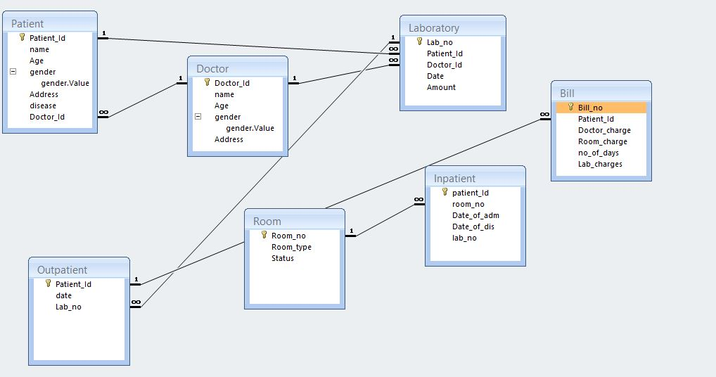

4.3 Evidence of data analysis using tables, forms and reports

.4.3.1 Tables
It’s an object you define and use to store data. Each table contain information about
a particular subject such as Doctor, patient, Laboratories, inpatient etc.
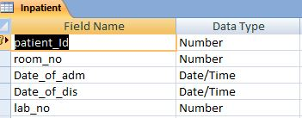
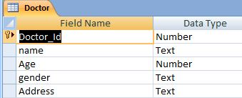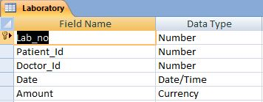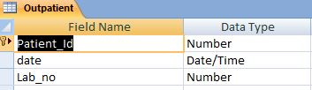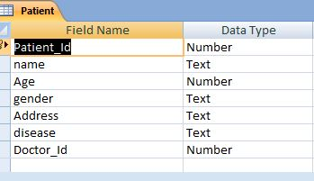

4.3.2 Query
Query is an object that provides a customer view of data from one or more tables. In access you can write sql statement to create your queries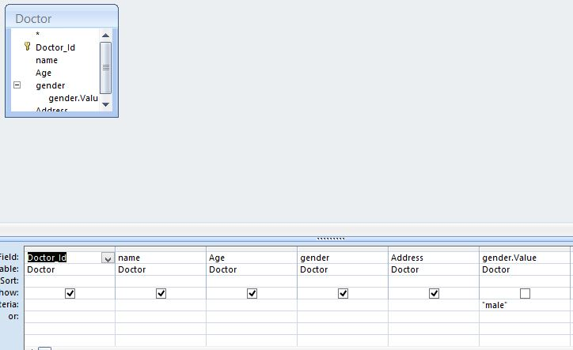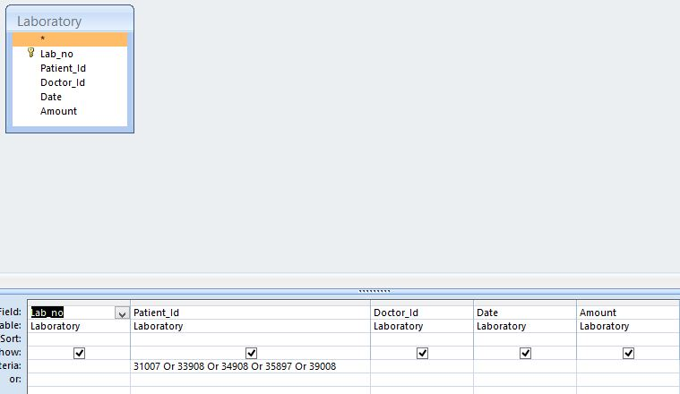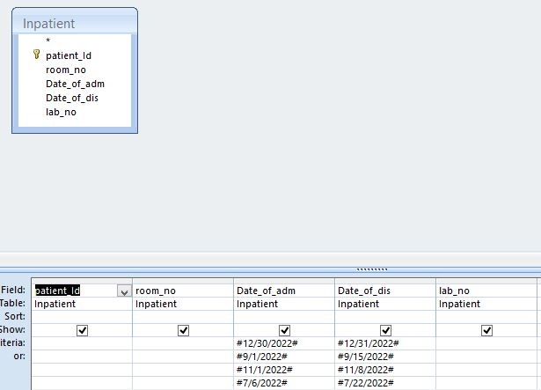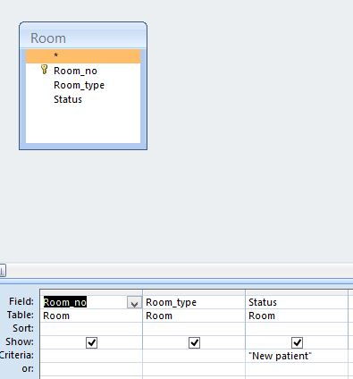

4.3.3 Forms
It’s an object that defines primarily for data input or display or for control of application. You use forms to customize the presentation of data that your application extracts queries or tables.
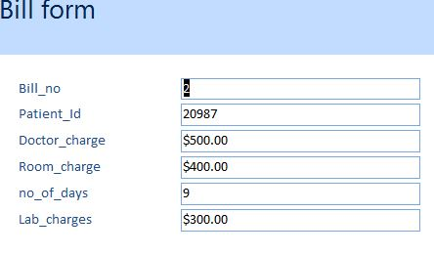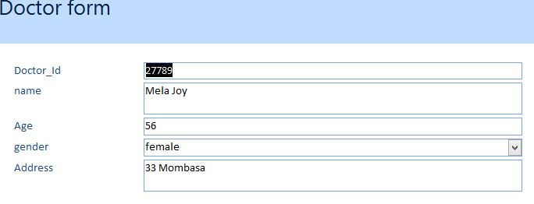
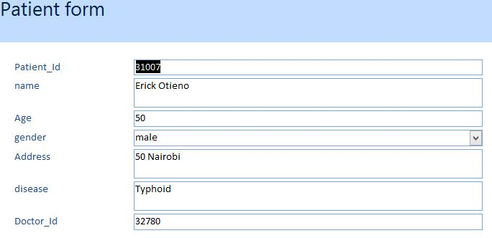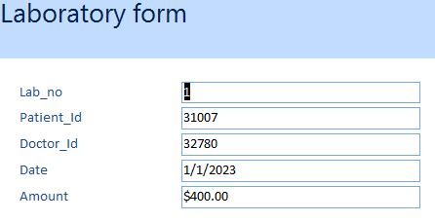

4.3.4 Report
It is an object designed for formatting, printing and summarizing selected data. You can view a report on your screen before you print it.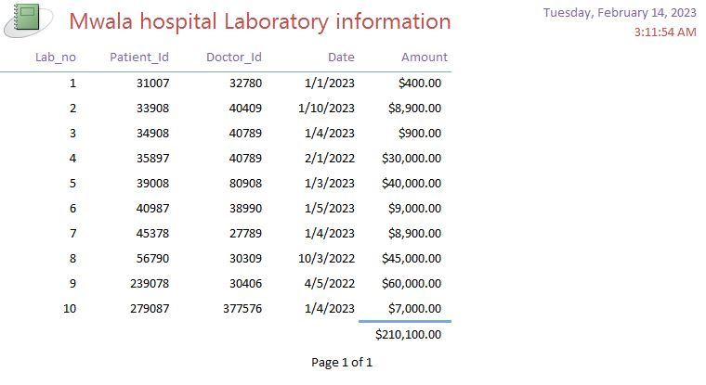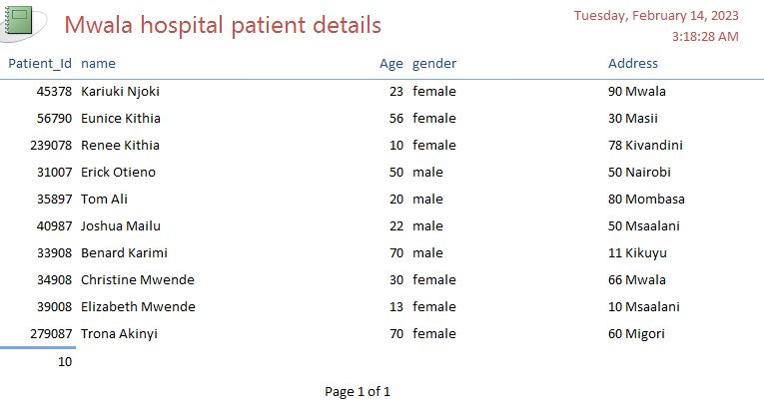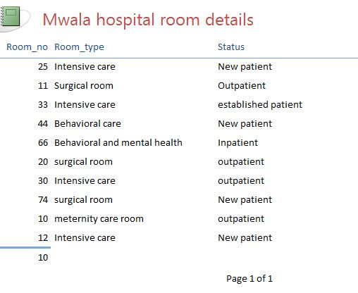

4.4 Conclusion
The system was designed in such a way that future modification can be done easily. The
Following can be deduced from the developed of project.
- The system has adequate scope for modification in future if it is necessary
- The system security, data security and reliability are the striking future
- Updating of information becomes so easier
- It is effectively overcomes the delay in communication
- Automation of the entire system improves the efficiency
- It provides a friendly graphical user interface which proves to be better when compared to existing system.
- Automation of the entire system improves efficiency.

4.5 Recommendations
This application avoids the manual work and the problems concern with it. It is an easy way to obtain the information regarding the various travel services that are present in our system.
I have worked in order to present an improved system better than the existing one regarding the information about various activities.
The next enhancement is, we will develop online service that mean, if patient have any problem he can send his problem to a doctor through internet from his home then doctor will send reply to him/her. In this patients have some login name and password.

5.1 References
Deepak Thomas “Beginning PHP 4 Database”, Wrox press ltd. Paperback 17 October, 2002, 70.
HTML & CSS http; //www.w3schools.com, last accessed
Bootstrap http: //getbootstrap.com/,last accessed
Google Maps, (2015, February).The British Library, London UK
Heimans R (1996.Gloves off (Tom Uren)[Oil Paint on canvas]Canberra. National Portrait Gallery
Kessel M. (Director (1995). The making of monologue: Robert Wilsons Hamlet

5.2 Appendices

