TRADE PROJECT
PROJECT TITLE: BRAKE AND SUSPENSION SYSTEM INSTALLATION DESIGN
PRESENTER:.
INDEX NUMBER :
INSTITUTE:
SUPERVISOR:
DEPARTMENT: AUTOMOTIVE ENGINEERING
PRESENTED TO KENYA NATION EXAMINATION COUNCIL FOR PARTIAL OF THE AWARD OF ARTISAN CERTIFICATE IN AUTOMOTIVE ENGINEERING.

SERIES: JULY 2024

DECLARATION
I hear by to clear that this project is my original work. I also confirm that it has not been presented to this institution or any other college for academic purposes or any other purpose.
NAME; …………………………………………………………………………
SIGNATURE; ……………………………………………………………………….
DATE; ……………………………………………………………………………….

DECLARATION BY SUPERVISOR;
SUPERVISOR; ………………………………………………………………………
SIGNATURE; ……………………………………………………………………….
DATE; ……………………………………………………………………………….

DEDICATION
I dedicate this project to my dear family who has been there for me but all times. They have put me to make sure that I complete my academic and able my supervisors who has guide through my artisan in automotive engineering.

ACKNOWLEDGEMENT
I thank God for giving mew life and good health. I would also like to acknowledge my supervisor for guidance through the process of preparing the project
Secondly I thank my parents for enabling and facilitating my study in artisan level in automotive engineering at institute name.

EXECUTIVE SUMMERY
The automotive industry is continuously involving for safety of the people and the performance. The most basic of the evolution is the braking system and suspension system. The brake system is important component of vehicle safety the project aims of elevating braking performance and suspension system to achieve optimal passenger comfort our project aim as exploration or the suspension and braking technology. The automotive industry approach to braking and suspension system research has been done to achieve now standard for safety, performance and comfort for vehicle design to come. Our project aims to investigate braking and suspension system to enhance the safety and comfort or vehicle while prioritizing driver and passenger.

INTRODUCTION TO BRAKING AND SUSPENSION SYSTEM INSTALLATION
It is designed to convert the vehicle kinetic energy. It contains several parts include pads, brake rotors, calipers and brake fluid. When driver hits brake, the brake pads apply pressure to the brake rotors causing friction.

TOOLS USED IN THE INSTALLATION OF BRAKE SYSTEM
- Caliper piston tool
- Screw driver
- Groves
- Brake bleed wrench
- Brake line wrench
- Brake rotors
- Tool box
- Wheel spanner

PROCEDURE OF REMOVING AND INSTALLATION OF BRAKE SYSTEM
Remove the wheel on a level surface, loosen the lug nuts without removing them and jack your car up. Unbolt and remove the caliper, loosen the caliper bolts and the caliper bleeder screw. Remove the old brake pads you can now see the old brake pads. Clean your brakes.
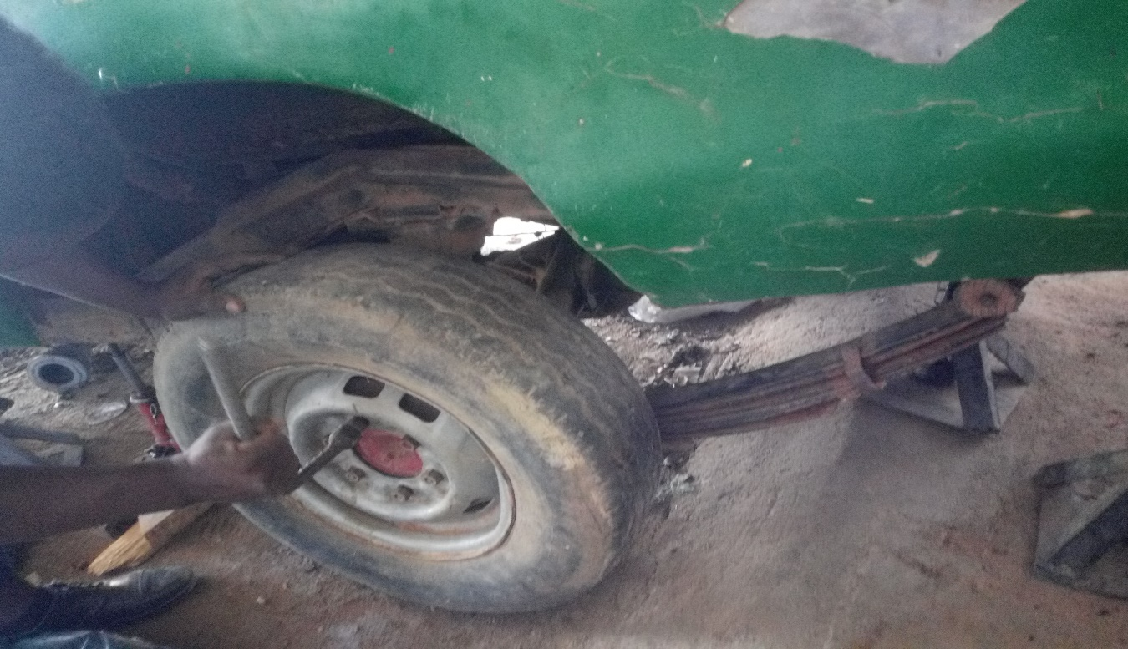
PROCEDURE OF REPLACING BRAKE SYSTEM
- Raising the vehicle
- Unscrew the wheel
- Remove the wheel
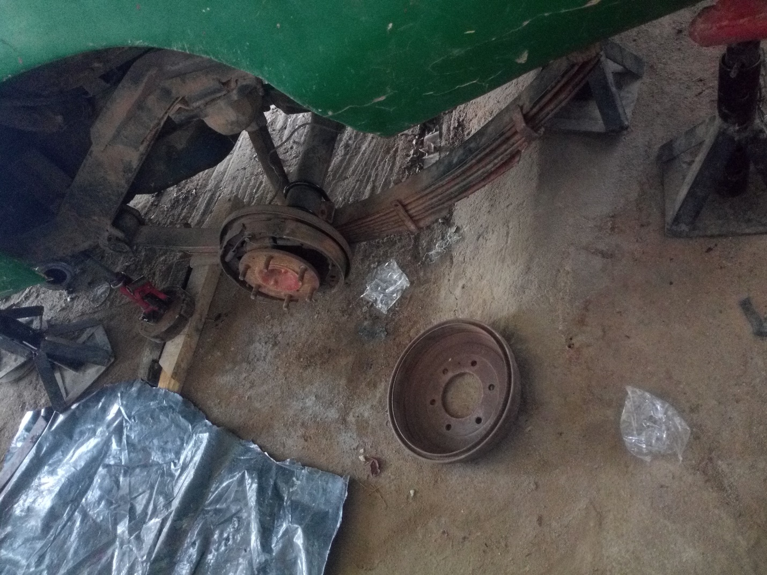
TYPES OF BRAKING SYSTEM
- Drum brake system.
- Disc brake system
- Hydraulic brake
- Electromagnetic brake
DISC BRAKE
Disc brake is a mechanism for slowing or stopping the rotation of a wheel from its motion. To stop the wheel friction material in the form of brake pads is forced against both sides of the disc.
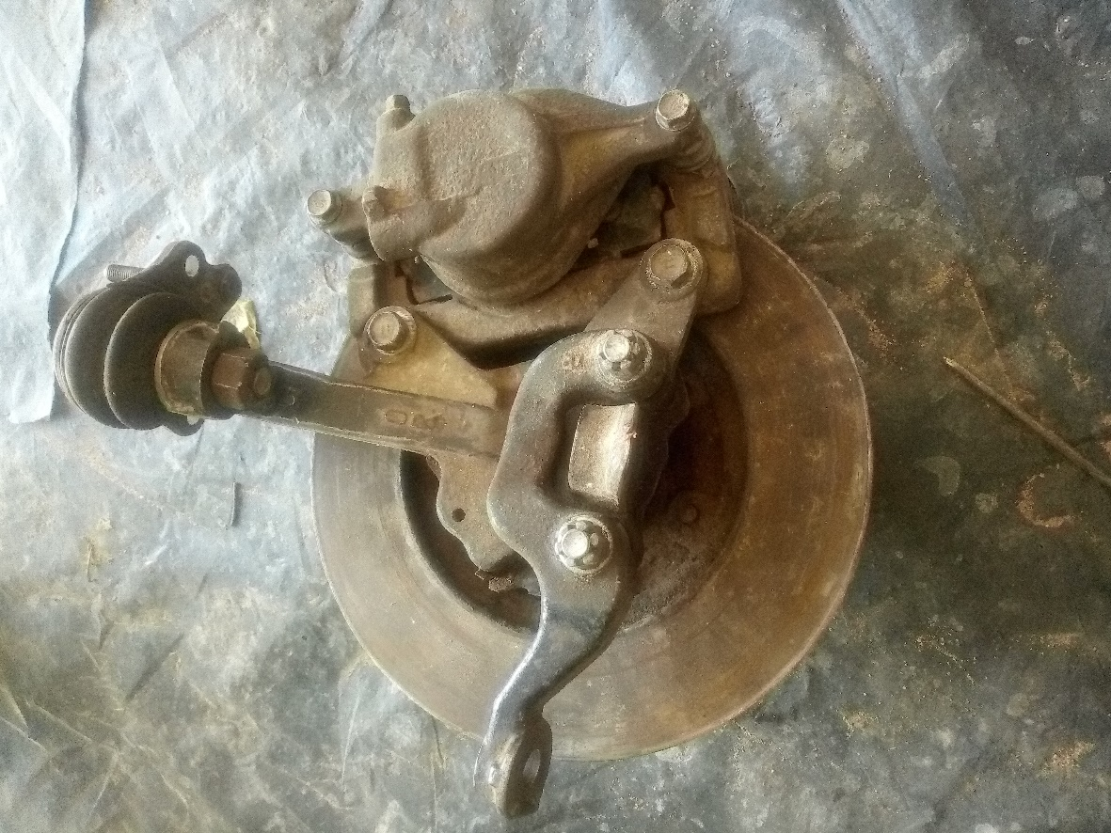
ADVANTAGE OF DISC BRAKE
- More effective at stopping a vehicle quickly. Quicker response time
- Light weigh design
- Easier maintenance and inspection
DISADVANTAGE OF DISC BRAKE
- More difficult to maintain
DRUM BRAKE
Drum brake is a traditional brake in which the friction is caused by a set of shoes or pads that press against a rotating drum shaped part
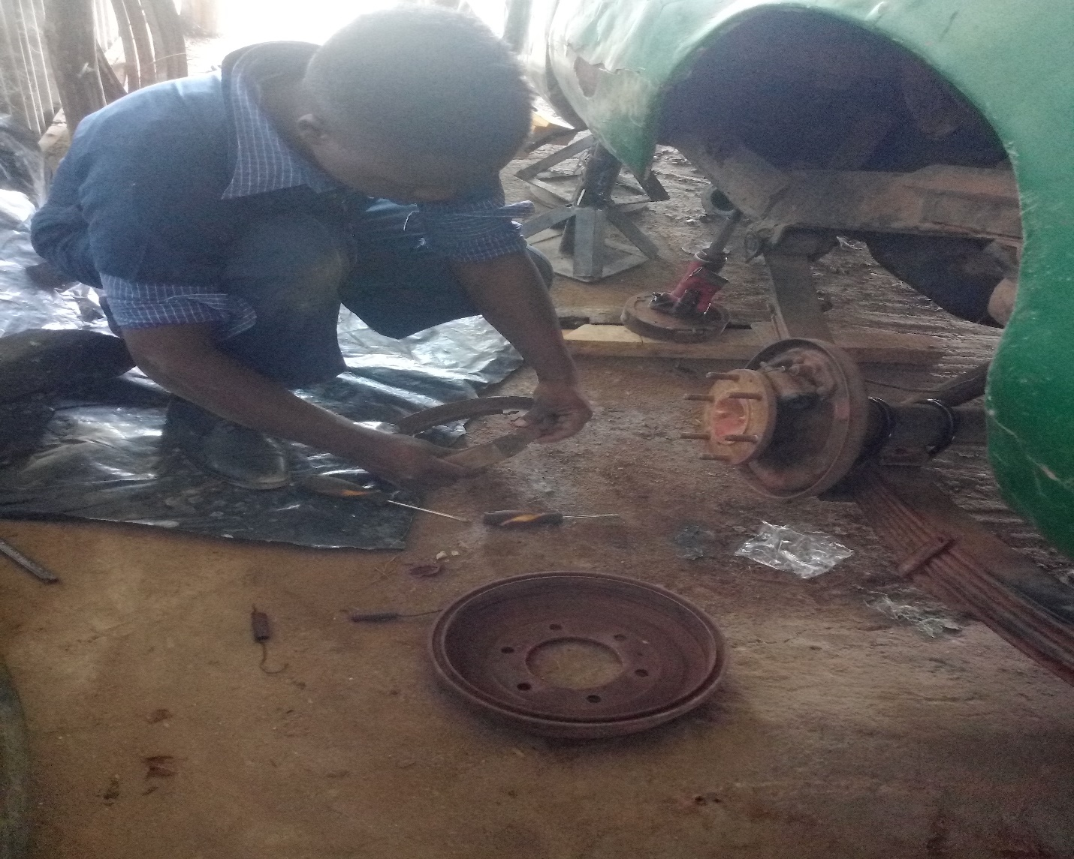
ADVANTAGES OF DRUM BRAKE
- It can provide more braking force than disc brake
- They have a large friction contact surface
- Their costs are comparatively lower
- They generate less heat
REASON FOR BLEEDING THE BRAKE SYSTEM
Is to ensure all air bubble are removed. If brakes are not bled and air bubbles are trapped within the brake fluid, hydraulic pressure is greatly reduced, marking the brakes less efficient. Which causes the vehicle stop have poor brakes and could cause accidents
PROCEDURE FOR BLEEDING BRAKE SYSTEM
- Get the right brake fluid
- Mouth the car
- Loosen the bleeder screw
- Check the brake fluid level
- Cover the screw opening with tubing
- Get an assistance to engage the brake pedal
- Repeat on each brake
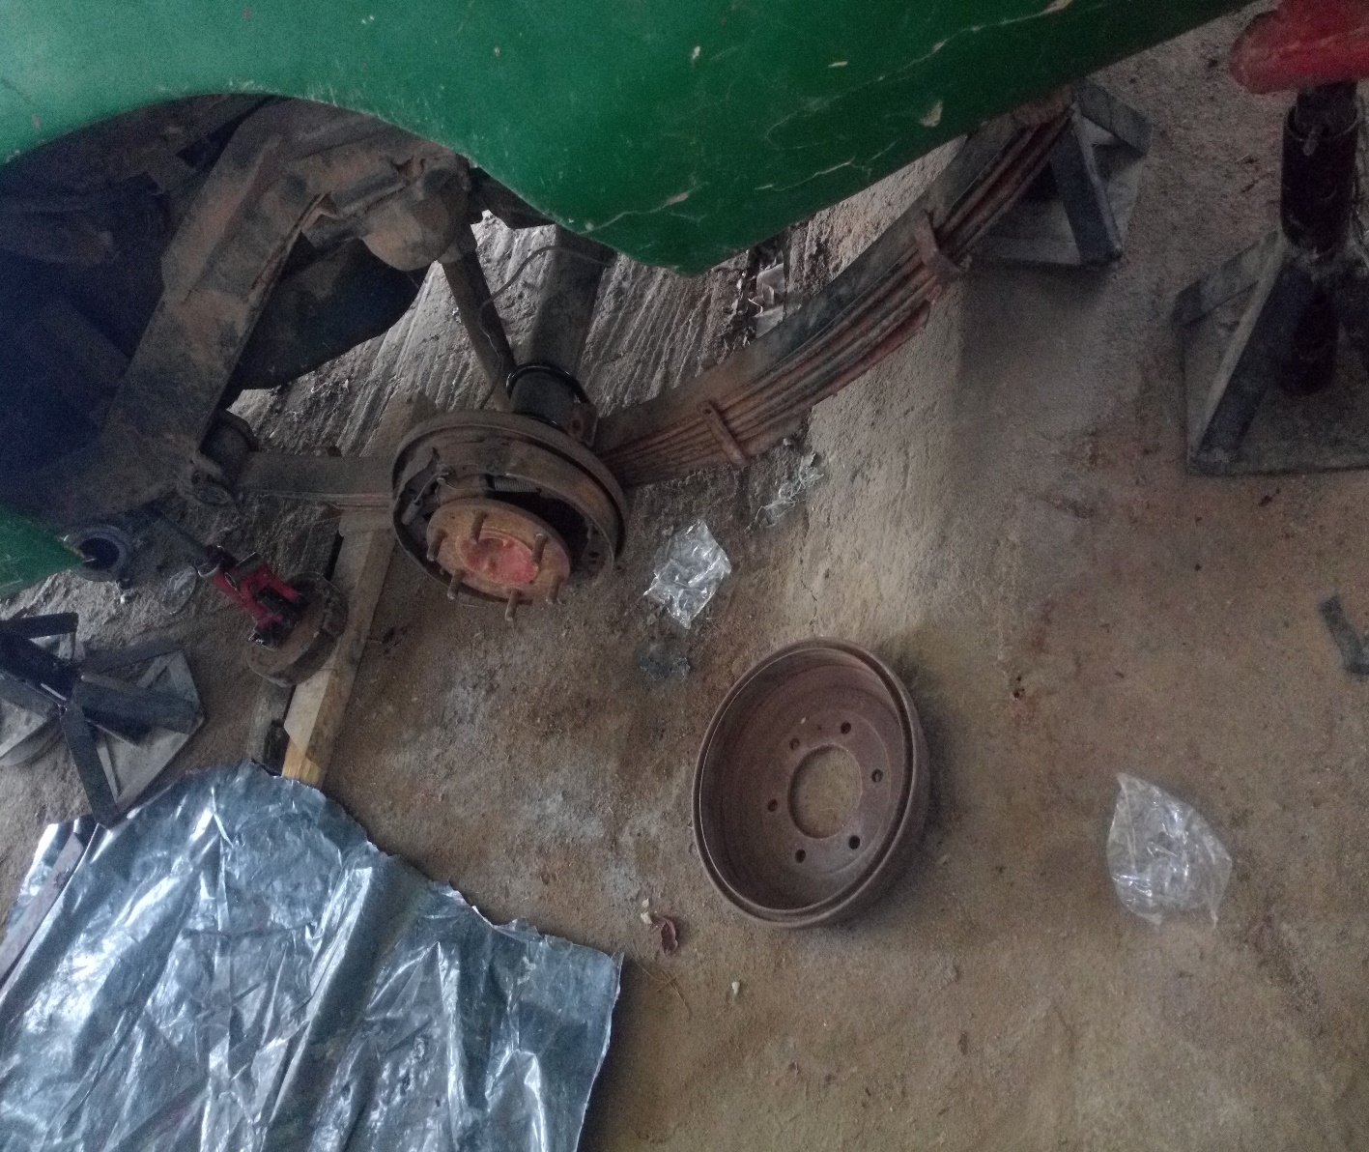
TOOLS USED FOR BLEEDING BRAKE SYSTEM
Box end wrench suitable for your car bleeder
Screw
12-inch-long section of clear plastic tubing Disposable bottle for waste fluid
PROCEDURE FOR CHANGING BRAKE PADS
- GATHER TOOLS AND MATERIAL
Make sure you have your tool and new brake pads handily.
Many calipers require a torn to remove the caliper bolts
Make sure that you have a correct tool before beginning the job
- REMOVE THE WHEEL
Start by loosening the lug nuts on one of your front sizes
Check the car up
Slide a jack stand and the frame to support the vehicle
Loosen the nut fully
Remove the lug nuts
Take the tire off
- TAKE OUT THE SLIDER BOLTS, THEN LIFT THE CALIPER
- You should see two bolt that are working to hold the caliper in place.
- You can remove the caliper completely.
- REMOVE THE OLD PADS, CLIPS
Slide the old brake pads out and then remove the abutment hardware
The new abutment should easily snap into place in the same sport where you removed
- ADDRESS THE PISTON
- You need to squeeze the piston back into the caliper
- Many vehicles have just one piston caliper but if caliper have two it’s important to push both back at once
- It is important to apply pressure and be patient as the piston tend to retract slowly

- KEEP AN EYE ON YOUR BRAKE FLUID

- You will want to keep watch on the brake fluid reservoir
- Remove some fluid if levels look, they might get too high
- INSTALL YOUR NEW BRAKE PADS
- The amount of disc should be applied between the pads and abutment hardware
- The pads can now be installed into the caliper.

- SLIDE THE CALIPER BACK INTO PLACE, PUT THE WHEEL BACK ON
- Once the brake pads are installed in the caliper, the caliper can be replaced in its normal position on the vehicle
- Replace the slider bolt
- will conclude the changing of the brake pads by putting You the wheel back onto the vehicle.

CONCLUSION
Brakes need to be change depending on different factors such as the type of vehicle the driving habit. The best way to tell if a vehicle is in need of a new brake system is by listening to what your vehicle is telling you. if you begin to notice a griding sound on your brakes when you press the brake padel its important you replace them with new once

INTRODUCTION TO SUSPENSION SYSTEM
Is the system of tires. Tire air, springs, shocker observer’s and linkages that connects a vehicle to its wheel and allows relative motion between the two-suspension system.
PROCEDURE OF REPLACING A SUSPENSION SYSTEM
- Loosen the nuts of the wheel
- You will need to jack up the vehicle
- Remove the wheels
- Disconnect the tire rod and ball joint from the steering knuckle
- Remove the sock and springs
- Install your new suspension system component in reverse order
- Make sure to use all necessary safety precaution when working on your car

TYPES OF SUSPENSION SYSTEM
Independent suspension system
- Dependent suspension system
- Leaf spring suspension system

- Damper suspension system
- Coil suspension system
- INDEPENDENT SUSPENSION SYSTEM
It allows each wheel on the same axle to move independently of the others.
ADVANTAGES OF INDEPENDENT SUSPENSION SYSTEM
- Better ride quality
DISADVANTAGES OF INDEPENDENT SUSPENSION SYSTEM
It is elevated expenses
- DUMPER SUSPENSION SYSTEM
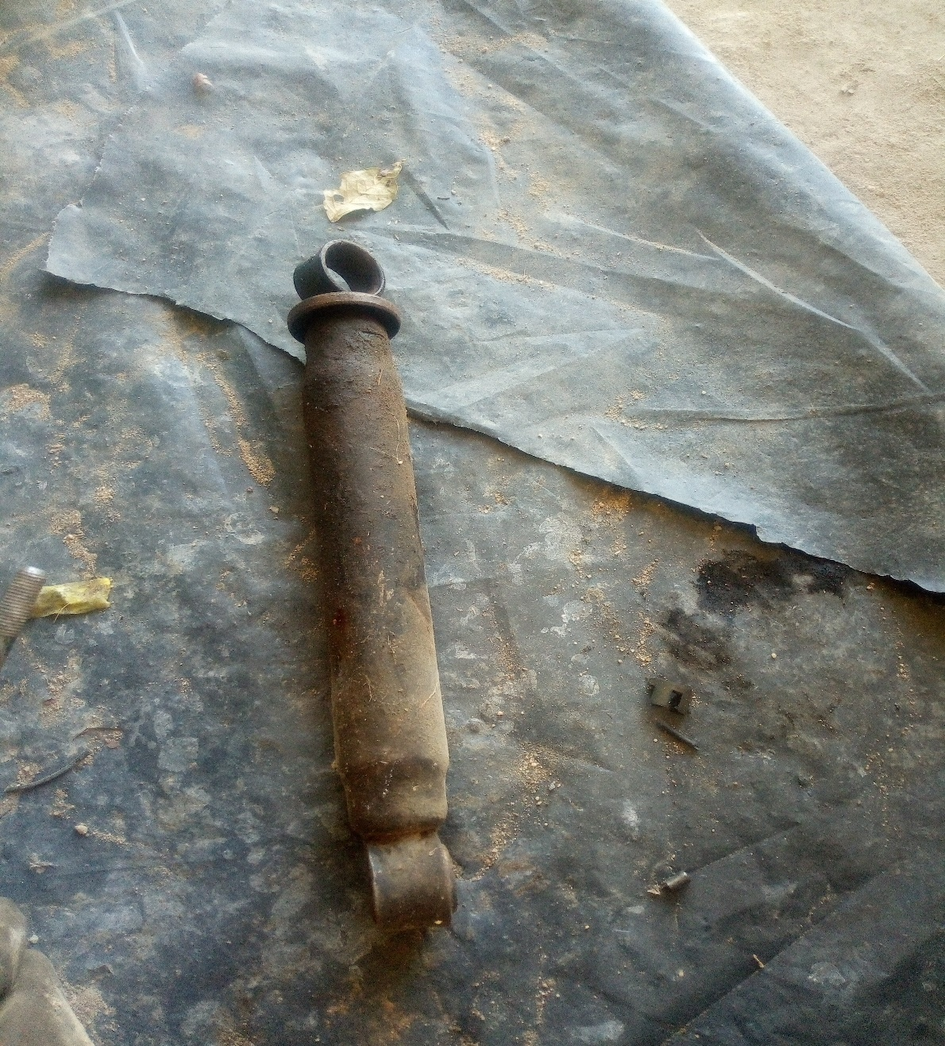
ADVANTAGES OF DUMPER SUSPENSION SYSTEM
- It prevents heat
- It saves money
- It saves energy
DISADVANTAGES OF DUMPER SUSPENSION SYSTEM
- High initial cost
- Sensitivity to temperature changes
- Leakages

- DEPENDENT SUSPENSION SYSTEM
It is fitted to vehicle that have beam axles. It’s rigid axle kind of suspension for light vehicle.
ADVANTAGES OF DEPENDENT SUSPENSION SYSTEM
- Durability
- Simplicity
- Cost effectiveness
DISADVANTAGES OF DEPENDENT SUSPENSION SYSTEM
The wheel cannot move independently
Reducing their ability to confirm terrain obstacles
- COIL SPRING SUSPENSION SYSTEM
ADVANTAGES O F COIL SPRING
- It absorbs their vibration and pump [s the road.
- They control axle dumping
DISADVANTAGES OF COIL SPRING SUSPENSION SYSTEM
- Not as suited heavy vehicle at the leaf spring
- More subject to cracking and braking under successful amount of pressure
- It lasts longer

CONCLUSION
The project enables us to understand the you. if different design and construction of a suspension system also enables one to know how to install and replace the suspension system, which is the best suspension system, and how you will be able to know when the suspension system needs repair

