EAGLE POWER STUDENTS MANAGEMENT SYSTEM

PRESENTER :
INDEX NUMBER :
INSTITUTION :
SUPERVISOR :

This Project Report Is Submitted To Kenya National Examination Council For Partial Fulfilment For Award Of Diploma In Information Communication Technology.

DECLARATION
I your name declare that this is my initial work and has never been presented to the Kenya National Examination Council or any other examination body for the award of certificate in diploma in information communication technology.

PRESENTER NAME:
SIGNATURE……………………………

SUPERVISOR’S NAME:
SIGNATURE……………………………

DEDICATION
I dedicate this project to my beloved family and friends for their efforts and support they have granted me during the development of this project.

ACKNOWLEDGEMENT
I thank the Almighty God for the good life and good health which He has given me to this far. My acknowledgement is to …institute name….. for providing a conducive environment and for their tireless support throughout my studies.
Finally, I pass my profound gratitude to my beloved brothers and sisters for their guidance, prayers and any support they have given unto me during the development of this project.

EXECUTIVE SUMMARY
Eagle power students’ management system is an innovative software solution designed to enhance the administrative processes within an educational institution. Its aim of development is to improve efficiency, communication and data management and many more features to suite the needs of students, administrators and tutors.
This system has user-friendly interfaces which provide ease of access to the users of the system. It has several forms which include the following:
- Admin login form: This form is only used by the admin to log in into the system. The admin will be requested to enter the username and password. This is to prevent unauthorized access to the system since this can interface with the data therein.
The admin will only be granted access upon provision of the correct username and password.
- Dashboard: This is a form interface which has all the button links to all the system forms.
- Enrollment form: This is a form which is used by the user or admin to register students into the system. This is done by feeding the student data into the system and then submit to the database.
- Fees payment form: This is a form interface which is used to record fees payment details of the students into the system.
- Courses form: This form will provide all the details of the courses being pursued by the students including course name, course code etc.
- Examination form: This form is used to capture and record examination data of the students and save it to the database.
In conclusion, students’ management system is a solution designed to revolutionize the way educational institutions manage their data. By offering user friendly interfaces, good databases and good features, students’ management system empowers students, educators and administrators to achieve high efficiency, transparency and success in their education matters.

Contents
DECLARATION ii
DEDICATION iii
ACKNOWLEDGEMENT iv
EXECUTIVE SUMMARY v
Table of Figures viii
CHAPTER 1 1
INTRODUCTION 1
Background of the study 1
Motivation 1
Statement of the problem 1
Objectives 2
Research questions 2
Significance of the study 2
Project scope 2
CHAPTER 2 3
LITERATURE REVIEW 3
Introduction 3
Different students’ management system. 3
Proposed students’ management system 4
Functional requirements of the system. 4
Non-functional requirements of the system 5
CHAPTER 3 6
Introduction 6
Waterfall model 6
Advantages of waterfall model. 7
Disadvantages of waterfall model 7
Data collection 7
Methods of data collection 7
Interviews 8
Questionnaires. 9
CHAPTER FOUR 11
SYSTEM DESIGN 11
Importance of system design 11
Database design 11
Entity Relationship Diagram 14
Wireframes 14
Implementation 15
System interfaces 15
System Dashboard 16
System reports 17
System testing 18
Unit testing 18
Test cases. 20
Conclusion 20
Recommendations 21
References 21
Appendix 22

Table of Figures
Figure 1: Entity Relationship Diagram 14
Figure 2: System Welcome form 15
Figure 3:Admin Login form 16
Figure 4:System Dashboard 16
Figure 5:Students Enrollment form 17
Figure 6: Wrong username 17
Figure 7: Correct username 18
Figure 8: Student Data Saved Successfully 19
Figure 9: Student Data deleted Successfully 19
Figure 10: Student not in database 20
Figure 11: Appendix 1 22
Figure 12: Appendix 2 22

CHAPTER 1

INTRODUCTION

Background of the study
Students management system is a system used to record, maintain and store students’ data in an institution. Example of such data include admission details of the students, class performance of the students, fees payment details and many more. As we can see in earlier times, institutions have been keeping records manually in files and there has been great problems to maintain them since some organizations have very large population. There has been a challenge in calculating and balancing of accounts with regard to students’ fees payment. With all these challenges, there has to be an automated system to help in solving the above problems. This project has come up with a students’ management system which will help in solving the above problems and many more.

Motivation
From the study about the performance of the existing systems, this project was motivated to come up with an improved students’ management system. This new system will have more improved features as compared to the existing ones. Some of these features include the ability to update students’ records without redundancy as in the existing systems, there has been a problem of duplicating students’ records. Another feature is the ability to automatically to calculate and print the receipt of student’s fees balance after fees payment. In the existing systems, ranking of students’ marks is a challenge but this new system will have the capability to calculate the total marks of student and rank him/her according to the criteria set.

Statement of the problem
With the improvement in technology and in the education sector, there have emerged many institutions offering different education facilities. As we can see, these institutions have different population; some with large populations and others with small population. Either with small or large population of students, data has to be maintained for good progress.
For example, during admission on new students, students are given admission numbers for their identification, their ID numbers and phone numbers have to be recorded, the day of admission, course enrolled etc. All this data has to be kept well without redundancy. On the other hand, students have to pay fees. Some pay in cash others through bank. Either the mode of payment, this data should be recorded including the amount paid, date of payment and the balance. There should be a receipt for the above payment if necessary.
There has been a problem in data management on most of the institutions. Some institutions lack computerized systems to run and maintain vast data. There has been a challenge in recording and ranking of students’ results and examinations. Others face a challenge when updating students’ records which leads to duplication.
This project seeks to address this problem of maintaining students’ records by proposing the design and implementation of a Students’ Management System which will provide the capability to record students’ admission details, record fees data and also print receipts for the same, show academic progress of the students, records and rank exam results of the students.

Objectives
- To record admission data of the students.
- To record and maintain academic data of the students.
- To update student’s records.
- To view already recorded students’ data.
- To record fees payment data.
- To print receipts after fees payment.
- To show examination results of a student.

Research questions
- Is there redundancy in the students’ records?
- Is there a challenge in calculating and balancing of the students’ fees balances?
- By what means do students get their results after exams?
- How long does it take to compile examination results?

Significance of the study
As the study involves development of a system which will be used to manage students’ records, it will make things easy for the various institutions which will make use the above system. The system will be of great help because it will make ranking of students’ marks easy. Ranking of marks is a very tedious job. It will also be used to calculate and print the fees balances of the students. The system will help in keeping and managing students’ information in general.

Project scope
This project will be implemented in four months. It aims at creating a students’ management system that will be implemented by most of the institutions. The projected will be completed by January 2024.

CHAPTER 2

LITERATURE REVIEW

Introduction
Management of student information is a very important action in institutions. It helps to improve accuracy and efficiency of students’ data thus enhancing ease of operations in the organization. The aim of this literature review is to an overview of the existing research and improvements which have been made in students’ management system.
As the number of institutions is growing very high in the country as well as in the world, there arises a need to manage the data of the students. Institutions have found the need of adopting the students’ management system. Various researches by different individuals have been made to determine or examine the factors influencing the adoption of students’ management systems.
An examples of such include the following;
A research published in Proceedings of the 2005 annual research conference of the South Africa Scientists and Information Technology (2005) came up with factors influencing the use of students’ management system in the big universities. It came up with the following findings;
- Students’ management systems can be used in the big universities to manage how the students attend their lectures.
- Can be used to manage how students pay their tuition fees.
- Can also be used to rank and print exam results and determine the performance progress of the students.
- Students’ management system can also be used to capture and store students’ data during enrolment of new students.
The above research concludes that this type of system is an important asset when it comes to management of students’ data thus enhancing easy management and running of institutions.

Different students’ management system.

Ellucian Banner
This is students’ management system designed for higher education. Ellucian Banner increases visibility and collaboration across departments, simplifies everyday processes, integrates with both enterprise resource planning (ERP) and customer relationship management (CRM) systems, and meets the needs of both students and staff. (jotform.com, N.D).

PowerSchool SIS
PowerSchool student information system lets you optimize your student management through flexible scheduling, third-party integrations and partners, and engaging and interactive online forums.
It also offers pre-built compliance-requirement reports and provides convenient, safe, and reliable access to student grades and progress. And with more than 13,000 customers globally — representing roughly 45 million students — PowerSchool knows a thing or two about effective student management. (jotform.com, N.D).

Gradelink
is software that helps schools to save time and improve enrollment process. This application helps teachers to take daily attendance effortlessly. It also enables you to manage classes and scheduling.

Features:
- Offers unlimited personalized supports via email and phone.
- Provides administrative reports.
- This School Management app allows sending school announcements in email.
- Helps you to track events in
- Mobile App: Yes. (Guru99.com, N.D).

Fedena
This is a multipurpose school management software which is used by thousands of educational institutions worldwide for all administration, management and learning related activities.

Proposed students’ management system
The above proposed students’ management system will be used in schools and big institutions with the following capabilities:
- Update students’ records.
- Print receipt after fees payment indicating the balance.
- Rank and print exam results.
- Automatically detect data redundancy.

Functional requirements of the system.
- Grading and transcript management.
- Fees management.
- Student profile management.
- Course registration.
- Student registration.

Non-functional requirements of the system
- Security – The system uses authentication and authorization mechanisms to protect student data from unauthorized access.
- Portability – The system is able to run on different machines.
- Interoperability – This system can be integrated with other systems and operate as required.
- Usability – The system has a user friendly –interface which is very easy for the user to interact with.
- Data integrity – The system ensures that the data is correct.

CHAPTER 3
METHODOLOGY

Introduction
Methodology refers to the study of research methods. In other terms we can say that methodology refers to a systematic way of carrying out a research about a certain task or activity. This makes programmers to make the right decision when designing their projects.

Waterfall model
This is a type of software development model. In this model, all phases of software development life cycle function one after the other in a linear manner. When the first phase is finished, only the second can start because this model assumes that everything takes place perfectly as planned in the previous stage.
Feasibility study

Requirement and analysis specification

s
Design

Coding and unit testing

Integration and system testing

Maintenance

Advantages of waterfall model.
- Clear milestone: This model has a well-defined milestone, making it easy to measure project progress at each step.
- The waterfall model is relatively easy to maintain since it is well defined.
- With waterfall model, it is easy to make predictions about project timeline because of its sequential nature.
- Since the project phases are well defined, management of the project is easy.
- Waterfall model can lead to production of quality project as one cannot proceed to the next phase of development while the previous has bugs.
- Simple and easy to use and understand.
- Works well for smaller projects where requirements are very well understood.

Disadvantages of waterfall model
- Poor model for long and ongoing projects.
- Adjusting the scope during the life cycle can end the project.
- It is difficult to measure progress within stages.
- Cannot accommodate changing requirements.
- No working software is produced until late during the life cycle.
- There are high amounts of risk and uncertainty.
- Waterfall is not a good model for complex and object oriented projects.
- It is not suitable for projects where requirements are at a moderate to high risk of changing.

Data collection
Data collection can be defined as:
- The process of gathering information for decision making.
- The methodological process of gathering information about a specific subject.
- We can also define data collection as the process of gathering information from various sources via different research methods and consolidating it into a single database.

Methods of data collection

Observation
This is a method of data collection which includes anthropology, psychology and many more. It also involves watching and recording, listening and touching.

Advantages of observation.
- No response bias – Since subjects are not directly questioned, there is no response bias or risk of participants giving socially desirable responses.
- Behavioural insights - Observation is well suited for studying human and also animal behaviour, making it valuable in fields like psychology, anthropology and ethology.
- Simple – It does not require much technical knowledge.
- More accurate – In other methods like interview, questionnaire etc, the researcher has to depend on information provided by the respondents, but in observation, the observer can directly check the accuracy from the observed results.
- Independent of people’s willingness to report – Observation does not require the willingness of the people to provide various information about them.

Disadvantages of observation
- Lack of reliability – Because social phenomena cannot be controlled or used for laboratory experiments, generalizations made by observation method are not very reliable.
- Limited to what is observable – Observation can only capture what is visible or audible making it less suitable for studying thoughts, feelings or internal processes.
- Observer bias – The presence of an observer can influence the subject’s behaviour potentially leading to observer bias. The researchers must remain objective.

Interviews
This involves two or more people exchanging information through a series of questions and answers.
Interview can also be defined as a qualitative research that relies on asking questions in order to collect data.
It can also be a structured or a semi-structured conversation between an interviewer and the respondent.

Advantages of interviews.
- Establishing rapport – interviews allow for the establishment of personal connection between the interviewer and the respondent.
- Flexibility – interviews can be flexible in terms of question order and the ability to probe for more information.
- Non-verbal cues – non – verbal cues such as body language and facial expression which provide additional context and insights into the respondent’s emotions and attitudes are available in face-to-face interviews.
- Probing complex issues – participants can easily elaborate their thoughts and experiences on complex topics, hence providing a more thorough understanding of the interview questions.
- Rich data – This method of data collection allow participants to provide rich and detailed data for the data being collected.
- Detailed assessment – interview is the best way to determine how much applicants know applicants know about the industry.
- Original data – Allow researcher to obtain the original data from the source.
- Better response – Interviews provide better and direct responses than other methods.

Disadvantages of interviews.
- Participant bias – participants may provide socially desirable responses or alter their answers based on what they perceive the interviewer wants to hear.
- Limited sample size – due to resource constraints, the sample size in interviewer-based studies is often limited.
- Interviewer bias – The interviewer may unintentionally influence participants through their tone, body language or the way questions are framed.
- Interviewee discomfort – participants may feel uncomfortable discussing certain topics or providing personal information in a face-to-face interview.
- Resource intensiveness – conducting interviews can be time consuming and resource intensive, especially when dealing with a large number of participants.
- Subjective interpretation – data collected through interviews is often subjective and may be interpreted differently by different peoples.
- Response fatigue – Repetitive interviews can lead to respondent fatigue, where participants may become less engaged, hence providing less thoughtful responses over time.

Questionnaires.
This is a set of questions designed to gather information about a certain subject from respondents. It’s commonly used in surveys, social research etc.

Advantages
- Objectivity – The standardized nature of questionnaires help maintain objectivity in data collection hence reducing the potential for responsive influences.
- Unbiased responses – when the questionnaires are well designed, they help reduce interviewer bias, ensuring that each respondent interprets and responds to questions independently.
- Geographic reach – online questionnaires enable researchers to reach a wide geographic audience, making it possible to collect data from diverse population without the need for physical presence.
- Efficiency – questionnaires provide an efficient way for collecting data from large participants simultaneously.
- Quantitative data – questionnaires are well suited for collecting quantitative data with numerical values.
- Cost effective – questionnaires are more cost-effective than other methods, more so when dealing with online survey platforms.
- Ease of analysis – data collected through questionnaires is easy to organize and analyse, using statistical software, allowing for efficient data processing.

Disadvantages
- Technology barriers – online questionnaires may be inaccessible to individuals with limited internet access.
- Dependency on literature – questionnaires assume a certain level of literacy hence not suitable for people with low literacy levels.
- Question wording bias – poorly phrased questions can introduce ambiguity hence affecting the reliability and validity of the collected data.
- Misinterpretation of questions – participants may misinterpret the wording of questions, leading to inconsistence responses.
- Low response rates – there can be low response rate in questionnaires especially in mailed or online questionnaires, which may lead to sample bias hence affecting the generalizability of the findings.

CHAPTER FOUR

SYSTEM DESIGN
System design can be defined as the process of defining the architecture, interfaces, components, modules and data for a system to satisfy given requirements. It involves translating user requirements into detailed steps that guide the process of joining the modules, components, interfaces etc.
System design can also be described as the phase that bridges the gap between problem domain and the existing system in a manageable way focusing on the solution domain. It’s in this phase where software specifications document is converted into a format that can be implemented and decide how the system will operate. Here, the complex activity of system development is divided into smaller units which coordinate with each other to achieve main objective of system development.

Importance of system design
- Supports system security – During system design, security considerations are integrated into the system helping to identify and address potential vulnerabilities.
- Improved collaboration - system design provides a common understanding of the system architecture, interfaces and components promoting effective communication and coordination.
- Minimizes risks – Since system design involves risk analysis and mitigation strategies, identifying potential risks early in the design phase help developers to incorporate safeguard plans thus reducing the likelihood of issues arising during implementation.
- Ease of maintenance – when system components are in modules and clearly defined, it becomes easy to maintain the system i.e. update or replace specific parts without affecting the entire system.
- User satisfaction (meet user requirements) – A well designed system ensures that the specified functional and non-functional user requirements are met.
- Efficiency – A well designed system is more efficient in terms of performance and resource utilization.

Database design

Admin login table
 | Data type | Data value | Description
Admin_id | Int(auto increment) | (5), | Primary key
Username | Varchar | (30), | Admin username
password |  | (30), | password

Students’ enrolment table
 | Data type | Description
Student_AdmissionNumber | Int(auto increment) | Primary key
Student_Name | text | Name of the student being enrolled
Date_Enrolled | date | Student enrollment date
Age | text | Student age
gender | text | gender of the student being enrolled
Course | text | course of the student being enrolled

Examination table
 | Data type | Description
examcode | Int(auto increment) | Primary key
Student_admissionnumber | text | admission number of the student
student name | text | name of the student
marksObtained | text | marks the student got
grade | text | grade of te student
Status | text | Status of the sudent e.g. pass
date | date/time | exam date

Fees payment table
 | Data type | Description
Student_admissionnumber | Int(auto increment) | Primary key
student_name | text | name of the student who has paid the fee
Amount_Received | currency | amount Received
Payment_Date | date | Date of fees payment

Course table
name | type
Course_ID | Int(auto increment)
name | text
course duration | text
level of study | text

Entity Relationship Diagram
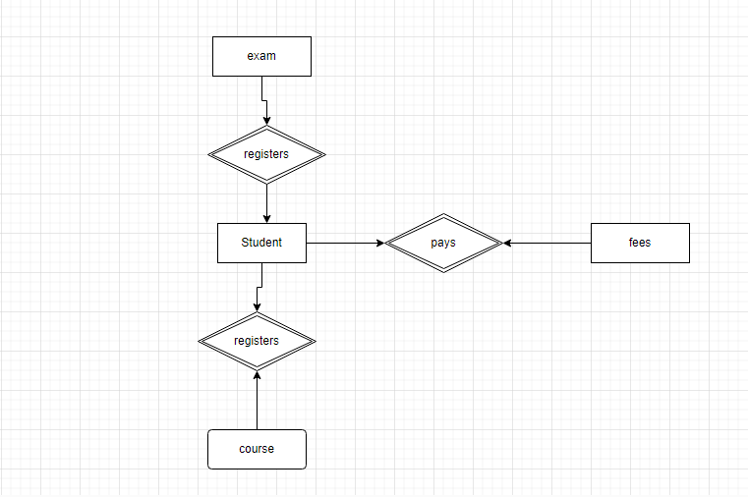
Figure 1: Entity Relationship Diagram

Wireframes
User Login Form

User Name

Password

Exit
Login

Implementation
The system is designed using visual basic programming language on Microsoft visual studio integrated development environment.

System interfaces

Welcome form
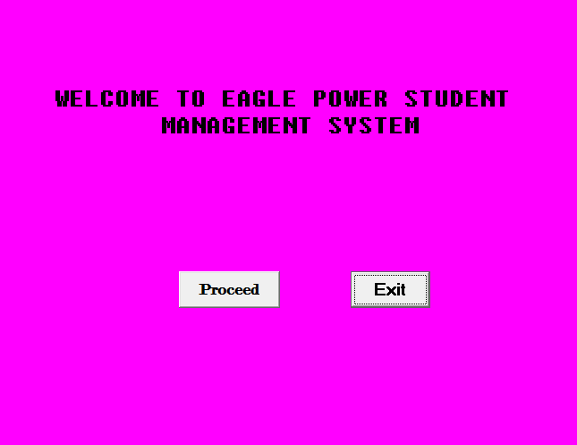
Figure 2: System Welcome form

This is the first form of the system which displays a welcome message of the system. It has two buttons which are proceed button which when clicked takes you to the next form. The exit button exits the system when clicked.

Admin login form
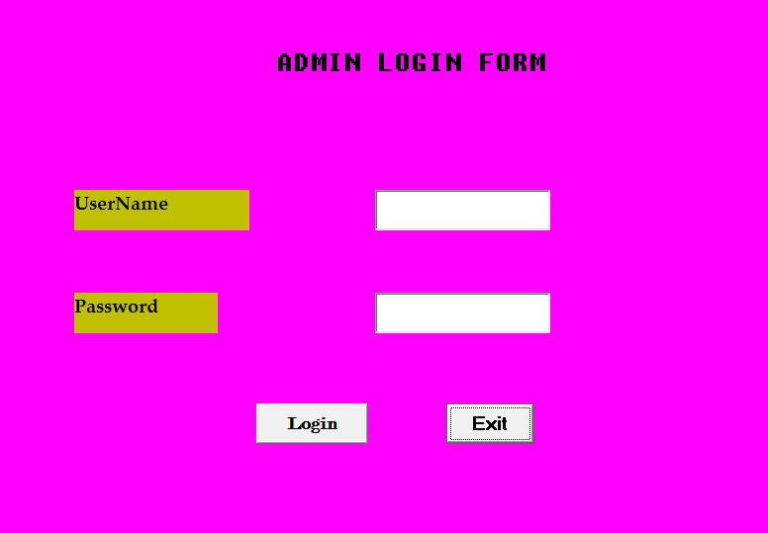
Figure 3:Admin Login form
This is the form which is used by the admin to log into the system. It accepts admin user name and password.

System Dashboard
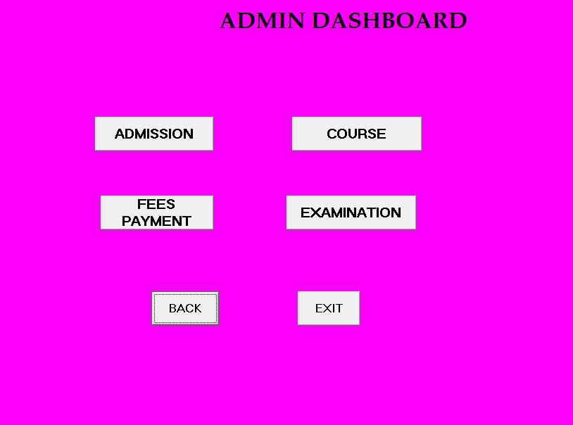
Figure 4:System Dashboard
This is the system dashboard which has all the button links to all the forms in the system.
The admission button will take you to the admission form when clicked while the course button when clicked will open the courses form.
The fees payment button opens the accountancy form which is used for fees payment while the examination button opens the examination form which shows the exam data of the students.
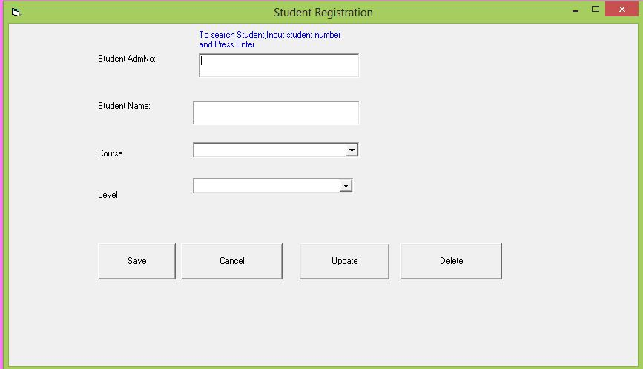
Students enrolment form
Figure 5:Students Enrollment form

This form is used to register students into the system

System reports

Admin login form
When the wrong username or password is entered, it displays a message box for wrong username or password. So in order to login, you must provide the correct username and password.
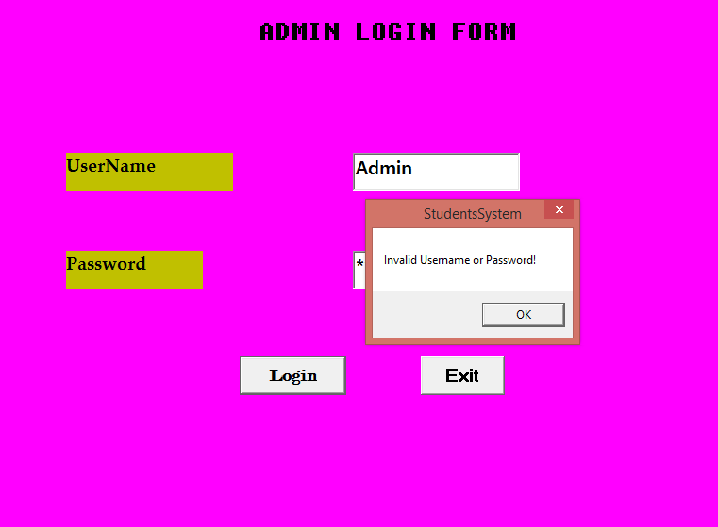
wrong username or password
Figure 6: Wrong username

Correct username and password

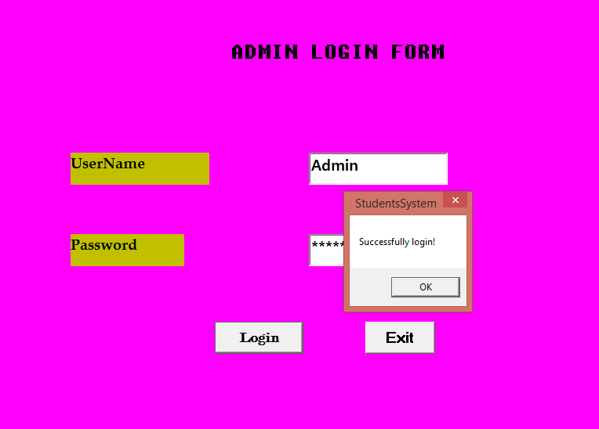
Correct password
Figure 7: Correct username

System testing
System testing is the process of software testing where a complete, integrated software application is tested as a whole to evaluate its compliance with the specified requirements. It is done after integration testing and before acceptance testing phase.
System testing is done to verify that the system meets its functional and non-functional requirements and ensure that all the components work together as intended.

Unit testing
Unit testing is a concept in software development and testing which involves testing of individual units of a software application to ensure that they are working correctly.
Student registration form
This shows that student data has been saved successfully.
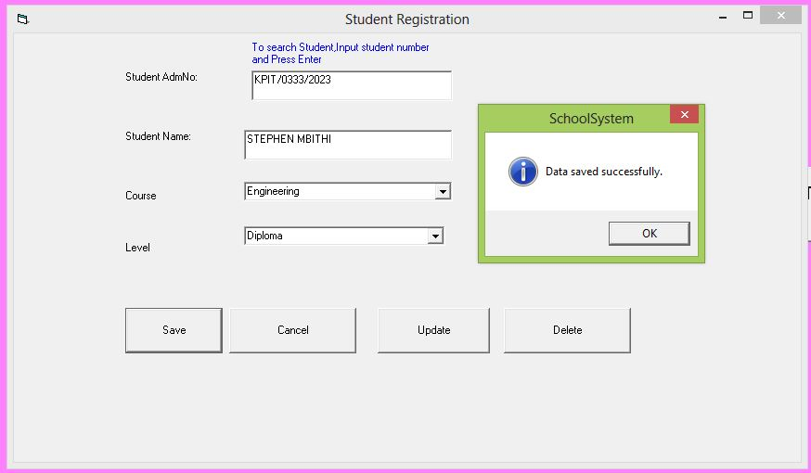
Figure 8: Student Data Saved Successfully
Student data has been deleted successfully
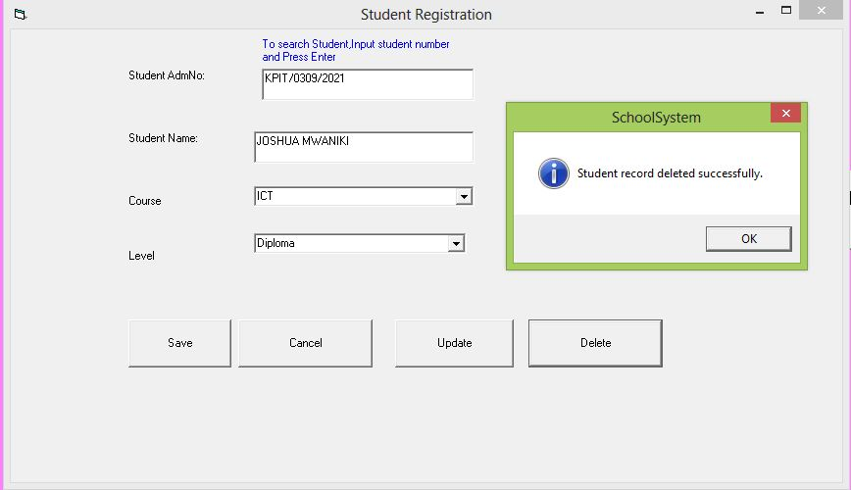
Figure 9: Student Data deleted Successfully
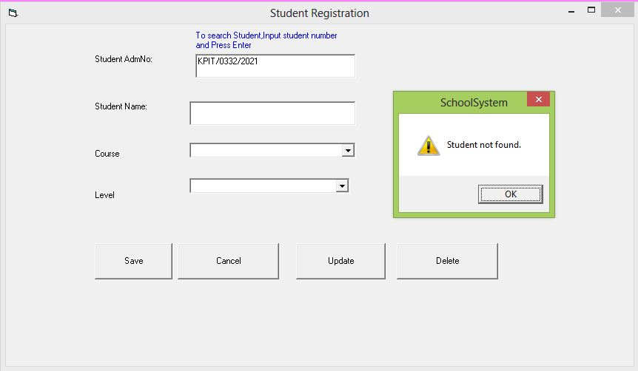
Figure 10: Student not in database
This form is used to search student data. If the data is available is displayed on the form else a message box is displayed showing that the tudent data is not found.

Test cases.
These refer to the detailed specifications of conditions that need to be executed to verify the functionality of a software application. They serve as guidelines for testers to validate where the software meets its specified requirements.
Test case no | test being done | expected results | actual results
1 | login with wrong details  username: Admin  Password:ADmin0000 | System should deny login and display message to the user | System denied login and displayed to the user a message to enter correct details.
2 | Login with correct details  username: Admin  Password:admin0000 | System should accept login and display message to the user | System allowed login and displayed to the user a message that the login was successful

Conclusion
After the development of the system, I managed to achieve the following:
- Deny the user access to the system if wrong details are used to login. This was one by setting a unique username and password so as to prevent unauthorized access to the system.
- Allow access to the system if the correct details are used to login to the same. This was one by setting a unique username and password so as to prevent unauthorized access to the system.
- Save students data. This was achieved by linking the system with database.
- Delete data. In case of data redundancy, the system is able to delete data. The data is searched using the student’s admission number.
- Retrieve data. This is done by typing the unique admission and then you use the find button to query the data from the database.

Recommendations
Through the techniques which have been used to develop the above system, below are the future works of the system:
- The system can be improved to print fees receipts after the students pay. The receipt will include the student details like the admission number, date of payment and time and also calculate the balance of the fee.
- The system will also be able to generate the student’s report based on his/her academic performance and then grade the student based on the grading system used.
- The system will also provide access to the students such that they can view their data but unable to edit or delete the same.
- The system will able to insert the student’s passport on the examination report form.
- The system will be able to provide a graph of the continuous performance of the students on the academic and games.

References
- "How schools are caught up in a £200m MIS 'turf war'". schoolsweek.co.uk. 13 February 2023. Retrieved 22 December 2023.
- "Data Demands: Are management information systems a help or a hindrance?". Schools Week. 25 November 2015.
- Archived copy". publications.teachernet.gov.uk. Archived from the original on 28 August 2006. Retrieved 13 January 2022.
- Montagu to acquire Capita's ESS business and invest in ParentPay Group". 14 December 2020.
- Homepage | Education Software Solutions". Archived from the original on 2 April 2010.
- Modules for Secondary schools and academies". Capita Group. Archived from the original on 12 August 2013. Retrieved 14 November 2014.

Appendix
Figure 11: Appendix 1

Figure 12: Appendix 2

