REPORT
RESTAURANT BILLING SYSTEM
PRESENTER NAME:
INDEX NO:
INSTITUTION:
SUPERVISOR:
SUBMISSION: THIS PROJECT REPORT IS SUBMITTED TO KENYA NATIONAL EXAMINATION COUNCIL FOR AWARD IN DIPLOMA IN INFORMATION COMMUNICATION TECHNOLOGY.
DATE:

Declaration
This work is original and personally undertaken by your name and it has never been presented by any person to any institution or Kenya national Examination council for award. The work has received strict and appropriate supervision.
SUPERVISOR NAME:
SIGNATURE:
DATE:

Dedication
I sincerely dedicate this work to institute name and my beloved parents for supporting me to exploit my ability in this project. I also dedicate this work to my friends who assisted me during my research project.

Acknowledgement
I wish to acknowledge my lecturer and institute name for their continuous support in all aspects during decision making for this project. I will not forget the friends who assisted me and motivation they offer to the success during research of this project.

Executive summary
This report presents an in-depth analysis of restaurant billing system, with the objective of assessing its efficiency, accuracy, and overall impact on financial operations. The scope of the report includes a detailed evaluation of the system’s features, such as data entry, payment processing and reporting capabilities.
The study utilized a combination of system performance metrics and user feedback. Key findings indicate that the billing system significantly enhances operational efficiency by automating the billing process, thereby reducing manual errors and processing time. The system supports cash payment methods and generates comprehensive financial reports. It also adheres to industry security standards.
Despite its overall effectiveness, some limitations were identified, including occasional delays in payment processing during peak times and the need for more customizable reporting features. Based on these findings, the report concludes that the restaurant billing system is a valuable tool for financial management and customer satisfaction but can be further optimized.
To address the identified limitations, the following recommendations are proposed:
Optimize Payment Processing: Implement additional server resources or load balancing during peak times to minimize delays.
Enhance Reporting Features: Develop more customizable reporting options to meet specific departmental needs.
User Training: Provide regular training sessions for users to maximize the system’s capabilities.
Feedback Mechanism: Establish a continuous feedback mechanism to gather user input for ongoing system improvements.
Implementing these recommendations will further enhance the performance and user satisfaction of the billing system, ensuring it remains a robust and effective solution for our organization’s financial operations

TABLE OF FIGURES

Figure 1 8
Figure 2 10
Figure 3 10
Figure 4 11
Figure 5 13
Figure 6 14
Figure 7 15
Figure 8 17
Figure 9 18
Figure 10 18
Figure 11 19

ABBREVIATION

UAT User Acceptance Testing
SQL Structured Query Language
UI User Interface
IOS IPhone Operating System

TABLE OF CONTENT
Declaration ii
Dedication iii
Acknowledgement iv
Executive summary v
TABLE OF FIGURES vi
ABBREVIATION vii
TABLE OF CONTENT viii
CHAPTER 1 1
INTRODUCTION 1
1.1 Background 1
1.2 Problem Statement 1
1.3 Objectives 2
1.4 Significance of the Project 2
1.5 Scope of the Project 3
CHAPTER TWO 4
LITERATURE REVIEW 4
2.0 Introduction 4
2.1 Literature Review methods 4
2.2 Different restaurant billing system. 5
2.3 Proposed restaurant system 5
2.3.1 System functional requirements 5
2.3.2 System non-functional requirements 6
CHAPTER 3 7
SYSTEM DESIGN 7
3.1 System Architecture 7
3.2 Data Flow Diagrams 8
3.3 User Interface Design 9
3.4 Database Design 11
CHAPTER 4 12
SYSTEM IMPLEMENTATION 12
4.1 Development Tools and Technologies 12
4.2 Implementation Process 12
CHAPTER 5 13
TESTING AND EVALUATION 13
5.1 Testing procedures 13
5.2 Test Cases 13
5.3 Evaluation metrics 17
5.4 Results and Analysis 18
CHAPTER 6 20
CONCLUSION AND RECOMMENDATIONS 20
6.1 Summary of Findings 20
6.2 Recommendations for Future Work 20
6.3 Final Thoughts 21
REFFERENCES 22
APPENDIX 1 23

CHAPTER 1

INTRODUCTION

1.1 Background
The hospitality industry, particularly the restaurant sector, thrives on efficiency, customer satisfaction, and accurate management of operations. One of the critical aspects of restaurant management is the billing process. Traditional methods of billing, often involving manual entries and paper-based records, have become increasingly obsolete in the face of rapid technological advancements. These methods are not only time-consuming but also prone to errors, inefficiencies, and security risks. As a result, there is a growing need for a robust, reliable, and efficient digital billing system that can streamline operations, enhance accuracy, and improve data management.
The Restaurant Billing System is designed to address these challenges by providing a comprehensive solution that automates the billing process, ensures data accuracy, enhances security, and offers seamless integration with other restaurant management functions. This system not only simplifies the billing process but also provides valuable insights through data analytics, thereby helping restaurant managers make informed decisions to improve overall efficiency and customer satisfaction.

1.2 Problem Statement
The current manual billing systems in many restaurants present several significant issues that impact efficiency, accuracy, and customer satisfaction:
- Inaccuracy: Manual entry of billing information is susceptible to human errors, leading to inaccurate billing and potential disputes with customers.
- Time Inefficiency: Processing bills manually is time-consuming, affecting the overall speed of service and customer turnover rates.
- Data Management: Manual systems struggle with effective data storage and retrieval, complicating tasks like reporting, analysis, and record-keeping.
- Security: Manual systems are less secure, with higher risks of unauthorized access, data breaches, and loss of critical information.
- Resource Intensive: Significant resources are spent on stationery, manual record-keeping, and reconciliation processes, increasing operational costs.
- Scalability Issues: Manual systems are not easily scalable to handle increased volumes of transactions or additional locations.

1.3 Objectives
The primary objectives of the Restaurant Billing System are:
- To provide a user-friendly interface for managing restaurant billing operations.
- To ensure accurate and efficient calculation of bills and change.
- To store transaction details securely in a database.
- To generate comprehensive sales reports for analysis.

1.4 Significance of the Project
Implementing a digital Restaurant Billing System will bring about significant improvements in the way billing operations are managed, offering numerous benefits:
- Increased Accuracy: Automated billing reduces human error, ensuring accurate billing information and improving customer trust.
- Improved Efficiency: Streamlined billing processes save time, enhancing overall service speed and customer satisfaction.
- Better Data Management: Secure digital storage allows for easy data retrieval, comprehensive reporting, and valuable insights through data analytics.
- Enhanced Security: Controlled access to the system ensures that sensitive billing data is protected from unauthorized access and breaches.
- Resource Savings: Digital processes reduce the need for stationery and manual labor, cutting operational costs and increasing profitability.
- Scalability: The system can easily scale to handle increased transaction volumes and additional locations, supporting business growth and expansion.

1.5 Scope of the Project
The Restaurant Billing System will encompass the following features:
- Login Form: Secure login functionality for accessing the system, with different roles for cashiers and administrators.
- Cashier Form: Interface for cashiers to process bills, including item selection, quantity input, and total calculation.
- Administrator Form: Interface for administrators to manage system settings, view reports, and perform data analytics.
- Data Input: Easy input of billing data, including item details, prices, and quantities.
- Data Storage: Secure storage of billing data in a centralized database, ensuring data integrity and easy retrieval.
- Receipt Printing: Automated printing of receipts, providing customers with clear and accurate billing information.
- Bill Processing: Efficient processing of bills, including automated calculations, discounts, taxes, and total amounts.
- Reporting and Analytics: Generation of detailed reports and analytics on billing data, providing valuable insights for decision-making.

CHAPTER TWO

LITERATURE REVIEW

2.0 Introduction
The efficient operation of a restaurant depends on several factors, with the billing system being a critical component. In recent years, billing system in restaurants has undergone significant advancement to enhance accuracy, speed and satisfaction on the field of work. This literature review aims to explore the existing research and development in restaurant billing systems, focusing on technology adoption, security and satisfaction to the field of work.
The adoption of technology in restaurant billing system has gained substantial attention. Kaul et el. (2019) investigated the impact of tablet-based billing system on order accuracy and efficiency. They found that integrating tablet for order entry and payment processing reduced errors and improved the overall speed of service.
Nguyen and Smith (2020) explored the adoption of using mobile payment apps in restaurants. Their study revealed that many customers appreciated the convenience of mobile payment.
Security concerns are paramount in restaurant billing system, particularly with the increasing use of digital transactions. Patel & Sharma (2019) explored security vulnerabilities on Point of Sale systems commonly used in restaurants. Their findings underscored the importance of regular security updates and training for staff to mitigate risks.
Regarding to data privacy, yang et al. (2020) investigated customers’ concerns about sharing personal information during the billing process. They found that transparency in data handling and explicit consent requests and alleviate customer’s apprehensions.

2.1 Literature Review methods
Literature reviews are essential in research to provide context and identify gaps in existing knowledge. The following are some method of conducting a literature review.
Selection criteria: this establishes criteria for including or excluding sources, such as publication date, source type and relevance to your topic.
Organize the literature: create a logical structure for your review, such as chronological, thematic, or methodological organization.
Write the review: compile your finding into a coherent narrative, discussing the existing knowledge and research gaps.

2.2 Different restaurant billing system.
Restaurant billing systems have evolved over the years, adapting to technological advancements and changing customer preferences. Here are some different types of restaurant billing system.
Traditional Cash Register: This is the most basic form restaurant billing system, where orders were manually entered and the total bills calculated. But it lacks efficiency and features of modern systems.
Cloud-based systems stores data and processes in the cloud, making it accessible from anywhere with an internet connection. This is especially useful for multi-location restaurants and chains.
Integrated payment solution: A modern billing system often integrates with payment gateways and offers various payment methods including credit cards, mobile wallet etc.
Customized billing software: Some upscale restaurants opt for customized billing software tailored for their specific needs. These systems can include unique features and branding.
Multi-language Billing System: In restaurant catering to diverse clientele, multi-language billing systems are used to ensure that customers can view and understand their bills in their preferred language.

2.3 Proposed restaurant system
A restaurant billing system is a software solution used by restaurant to manage and process customer orders, calculate bills and handle payments. It typically includes features like menu management, order processing and table and payment processing.

2.3.1 System functional requirements
System functional requirements are the essentials for a restaurant billing system to efficiently manage and process customer receipts, calculate bills and handle payments. They include:
Reporting and analysis as a system should generate reports on sales.
Data backup and recovery a system should regularly backup data to prevent data loss and provide mechanism for data recovery.
User friendly interface as it deals with input controls allow users to input information into the system. If you need your users to tell you what country they are in, for example, you’ll use an input control to let them do so and navigational components help users move around a product or website. Common navigational components include tab bars on an iOS device and a hamburger menu on an Android.

2.3.2 System non-functional requirements
Non-functional requirements are a set of specifications that describe the system’s operation capabilities and constraints and attempt to improve its functionality. These are basically the requirements that outline how well it will operate including things like speed, security, reliability, data integrity, etc.

CHAPTER 3

SYSTEM DESIGN

3.1 System Architecture
The system architecture of the Restaurant Billing System is designed with a modular approach to ensure scalability, flexibility, and robustness. The key components of the system include:
- User Interface (UI): Designed for ease of use, with separate forms for cashiers and administrators. The UI includes:
  - Login Form: Allows users to log in as either a cashier or an administrator. The login form validates user credentials and grants access to appropriate functionalities based on the user role.
  - Add Items Form: Enables users to add new items to the restaurant menu, delete existing items, and save changes. This form includes text boxes for item code, item name, and item price, as well as buttons for adding, saving, and deleting items.
  - Payment Form: Facilitates the processing of payments. Users can enter order details, calculate the total bill, process payments, calculate change, and print receipts. This form includes text boxes for order number, customer name, total bill, amount paid, and change, a combo box for selecting the payment method, and buttons for processing payment, printing receipts, and canceling the operation.
  - Sales Reporting Form: Displays sales data retrieved from the database. Users can view individual sales transactions and compute total sales. This form includes a list box for showing sales data and a button for fetching and displaying sales.
  - Login Form: Secure login functionality with role-based access control.
  - Cashier Form: Interface for cashiers to process bills, including item selection, quantity input, and total calculation.
  - Administrator Form: Interface for administrators to manage system settings, view reports, and perform data analytics.
- Database: Securely stores all billing data, ensuring easy retrieval and long-term storage. The database includes tables for users, items, transactions, and receipts.
- Processing Engine: Automates the billing process, ensuring accurate calculations and efficient processing of bills.
- Printing Module: Handles the automated printing of receipts, providing customers with clear and accurate billing information.
- Reporting and Analytics Module: Generates detailed reports and analytics on billing data, providing valuable insights for decision-making.

3.2 Data Flow Diagrams
Data flow diagrams illustrate the movement of data within the system, from input through processing to storage and output. The key data flows include:
- Login Data Flow: Data entered in the login form is validated against stored user credentials, determining access to the cashier or administrator forms.
- Billing Data Flow: Item selection and quantity input data flow into the processing engine, where calculations are performed, and the total amount is determined.
- Storage Data Flow: Processed billing data is stored in the database, ensuring data integrity and easy retrieval.
- Receipt Data Flow: Receipt data flows into the printing module, generating a printed receipt for the customer.
- Reporting Data Flow: Stored billing data is accessed by the reporting and analytics module to generate detailed reports and insights.
Figure 1
DATA FLOW DIAGRAM

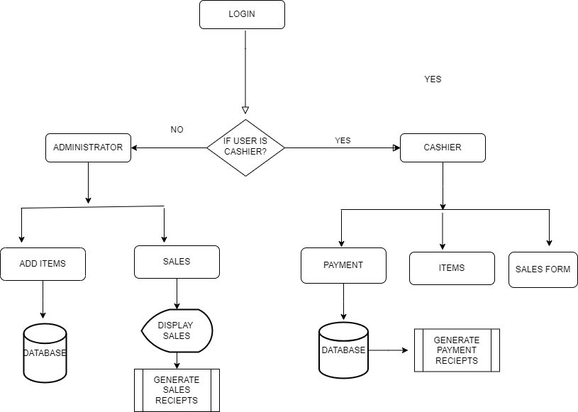

3.3 User Interface Design
The user interface is designed to be intuitive and accessible, ensuring that users can navigate the system with ease. Key design principles include:
- Simplicity: Clear and straightforward design to minimize complexity and enhance usability.
- Consistency: Consistent layout and design elements to provide a familiar and predictable user experience.
- Accessibility: Ensuring the interface is accessible to all users, including those with disabilities.
- Responsiveness: Adapting the interface to different devices and screen sizes for a seamless user experience.

LOGIN FORM

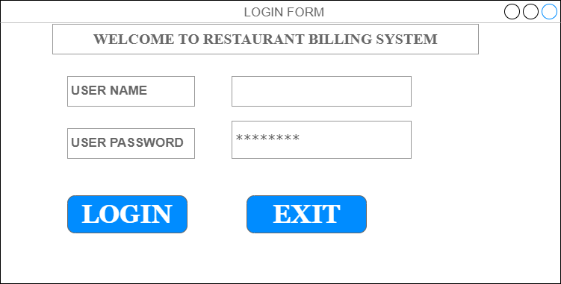
Figure 2

PAYMENT FORM
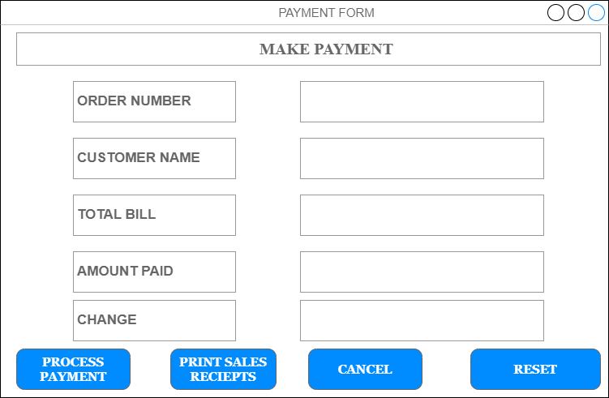
Figure 3

3.4 Database Design
The database design ensures efficient storage and retrieval of billing data, with tables representing users, items, transactions, and receipts. Key design considerations include:
Normalization: Ensuring the database is normalized to minimize redundancy and improve data integrity.
Indexing: Using indexing to enhance query performance and speed up data retrieval.
Security: Implementing security measures such as encryption and access controls to protect sensitive data.
Figure 4

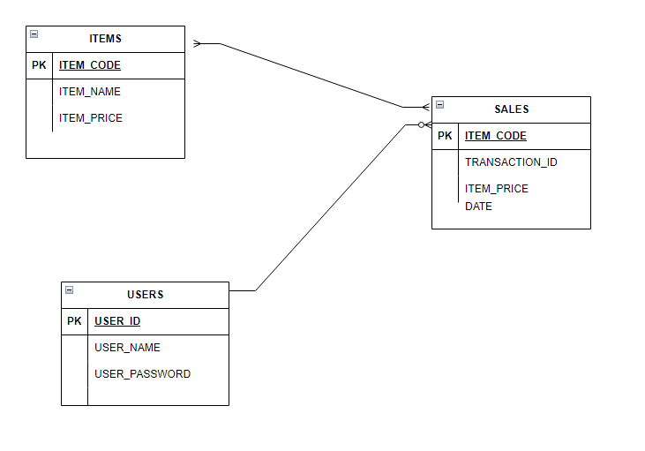

CHAPTER 4

SYSTEM IMPLEMENTATION

4.1 Development Tools and Technologies
The development of the Restaurant Billing System utilizes modern tools and technologies to ensure reliability, scalability, and performance. Key tools and technologies include:
- Programming Languages: Visual Basic programming language and SQL languages were used to develop the system.

4.2 Implementation Process
The implementation process follows a structured approach, including the following phases:
Requirement Analysis: Gathering and analyzing requirements from stakeholders to understand their needs and expectations.
System Design: Creating detailed design documents and diagrams to outline the system architecture and data flows.
Development: Coding and integrating different system components, following best practices for software development.
Testing: Conducting unit, integration, and system testing to ensure the system functions correctly and meets requirements.
Deployment: Deploying the system to a cloud-based environment, ensuring it is accessible and functional.
Maintenance: Providing ongoing support and updates based on user feedback and emerging requirements.

CHAPTER 5

TESTING AND EVALUATION

5.1 Testing procedures
Testing procedures are critical to ensure the system functions correctly and meets the defined requirements. Key testing procedures include:
Unit Testing: Testing individual components for functionality and correctness.
Integration Testing: Ensuring that different components work together seamlessly and data flows correctly between them.
System Testing: Testing the complete system for performance, security, and usability.
User Acceptance Testing (UAT): Involving end-users to test the system in a real-world environment and provide feedback.

5.2 Test Cases
1. Login Functionality
Objective: Ensure that users can log in as either a cashier or an administrator with valid credentials.
Test Steps:
Open the login form.
Enter valid credentials for a cashier and log in.
Verify that the cashier interface is displayed.
Log out and repeat steps 2 and 3 for an administrator.
Expected Result: Users should be able to log in with valid credentials and access the appropriate interface.

Figure 5

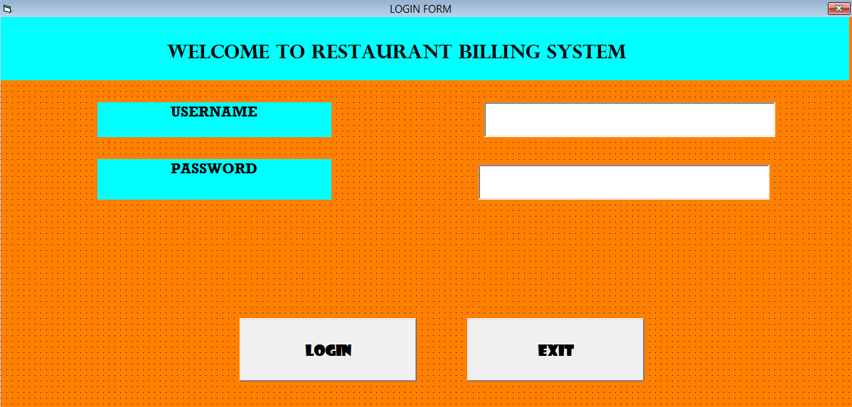

2. Add Items Functionality
Objective: Ensure that new menu items can be added, saved, and deleted correctly.
Test Steps:
Open the Add Items form.
Enter item details and click the "Add" button to generate a random item code.
Click the "Save" button to save the item details.
Verify that the item details are saved in the database.
Click the "Delete" button to delete the item.
Verify that the item is deleted from the database.
Expected Result: Items should be added, saved, and deleted correctly, with changes reflected in the database.
Figure 6
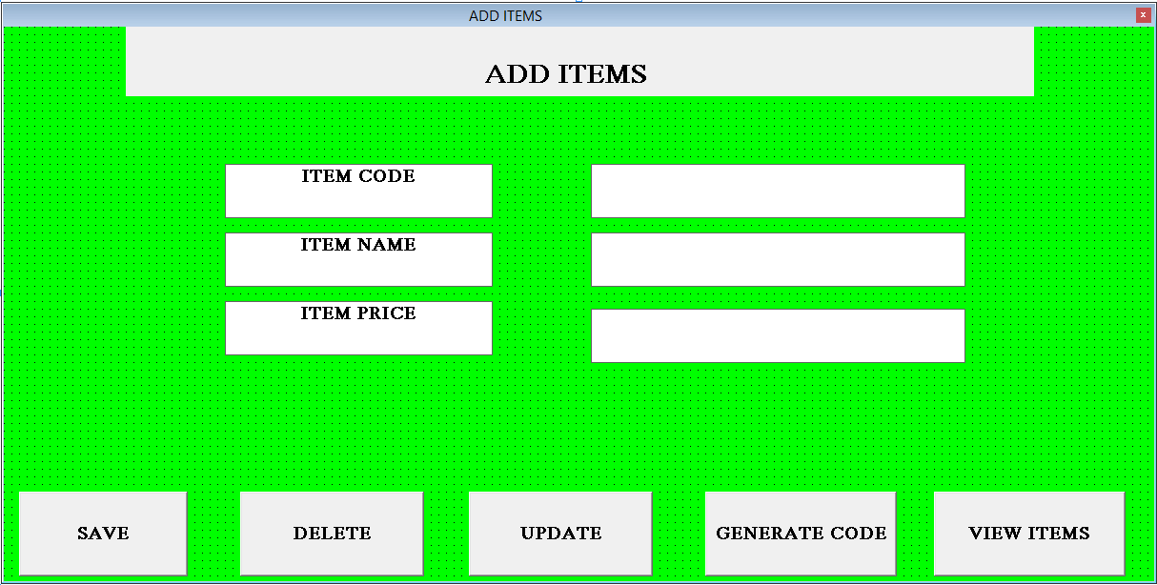
3. Payment Processing
Objective: Ensure that payments can be processed accurately, and changes are calculated correctly.
Test Steps:
Open the Payment form.
Enter order details, including order number, customer name, total bill, amount paid, and select a payment method.
Click the "Process Payment" button.
Verify that the change is calculated correctly and displayed in the change text box.
Verify that payment details are saved in the database.
Expected Result: Payments should be processed accurately, with correct change calculations and details saved in the database.
Figure 7
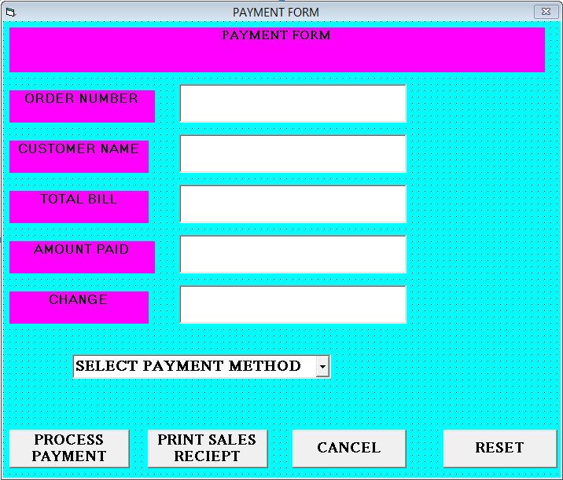
4. Print Receipt
Objective: Ensure that receipts can be printed with correct details.
Test Steps:
Open the Payment form.
Enter order details and process a payment.
Click the "Print Receipt" button.
Verify that a receipt is printed with the correct details, including order number, customer name, total bill, amount paid, change, and payment method.
Expected Result: Receipts should be printed with correct details.
5. Sales Reporting
Objective: Ensure that sales data can be fetched and displayed correctly.
Test Steps:
Open the Sales Reporting form.
Click the "Show Sales" button.
Verify that sales data is fetched from the database and displayed in the list box.
Verify that the total sales amount is calculated and displayed correctly.
Expected Result: Sales data should be fetched and displayed correctly, with accurate total sales calculations.
Figure 8
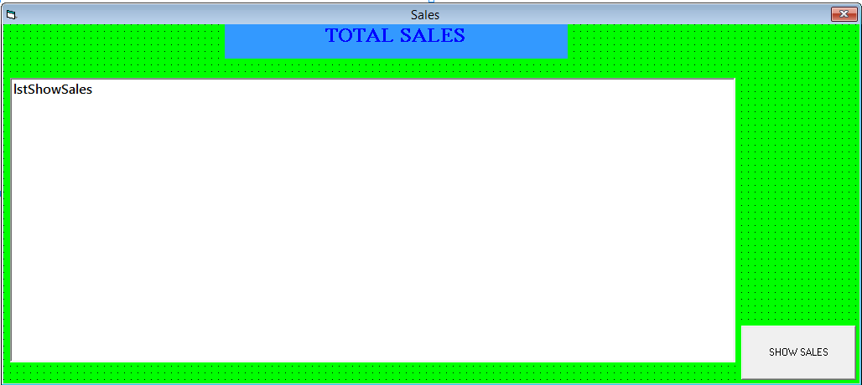
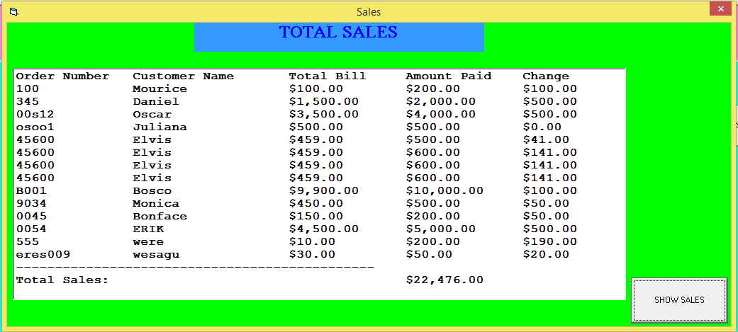

5.3 Evaluation metrics
Evaluation metrics are used to assess the performance and effectiveness of the system. Key metrics include:
Accuracy: Measuring the correctness of bill calculations and data processing.
Efficiency: Assessing the time taken for different processes, including bill processing and receipt generation.
User Satisfaction: Gathering feedback from users on the system’s usability and overall experience.
Data Integrity: Ensuring the security and accuracy of stored data, protecting against unauthorized access and data breaches.

5.4 Results and Analysis
The results from testing are analyzed to identify any issues and areas for improvement. The system’s performance is evaluated against the defined metrics, with any discrepancies addressed through iterative development and testing cycles.
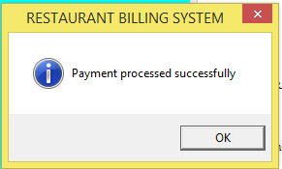
Figure 9
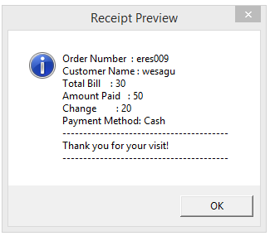
Figure 10
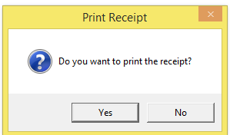
Figure 11

CHAPTER 6

CONCLUSION AND RECOMMENDATIONS

6.1 Summary of Findings
The Restaurant Billing System effectively addresses the issues associated with traditional billing systems by ensuring accuracy, enhancing efficiency, and improving data management. Key findings include:
Enhanced Accuracy: Automated billing processes significantly reduce human error, ensuring accurate billing and improved customer trust.
Improved Efficiency: Streamlined billing processes save time, enhancing overall service speed and customer satisfaction.
Better Data Management: Secure digital storage allows for easy data retrieval, comprehensive reporting, and valuable insights through data analytics.
Enhanced Security: Controlled access to the system ensures that sensitive billing data is protected from unauthorized access and breaches.
Resource Savings: Digital processes reduce the need for stationery and manual labor, cutting operational costs and increasing profitability.
Scalability: The system is easily scalable to handle increased transaction volumes and additional locations, supporting business growth and expansion.

6.2 Recommendations for Future Work
Future enhancements to the Restaurant Billing System could include:
Mobile Application: Developing a mobile app for easier access and on-the-go billing, allowing staff to process orders and payments directly at the table.
Advanced Analytics: Incorporating advanced data analytics and machine learning algorithms for deeper insights and predictive analysis.
Integration with Other Systems: Allowing integration with other restaurant management systems, such as inventory management, customer relationship management (CRM), and supply chain management, for seamless data exchange and comprehensive management.
Multi-Language Support: Implementing multi-language support to cater to a diverse user base and improve accessibility.
Customization Options: Providing customization options for different types of restaurants, allowing them to tailor the system to their specific needs and preferences.

6.3 Final Thoughts
The Restaurant Billing System represents a significant advancement in the way restaurants manage billing operations. By addressing the limitations of traditional manual systems, these digital solutions ensure a more efficient, accurate and secure process for handling transactions. The system's scalability and flexibility make it a valuable tool for restaurants of all sizes, supporting their growth and enhancing customer satisfaction.
The successful implementation of the Restaurant Billing System demonstrates the importance of leveraging modern technologies to improve operational efficiency and drive business success. As the hospitality industry continues to evolve, adopting innovative solutions like this will be essential for staying competitive and meeting the ever-changing demands of customers.

REFFERENCES
- Nguyen & Smith(2020), Explored the adoption of using mobile payment apps in restaurants.
- Kaul et el. (2019), investigated the impact of tablet-based billing system on order accuracy and efficiency
- Patel & Sharma (2019), Explored security vulnerabilities on Point of Sale systems commonly used in restaurants.
- Yang et al. (2020), Investigated customers’ concerns about sharing personal information during the billing process.

APPENDIX 1
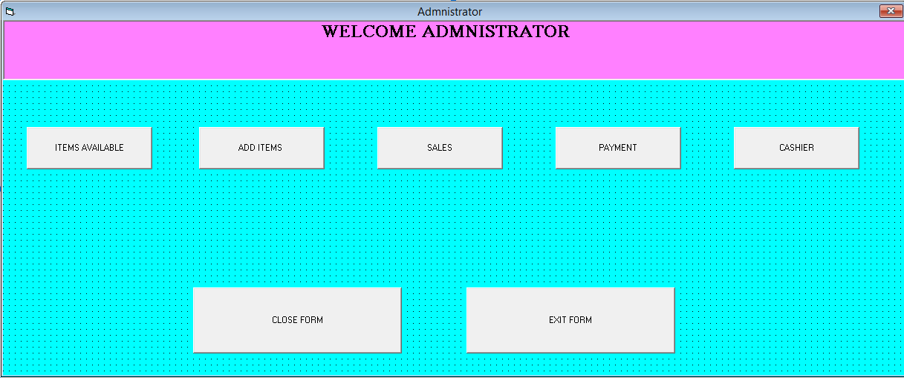

APPENDIX 2
