REPORT
SCHOOL EXAMINATION MANAGEMENT SYSTEM
PRESENTER NAME:
INDEX NO:
INSTITUTION:
SUPERVISOR:
SUBMISSION: THIS PROJECT REPORT IS SUBMITTED TO KENYA NATIONAL EXAMINATION COUNCIL FOR AWARD IN CERTIFICATE IN INFORMATION COMMUNICATION TECHNOLOGY.
DATE: 20TH JUNE 2024

Declaration
This work is original and personally undertaken by your name and it has never been presented by any person to any institution or Kenya national Examination council for award. The work has received strict and appropriate supervision.
SUPERVISOR NAME:
SIGNATURE:
DATE:

Dedication
I sincerely dedicate this work to institute name and my beloved parents for supporting me to exploit my ability in this project. I also dedicate this work to my friends who assisted me during my research project.

Acknowledgement
I wish to acknowledge my lecturer and institution name for their continuous support in all aspects during decision making for this project. I will not forget the friends who assisted me and motivation they offer to the success during research of this project.

Executive summary
The "School Examination Award System" is developed to automate the management of examination results and the distribution of student awards within educational institutions. The system, implemented using Microsoft Access and VBA, addresses the inefficiencies and inaccuracies of traditional manual processes. Key components include a dashboard for navigation, class details management, merit list generation, student report forms, comprehensive student information management, voucher issuance, badge awards, and remedial list generation. The system underwent thorough testing, including unit, integration, and user acceptance testing, and was found to be functional, efficient, and user-friendly. Future enhancements could include advanced reporting, automated notifications, mobile access, system integration, and enhanced security. The system significantly improves the accuracy and efficiency of managing academic records and awards, offering substantial benefits to school administrators and teachers.

ABBREVIATION

- UAT User Acceptance Testing
- VBA Visual Basic for Applications
- MS Access Microsoft Access

TABLE OF CONTENT
Contents
Declaration ii
Dedication iii
Acknowledgement iv
Executive summary v
TABLE OF CONTENT vii
CHAPTER 1 1
INTRODUCTION 1
1.1 Background 1
1.2 Problem Statement 1
1.3 Objectives 1
1.4 Scope 1
1.5 Methodology 2
CHAPTER 2 3
LITERATURE REVIEW 3
2.1 Overview of School Examination Award Systems 3
2.2 Examination and Award Management 3
2.3 Existing Solutions 3
2.4 Gaps in Current Systems 4
CHAPTER 3 5
SYSTEM DESIGN 5
3.1 System Architecture 5
3.2 Database Design 5
3.3 User Interface Design 6
3.4 Data Flow Diagrams 6
CHAPTER 4 8
SYSTEM IMPLEMENTATION 8
4.1 Development Environment 8
4.2 Dashboard Form 8
4.3 Class Details Form 10
4.4 Merit List Form 10
4.5 Report Forms 11
4.6 Student Details Form 11
4.7 Voucher Form 13
4.8 Badge Award Form 14
4.9 Remedial List Form 15
CHAPTER 5 17
TESTING AND EVALUATION 17
5.1 Testing Strategy 17
5.2 Unit Testing 17
5.3 Integration Testing 17
5.4 User Acceptance Testing 17
5.5 Evaluation Results 18
CHAPTER 6 19
CONCLUSIONS AND RECOMMENDATIONS 19
6.1 Summary of Findings 19
6.2 Recommendations for Future Work 19
6.3 Conclusion 19

CHAPTER 1

INTRODUCTION

1.1 Background
The education sector increasingly relies on digital solutions to enhance the management and dissemination of information. One critical area is the management of examination results and student awards. Traditionally, this process is manual and prone to errors, inefficiencies, and delays. The "School Examination Award System" aims to address these challenges by providing a centralized, automated system for managing examination results and awards.

1.2 Problem Statement
The manual process of managing examination results and student awards is inefficient and error-prone. It involves significant paperwork, is time-consuming, and lacks the capability to quickly generate accurate reports and awards lists. This results in delays and inaccuracies that affect the overall quality of educational administration.

1.3 Objectives
The primary objectives of the "School Examination Award System" are:
- To automate the management of examination results.
- To streamline the process of generating merit lists and student awards.
- To provide a user-friendly interface for school administrators and teachers.
- To ensure data accuracy and integrity.

1.4 Scope
The system will cover:
- Management of class details including teachers and students.
- Generation of merit lists based on examination results.
- Creation of individual student report forms.
- Management of student details, including personal and academic information.
- Issuance and tracking of vouchers and badges.
- Identification of students requiring remedial classes.

1.5 Methodology
The system will be developed using Microsoft Access and VBA (Visual Basic for Applications). The methodology includes:
- Requirements gathering through stakeholder interviews and analysis.
- System design based on identified requirements.
- Implementation using MS Access for the database and VBA for automation.
- Testing to ensure functionality and performance.
- Evaluation based on user feedback and testing results.

CHAPTER 2

LITERATURE REVIEW

2.1 Overview of School Examination Award Systems
School management systems are designed to automate various administrative tasks within educational institutions. These systems typically include modules for managing student information, attendance, grades, and communication between teachers, students, and parents.
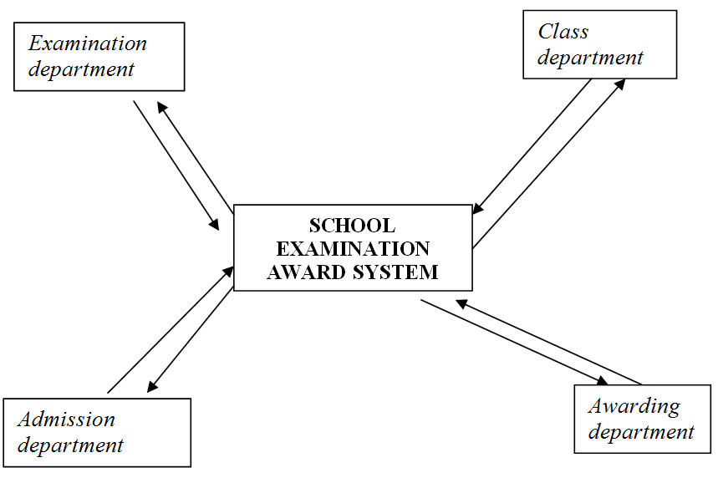

2.2 Examination and Award Management
Examination and award management systems specifically focus on handling the logistics of exams and the distribution of awards. These systems streamline the process of recording exam results, calculating grades, and generating awards such as certificates, badges, and scholarships.

2.3 Existing Solutions
There are several existing solutions for school management and examination award systems, including:
- PowerSchool: A comprehensive K-12 education technology platform that includes grade management and reporting features.
- Blackbaud: Provides a suite of tools for managing student information and academic performance.
- Edmodo: A platform for communication, collaboration, and coaching within schools, also supporting grade tracking.

2.4 Gaps in Current Systems
While existing systems offer various features, they often lack:
- Customization options tailored to specific school needs.
- Integration capabilities with other school systems.
- Simplified user interfaces for non-technical users.
- Affordable solutions for smaller educational institutions.

CHAPTER 3

SYSTEM DESIGN

3.1 System Architecture
The system architecture of the "School Examination Award System" includes:
- Database Layer: Using MS Access to store and manage all data.
- Application Layer: Using VBA for business logic and automation.
- Presentation Layer: Using MS Access forms for user interaction.

3.2 Database Design
The database design involves several tables:
- Students: Stores student information.
  - Fields: StudentID (Primary Key), Name, DateOfBirth, Gender, ClassID.
- Classes: Stores class information.
  - Fields: ClassID (Primary Key), ClassName, TeacherID.
- Teachers: Stores teacher information.
  - Fields: TeacherID (Primary Key), Name, Subject.
- Exams: Stores examination results.
  - Fields: ExamID (Primary Key), StudentID, Subject, Score.
- Awards: Stores award details.
  - Fields: AwardID (Primary Key), StudentID, AwardType, DateAwarded.
- Vouchers: Stores voucher details.
  - Fields: VoucherID (Primary Key), StudentID, Amount, DateIssued.

3.3 User Interface Design
The user interface consists of:
- Dashboard Form (frmDashboard): Central navigation form.
- Class Details Form (frmClassDetails): Form for managing and viewing class details.
- Merit List Form (frmMeritList): Form for generating and viewing merit lists.
- Report Forms (frmReportForms): Form for generating student report forms.
- Student Details Form (frmStudentDetails): Form for managing student details.
- Voucher Form (frmVoucher): Form for issuing and managing vouchers.
- Badge Award Form (frmBadgeAward): Form for issuing and managing badges.
- Remedial List Form (frmRemedialList): Form for generating remedial lists.

3.4 Data Flow Diagrams
Level 0: Context Diagram
Shows the system as a single process interacting with external entities such as administrators, teachers, and students.
Level 1: Data Flow Diagram
Details the main processes within the system, including:
- Manage Class Details
- Generate Merit Lists
- Create Report Forms
- Manage Student Details
- Issue Vouchers
- Award Badges
- Generate Remedial Lists

CHAPTER 4

SYSTEM IMPLEMENTATION

4.1 Development Environment
The system is developed using:
- Microsoft Access: For database management and form creation.
- VBA (Visual Basic for Applications): For writing scripts to automate tasks and handle business logic.

4.2 Dashboard Form
The Dashboard form (frmDashboard) serves as the main navigation interface, allowing users to access different sections of the system through buttons. The buttons trigger VBA code to open the respective forms.
vba
Copy code
Private Sub btnClassDetails_Click()
DoCmd.OpenForm "frmClassDetails"
End Sub

Private Sub btnMeritList_Click()
DoCmd.OpenForm "frmMeritList"
End Sub

Private Sub btnReportForms_Click()
DoCmd.OpenForm "frmReportForms"
End Sub

Private Sub btnStudentDetails_Click()
DoCmd.OpenForm "frmStudentDetails"
End Sub

Private Sub btnVoucher_Click()
DoCmd.OpenForm "frmVoucher"
End Sub

Private Sub btnBadgeAward_Click()
DoCmd.OpenForm "frmBadgeAward"
End Sub

Private Sub btnRemedialList_Click()
DoCmd.OpenForm "frmRemedialList"
End Sub
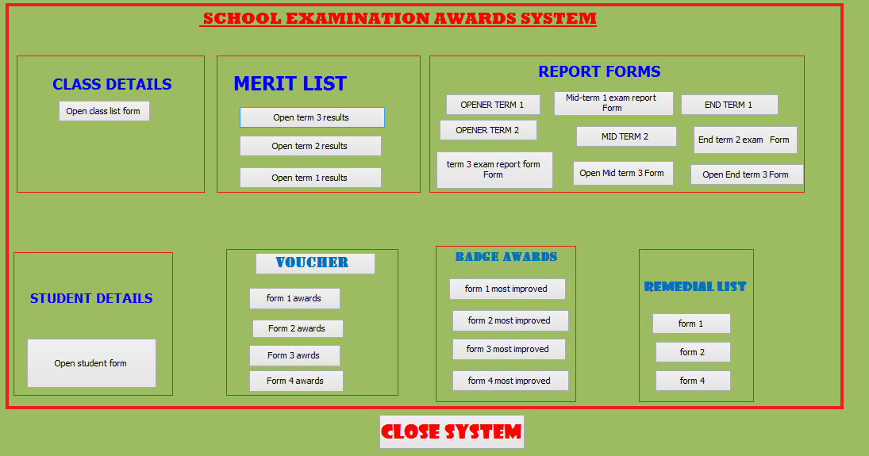

4.3 Class Details Form
The Class Details form (frmClassDetails) displays information about classes, including the class teacher and students. It includes navigation controls to browse through students and a button to view class teacher details.
vba
Copy code
Private Sub btnViewTeacher_Click()
Dim teacherID As Integer
teacherID = Me.TeacherID ' Assuming TeacherID is a field in frmClassDetails
DoCmd.OpenForm "frmTeacherDetails", , , "TeacherID=" & teacherID
End Sub

4.4 Merit List Form
The Merit List form (frmMeritList) generates and displays merit lists based on examination results. Users can filter the merit lists by class or grade.
vba
Copy code
Private Sub btnGenerateMeritList_Click()
Dim classID As Integer
classID = Me.cboClass ' Assuming cboClass is a combo box to select class
Me.subformMeritList.Form.RecordSource = "SELECT * FROM MeritList WHERE ClassID=" & classID
Me.subformMeritList.Requery
End Sub

4.5 Report Forms
The Report Forms (frmReportForms) generate detailed report forms for individual students, including academic performance and award details.
vba
Copy code
Private Sub btnGenerateReport_Click()
Dim studentID As Integer
studentID = Me.cboStudent ' Assuming cboStudent is a combo box to select student
Me.subformReport.Form.RecordSource = "SELECT * FROM StudentReports WHERE StudentID=" & studentID
Me.subformReport.Requery
End Sub

4.6 Student Details Form
The Student Details form (frmStudentDetails) allows for the management and display of detailed information about students. This includes personal details, academic records, and awards.
vba
Copy code
Private Sub btnSaveStudentDetails_Click()
Dim db As DAO.Database
Dim rs As DAO.Recordset

Set db = CurrentDb
Set rs = db.OpenRecordset("SELECT * FROM Students WHERE StudentID=" & Me.StudentID)

If rs.EOF Then
rs.AddNew
Else
rs.Edit
End If

rs!Name = Me.txtName
rs!DateOfBirth = Me.txtDateOfBirth
rs!Gender = Me.cboGender
rs!ClassID = Me.cboClass
rs.Update

Set rs = Nothing
Set db = Nothing

MsgBox "Student details saved successfully!"
End Sub

4.7 Voucher Form
The Voucher form (frmVoucher) manages the issuance and tracking of vouchers for students.
vba
Copy code
Private Sub btnIssueVoucher_Click()
Dim db As DAO.Database
Dim rs As DAO.Recordset

Set db = CurrentDb
Set rs = db.OpenRecordset("SELECT * FROM Vouchers WHERE VoucherID=" & Me.VoucherID)

rs.AddNew
rs!StudentID = Me.cboStudent
rs!Amount = Me.txtAmount
rs!DateIssued = Me.txtDateIssued
rs.Update

Set rs = Nothing
Set db = Nothing

MsgBox "Voucher issued successfully!"
End Sub
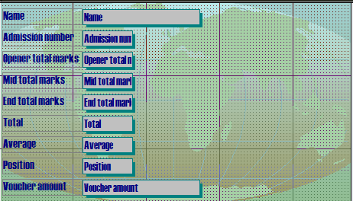

4.8 Badge Award Form
The Badge Award form (frmBadgeAward) manages the issuance and tracking of badges awarded to students.
vba
Copy code
Private Sub btnAwardBadge_Click()
Dim db As DAO.Database
Dim rs As DAO.Recordset

Set db = CurrentDb
Set rs = db.OpenRecordset("SELECT * FROM Awards WHERE AwardID=" & Me.AwardID)

rs.AddNew
rs!StudentID = Me.cboStudent
rs!AwardType = Me.cboAwardType
rs!DateAwarded = Me.txtDateAwarded
rs.Update

Set rs = Nothing
Set db = Nothing

MsgBox "Badge awarded successfully!"
End Sub

4.9 Remedial List Form
The Remedial List form (frmRemedialList) generates lists of students needing remedial classes based on their performance.
vba
Copy code
Private Sub btnGenerateRemedialList_Click()
Dim threshold As Integer
threshold = Me.txtThreshold ' Assuming txtThreshold is a text box for the performance threshold
Me.subformRemedialList.Form.RecordSource = "SELECT * FROM Students WHERE AverageScore < " & threshold
Me.subformRemedialList.Requery
End Sub

CHAPTER 5

TESTING AND EVALUATION

5.1 Testing Strategy
The testing strategy involves:
- Unit Testing: Testing each form and its functionalities individually.
- Integration Testing: Testing the interaction between different forms and modules.
- User Acceptance Testing (UAT): Involving actual users to test the system and provide feedback.

5.2 Unit Testing
- Dashboard Form: Test all buttons to ensure they open the correct forms.
- Class Details Form: Test displaying and navigating class and teacher information.
- Merit List Form: Test generating and filtering merit lists.
- Report Forms: Test generating student report forms.
- Student Details Form: Test saving and updating student information.
- Voucher Form: Test issuing and tracking vouchers.
- Badge Award Form: Test issuing and tracking badges.
- Remedial List Form: Test generating remedial lists based on performance.

5.3 Integration Testing
- Test navigation from the Dashboard form to other forms and back.
- Test data flow between forms, such as updating student details and seeing the updates in reports and merit lists.

5.4 User Acceptance Testing
- Involve teachers, administrators, and other stakeholders to test the system.
- Collect feedback and make necessary adjustments.

5.5 Evaluation Results
- Functionality: Ensure all functionalities work as expected.
- Usability: Gather user feedback on the ease of use and make improvements.
- Performance: Ensure the system is responsive and handles operations efficiently.
- Accuracy: Verify the accuracy of data and generated reports.

CHAPTER 6

CONCLUSIONS AND RECOMMENDATIONS

6.1 Summary of Findings
The "School Examination Award System" successfully automates the management of examination results and student awards. It provides a user-friendly interface, efficient data management, and streamlined operations. The system meets the identified requirements and offers significant improvements over manual processes.

6.2 Recommendations for Future Work
To further enhance the system, consider the following recommendations:
- Advanced Reporting: Implement more advanced reporting features, including graphical reports and analytics.
- Automated Notifications: Add functionality to send automated notifications to students and parents about awards and remedial classes.
- Mobile Access: Develop a mobile version of the system for easier access on smartphones and tablets.
- Integration with Other Systems: Integrate the system with other school management systems for seamless data exchange.
- Enhanced Security: Implement more advanced security measures, such as role-based access control and encryption.

6.3 Conclusion
The "School Examination Award System" provides a comprehensive solution for managing school awards based on examination results. By leveraging MS Access and VBA, the system offers a robust, efficient, and user-friendly platform for school administrators and teachers. With future enhancements, the system can be further improved to meet evolving needs and provide even greater value to schools.

REFERENCES
- Alexander, M., & Kusleika, R. (2018). Microsoft Access 2019 Bible. Wiley.
- Ulrich, L. A., & Cook, K. (2018). Access 2019 for dummies. For Dummies.
- Korol, J. (2019). Access 2019 programming by example with VBA, XML, and ASP. Mercury Learning & Information.
- Lambert, J. (2018). Microsoft Access 2019 step by step. Microsoft Press.
- Hennig, T., Cooper, R., Griffith, G. L., & Stein, A. (2014). Programming Microsoft Access 2013: Tips, tricks, and traps. Sybex.
- Couch, A. (2016). Access 2016 VBA programming for dummies. For Dummies.
- Mansfield, R. (2019). Mastering VBA for Microsoft Office 365. Sybex.

APPENDIX

