COMPETENCE BASED CURRICULUM

GRADE 4

CREATIVE ARTS

NOTES

STRAND 1 CREATING & EXCUTION.
1.1 Indigenous Kenyan percussion instruments.

Classifying indigenous Kenyan percussion instruments.
- Percussion instruments are instruments that are played by hitting or shaking.
- There are two groups of percussion instruments:
✰ Non melodic percussion instruments- these are instruments that do not produce different pitches.
Examples are:
  - Drums.
  - Shakers.
  - Jingles.
  - Bells.
  - Kayamba.

✰ Melodic percussion instrument- these are instruments that can produce different pitches to make a tune or a melody.
Examples are:
  - Marimba.
  - Adongo.

- A percussion instrument can be identified by either listening to its sound or by looking at it.
Drums  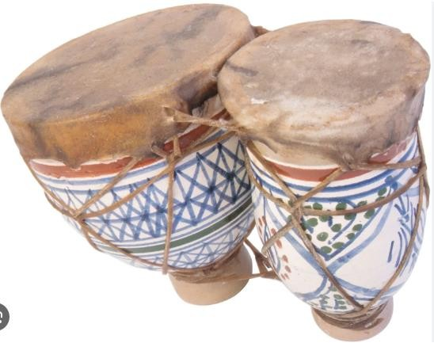 | Shakers  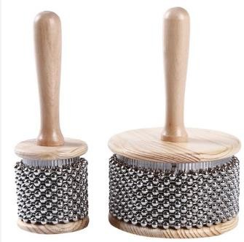 | Kayamba  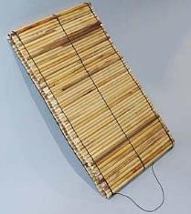

Jingles  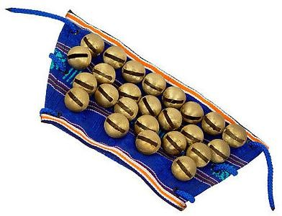 | Marimba  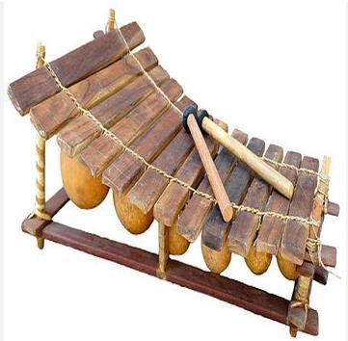

Parts of a percussion instrument.
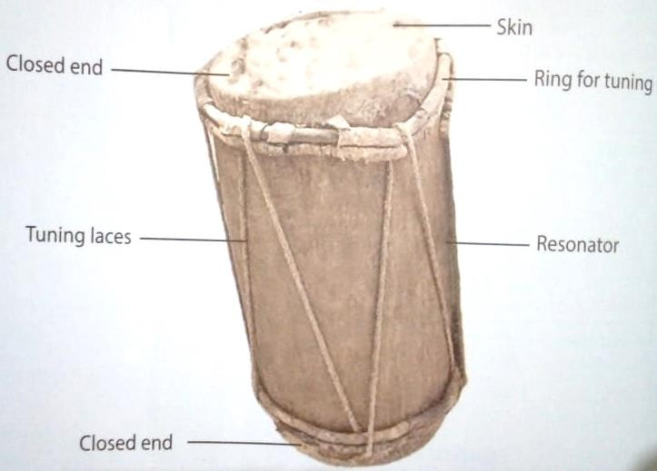
Skin -it is hit to vibrate and produce sound.
Pegs -fix the skin on the resonator. Resonator- makes the sound louder. Laces -use for tuning.
Sling -for holding the drum while playing.

Tools and materials used for making a percussion instrument.

Percussion instruments can be made from locally available materials such as:
- Rattles.
- Shakers.
- Drums.
- Gourds.

Methods of tuning drums.
- Warming in the sun.
- Shaking.
- Warming near fire.
- Rubbing with the palm of a hand.
- Playing a short tune.
- Tightening the membrane using laces.
- Beating/hitting the membrane.
- Hitting the tuning ring and tightening the ropes.
- Soaking the drum in arm water.

1.2 Netball
🢖 Netball is a non-contact game in which players are not allowed to come in contact with each other.
🢖 It is played by two teams of seven players.
🢖 Each team tries to score as many goals as possible before the end of the game.
🢖 The game is played by both boys and girls.

Chest pass in Net ball.
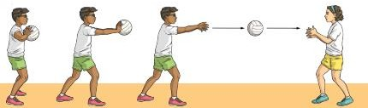

- Chest pass is a way of throwing the ball to a teammate where the ball is released and received at the chest level.
- The pass is usually used when the teammates are not far from each other.

Learning points for the chest pass.
- Grip
- Spread your fingers out behind the ball to form a W formation, holding it at chest height with your elbows out in front of you.

Stance.
- Face the direction you want the ball to go in.
- Step forwards with your dominant foot as you begin to straighten your arms.

Execution of the pass.
- Push the ball away from your body at chest height by powerfully extending the arms forwards and flicking the wrists.
- Follow through with the arms, wrists, hands and fingers in the direction of the throw.

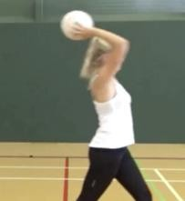
Over head pass

It is a pass launched from above the head.
It is thrown to a team mate who is not close.

Catching in Netball.
This is the act of receiving a pass from an opponent.
Catching in netball can be done by double-handed catching. This is where both hands are used to receive the ball from a teammate.
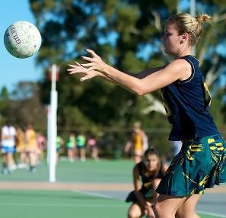

Classifying colours.
- There are many colours all around us.
- Some of the colours are green, yellow, orange, purple, red and blue.
- We can classify some of the colours as either primary or secondary colours.
- A colour wheel is a circular diagram vided into sections that shows how colours are related to each other.
- A colour wheel helps in colour classification.
- By looking at a colour wheel, you can easily see how different colours relate.

Primary colours.
🢖 The primary colours are: red, blue and yellow.
🢖 These are basic or pure colours.
🢖 They cannot be obtained by mixing other colours.
🢖 However, they are mixed in various amount to get other colours.

Secondary colours.
  - Secondary colours are obtained by mixing any two primary colours in equal proportions.
  - For example,
    - Yellow + blue=green.
    - Yellow + red = orange.
    - Red + blue =purple or violet.

1.3 Composing rhythm.
🢖 Some sounds are long while others are short.
🢖 Rhythm is made of long and short to make a pattern.
🢖 Sound taa can be used to represent long sounds. Sounds ta-te will represent short sounds.
🢖 Sound taa and ta-te are called French rhythm names.
🢖 The length of sound taa is equal to that of ta-te combined.
🢖 The two sounds ta-te are equal to one sound taa in length as shown.

A
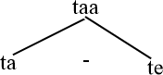
B. taa taa taa taa.

C.
taa | taa | taa | taa
ta-te | Ta-te | Ta-te | Ta-te

Creating Rhythm.
Rhythms are created by combining short and long sounds in different ways.
Sound taa will be used to represent long sounds. Sound ta-te represents shorts sounds. The sound taa and ta-te will be combined in creating different rhythms.

Appreciation of rhythms created.
🢖 Rhythms created can be shared. This can be done through clapping or tapping the rhythm and exchanging with classmates.
🢖 The more you exchange, the more rhythms you get.
🢖 Sharing rhythm created helps in making corrections and making them better.

Recording rhythms.
- There are two types of recordings: video and audio recording,
- In video recording, both sounds and pictures are recorded.
- In audio sound, only sound is recorded.

Audio recording.
- Take a device close to person clapping the created rhythm.
- Ensure the environment is quiet.
- Go to recorder.
- Touch red to start recording.
- Touch red to stop recording.
- Use the save button to save the recording.
- Share the recording with your friends.

Video recording.
- Go to camera.
- Select video.
- Focus the camera on the individual clapping the rhythms.

- Touch the red button to start recording.
- Touch the red button to stop and save the recording.
- Share the recording with your friends.

1.4 Composing melody.

Singing d r m.
Pitch is how high or low sound is. Sound can be high in pitch.
Sound can also be low in pitch.
doh, re and mi are some of the pitch names. They can also be written as d, r and m.
re is higher that doh in pitch. mi is higher that re and doh.
doh , re and mi sounds move up in pitch as shown below.
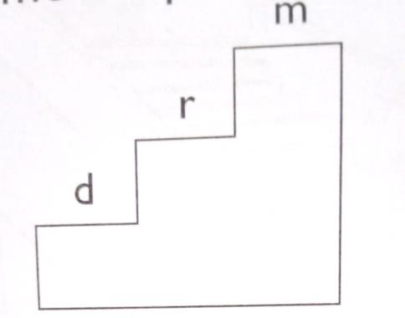

mi , re and doh sounds move down in pitch as shown below.
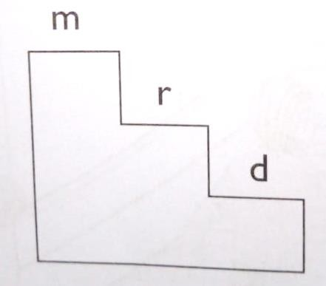

The sol-fa syllabus.
doh, re and mi are examples of sol-fa sounds. They are also called sol-fas.
These solfas can also be written as d r m. d r m are of different sounds.
The sounds d r m can be combined to make tunes,

Making melodies using doh, re and mi.
A melody is also a tune.
Making melodies is also called composing or creating melodies. Good melodies are made if different pitches.
Good melodies are remembered for a long time. doh, re and mi are of different pitches.
doh, re and mi are called sol-fa names.
We can make melodies using doh, re and mi.

Making melodies for descant recorder using B, A and G.
A melody is also called atune. Melodies are made of different pitches.
Good melodies are remember for along time. B, A and G are of different pitches.
When B is mi, A is re and G is doh, as shown in the diagram below.

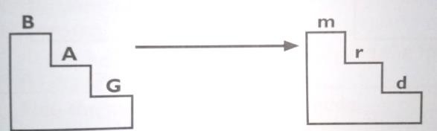

We can make melodies using B, A and G.

Interpreting melodies can made by:
- Repeating sounds.
- Using sounds that are higher or lower by a step.
- Using sounds that are higher or lower by a skip.

STRAND 2. PERFORMANCE AND DISPLAY.
2.1 Athletics.

Sprint start in Athletics.

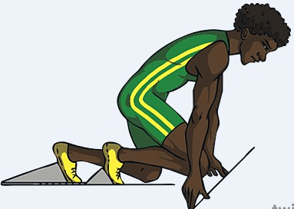
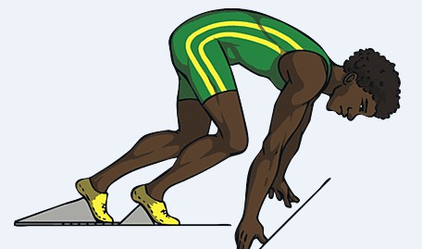

🢝 Starting blocks are used by athletes in sprint races.
🢝 A starting block is a fixed object with an angled surface which the athlete uses to push off from at the start of a race.
🢝 It helps to increase the starting speed of an athlete.

Learning Points.
The setup of the starting block is done in the following way before an athlete assumes the preferred start position.
⭢ Place the start of the block rail one step from the start line.
⭢ Position the front block two steps from the start line.
⭢ Position the back block three steps from the start line.
⭢ Place the feet so that the tip of your running shoes touch the track.
⭢ Your body weight should push into the blocks.

⭢ Kneel on the back leg.
⭢ Place your hands wider than should-width apart behind the starting line.
⭢ Keep your fingers together and thumbs in.

Types of Sprint starts.
- Bunch or bullet start-the toes of the rear foot are approximately levelled with the heel of the front foot. Both feet are placed well back from the starting line.
- Medium start-the knee of the rear leg is placed opposite at a point in the front half of the front foot.
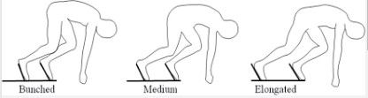
- Elongated start-the knee of the rear led is level with or slightly behind the heel of the front foot.

Athletics rules.

Observe the following rules when performing the bunch, medium and elongated sprint to ensure safety.
- Perform the given warm up activities before participation.
- Check the ground to ensure that it is not slippery and does not have obstacles.
- Use the lane assigned to you throughout.
- Follow the sprint start commands when starting a race.
- Ensure that the starting block being used is firmly fixed on the ground.

2.2 Gymnastics.

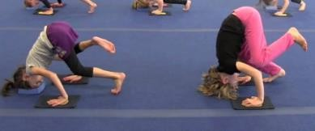
Balances and rolls in gymnastics. Head balance.

- The headstand, or sometimes head stand, is a pose that is an inversion posture of standing head down.
- One should slowly lift their legs from a tucked position and then extend their hips and legs to balance in an extended headstand

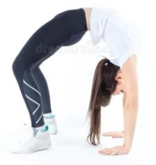
Crab balance.

This is a balance of your body weight on your hands and legs while the front of your body faces up towards the ceiling.

Backward roll.
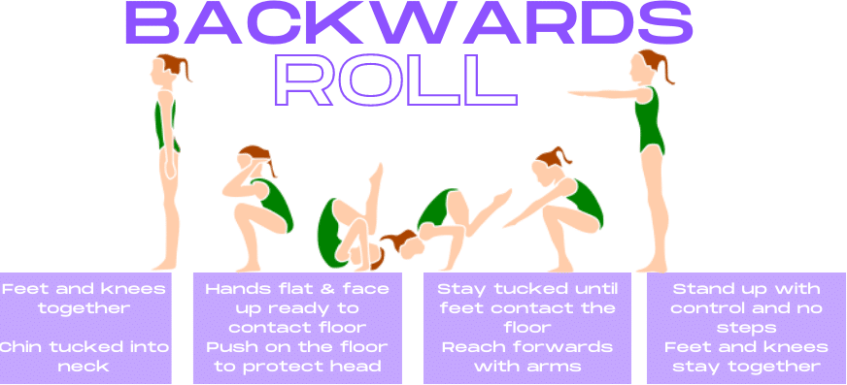

Side roll.
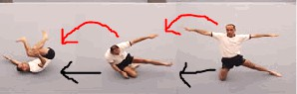

✰ This can be started by lying down on the back or front with the body outstretched. The gymnast then rolls onto their side and does a complete rotation of the body, remaining parallel to the performing surface.

2.3 Descant recorder.
- A descant recorder is a wind instrument.
- It is played by blowing.

Parts pf a recorder.
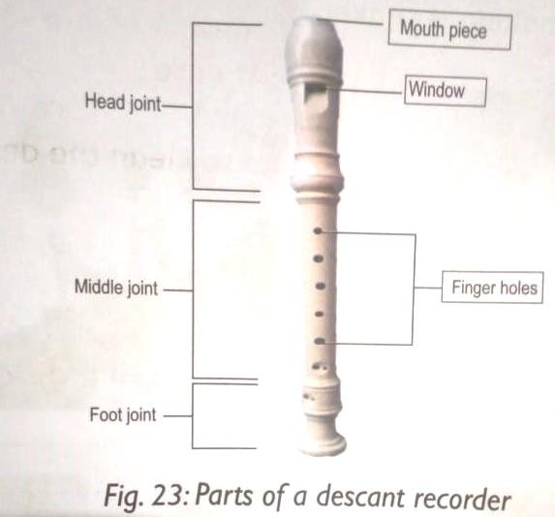
- The descant recorder is played by blowing.
- The mouth piece of the instrument is placed in the mouth.
- It is important to clean the descant recorder before and after playing it. This helps to prevent spread of germs and so keeps us healthy.
- To clean a descant recorder:
  - Gently pull the three pieces of the instrument apart.
  - Ise clean warm water and soap to clean.
  - Wipe each part with a clean dry cloth.
  - Put the descant recorder back in its case.

Care for and maintenance of descant recorder:
🢖 Observe hygiene by cleaning before and after playing.
🢖 The instrument should be stored properly.
🢖 When in use, the instrument should be handled properly to avoid breakage or damage.

Playing notes B A G on a descant recorder using correct techniques.
🢖 A descant recorder is played by blowing and fingering to produce different sounds.
🢖 Sit on a chair or stand straight.
🢖 Place the mouth piece between your lips.
🢖 Hold the descant recorder by placing the left hand on the upper side and the right hand on the lower side.
🢖 To play a descant recorder, we use all the fingers except the right-hand thumb and the left- hand small finger.
🢖 The right-hand thumb is used for supporting or holding the descant recorder in good position.
🢖 The sounds of a descant recorder are names using alphabets A B C D E F G.
🢖 The sounds are also called notes.
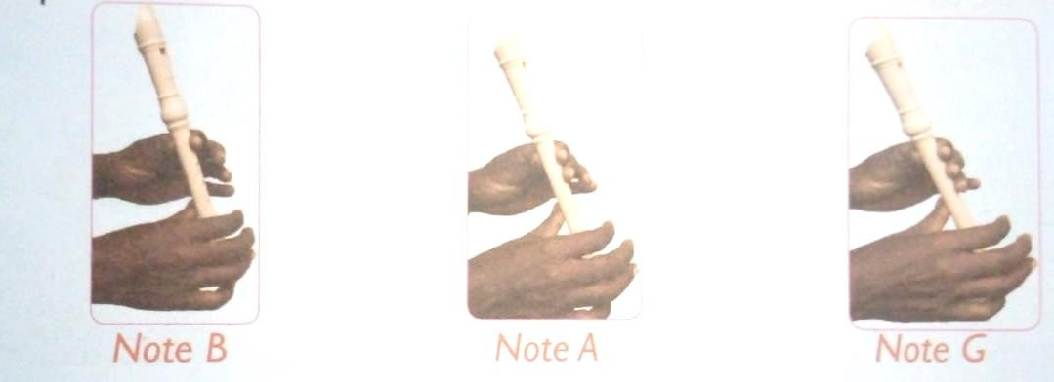

Playing notes B.
🢖 Cover the back hole with the left-hand thumb and the top first hole with the first finger.
🢖 The right-hand thumb should support the recorder.
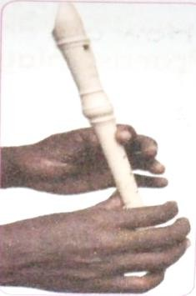

Playing note A
🢖 Cover the top two holes with the first finger and the index finger of the left hand.
🢖 Cover the back hole with the left thumb.
🢖 The right-hand thumb should support the recorder.
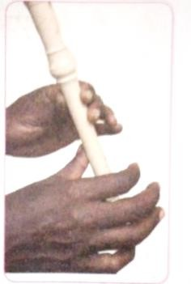

Playing note G.
🢖 Cover the back hole with the left-hand thumb and the top three holes with first finger, index finger and the ring finger of the left-hand.
🢖 The right-hand thumb should support the recorder.
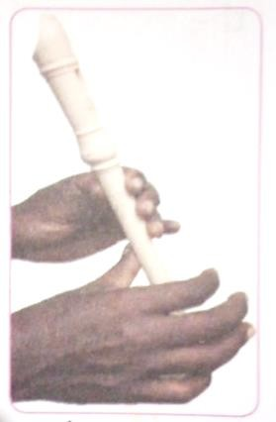

2.4 Swimming.

Crouch surface dive in swimming.
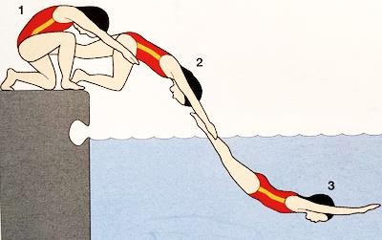
✰ Stance-In crouch surface dive one places their feet on the pool edge with one foot forward and one foot back, curling the toes of the front foot over the edge.
✰ Push-off -Weight is transferred from the back foot to the front foot as the swimmer 'tips' forward into the water, pushing against the pool edge with their toes.
✰ Descent – swimmer is in flight sessions which is between the pool side wall and water surface, his body is in a streamlined shape with hands forward above the head and legs backward put together
✰ Entry- the swimmer enters the water

Standing surface dive in swimming.
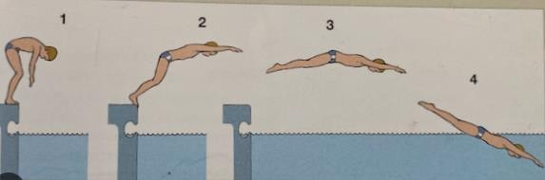

✰ Stance-In standing surface dive one places his or her feet together while standing on the sidewall top of the pool edge.

✰ Push-off -The swimmer 'tips' forward into the water, pushing against the pool edge with their toes.
✰ Descent – swimmer is in flight sessions which is between the pool side wall and water surface, his body is in a streamlined shape with hands forward above the head and legs backward put together
✰ Entry- the swimmer enters the water

Safety rules to observe while doing crouch and standing surface dives.
- Do some warm up activities before the exercise.
- Ensure entry is safe.
- Ensure the skills are executed well as trained to avoid slipping and injuries.
- Always consider safety of others.
- Determine the depth of the pull before diving.

2.5 Songs.
Singing different types of songs.
- There are different types of songs.
- The songs give us messages.
- Evry song has its own rhythm.
- Sing the song with correct dynamics. Dynamics tell us about the volume of the song. A song can be loud or soft.

Examples of types of songs:
a.) Action songs.
🢖 These are songs that are sung with actions.
🢖 The actions show the meaning of the words in the song.
🢖 The actions should be done in rhythm to the song.

Example of an action song.
Askari ee, vitani ee, Askari ee, vitani ee
Amevaa magwanda, buti, kofia ya chuma, linda nchi.

Importance of action songs.
  - Build strength in the body.
  - Helps to learn new things.
  - Helps in enjoyment and having fun.
  - Helps to make friends.
  - Hels to exercise our bodies.

b.) Patriotic songs.
🢖 These are songs that tell of our love for our country.
🢖 Our country is very important because it is our home.
🢖 Patriotic songs tell us to take care of our country, take care of the people, animal, plants, lake, rivers and everything in our country.
🢖 Some patriotic songs are a prayer for out country.
🢖 The songs may also praise our leaders.

Example of an action song.
Nchi yangu, nchi yangu. Kenya, kenya, kenya.
Nchi yangu, chini yangu. Naapa kipenda.
c.) Sacred songs.
🢖 Sacred songs are songs sang during religious activities, for example worshipping God.
🢖 The songs help us to have good behaviour such as kindness, love, sharing, forgiveness and honesty.
🢖 Some sacred songs are performed fast and other slowly.
Example of sacred song that has a message of love. This is my commandment that you love one another. That your joy may be full.
This is my commandment, that you love one another. That your joy may be full.
That your joy may be full. That your joy may be full.
This is my commandment, that you love one another. That your joy may be full.

d.) Topical songs
🢖 Topical songs are songs about the issues affecting the society at a given time.

Example of topical song.
Maji ni uhai, Maji ni uzima. Tuyatunze maji, Kwa uhai wetu.

Kenyan folk songs.
- Folk songs are sung by the people of a particular area or community.
- They are sung by:
⭧ Men.
⭧ Women.
⭧ Boys.
⭧ Girls.
⭧ Boys and girls together.
⭧ Men and women together.
- The songs are about people’s lives and activities.
- They give us message.
- They make us enjoy ourselves.
Types of Folk songs.
✰ Work folk songs-talk about work or daily activities.
✰ Funeral folk songs-performed in funerals and during burials.
✰ Naming folk songs -used during naming ceremonies of new bone.
✰ Initiation folk songs -performed during initiations as right of passage.
✰ Marriage folk songs -talk about marriage
✰ Worship folk songs -They pass massages about peoples worship experience and the God.

