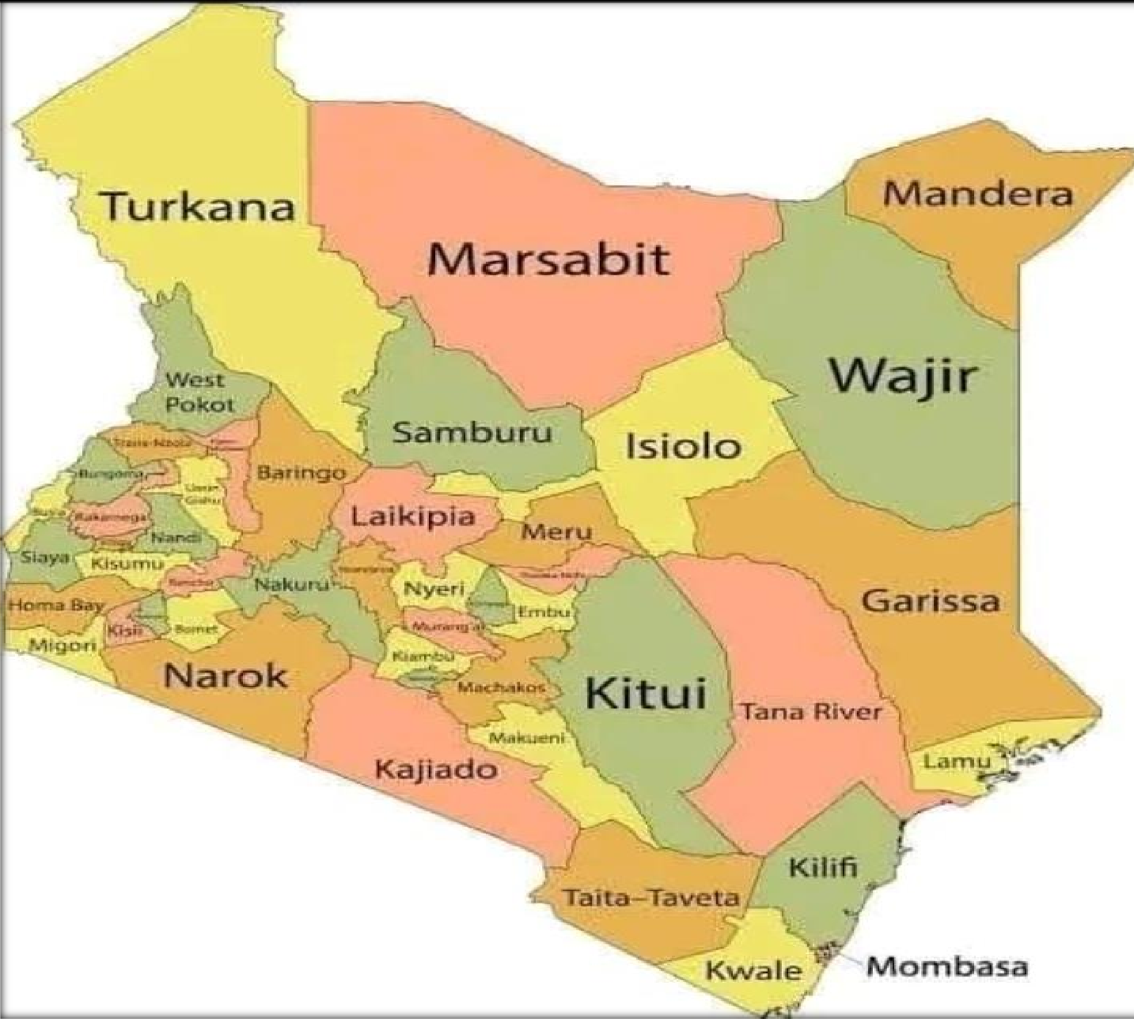










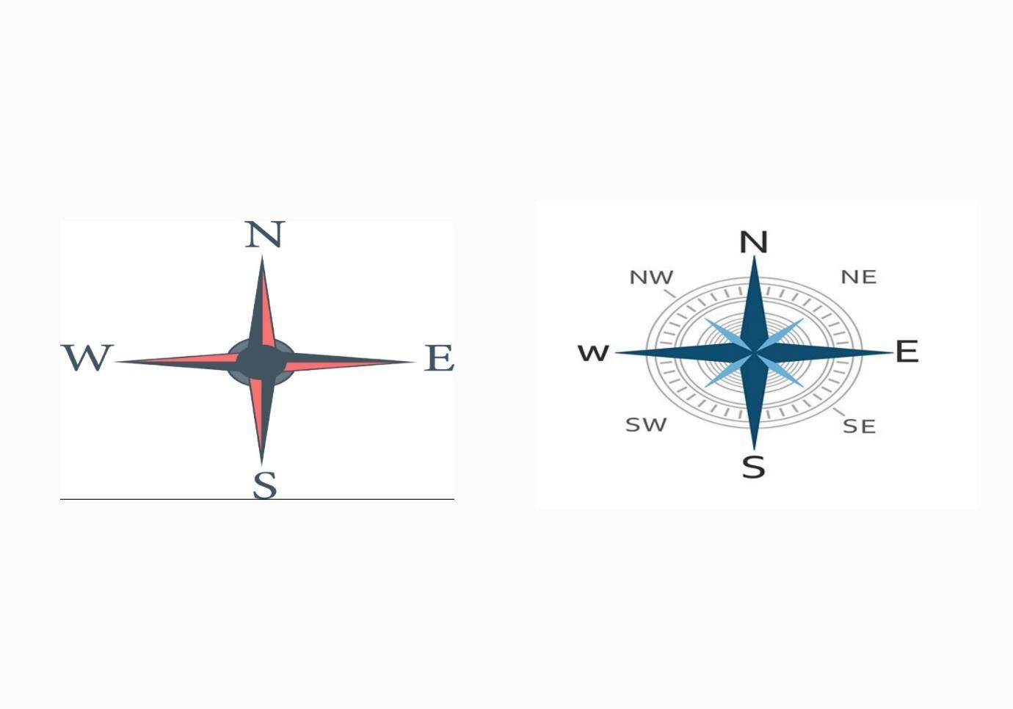

NATURAL AND BUILT ENVIRONMENT
Natural environment
Compass direction
A compass is an instrument used to give direction.
It has a needle that always point to the north.
A compass helps to establish the direction of one place from another. The four main points of a compass are known as cardinal points.
These points are: North, South, East and West. There are four other intermediate points.
They lie halfway between the cardinal points.

Map
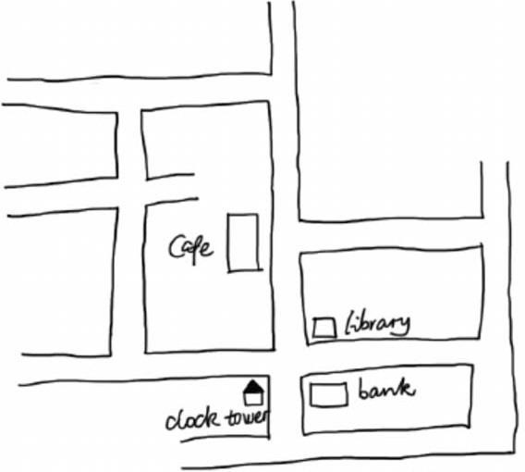
A map is a drawing that shows a part of the land and the things on the land.

Location and size of the county
Kenya is divided into parts called counties. Kenya has 47 counties.
A county is an area in the country that has its own government.

The largest county in Kenya is Turkana.
A county which has the capital city in Kenya is Nairobi. The smallest county in Kenya is Mombasa.
Our school is located in Narok County.

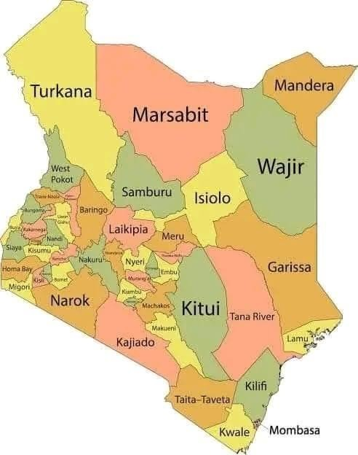
T

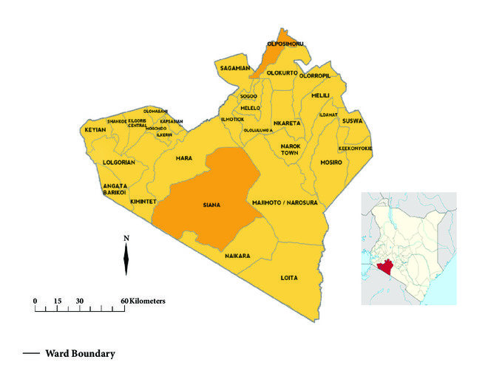
LOCATION OF NAROK COUNTY

SUBCOUNTIES IN NAROK COUNTY
Narok County comprises seven (7) sub-counties namely:
- Narok North,
- Narok West,
- Narok East,
- Narok South,
- Transmara East
- Transmara West.
- Transmara South.

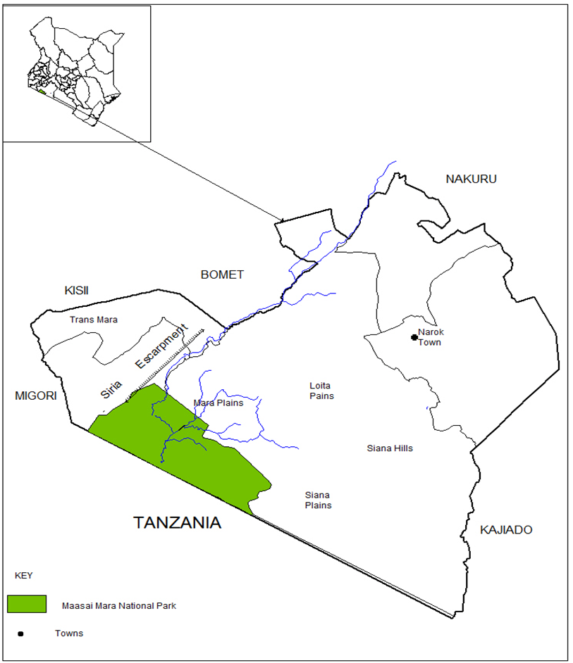
THE NEIGHBOURS OF NAROK COUNTY

- Every county in Kenya shares a boundary.
- Counties that share a boundary line with each other are said to be neighbours
- A boundary is an imaginary line that separates a place from another
Narok County is bordered by several other counties and international boundaries. The neighboring regions are:
- Nakuru County – To the north of Narok.
- Bomet County – To the east of Narok.
- Kajiado County – To the southeast of Narok.
- Kisii County – To the west.
- Migori County – To the South west.
- Tanzania – To the south, Narok shares an international border with Tanzania.
These neighboring counties contribute to the region’s diversity in terms of culture, economy, and geography. Narok’s proximity to Tanzania also makes it an important gateway for trade and tourism in the region

MAJOR PHYSICAL FEATURES IN NAROK COUNTY
Narok county is rich are physical features including:
- Rivers
- Valleys
- Hills
- Forests
- Swamps
- Plains
- Grasslands

Rivers
Narok County is home to several rivers that play a significant role in the region's agriculture, wildlife, and overall ecosystem. Some of the notable rivers in Narok County include:
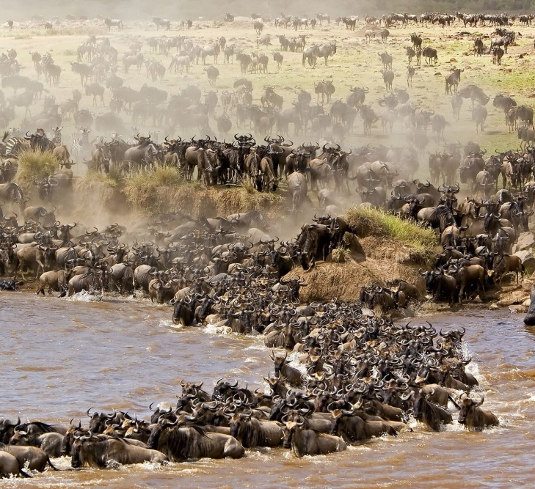
- Mara River – This is the most famous river in Narok County, as it flows through the Maasai Mara National Reserve. The Mara River is particularly well-known for its dramatic crossings during the Great Wildebeest Migration, where thousands of wildebeest, zebras, and other animals attempt to cross the river while evading predators.

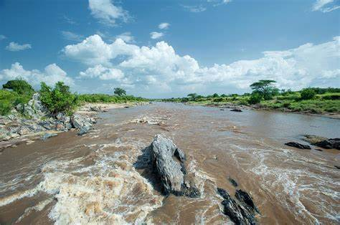

- Ewaso Ng'iro River – A major river that flows through the southeastern part of Narok County, it is important for irrigation and local agriculture. It passes through various towns and provides water for both people and livestock.
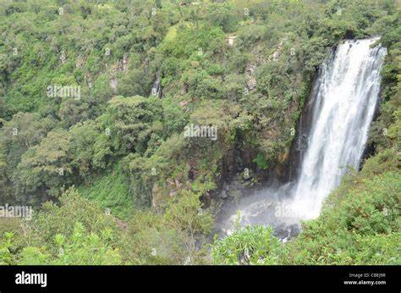
- Ngoswani River – This river flows through parts of the Narok region and is a key water source for communities in the area.
- Ololunga River – Another river that contributes to the water supply in parts of Narok County, especially in the southern regions.
- Sekenani River – This river is found within the Maasai Mara ecosystem and is an important water source in the area.
- Talek River – A smaller river that also flows through the Maasai Mara, supporting both the local wildlife and surrounding communities.
- Siana River – A small river that flows through the area, providing water to local communities and supporting farming activities.
- Maji Moto River – This is another small river located near Kilgoris, which serves as an important water source for the local populations and their livestock.
- Olenguruone River – Flowing through the Kilgoris region, this river contributes to local agriculture and helps maintain the ecosystem.
- Ithumba River – A smaller river in the region that plays a role in providing water to nearby farms and settlements.
These rivers provide crucial water resources for both the local communities and wildlife in the region. The Mara River, in particular, is central to the Maasai Mara National Reserve's ecology, supporting the diverse animal population found there.

Swamps
Narok County, with its diverse geography, is home to several swamps and wetlands that play a critical role in maintaining the region's ecosystem, supporting wildlife, and providing water resources for local communities. Some notable swamps in the county include:
- Mara Swamp – Located near the Maasai Mara National Reserve, the Mara Swamp is a key wetland area that supports both the wildlife and the local population. It is part of the broader Mara River Basin and is critical for regulating the flow of the Mara River, particularly during the rainy season.
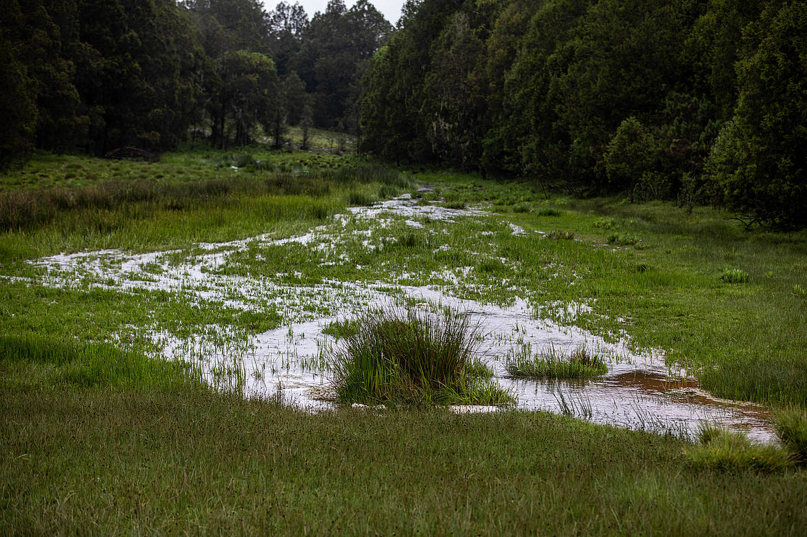

- Loita Swamp – Situated in the Loita Hills region of Narok County, Loita Swamp is an important wetland that helps regulate water flow and provides a habitat for various species of birds and other wildlife. It is located in a key watershed area that feeds into the larger Ewaso Ng'iro River system. 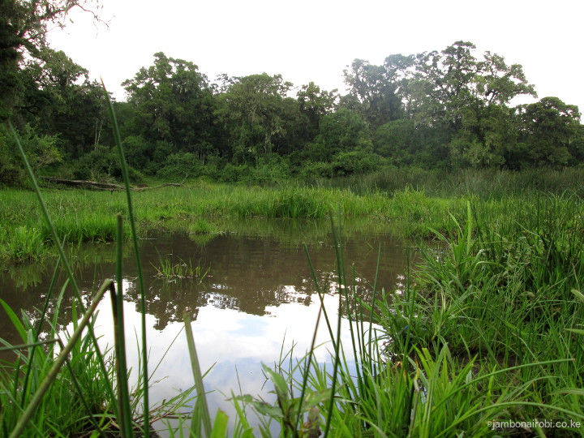

- Siana Swamp – Found near the Siana Conservancy in Narok County, this swamp is a vital wetland area that supports a variety of flora and fauna. It contributes to the water needs of local wildlife in the surrounding areas of the Maasai Mara ecosystem.
- Talek Swamp – Located near the Talek River in the Maasai Mara ecosystem, this swamp is another important wetland in Narok County. It provides water to both the local communities and wildlife.
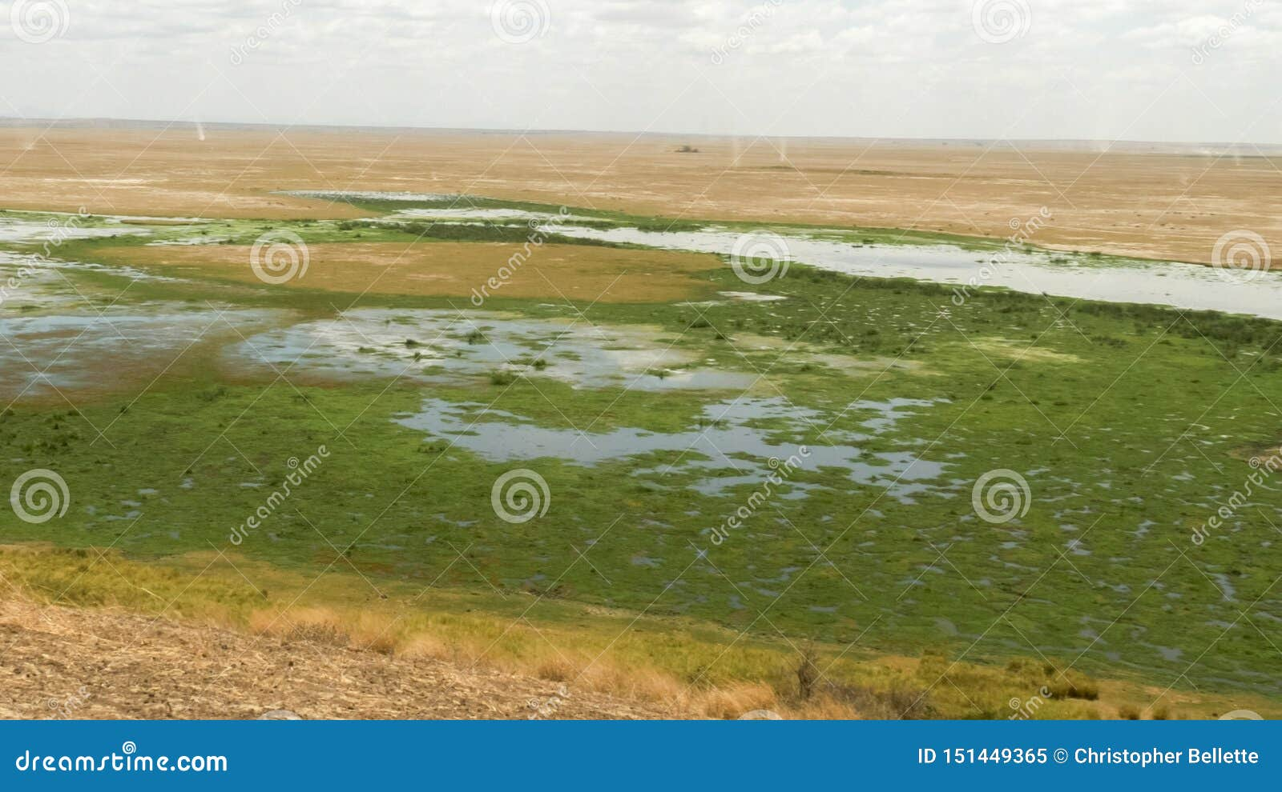
These swamps are essential for water conservation, agricultural activities, and maintaining the biodiversity of Narok County. They also serve as important habitats for various species of birds and aquatic animals, and they help in controlling floods and maintaining the ecological balance in the region.

Hills
Narok County, located in Kenya’s Rift Valley, is characterized by diverse landscapes, including highland areas with several notable hills. Some of the prominent hills in Narok County include:
- Loita Hills – These are some of the most well-known hills in Narok County, located to the south-east of Narok Town. The Loita Hills are an important feature of the area, supporting both the local Maasai communities and wildlife. The hills are also rich in biodiversity and serve as a watershed for several rivers that flow through the region.
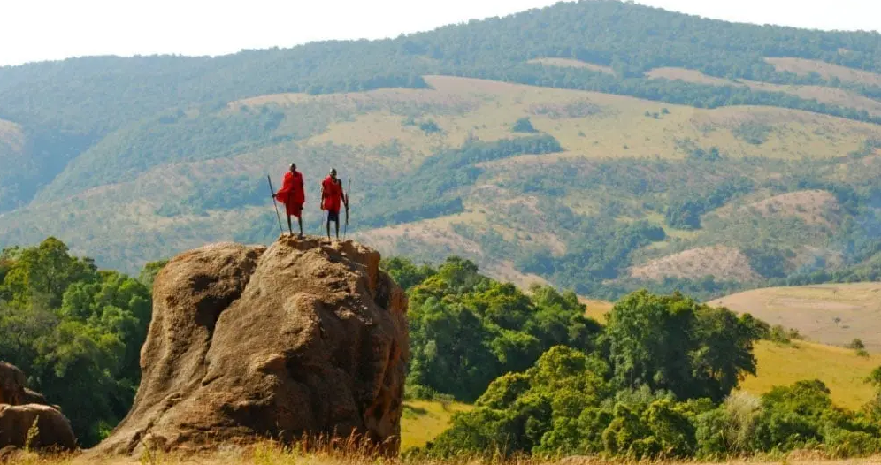

- Maasai Mara Hills – Located in the Maasai Mara region, these hills are part of the larger Maasai Mara ecosystem. The terrain here is diverse, with undulating hills and grasslands, offering panoramic views of the savannah and supporting a variety of wildlife species.
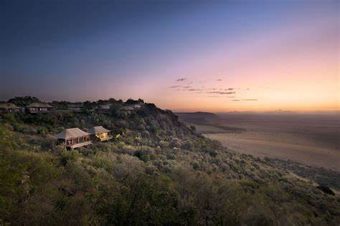
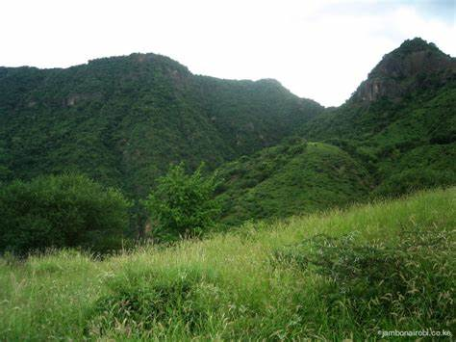
- Nguruman Hills – These hills are situated in the western part of Narok County, near the border with Kajiado County. Nguruman Hills are known for their steep slopes and unique vegetation. The area is also famous for the Nguruman escarpment, which offers dramatic views and is part of the larger Great Rift Valley.

- Enkutoto Hill – Found in the southern part of Narok County, this hill is part of the larger Maasai Mara region and is situated within the pastoral lands inhabited by the Maasai people. It provides elevated views of the surrounding plains and is part of the scenic landscape of the Mara ecosystem.
- Ololaimutiek Hills – Located near the western border of Narok County, the Ololaimutiek Hills form part of the broader Loita Hills range. These hills are home to wildlife and play an important role in the local ecosystem.
- Olorien Hills – Situated in the Kilgoris area, these hills contribute to the region's overall topography and offer elevated views of the surrounding plains. They are part of the broader Loita Hills range and are important for both local farming and pastoral activities.
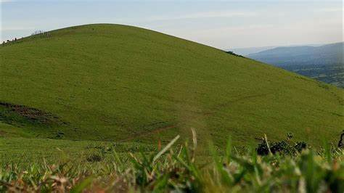
- Mount Love

- is a notable mountain located near Kilgoris, in the southern part of Narok County. It is situated within the broader Loita Hills range, an area known for its scenic beauty and ecological significance.
Mount Love is not a very large or widely known peak in terms of national recognition, but it holds importance locally due to its position and the role it plays in the environment and the lives of the people in the surrounding areas.

The mountain is known for its picturesque views and is often visited by locals for various purposes, including grazing livestock and as a destination for hiking or exploration. The region around Mount Love is also culturally significant, with the Maasai people living nearby and using the land for pastoralist activities.

These hills not only contribute to the physical geography of Narok County but also have cultural, ecological, and economic significance for the local communities, particularly the Maasai people who inhabit the region. Additionally, they provide important natural resources and contribute to the rich biodiversity found in the county.

Forests
Narok County is home to several important forests and forest reserves that contribute to the region's biodiversity, water conservation, and the livelihoods of local communities. Some of the key forests in Narok County include:
- Loita Forest
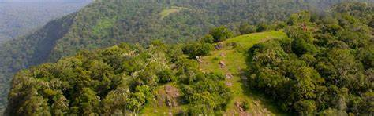
Located in the Loita Hills region, Loita Forest is a crucial indigenous forest in Narok County. It is rich in biodiversity and supports numerous plant and animal species. The forest is also important for water conservation, as it feeds into rivers that are vital for the surrounding agricultural communities. The Maasai people, who live in the region, also value this forest for cultural and practical purposes, such as gathering medicinal plants and firewood.

- Mara Forest Reserve
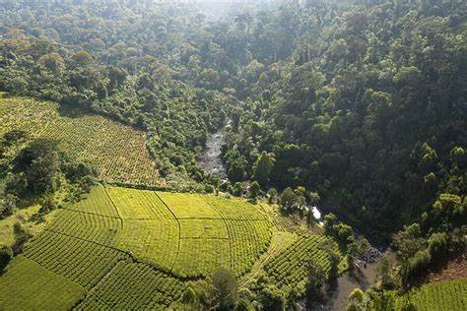
Situated near the Maasai Mara National Reserve, Mara Forest Reserve is an essential area for maintaining the ecological balance of the Mara ecosystem. It plays a critical role in water regulation and soil conservation, supporting both the local communities and wildlife. The forest is also important for tourists visiting the Maasai Mara, as it is home to a variety of wildlife species.

- Nguruman Forest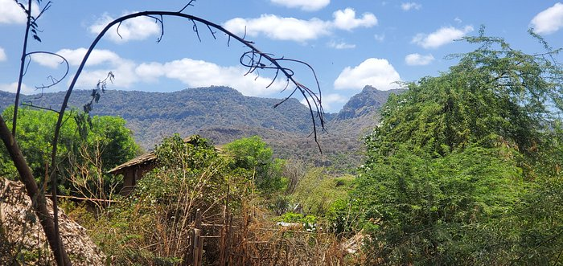
Found near the Nguruman escarpment in the western part of Narok County, Nguruman Forest is another significant forest area. The forest contributes to biodiversity conservation and water regulation for the region. It is also vital for preventing soil erosion in the area, especially given the steep topography of the Nguruman escarpment.

- Oloololo Forest
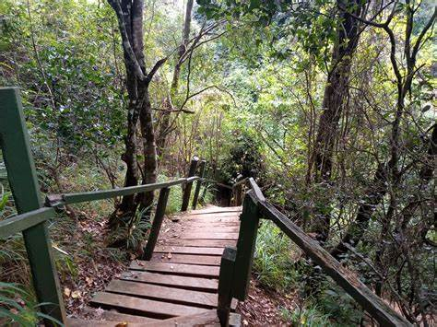

Located near the Maasai Mara National Reserve on the western side, Oloololo Forest is an important part of the Mara ecosystem. This forest helps in maintaining the hydrological balance of the area, contributing to the Mara River and other water sources that sustain both wildlife and local communities.

- Maji Moto Forest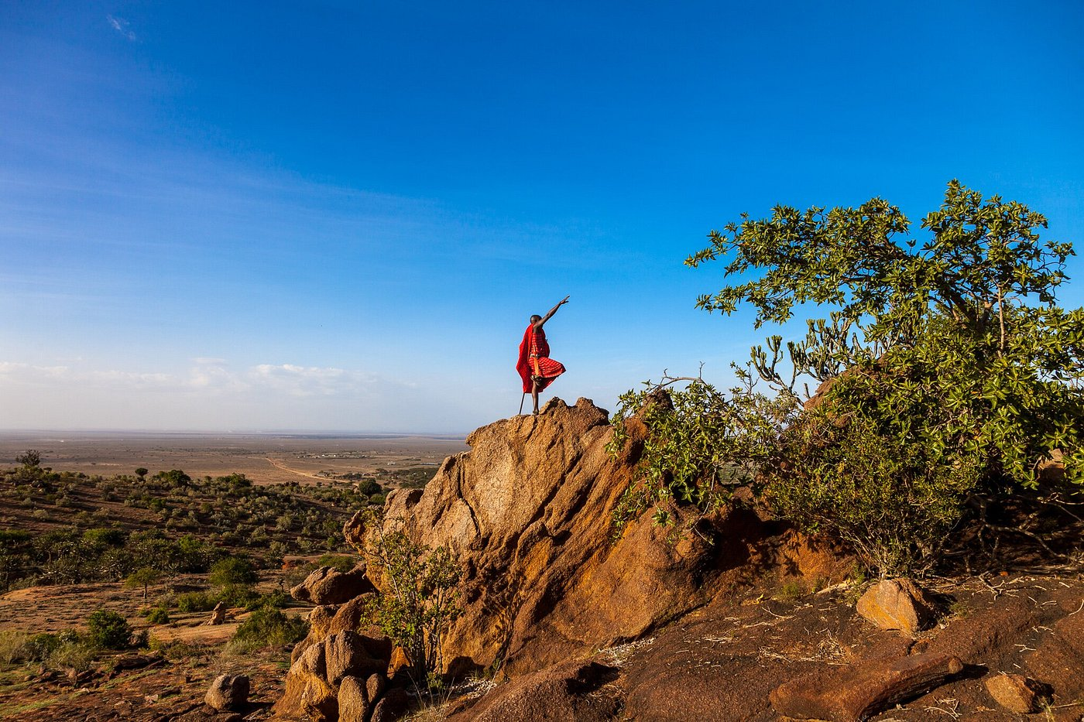
In the southern part of Narok County, the Maji Moto Forest plays a key role in providing water resources for nearby communities and supporting local agriculture. It is part of the broader Maasai Mara ecosystem and provides a habitat for a variety of wildlife species.

- Mau Forest is one of the largest and most significant forest ecosystems in Kenya. It spans several counties, including Narok, Bomet, Nakuru, Kericho, and others, and is a vital environmental resource for the country. In particular, a portion of the Mau Forest is located in Narok County.
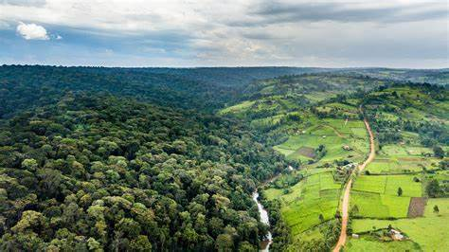

Key Features of the Mau Forest:
- Size and Importance:
  - The Mau Forest Complex covers an estimated 400,000 hectares, making it one of the largest forests in Kenya.
  - It is a crucial water catchment area for several major rivers, including the Mara River, Ewaso Ng'iro River, and Nyando River, which provide water for agriculture, hydropower generation, and human consumption.
  - Mau Forest also contributes to the regulation of the climate in the region, maintaining rainfall patterns and supporting biodiversity.

- Ecological Significance:
  - Mau Forest is home to diverse wildlife, including species such as elephants, buffaloes, leopards, and rare bird species. It is part of the Greater Mau Ecosystem, which is essential for Kenya’s biodiversity.
  - The forest acts as a critical water catchment area, supporting both the agricultural and pastoral communities in surrounding areas by regulating water flow and preventing soil erosion.
- Human Activities and Conservation Issues:
  - Over the years, the Mau Forest has faced significant threats due to deforestation, illegal logging, and encroachment for agricultural purposes. These activities have led to forest degradation, negatively impacting water sources, wildlife, and the climate.
  - The Kenyan government and conservation groups have made efforts to restore the forest through reforestation and conservation programs to protect this important resource.
  - The forest is vital to the livelihood of surrounding communities, particularly the Maasai people in Narok County, who rely on the forest for water, grazing land, and other resources.

- Mau Forest in Narok County:
  - The Mau Forest in Narok County is part of the broader Mau Forest Complex, and it plays a significant role in the region’s water supply, supporting local agriculture and pastoralism.
  - The forest is situated near key areas such as Maasai Mara, which depends on the water resources from the Mau to support both wildlife and human populations.
These forests are vital not only for environmental conservation but also for the cultural and economic well-being of the local Maasai communities. They support agriculture, offer medicinal plants, and serve as grazing grounds for livestock, all while contributing to the preservation of the region’s natural heritage.

Plains
Narok County is known for its expansive plains, which are essential for agriculture, grazing, and wildlife. These plains, particularly in the Maasai Mara region, offer vast landscapes that are not only critical to the local economy but also play a crucial role in the region’s ecological systems. Here are some notable plains in Narok County:
- Maasai Mara Plains:
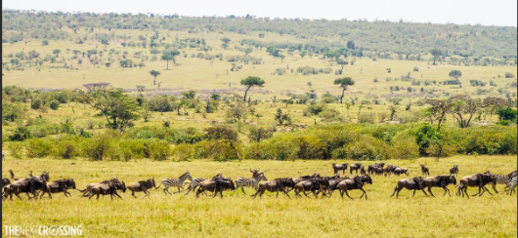

  - The Maasai Mara Plains are perhaps the most famous plains in Narok County, forming part of the larger Maasai Mara National Reserve. These vast savannahs are home to a diverse range of wildlife, including the "Big Five" (lion, leopard, elephant, buffalo, and rhinoceros), and serve as the backdrop for the renowned Great Wildebeest Migration, one of the most spectacular wildlife events in the world.
  - The plains are also used by local Maasai pastoralists for grazing their livestock, which is central to their way of life.

- Loita Plains:
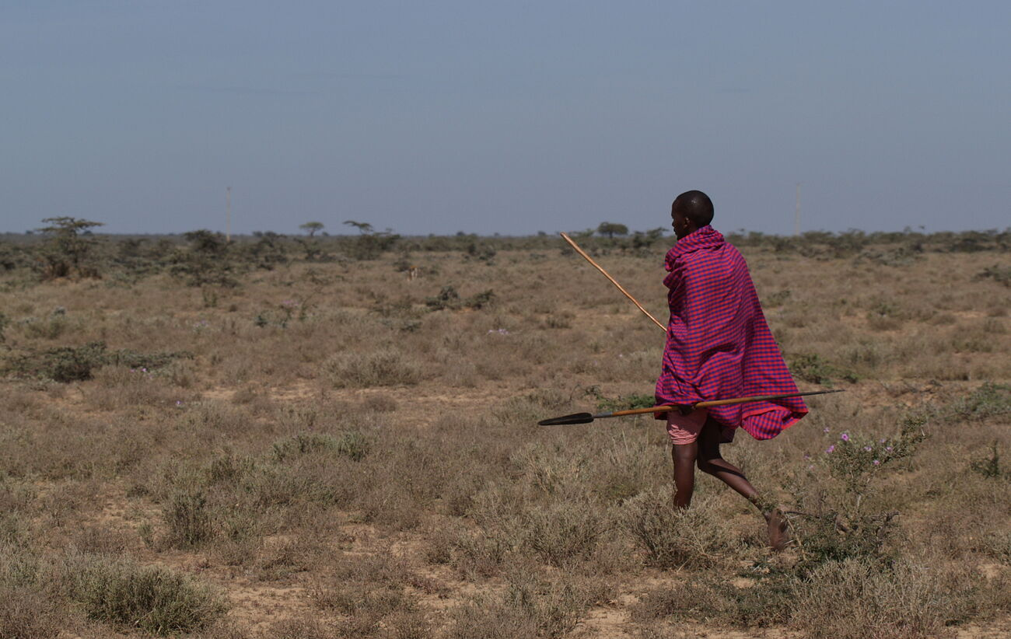
  - Located in the Loita Hills region of southern Narok County, the Loita Plains are another expansive area of grassland. The plains are important for both pastoralism and agriculture. The Loita Plains also support wildlife and serve as a key grazing ground for Maasai herders, who practice traditional pastoralism in the area.
- Siana Plains:
  - Situated near the Siana Conservancy, the Siana Plains are part of the larger Maasai Mara ecosystem. These plains are home to a variety of wildlife and are important for grazing livestock. The Siana Plains also contribute to the scenic beauty of the Maasai Mara region, with wide-open spaces and grasslands extending over vast areas.
- Narok Plains:
  - The Narok Plains are located around the town of Narok, the county’s administrative capital. These plains are used for agriculture, particularly crop farming and livestock grazing. The area has fertile soils, which support farming activities, and the plains are part of the broader agricultural landscape of Narok County.

Importance of the Plains:
- Agriculture: These plains support large-scale farming, especially in the Narok region, where both crop farming and livestock grazing are essential to the local economy.
- Pastoralism: For the Maasai communities, the plains provide vital grazing land for cattle, sheep, and goats, which are key to their cultural and economic life.
- Wildlife Conservation: The plains in the Maasai Mara and surrounding areas are crucial for wildlife conservation. They provide habitat for a wide range of species and are part of a larger ecosystem that supports the annual wildebeest migration and other wildlife tourism activities.
In summary, the plains in Narok County, particularly in the Maasai Mara, Loita, and Siana regions, are critical to the local environment, economy, and culture. They support wildlife conservation, livestock grazing, and agriculture, making them integral to the county's natural and human systems.

Valleys
Narok County, located in the Rift Valley region of Kenya, is characterized by dramatic topography, including several notable valleys. These valleys are part of the broader Rift Valley system and are important for agriculture, water resources, and biodiversity. Here are some key valleys in Narok County:
- Maasai Mara Valley:
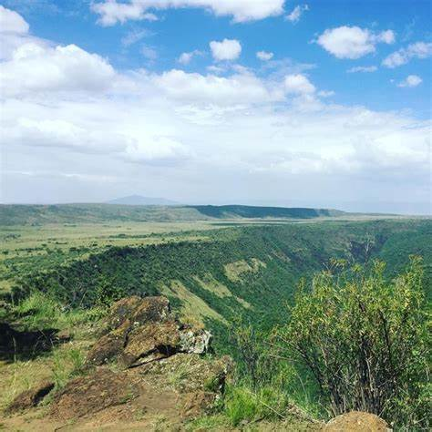

  - The Maasai Mara Valley is located within the Maasai Mara National Reserve and is part of the larger Great Rift Valley system. The valley is characterized by vast open plains and grasslands, which support diverse wildlife, including the iconic wildebeest migration. The Maasai Mara Valley is an important part of the Maasai Mara ecosystem and plays a role in water drainage and wildlife habitat.
- Loita Valley:
  - The Loita Valley is situated in the Loita Hills region in southern Narok County. This valley is an important part of the local Maasai land and provides grazing areas for livestock, as well as agricultural land for local communities. The Loita Valley is also ecologically significant, as it helps regulate water flow in the region and supports biodiversity.
- Nguruman Valley:
  - The Nguruman Valley lies in the western part of Narok County, near the Nguruman Escarpment. This valley is part of the Great Rift Valley and is known for its steep cliffs and unique geological features. It also has a rich biodiversity, with many plant and animal species that thrive in the valley's ecosystem. The valley is important for the local communities and agriculture, particularly around the Nguruman area.

- Ewaso Ng'iro Valley:
  - The Ewaso Ng'iro Valley is formed by the Ewaso Ng'iro River, which flows through the southeastern part of Narok County. The valley is critical for agriculture and livestock farming in the region, as the river provides essential water resources for irrigation and domestic use. The Ewaso Ng'iro Valley is a vital area for both human populations and wildlife.

Importance of the Valleys:
- Water Resources: Many of the valleys, especially those associated with rivers like the Ewaso Ng'iro and the Mara River, are crucial for water supply in the region. These valleys sustain local communities, agriculture, and wildlife.
- Agriculture: The fertile lands in some of the valleys, particularly in the Loita Valley and Nguruman Valley, support both crop farming and pastoralism, which are central to the livelihoods of the local communities.
- Wildlife Habitat: Valleys like the Maasai Mara Valley are key wildlife habitats, supporting large populations of herbivores, carnivores, and other species. The valleys are also important for tourism, particularly in the Maasai Mara region, which is known for its rich wildlife and the Great Wildebeest Migration.
In summary, the valleys in Narok County, such as the Maasai Mara Valley, Loita Valley, Nguruman Valley, and Ewaso Ng'iro Valley, play a crucial role in the county's ecology, economy, and culture, supporting agriculture, wildlife conservation, and the well-being of local communities.

HISTORICAL BUILT ENVIRONMENTS IN NAROK COUNTY'
Narok County, rich in both natural and cultural heritage, is home to several historical built environments that reflect the region's long history and the cultural practices of its indigenous people, particularly the Maasai. While Narok is primarily known for its natural landscapes, some historical sites and built environments stand out due to their significance in the region's development and culture. Here are a few examples:

Traditional Maasai Bomas:
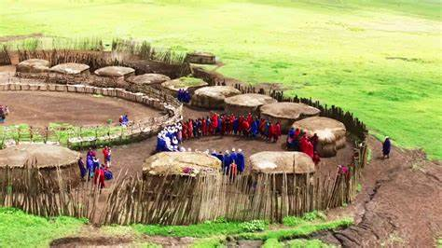
- The Maasai people, who are the dominant ethnic group in Narok County, have a rich cultural heritage that is expressed through their traditional bomas (homesteads)
- These traditional houses are called manyattas

- These bomas are built using locally available materials such as mud, timber, and grass, and they are organized in a circular fashion. The structure of a Maasai boma often includes enclosures for cattle, which are central to Maasai pastoralist life, and houses made of mud and thatch for the family. These traditional homesteads are not only functional but also reflect the Maasai social structure and lifestyle.
- While these bomas are not formal "built environments" in the urban sense, they are deeply rooted in the historical and cultural practices of the Maasai people and have been in use for generations.

Old Mission Stations and Churches:
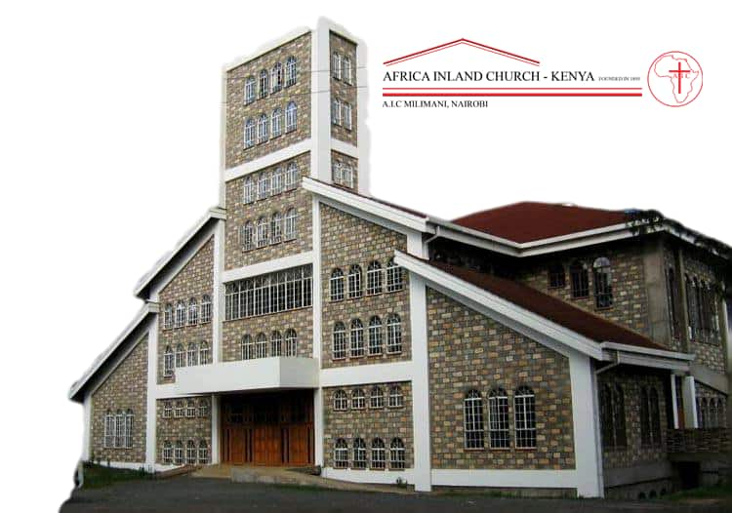

- Missionaries established several stations in Narok County during the colonial period. These stations were some of the first formal built environments in the region. Churches and mission schools were often the focal points of these stations, serving as centers for education and Christianity.
- Some of the old mission stations have remained part of Narok's historical fabric. Churches like the Anglican Church of Kenya (ACK) and Catholic churches in Narok town, along with schools built by missionaries, still exist today.

3. Narok Town:
- As the administrative capital of Narok County, Narok Town itself has grown from a small market town into a bustling urban center. The town developed with significant influence from colonial-era structures, which included government buildings, roads, and the introduction of modern amenities such as electricity and healthcare facilities. Many of these early buildings have been renovated or replaced over time, but they remain an important part of the historical built environment in the region.

Maasai Mara National Reserve Gate and Facilities:
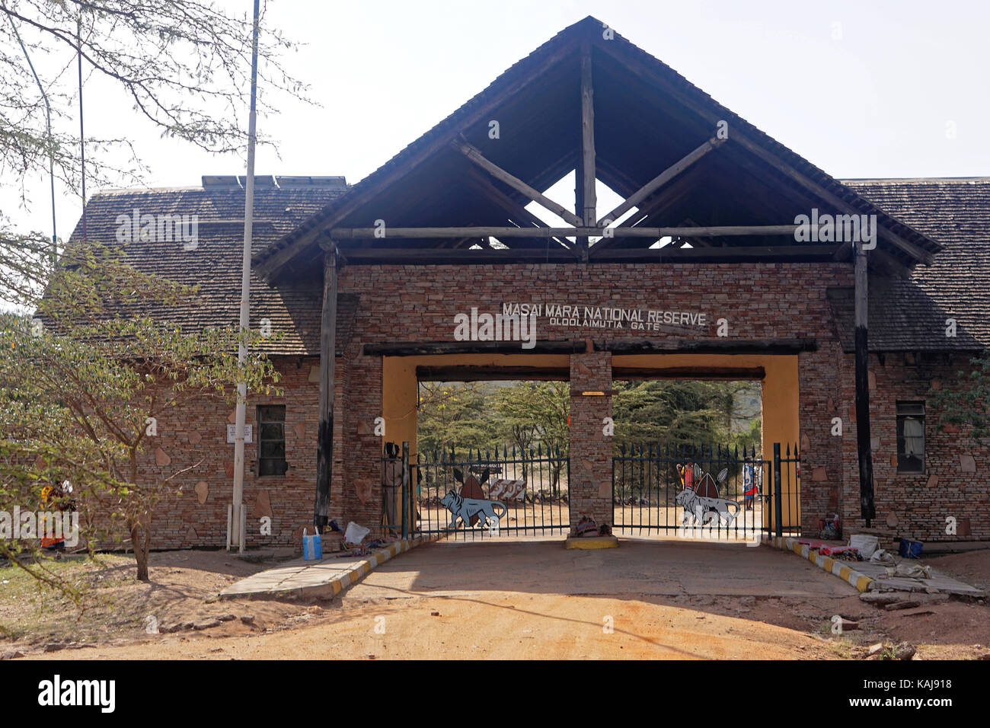
- The Maasai Mara National Reserve, while primarily known for its natural beauty and wildlife, also has built environments that play a crucial role in tourism and conservation. This includes entry gates, lodges, and campgrounds built over time to accommodate the growing tourism industry in the area. The Mara Conservancy's headquarters, conservation offices, and safari lodges reflect modern adaptations of the region's historical context of wildlife conservation, community involvement, and the Maasai culture.

Historical Sites Around the Rift Valley:

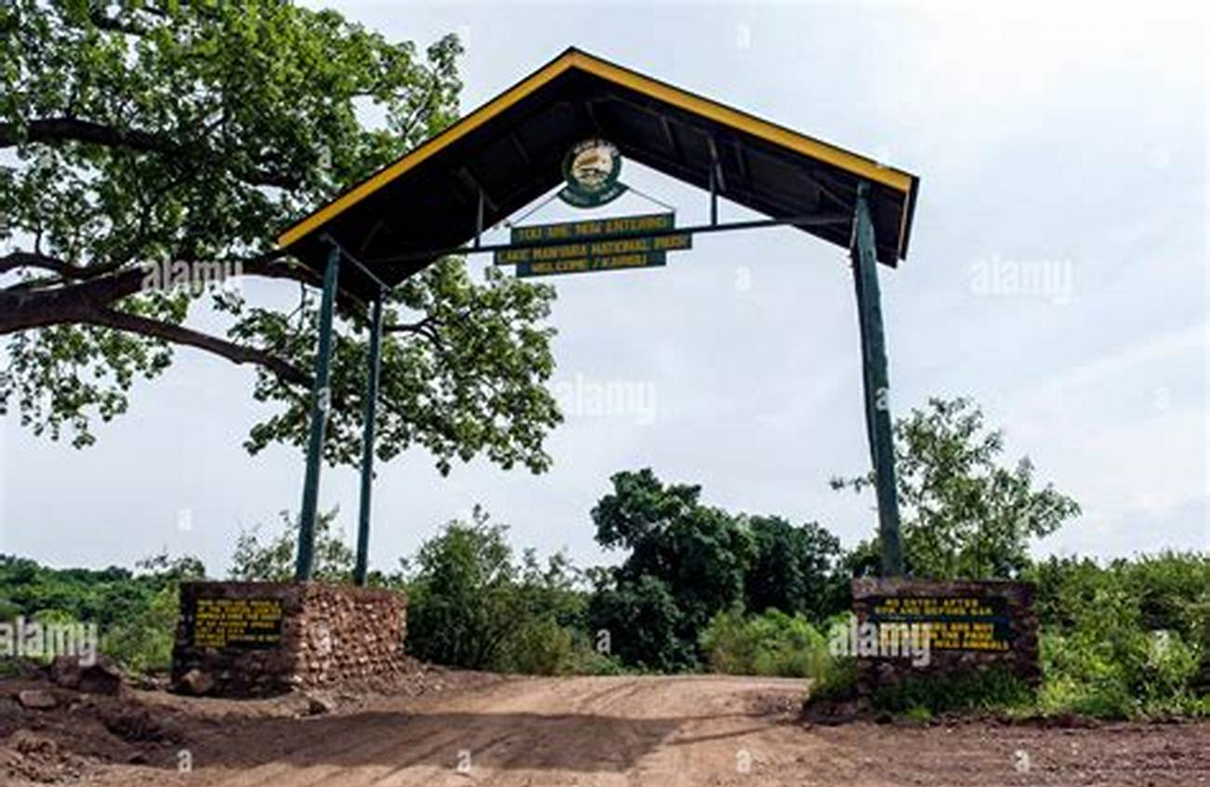
- The Great Rift Valley, which runs through Narok County, has been a significant part of human history for thousands of years. While most of the historic elements are natural (such as the Ngorongoro Crater), human settlements along the Rift Valley also contributed to the development of historical built environments, including ancient caves, archaeological sites, and stone structures used by early human populations.

Government Buildings and Infrastructure from the Colonial Era: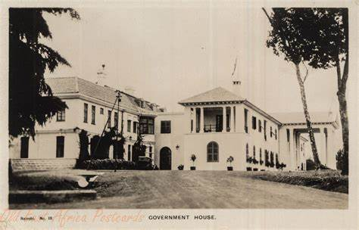
- Like many parts of Kenya, Narok was influenced by British colonial infrastructure, including administrative buildings, roads, and railways. These colonial-era structures, such as old government offices and the early infrastructure in Narok Town, are still visible and serve as a reminder of the county's history during the colonial period.

In Summary:
While Narok County is more famous for its vast plains, wildlife, and indigenous Maasai culture, it is also home to several historical built environments. From traditional Maasai bomas to colonial mission stations and the infrastructure that developed with Narok Town, these built environments provide a window into the region's rich cultural, social, and historical past.

Importance of physical features

  - Hills and mountains are sources of rivers.
  - Some Hills and mountains are tourist attractions.
  - Hills are suitable sites for installation of communication equipment e.g masts.
  - Rivers, lakes, oceans and swamps provide water for domestic use.
  - Some rivers are used as boundary markers.
  - Plains are suitable farming areas.
  - Plains are good grazing areas for livestock.
  - Some plains are home to wildlife which attracts tourists.
  - Reeds growing in swamps are used for weaving and basketry
  - Some rivers and lakes are used to provide means for transport.

Ways of protecting physical features
        - Creating awareness on their importance.

        - Avoid dumping or disposing wastes into water sources.

        - Planting more trees (Afforestation)

        - Forest-fencing using electric fence.

        - Enforcing laws enforcing on waste disposal from factories.

        - Discourage farming along the River Bank.

        - Control erosion to curb silting and pollution.

Seasons in the county

Season-is a long period of time over which one type of weather is experienced. A season can be hot, dry, cold or wet. March, April and May are wet months. January and February are dry months. Seasons affect our activities in the county.

Activities carried out during wet season

- Planting crops
- Weeding
- Fishing

Activities carried out during dry season

- Fishing
- Harvesting crops
- Collecting sand
- Repairing roofs
- Digging

Activities carried out during cold season
- Planting crops
- Fishing
- Weeding

Activities carried out during hot season
- Fishing
- Harvesting crops
- Collecting sand
- Digging
- Repairing roofs

Work to do
- What is a season?
- Write down activities done during the rainy season.

- Which seasons are experienced in our county?

Built environments

A built environment refers to the environment made by human beings to enable them carry out various activities.

Historical built environment in the county
Historical built environment have way of life and beliefs about people. Kenya is blessed with numerous historic built environments.

They include;
- museums,
- monuments,
- cultural centres
- and old buildings.

Examples of Historical built environment in Nairobi County

      - Nairobi museum.

      - Jomo Kenyatta statue.

      - Bomas of Kenya.

What i should know

Museum is a place where works of art, culture and other important items kept.
Museum curator is a person who is in charge of objects in a museum.

Monument is a structure that reminds people of important events or famous people.

Cultural centre is a place or building that promotes the culture of a community.

Importance of the historical built environment

      - Help us to learn our history and culture.

      - Promotes peace and unity as we are able to understand other cultures.

      - Source of revenue to our county.

      - It has created employment to many people.

Ways of taking care of historical built environment

      - Ensuring there's a good security in history buildings.

      - Keeping the monuments and cultural centre buildings clean.

      - Repairing cultural centre buildings.

PEOPLE AND POPULATION

Interdependence of people

Depend- to rely on somebody or something for a certain thing.

Interdependence- being dependent on each other for different things.

We need each other in different ways. We cannot get all the things we need. Interdependence makes work easier.
It also promotes unity among the people.

Importance of interdependence in the county

- It promotes love and unity.

- Work is done faster.

- The environment is taken care of.

- It leads to development of schools, roads and hospitals.

- Members of the community are able to get the things they need for their families.

Population distribution in the county

Population- refers to the total number of people living in an area.
Population distribution- is the way people are spread out over a given area of land. Population distribution can be dense, sparse or uneven. Areas with both sparse and dense populations are said to be uneven. Dry areas are sparsely populated. Many dots on a map means that the population distribution in that area is dense. Few dots on a map means population distribution in that area is sparse.

Factors that contribute to dense population

  - Fertile soils.
  - Water.
  - Good transport and communication.
  - Good climate.
  - Trading centres.
  - Flat lands

Factors that contribute to sparse population

      - Steep slopes.

      - Harsh climate.

      - Lack of water.

      - Pest and diseases

      - Large tracts of land being utilized for farming.

      - Some vegetation.



Patterns of population distribution

        - People settle on the land in different ways.
        - Population in an area can form different patterns.
- The patterns of population distribution may be represented on a map using colour, shading as well as dots.
- When people settle along a certain road, a river or railway-it is referred to as linear pattern.
- When people settle around a water point, an industry or a town-the pattern is referred to as clustered or nucleated.
- When people settle without any order.The houses are built anywherethe pattern is referred to as scattered.
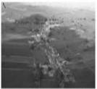
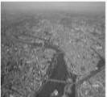

Linear Nucleated

Work to do

- What is population?
- An area that has many people living close together is populated.

- Draw an area that is:

  - Sparsely populated.

  - Densely populated.

CULTURE AND SOCIAL ORGANISATIONS

Culture-is the way of life of a community.

It is influenced by the customs, beliefs and traditions of a
community.

Aspects of culture
    - The food we eat.
    - The houses we live in.
    - Sports and games we take part in.
    - Festivals and ceremonies.
    - The artefacts they keep.

What I should know
Aspects of culture-are also referred or known as elements of culture.

Artefacts-are tools and items that were made and used by our ancestors.

Cultural artefacts are kept in a museum.

Examples of cultural artefacts

- Bows and arrows.

      - Drums and jingles.

      - Bangles, bracelets and earrings.

      - Gourds and

      - calabashes.

      - Spears and


      - shields.

Work to do
- What is culture?

- Name the aspects of traditional culture in your county.

- Draw some cultural items that you know from your community

The School

A school is an institution where learners go to learn.

The history of the school

      - Every school has its own history.

      - Learners should get informed of how their school started.

      - Here are some of the things learners should know about their school:

- The year in which their school was started.

- Who started the school?

- The reason why it was started.

- Who was the first head teacher?

- How many pupils were there when it got started?

- How many teachers were there when it was started?

- Who is the current head teacher?

- How many learners are there now?

The school motto and values
School motto-a short statement about the aims and beliefs of a school.

Importance of a school motto

- A school motto guides the behaviour of learners.
- It helps learners to remember what they need to do to perform well in school.
- It encourage learners to develop some values such as patience,
determination and discipline.
- It also reminds learners to be good examples to others.

Where a school motto can be written

On the school signpost

on the school gate.

On the school van or bus.

On the school badge.

On the pupils exercise books.

Examples of a school motto

        - Strong foundation is the key to success.
        - Pathway to excellence.

        - Hard work pays.

        - Education is the key to success.

        - Aspire for success.

        - Jishinde ushinde

        - Prayer and knowledge is our shield

        - Bidii mbele

Work to do

- Write down your school motto.

Core values in the school

These are the most important beliefs of a person or group.

Examples

Responsibility.

Love.
Determination.

The school routine

- A school routine is a set of activities that have been planned to take place every day in the school.

- Day schools and boarding schools have different routines.

- Lower and upper primary have different routines.

- A class timetable shows part of the school routine.

- A school routine guide us in our activities at school.

Work to do

  - What is a school motto?

  - Write to places where a school motto can be written.

a)

b)

c)

  - The values of a school can be found in a school routine.

  - What is a school routine?

  - What is a school?

  - What are some of the core values in a school?
a)

b)

c)

d)

RESOURCES AND ECONOMIC ACTIVITIES

- Resources are things that we use to make income or create wealth.

- Water, soil, animals, forests and minerals are examples of resources.

- People in the counties exploit resources to create wealth and satisfy their needs.

- We should strive to conserve our resources so that the future generations can benefit from them.

Work to do

- Name water bodies found in your county.

- Name some forests found in our county.

- Animals kept at home are called

- Many trees growing together are called

- .Name three types of soils in your county.

Economic activities in the county

People do different activities to earn money.

Economic activities are the various ways we use resources to earn money.

The major aim of economic activities is to produce goods and make them available to consumers.

Main economic activitiesin our county
    - Agriculture
    - Trade
      - Transport
      - Communication
      - Fishing
      - Industry
      - Forestry
      - tourism

Trade in the county
- Trade is an economic activity that involves buying and selling of goods and services.

- There are two methods of trades; Barter trade and currency trade.

- Barter trader occurs when two people exchange goods and services without use of money.

- Barter trade is not flexible.

- Goods cannot be broken into smaller units.

- Currency trade involves the use of money.

- Money was introduced by Europeans.

Before introduction of coins and notes, Arabs used cowrie shells or beads as currency.
All counties have tradling centres or markets where trade takes place.

Importance of trade in the county

- Promotes peace and understanding.
- It enables people to get jobs.
- It leads to interaction of people in the county.
- It leads to the growth and expansion of towns.
- It enables people to get goods and services they need.
- It enables the county to collect taxes (revenue).

Taxes is the money paid to the government to enable it provide services to the people.

Work to do

  - What is trade?

  - The exchange of goods for other goods is known as

  - The use of money to pay for goods and services is known as trade.
  - Which people introduced coins and notes?

  - Write down three ways on how trade is important in your county.

Industries in the county

Industry is an activity where raw materials are made into useful products.

There are modern industries and traditional industries.

In traditional industries, production is on small scale.

Most of the work is done by people as opposed to machines.

Traditional industries have been around for a long time.

Modern industries produce goods on a large scale.

Examples of Traditional industries

        - Weaving and basketry

        - Leather work

        - Pottery

        - Ironworking

        - Woodwork and carving

        - Boat making

        - Granary making

        - Gourd making

        - and beading.

Examples of modern industries

          - Cement manufacturing

          - Petroleum refining
- Tea processing

- Milk processing

          - Paper making

          - Steel making

          - Baking

          - Computer assembly

Benefits of industries in the county

- People are able to get goods that they need.
- Industries provide jobs for the people in the county.
- Industries brings development to the county.

- The county government earns money from industries.

Transport
This is the movement of people and goods from one place to another.

Transport takes place in all counties

Forms of transport

- Roads
- Railways
- Air
- Water

Means of Transport


- Buses
- Cars
- Lorries
- Trains
- Aeroplanes
- Ship
- Boats

Communication

This is the sending of messages or information from one person to another.

Examples of means of communication

Radio.
Newspapers.
Mobile phones.
Television.
Letters.

Mining
This is the activity of

removing/extracting minerals from the ground.

Examples of minerals
- Iron
- Salt
- Gold
- Gemstones
- Sand
- Oil

- Coal

Forestry
This is the planting of trees and taking care of them. It is also taking care of trees that grows on their own.
Many counties have forest.

Examples of forests in Nairobi County

Karura forests

Ngong forest

Mau forest

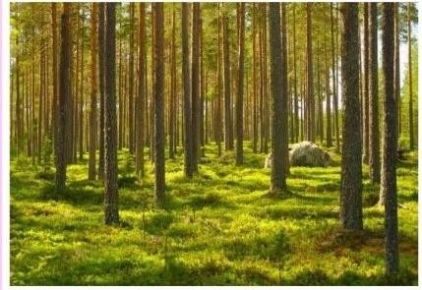

More notes to come…………………………………..

Tourism
This the practice of travelling from one’s home area to other places to see interesting things.

Enterprise project in School

Project-is any work that is planned and done in an organised way to produce something new or to improve something.

Enterprise-A big project that brings money or income.

Projects we can start in school to earn money
Growing of kales.

Rearing of rabbits.
Poultry farming.
Making necklaces and bangles from seeds and beads.

Growing of onions.
Making flower vases from used plastic containers.

Planning for projects
Sharing roles and duties.
Writing down rules for the project to ensure safety.
Deciding on the things that need to be available for the project. (Budget)

Deciding on how to market the project.
Getting out permission from the head teacher/school director to carry out
the project.

Carrying the project
Making the

items e.g. necklaces, bangles etc. Marketing
the items.

Selling the items.
Checking on the success of the project.

Work to do
- What is a resource?
- Name three resources in our county?
- Protecting and taking care of resources is called?

- What is an enterprise project?
- Name five enterprise projects we can carry out in school.
- What is an industry?
- Name three industries in our county.
- Name two types of trade.
- Write five benefits of trade.
- What is an economic activity?

POLITICAL SYSTEMS AND CHANGE

Community leadership

Community leaders are people who are recognised in the community as having a special abilities, talents.

They represent the community's interests and plays a role of protecting them. This role could be paid for or voluntarily.
These leaders are normally consulted before important decisions in the community are made.

Leaders in the community

Council of elders.
Political leaders’ e.g. governors, senators, MPs etc.
Institution leaders’ e.g. head teachers, managers, prefects. Cultural leaders.
Religious leaders. E.g. pastors, I mams etc.

Duties/Roles/Functions of Community leaders
They lead people in prayers and worship.
They teach people good values in society.

They solve problems in the community.
They lead people in cultural events in the community.
They guide people to know what is right and wrong.

They ensure the culture and traditions of the community are not forgotten.

Qualities of a good leader
He/she should be a role model.(Lead by example) Willing to serve.
Honest and have integrity. Does not give or accept bribes. Must have self-control.
Must be mature and full of wisdom. Must be gentle and peaceful.
A good leader is fair.
Obeys the laws and leaders in authority. Must be orderly.
Work to do

  - Who is a community leader?
  - Name two examples of political leaders
  - Write down four qualities of a good leader.
  - List three duties of a community leader.
  - Name three institution leaders in our county.

CITIZENSHIP

Good citizenship in school

Citizen- is a person who belongs to a particular country.
Citizenship- the state of belonging to a country and enjoying the rights that the citizens of that country enjoy.
A good citizen in school respect their and other people property.
Good citizenship in school results in good relationships between learners and teachers. We should practise good citizenship to ensure peace and prosperity.

Qualities of a good citizen in school

Obedience, Hardworking, Honest, Taking care of our environment by planting trees and cleaning. Loving our school and teachers, Law abiding, taking care of less fortunate, Generous, Should be responsible and tolerant.

Cultural practices
These are actions of a community that are guided by certain beliefs and attitudes. Some cultural practices may hurt children and deny them their rights.

Examples of cultural practices that violate rights of children.
- Female genital mutilation.
- Early marriages.
- Force marriage.
- Child labour.
- Nutritional taboos.
- Traditional birth practices e.g preference of certain gender.

How children are abused in the community

- Excessive beating/canning without consideration.
- Using abusive language to them.
- Forcing young girls to get married.
- Mistreating children with special needs.
- Child trafficking/Stealing children.
- Body injuries.
- Poor health.
- Absenteeism from school.
- Tiredness and fatigue.
- Low self-esteem.
- It leads to poor performance.

How we can prevent children from abuse

- Speaking against the vice.
- Reporting the cases to relevant authority.
- Creating awareness to the public about child abuse.
- Establishing rehabilitation centres.
- Introducing strict laws against child abuse.

Ways we can protect ourselves from abuse

Child rights
- Stay in touch with friends and neighbours.
- Walk to and from school in groups.
- Scream loudly when you are in danger.
- Avoid using lonely roads.
- Keep important telephone numbers e.g those of parents and police to call when in trouble.
- Talk about cases of abuse to those people that you trust.

These are entitlement that children are supposed to be given They include;

Right to food. Right to shelter.

Work to do

  - Name three cultural practices that are harmful to children.
  - Write down three ways in which children are abused.
  - Name five effects of child abuse.
  - Name three ways that can be used to protect children from abuse.

Peace

Peace is a state of calmness without quarrels or fights.
It is referred as the state of being in harmony with others.

What promotes peace in school?

- Respecting each other.
- Obeying school rules and teachers instructions.
- Being punctual in school.
- Finishing teacher’s assignments.
- Treating each other fairly.
- Doing duties given to you.
- Helping those in need like persons with disabilities.
N/B: Things that promote peace are also known as factors that promote peace.

Peace education project
Identifying a peace education project that can be undertaken in school.
Initiating the peace project at school.
Planning a peace project at school.
Sharing responsibilities for peace project at school.
Evaluating success of peace project at school. The good things.

Peace project ideas
Peace education clubs.
Peace garden
Host conflict-resolution workshops.
Conduct entertainment

programmes including skits and plays. sports
tournaments.

Make posters for community sensitisation.

Work to do

  - What is peace?
  - Identify four factors that can promote peace in school.

  - How can we live in peace with others in the school?
  - Give two benefits of living in peace in school.

GOVERNANCE IN KENYA

Democracy in school

Democracy is a situation when people are given freedom to make discuss and share ideas freely.
Learners are treated fairly and are allowed to take part in making decisions on issues affecting them.
It brings about feelings of satisfaction and justice among learners.

Importance of democracy in school
Learners are able to express their ideas without fear.
It promotes peace and harmony in the school.
Promotes understanding between pupils and teachers.
Democracy in school helps us to choose leaders of our own choice.
Promotes equality and respect In school
Enables children to speak out their problems.

Children's government in school

The children government is a representative body in schools. It is made up of the following;
    - President·
    - Deputy president.
    - Representative of all classes·
    - Games prefects or leaders.
    - Environmental/Sanitation prefects.
    - Club representatives.

Members of children's government serve as voice of all learners in school.
It encourages learners to talk freely about ideas and issues affecting them.

Functions of the children's government in school
Help in coordinating activities in the school.
Report any problem to the teachers from the pupils.

duties.
Maintaining order in the school.
Maintaining cleanliness in the school by assigning pupils to perform d ifferent

Promotes music and drama in school through the prefect clubs. Promoting environmental conservation through the environmental and sanitation prefects.

Ways of supporting children's government

_ By listening to them.

By helping them.
By following school rules to avoid conflict.

Work to do

- What is children's government?
- Write down three leaders in children’s government.
- Write down three benefits of democracy in your school.
- Give the meaning of democracy.
- How do you support children's government in school?

The county government in Kenya

The republic of Kenya has two levels of governments;

National government.
  - County government
The county government is headed by the county governor.
The governor is elected by people together with deputy governor.
The county government is made up of;
The county assembly.
· The county executive.
There are 47 counties in Kenya.

The county assembly
Consist/comprises the following;

Members elected by

people from each ward. (MCAs)
Members representing

special groups.

Special seat members nominated by political parties.
The county assembly speakers.

NB: The main duty/work/function of the county assembly is to make county laws.

The county executive
Made up of;

The governor (head of county government) Deputy Governor:
Members of the county executive committee appointed by the
governor:
Other officials appointed by the governor:

NB: The main work/role of the county executive committee is implementing policies are carrying out executive functions in the county.

Duties of the county governor
Ensuring peace and order in the county.

Appointing members of the county executive committee and other county
officials.
Ensuring county government officers perform their duties well.
Receiving important visitors to the county.
Acting as a link between national government and county government Preparing reports for the county assembly on matters relating to the county.

Ensuring development projects are undertaken in the county.
Ensuring all laws are followed in the county. Guiding the county executive committee in preparing some laws in the county.

Services provided by the county government

Clean water and sanitation.
Maintaining county roads.
Health
Controlling plant and animal diseases.
Waste management
Education

Ways in which county

government get money

(Sources of revenue)

Grants (money) from national government. This is the main source.
Money from land rates.
Parking fees.
Rents from county houses.
Taxes called cess.(A form of tax charged by a county government for transportation of some goods into or within the county)

Sales of business permits and licences. Loans/Borrowing but with approval from the national government.

Work to do

- Who is the head of the county executive committee?
- Name three duties of a county governor in our county.
- State four ways through which the county government obtains or gets money.
- Who represent a ward to the county assembly?
- The county government is made up of the and the

- Name two other officers who make up the county government.
- Who is the head of the county government?

