COMPETENCE BASED CURRICULUM

GRADE 5

CREATIVE ARTS

NOTES

STRAND 1-CREATING & EXCUTION.
1.1 Indigenous Kenyan Wind Instruments.

Wind instrument.
- A wind instrument is a musical instrument which is played by blowing air into it.
- Wind instruments are found in most communities in Kenya.
- Different communities have indigenous names for their wind instruments.
- The instruments vary in shapes and sizes and materials used to make them. Chivoti Ndurerut
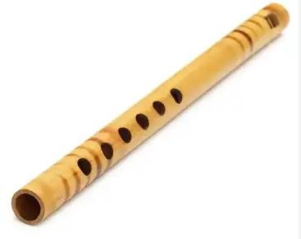
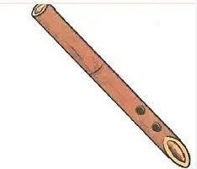

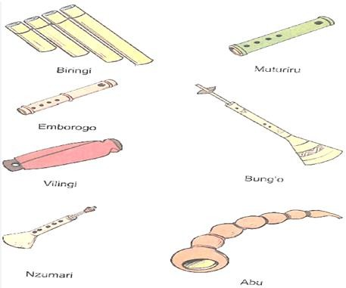
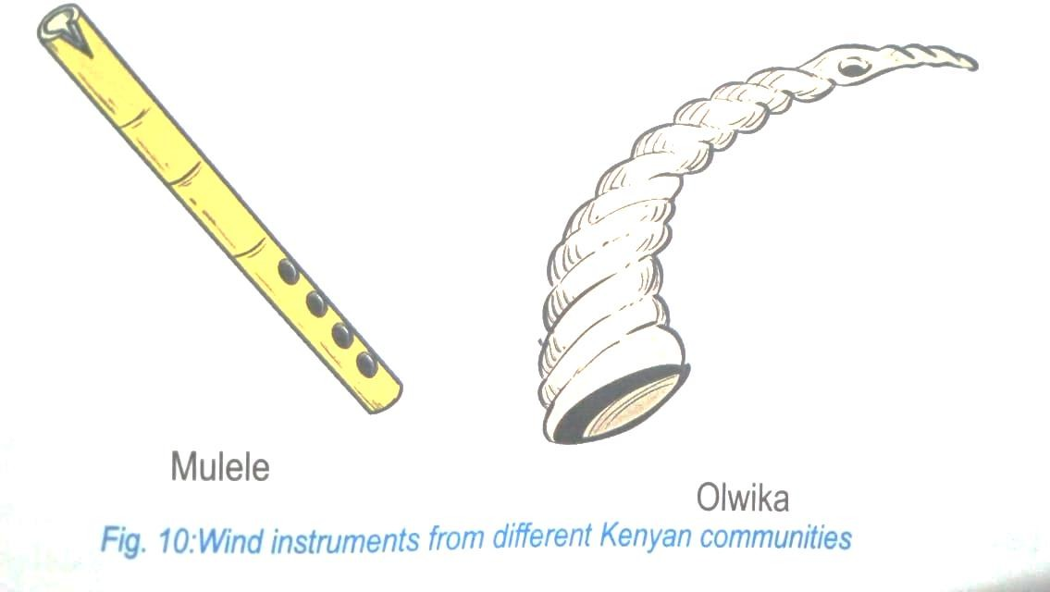

Parts of a wing instrument.
- Air is blown into wind instrument through a hole called the blowing hole or mouthpiece.
- A wind instrument has other holes used to produce different sounds or pitches when played.
- A wind instrument has an open end used to let out air when played.
- Some wind instruments have mouthpieces made of reeds.
- Wind instruments are made from different materials.
- Some instruments have a closed end to help air to pass in a particular direction.

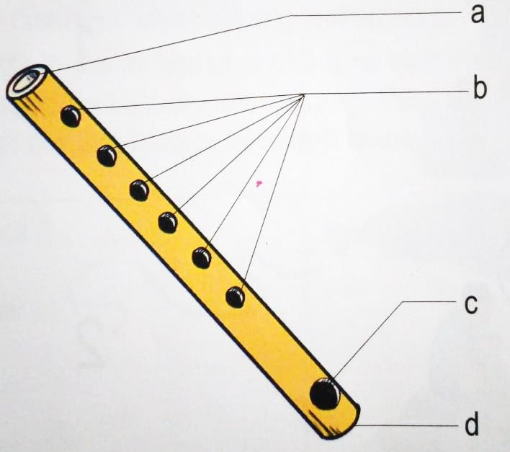
  - Open end.
  - Fingering holes.
  - Mouthpiece.
  - Closed end.

Steps in Making a wind Instrument.
⮎ Collect the materials needed in making a wind instrument such as:
⮎ Ensure the tube being used is hollow.
⮎ Mark and Cut holes as required.
⮎ Ensure you handle the knife carefully to avoid injuries.
⮎ Clean the place by collecting litter after making the wind instrument.

Care for A wind instrument.
⭧ Materials used for making most of the wind instruments are breakable, hence the instruments should be handled with care.
⭧ Some wind instruments have straps for hanging them for safe storage.
⭧ Use a clean piece of cloth to wipe the mouthpiece. This will reduce the risk of communicable diseases when sharing instruments.
⭧ Moisture collects in the air passage of a wind instrument as it is played. The air passage
should be kept dry after playing by passing a feather or a clean piece of cloth through the air passage.

Role of wind instruments in music making.
- Some are used to introduce the performance such as whistles and some flutes, for example, chivoti.
- Some may be played between parts of a song to bridge (fill the gaps or moments when the singers are silent).
- These instruments can also be played to respond to a soloist. For example, some flutes such as chivoti.
- They provide accompaniment to songs and dances.
- Wind instrument also signals the start or change of a song.
- Other such as horns, for example Olwika of the Luhya is used to mark the climax of the performance.
- Solo wind instruments are used for music making during leisure time.
- Wind instruments that do not play melodies such as the Olwika of Luhya can be used to help in keeping the speed of the performance.

1.2 Football.

Skills of kicking, stopping and goalkeeping used football.
a.) Kicking:
Instep kicking technique-An in-step football kick involves a performer striking the football with the top part of the foot.
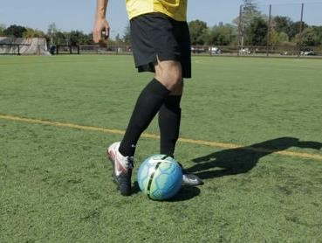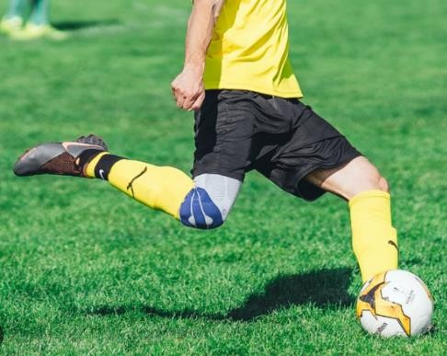

b.) Stopping:

Inside of the foot stopping.
Use the inside of your foot to stop the ball with an inside trap.
The inside trap is the easiest trap to master and also the most common one in soccer.
As the ball moves toward you, rotate your foot toward the ball so that the inside of your foot is facing it.
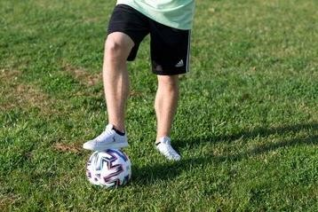

c.) Goalkeeping:
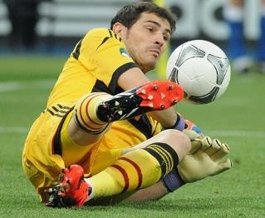
A goalkeeper is a specialised position in the football whose main role is to stop the opposing team from scoring (putting the ball over the goal-line of the goal).

Stance in goalkeeping.
🢖 This is done by having your feet shoulder width apart.
🢖 The body weight should be on the balls of your feet.
🢖 Both the knees and the back should be slightly bend.
🢖 The hands should be positioned out in front comfortably in the hip area.
🢖 This stance will help a goalkeeper maintain proper balance and keep their weight forward.
The shape of the keeper will appear concave.


Shot stopping in goalkeeping.
✰ A shot stopping action is an action which actually stops the ball from crossing the goal line, a shot preventing action is an action which prevents a shot from ever happening in the first place.
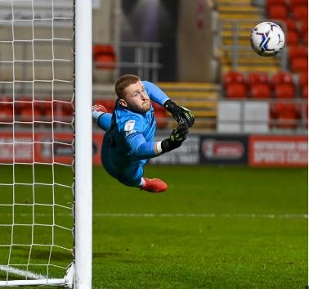

1.3 Composing Rhythm.

Interpreting rhythmic patterns using French rhythm names.
🢖 French rhythm patterns can be written using music symbols.
🢖 These symbols are called notes.
🢖 The notes have different names.
🢖 The French rhythm names with their matching notes have same length of sound.
🢖 The length of sound of a note is called time duration.

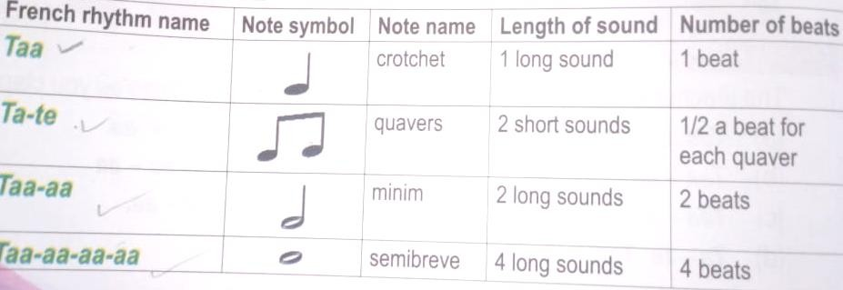
- A song is made up of different words written as a poem.
- The words are made up of syllables.
- These syllables may carry long or short sounds.
- The natural rhythms help us to find the correct rhythms to use in the writing the rhythm of a song.
- We can use French rhythm names to show the length of words or syllables.
- We can use French rhythm names or note symbols to write rhythms of songs.
- Rhythms can be created using the note symbols 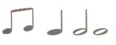
- Rhythms can be interesting by varying the note symbols.
- Songs are also made of bot strong and weak beats.
- The beats can be grouped into twos, threes, or fours.
- The strong and weak beats can be identified from words within a rhythmic pattern.

- The strong songs the strong beat occur first followed by the weak beat,
- This helps us to feel the song either in twos or in fours.
- Conducting can help to identify if a song is in two or four beat patterns, this helps us to know if the song is either in two or four beat patterns
- When conducting, the strong beat is shown by the hand’s downwards movement.

- Different rhythms can be created using French rhythms names.
- Taa-aa-aa-aa, Taa-aa, Taa and Ta-te

- The note symbols 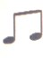 ’ , and can also be used to create rhythms.
- When creating a rhythm pattern, the note symbol should be varied to make the rhthm instresting.

1.4 Composing Melody.
- Music sounds can be sung using sol-fa syllables.
- In grade 4 you have learnt about the first three sol-fa syllables d-r-m.
- Here we will learn about f and s.

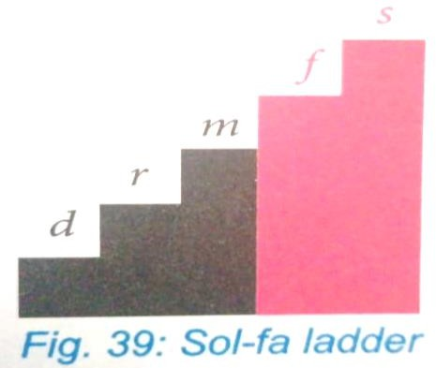
Sol-fa syllables are used to help in sounding music notes.
d-r-m-f-s are the first five sol-fa syllables sung as doh, re, mi, fa, so.

doh is the first note, re, the second note, mi, the third note, fa, the fourth note, and so the fifth note.
Singing the sol-fa syllables from the lowest to the highest d-r-m-f-s is called ascending. Singing the sol-fa syllables from the highest to the lowest s-f-m-r-d is called descending.

Interpreting the hand signs of the Sol-fa syllables d r m f s.

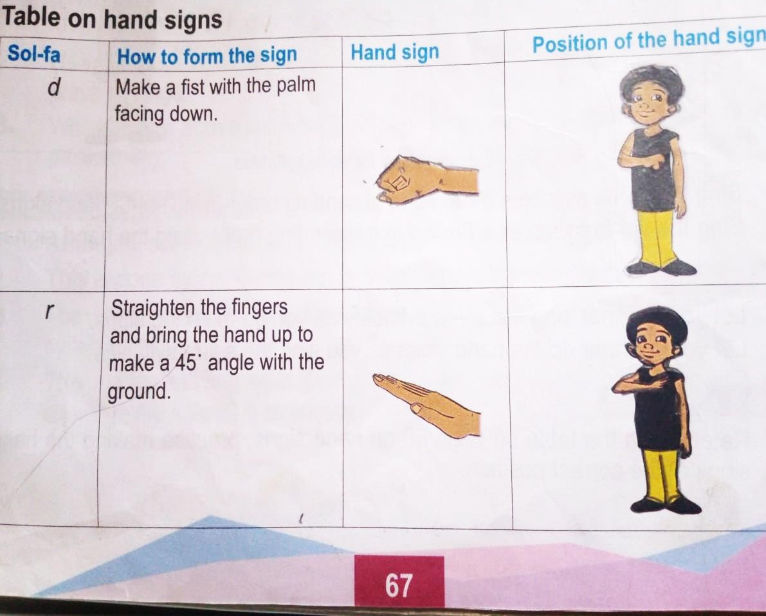

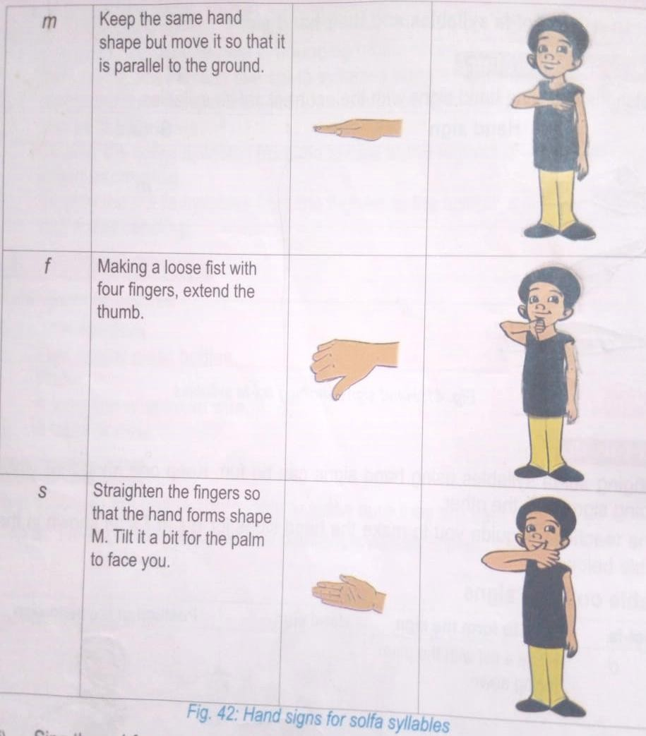
🢖 Arranging sol-fa syllables in different patterns makes a melody.
🢖 This is done by combining sol-fa syllables of different pitches.
🢖 The combination can be done using step by step movement of the sol-fa syllables.

🢖 This means moving from one pitch to the next, either above or below as shown in the following examples:
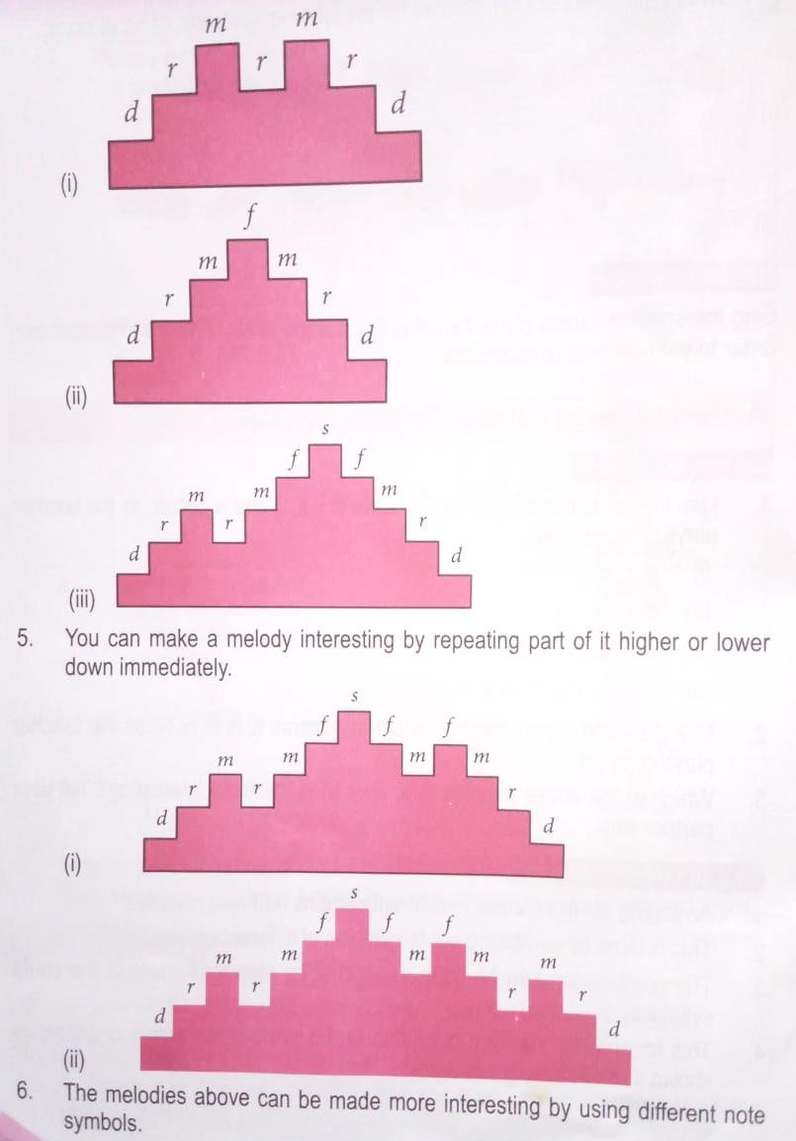

1.5 Rounders.
Features of a rounders bat.
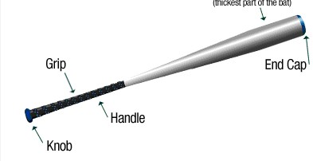

Features of a rounders bat include:
Knob – ensures the bat is tightly secured within the arms. Handle – for holding
Grip – prevents injury on the arms when holding the bat by preventing direct contact to the wooden parts blisters.
Head – the thick part used to hit the rounders ball. Length –
Thickness -

STRAND 2 PERFORMANCE & DISPLAY.
2.1 Athletics Visual Baton Exchange Non-Baton Exchange.

Appropriate materials for plating a skipping rope and making relay baton.
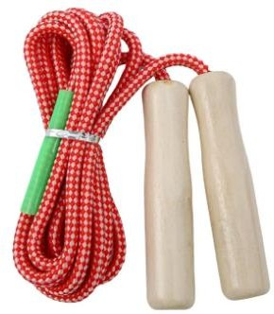
For skipping rope, you need:
- Pair of scissors.
- Sisal.
- Leather fibre.
- Recycled polythene bags.
- Old fabric materials such as cloths.
- Plastic/wooden handles.

For baton, you need:
- Wood.
- Rubber.
- Metal.
- Plastic tubing.
- Old magazine.
- Cardboard.

How to improvise a baton to use.

- Cutting a sizeable straight stick of your choice.
- Peel off the bark parts to remain with woody part.
- Dry the peeled part until all water/fluid is finished.
- Make decorations on the dried stick using the following methods:
⮎ Painting -using paint on the surface.
⮎ Smoking -partially heated from direct flames.
⮎ Incising-decorate an object with a cut or cuts.
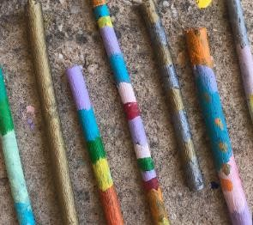
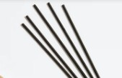
Painted baton sticks. Smoked/heated sticks.

2.1 Puppetry.
Puppets are items manipulated to act like people or animals.
- There are different kinds of puppets.
- Some types of puppets are finger puppets, hand puppets, glove puppets, rod puppets, shadow puppets and marionette.
- Glove puppets are puppets that are fitted on the hand and manipulated using the hand as well.
- Rod puppets -are manipulated by a stick.

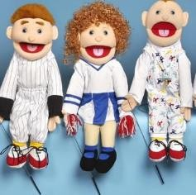
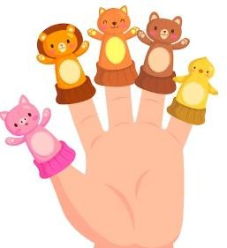
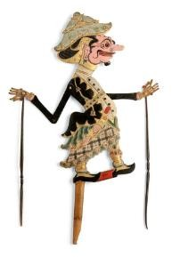
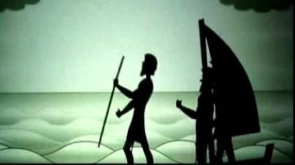
Hand puppetry Rod puppetry Shadow puppetry

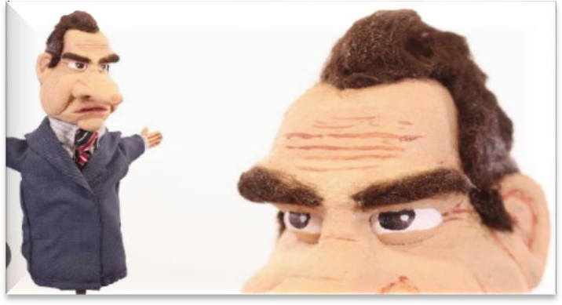
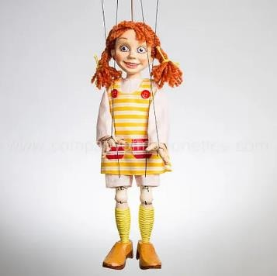
Glove puppetry Marionettes-(manipulated by strings)

Materials used in making puppets.
⭧ Wood.
⭧ Old rubber.
⭧ Bana stalks.
⭧ Maize stalks.
⭧ Cobs.
⭧ Styrofoam boards.
⭧ Wires.
⭧ Strings

Tools such as:
⭧ Hammers,
⭧ Knives.
⭧ Scissors.

2.3 Swimming.

Front crawl technique in swimming.
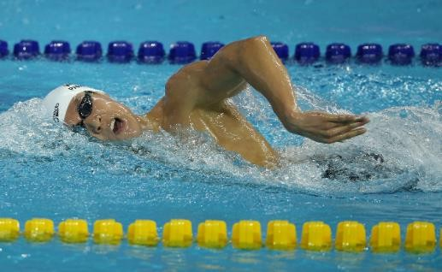

🢖 To do the front crawl arm stroke your thumb should always enter the water first with your hand at a 45-degree angle.
🢖 Your arm will twist as you pull your hand back through the water, creating a paddle
underwater.
🢖 You'll pull the water back all the way to your hip before the arm exits the water.

2.4 Performing A Kenyan Folk Dance.

Components of a Kenyan folk dance.
🢖 Soloist-the person who leads the rest of the participants in singing the melodies during the performance of the dance.
🢖 Response group-they provide the answer to the soloist during dance.
🢖 An instrumentalist-plays an instruments or various instruments to accompany a dance.
🢖 Dancers-they make dance moves, patterns and formations.
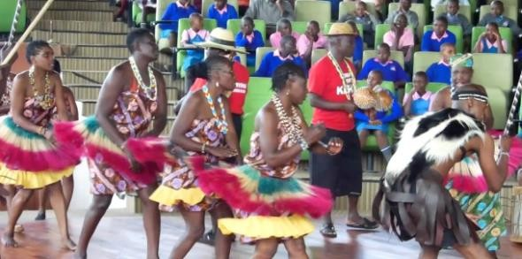

Costumes, ornaments and body adornments in Kenya folk dance.
✰ During a folk-dance performance, the participants wear specifically designed clothes, hides or skins called costumes.

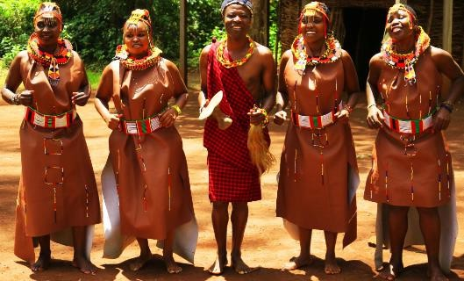

✰ The participants also decorate their bodies using paints to make patterns. This is called body adornments.
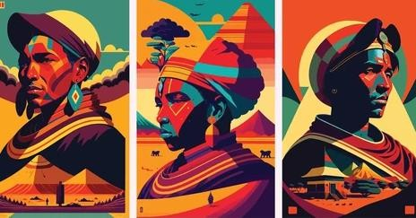

✰ Dancers also use beads, necklaces, bracelets and ankles during the dance performance.
These are called ornaments.
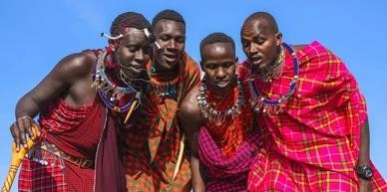

Making of Ornaments using recyclable materials. Materials:
🢖 A piece of thread.
🢖 A pair of scissors.
🢖 Grains such as beans or maize (soak them in water before use to make them soft.)
🢖 A needle.

Steps of making an ornament.
🢖 Cut a thread to a desired length to fit your head, neck or wrist. Handle the scissors with care to avoid injuring yourself or your partners.
🢖 Carefully pass the needle and thread through the grains one by one. Mix grains of
different colours and beauty.
🢖 Fill up the thread with grains.
🢖 Leave up allowance for fastening the ornament at both ends of the thread.
🢖 The ornament is ready for use. This ornament can be worn on the head, neck, wrist or ankle.
🢖 Ensure all the waste materials are cleared to avoid accidents and injuries.

Appreciating the role of folk dance.
- Folk dance preserves our cultural identity.
- We can appreciate other cultures by performing their folk dances using costumes, body adornments and ornaments.
- Appreciation of different cultures promotes unity and patriotism.

2.5 Playing the Descant recorder.
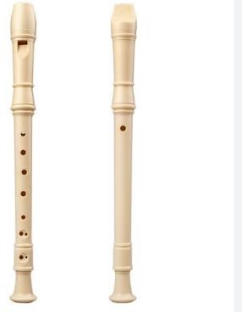
- A descant recorder is played by blowing through the windway that is a narrow channel on the head joint which directs blown air in a gap called window.
- The Descant recorder is divided into three parts as shown below.
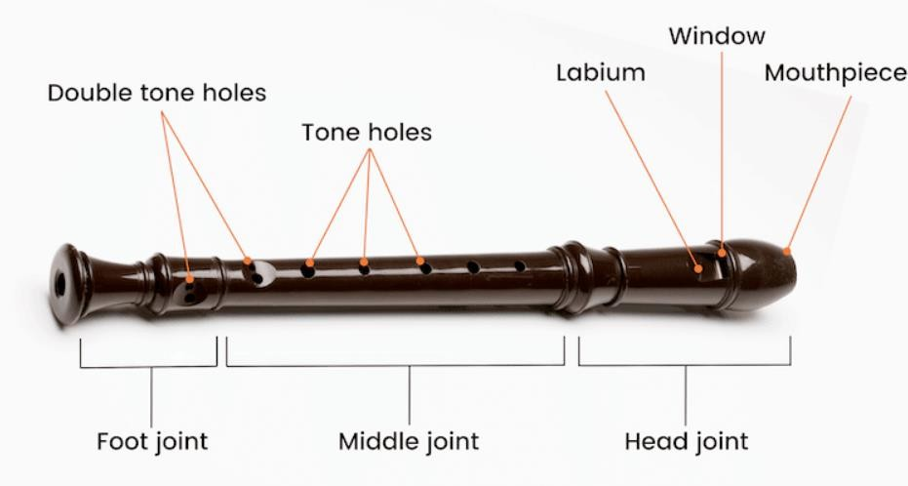

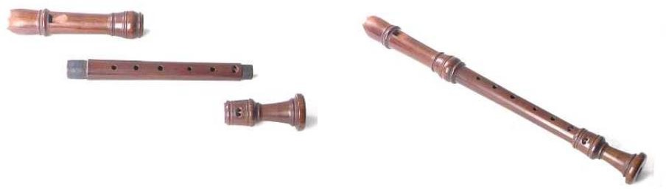
Playing notes G A B C D.
Hand position.
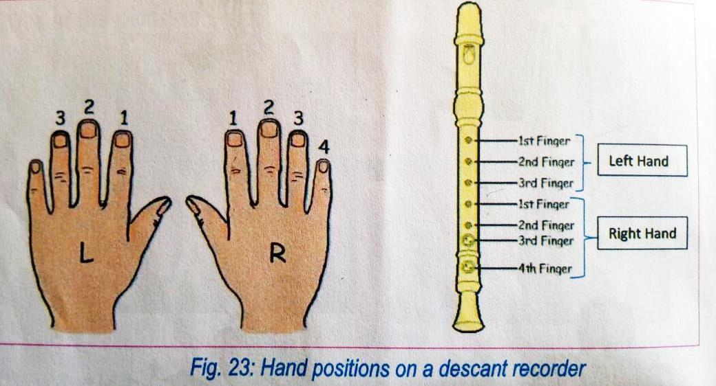
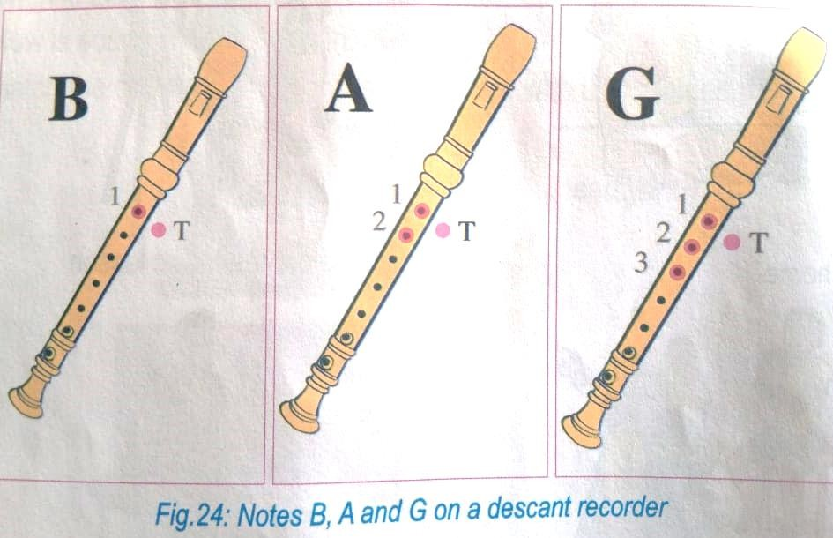
Notes B, A, G, C and D on A Descant recorder.

- The left hand should always be at the top for both right and left-handed persons.
- The number besides the finger holes show the finger to be used when playing notes, while the letter T stands for the left-hand thumb.
- Always blow air gently into your descant recorder through the open end of the head joint, also known as the mouthpiece. Ensure that the airflow is steady as you blow it.
- Listen carefully to any sound on the recorder by either you or your classmates to make sure it sounds correctly.
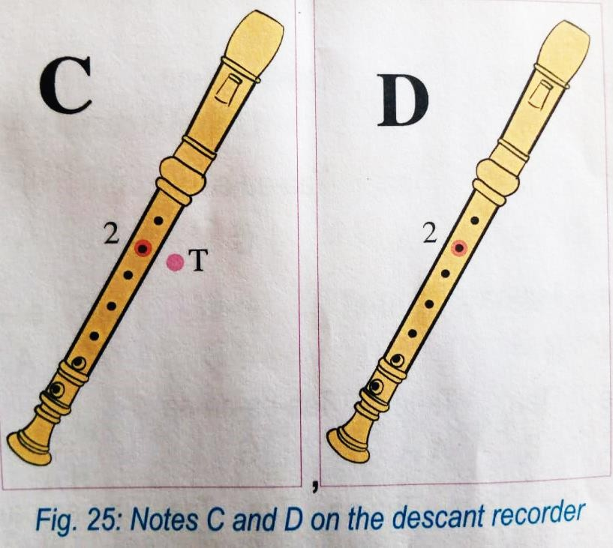

STRAND 3 APPRECIATION IN CREATIVE ARTS.

3.1 Analysis of Creative Arts Work.
Kindly we cannot provide these notes as they are not available I any current learners text book.
We inform you that we will update any part left out due to unmatching of the content from the designs and the current course books as well as introduction of new content in the revised 2024 curriculum designs.

