COMPETENCE BASED CURRICULUM

GRADE 6

CREATIVE ARTS

NOTES

STRAND 1 CREATING AND EXCUTION.
1.1 Indigenous Kenya String instruments.
🢖 Most communities in Kenya use string instruments in their music.
🢖 The instruments from different communities vary in design, shape, size and number of strings.
🢖 String instrument produce sound through vibration of strings.
🢖 Some string instruments have many strings and others have only one or two strings.

Instruments from different communities in Kenya.

Bukandit of the Kipsigis.  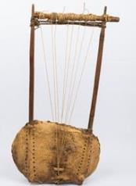 | Wandindi of the kikuyu.  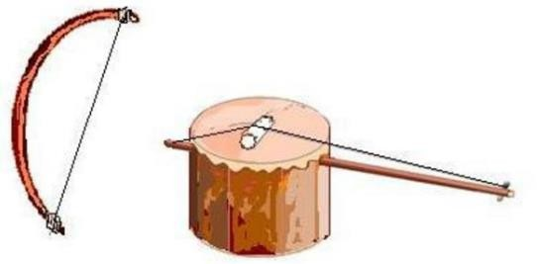
Adeudeu of the iteso.  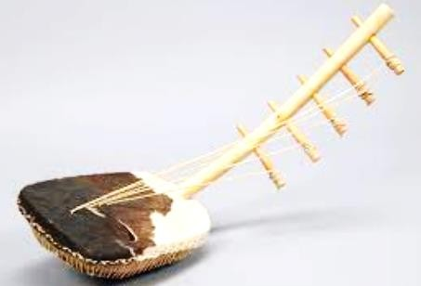 | Litungu of the Luhya.  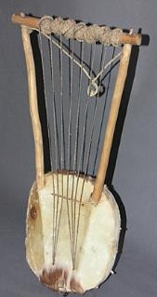

Nyatiti of the Luo.  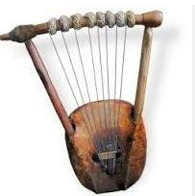 | Shiriri of the Luhya.  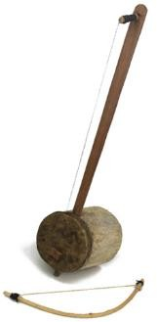
Kimeng’eng of Kalenjin  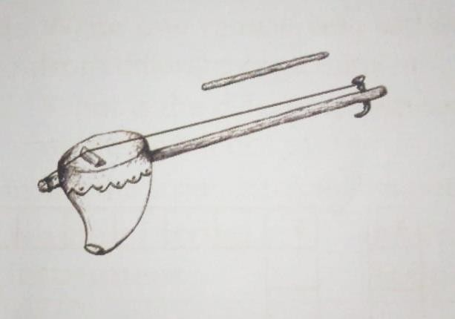 | Zeze of the Taita.  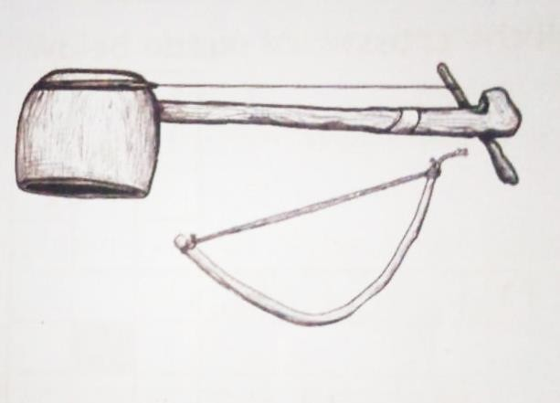

Parts of A fiddle and their function.

🢖 A fiddle is a string instrument that has one or two strings.
🢖 Parts of a fiddle and their function include:
- Resonator –amplifies the sound produced.
- String –vibrates to produce sound.
- Neck or arm stick –holds the instrument together.
- Bridge –raises the string off the resonator a and transfers sound to the resonator.
- Membrane –transfers sound to the resonator.
- Tuning peg –used for tightening and loosening the string to tune the instrument.
- Bow -it is rubbed against the string to produce sound.

 Resonators is usually covered with a skin membrane.
 Some fiddles such as mbeve of the akamba and ong’eng’o of the abagusii are covered on both sides.
 Most fiddles have a wooden resonator while others such as Kimeng’eng of the Kalenjin
have a resonator made of a gourd.

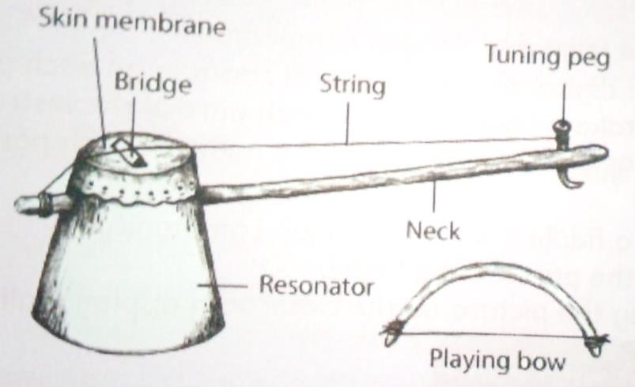

Tools and materials used to assemble string instrument from the locality.

🢖 Membranes such as:
- Leather or skin.
- Canvas or fabric.

🢖 Resonators such as:

- Cylindrical containers.
- Carton materials.
- Hollow wood.
- String.

Turning a fiddle.
  - Tuning is done to ensure that the fiddle produces the desired pitch.
  - It is done by tuning the tuning peg to either loosen or to tighten the string.
  - It the sound is lower than the required pitch, the string should be tightened. If the sound is higher than the required pitch, the string should be loosened.
  - When tuning, the string is plucked, struck or bowed to test the sound until it gets to the desired pitch.

Care and maintenance of A string instrument.

Reasons for taking care of string instruments include:
🢖 To function better.
🢖 To last longer.

Some ways of ensuring that a string instrument stays in good condition and lasts longer are:
    - Keep instruments away from water or any liquid. This is because wooden resonators may soak in water and it may rot.
    - Handle the sting instruments with care to avoid breakage.
    - Be gentle when turning a string instrument in order to avoid snapping of the string.
    - Sisal fibres on the bow my break when the instrument is played for a long time. Replace the sisal threads whenever this happens.
    - Apply rosin on the sisal fibres on the bow. This helps to create friction required to produce sound. Rosin may be obtained the sap of pine trees. The sap is heated until all the liquid vaporizes, leaving a yellowish or blackish wax called rosin.

How to clean an instrument:
✰ Dip a piece of cloth in the soapy water.
✰ Squeeze out as much water as possible.
✰ Wipe every part of the instrument.

1.2 Volleyball.

Single Hand dig pass.

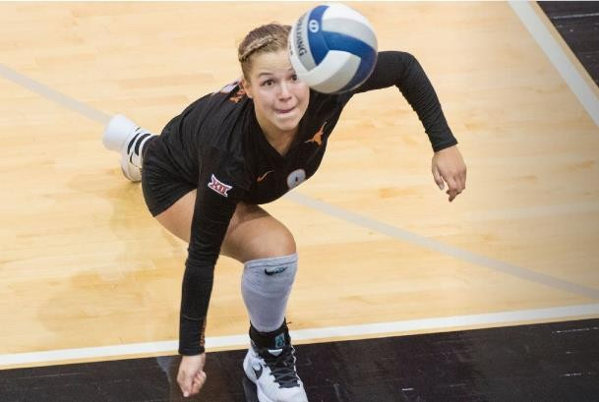

🢖 Single hand dig pass is where a player uses one hand to receive or pass the ball.
🢖 It is used when the ball cannot be reached with both hands.

Safety instructions.
🢖 Make sure you warm up before any exercise.
🢖 Make sure the place is cleared from any hazards and risks such as rocks, sticks and items that can hurt you when playing.
🢖 Remember to take care of your environment for a better future.

Warm up activities.
⭢ High knees.
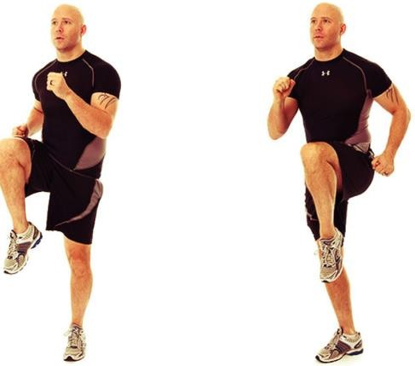

⭢ Half squat.
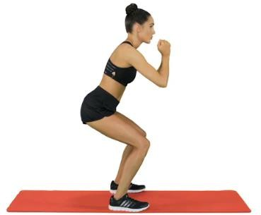

Over arm serve.
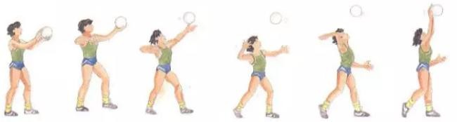
Over arm serve is where a player tosses the ball with one hand and strikes it in the air above
their head with the other hand so that it crosses the net and lands into the opponents’ side.

Safety instructions.
- Ensure you perform thorough warm up activities.
- Avoid congestion by maintaining a safe distance from your peers.
- Follow instructions.

Warm up activities.
Perform Arm swings.

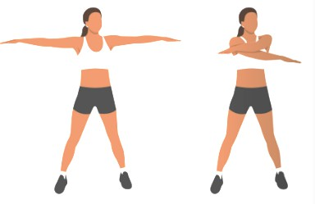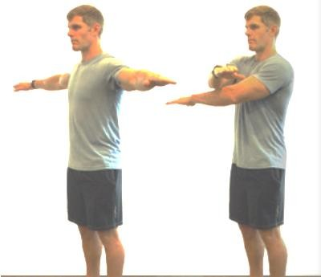

Minor Games and basic rules.
Minor games are small sided games that help you practice skills learnt in volleyball while applying the rules of the games.

Safety precaution.
⭢ Never fist hit the ball as you could hit someone’s face.
⭢ Do not swing on the post.
⭢ Do not go under the net, always walk around the nets.
⭢ Do not throw the ball over the net, roll it under the net.

1.3 Composing Rhythm.

Interpret Rhythms
🢖 When beats are arranged in a certain way, the form a rhythmic patter.
🢖 The beats may be represented by music notes of French rhythm names.
🢖 Some beats may be long in value while others may be short.
🢖 The value of a crotchet beat, for example, is one count while that of a minim is two counts.
🢖 A beat may also have three counts. It is represented by dotted minim as shown.
 .

🢖 The value of the dot is half that of the note. The corresponding French rhythm name for the dotted minim is taa – aa – aa.
🢖 The value of taa taa taa is equal to that of taa – aa – aa.

Music notes and their rests.
🢖 Music notes are symbols that represent rhythm and sound.
🢖 A moment of silence is a strong or music is called a rest.
🢖 There are different symbols that represent different rests.
🢖 The table below shows music notes, their corresponding rests and the value.
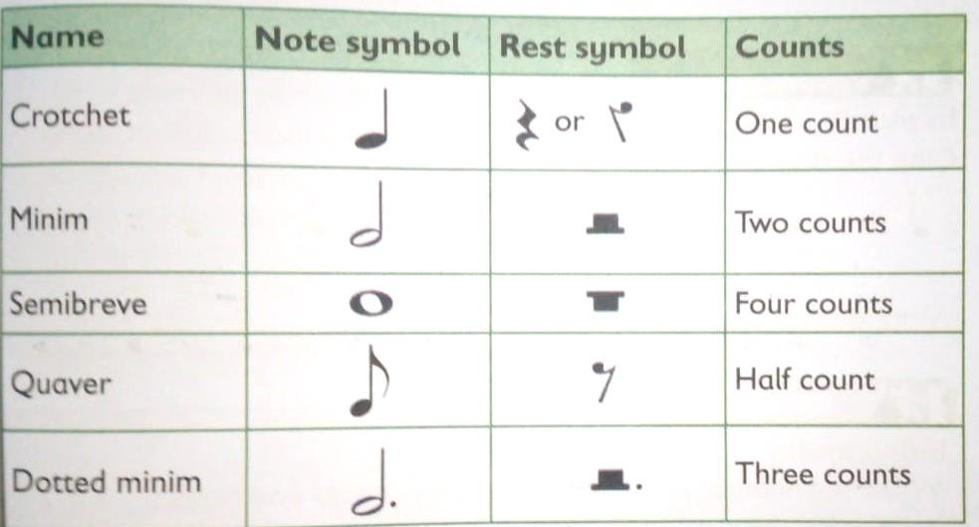

Interpreting and recognizing rhythms orally and aurally. Rhythm can be interpreted through reading or hearing. When heard, we interpret them by witting or imitating them.
The imitations may be done through clapping, tapping, stamping our feet or sounding their French rhythm names.
When written, we interpret them by sounding them. The writing may be done using notes or French names.

The rhythm may be in two, three or four beat patterns.
Oral interpretation of rhythms –is when we sound the rhythms after hearing them. We may also use French rhythm names.

Aural recognition and interpretation of rhythm is when we hear rhythms and demonstrated what we hear. We may demonstrate orally or by writing.

Things to know about creating rhythms.
🢖 Good rhythms can be created when we combine long and short sounds.
🢖 The rhythms can also be created when we also include rests of different values.
🢖 Good rhythms should have patterns that are repeated in the same way or with some changes.
🢖 The rhythms could also be in two, three or four beat patterns.
🢖 We can take a short rhythmic pattern then repeat it in may different ways. We call this development of the rhythm.
🢖 Always find ways of making your rhythms better.

This is how to create rhythms.

Combining long and short notes.
An example:
This is a four-beat rhythmic pattern.
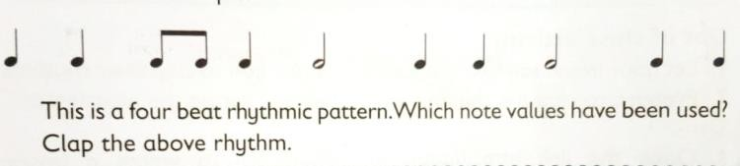

Creating rhythm that have both notes and rests.
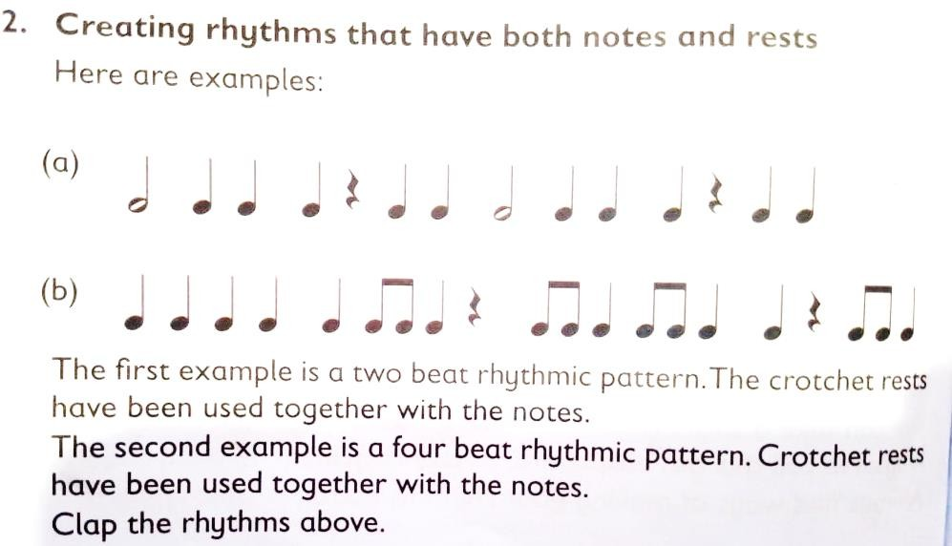

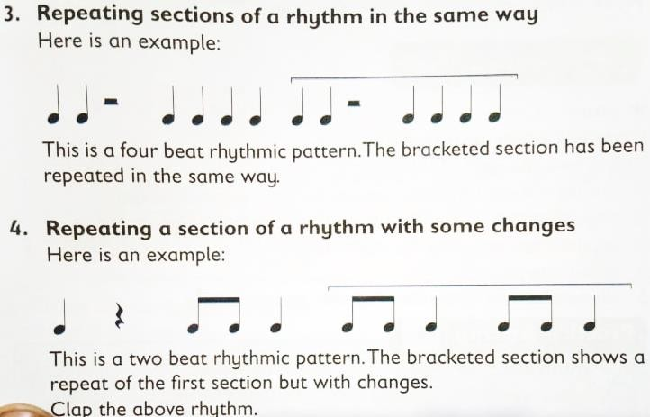

1.4 Gymnastics.
Elbow stand.
This in an inverted balance which uses the forearms as the base for the balance.
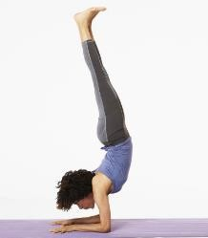
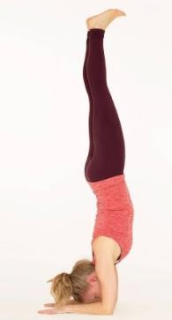
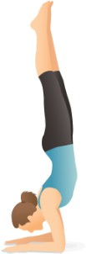

Safety instructions.
- Warm up before the activity.
- Perform the activity in an open, flat and safe place.
- Have proper sports attire.
- You can practice with a partner for support.
- If you lose balance while in the inverted position, quickly bring one or both the feet to the ground underneath you, if you are falling backwards.
- Do not hold the elbow stand balance for more than 30 seconds.

Warm up activities include;
  - Jog and jump.
  - Bear crawl.
  - Side stretch.

  - Cross body shoulder stretch.

Dive forward roll into squat stand.
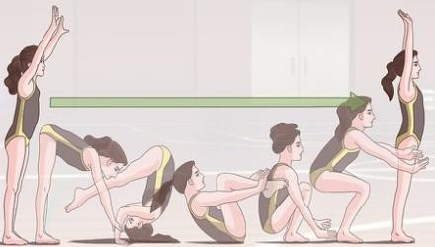

Dive forward roll into squat stand is a gymnastic action that begins with a horizontal forward diving action.
The dive action results in a forward role which finishes with a squat stand. The role can be used to recover from a fall safely.

Safety instructions.
- Perform the activities in an open, flat and safe place.
- Have proper attire.
- Observe safety precautions when practicing the dive forward role into squat stand.

Warm up activities include:
Run with arms wide at the sides. Arm circles.
Walking on toes.
Seated twist.

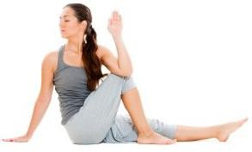
Seated twist warm up activity

Fence vault.
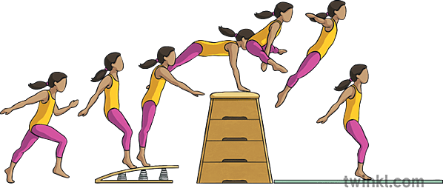
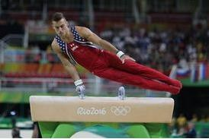
A fence vault is a gymnastic movement that allows a gymnast to jump over an object. This skill can be used to jump over an obstacle such as a fence, gate or wall.

Safety instructions.
- Do some warm ups before the activity.
- Use appropriate vaulting equipment and observe safety.
- Always perform a vaulting activity under the supervision of an adult.

Warm up activities.
Jump rope. Frog jumps.
Knees to chest stretch.

Things to learn for the fence vault.
- Approach the vaulting box with a short run.
- Jump and place the nearest hand on top of the vault box.
- Swing your leg which is nearer the box over the box. Bring the other leg to join the first leg.
- As you go sideways over the box, transfer your weight from one hand to the other.
- Keep your legs straight and together as they pass over the box.
- Land softly, with knees slightly bent or in a standing position.

Partner balance.
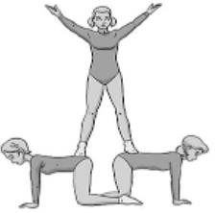
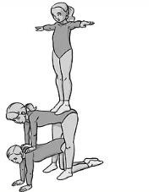
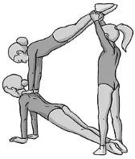
Partner balance are gymnastic moves that require participants to work in pairs or in threes.

Safety instructions
  - Have proper attire.
  - Wear gymnastics shoes or be barefooted.
  - Mount very carefully and slowly without hurting the base partner.
  - Practice using mats or padded areas.
  - Partners should be of similar size and weight.
  - Partners should warm up before the activity.
  - Partners performing the pyramids should know their roles.
  - When starting on a partner during balances, step on the backbone to avoid injuring the partner.

Warm up activities.
Butts kicks.
Side reach.
Torso twists.

1.5 Composing Melody.

Singing d r m f s l t d.
The sol-fa syllables l t d are higher than d r m f s in pitch.
When written on the sol-fa ladder, l t d are progressively higher in pitch as shown below.

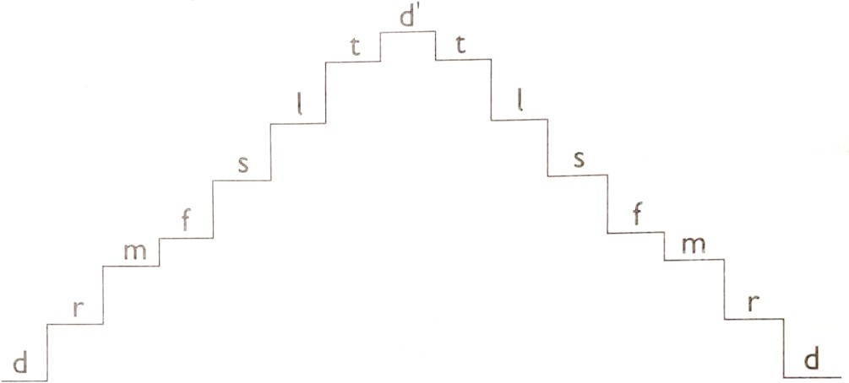
l is the short form of the sol-fa syllable lah. t is the short form of sol-fa syllable te
the sol-fa ladder, ‘d r m f s l t d’ can be performed in ascending and descending order.
We may sing the sol-fa ladder using the following:
- The sol-fa syllabus
- Other syllables such as la, pa, mew, ta, ki.
- Vowel sounds: that is either a e I o u.

  - Every sol-fa syllable should be sung at the same pitch when ascending and when descending.
  - We can also sing the sol-fa ladder with variations. For example, we can sing it with repletion of the same sound. For example, we can sing

d d d r r r m m m f f f s s s l l l t t t d d d

  - we can also sing the ladder to different rhythm patterns. We can sing a song using sol-fa syllable instead of words.
  - It requires time and practice to perfect singing sol-fa syllables in a song.
  - The sol-fa syllables help us to make associations between different pitches.

Performing d r m f s l t d” using hand signs.

- Each sol-fa syllable has a hand sign.
- The hand sign helps us to see and relate the pitches or sound of the sol-fa syllable.
- Below are hand signs for sol-fa syllable l t and d’.
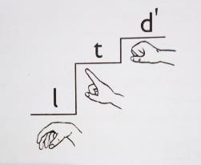

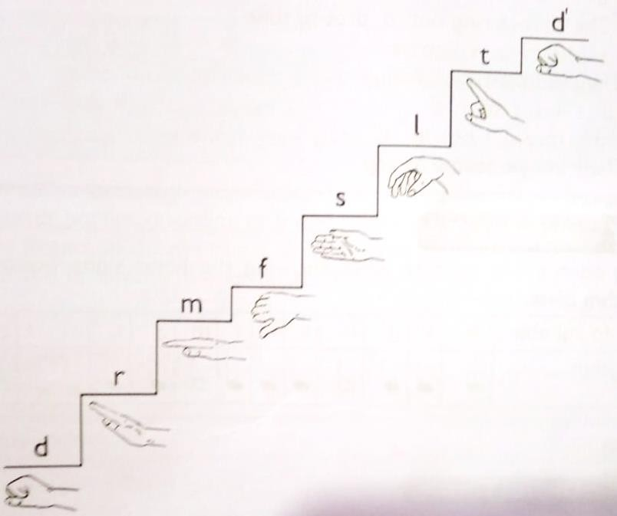
Other hand signs include:

∙

Performing & appreciating melodies.
- When we create a melody or listen to one, we can perform it by either singing it or playing it on an instrument.
- Singing the sol-fa syllbles d r m f s l t d’ make a similar melody to that produced when you
play C to C.
- In this lesson, w shall take the pitch melody to be the sound produced when we play the note C on the descant recorder.
- We appreciate our own created melodies by performing them.
- We can sing them using sol-fa syllables or playing them on an instrument.
- We may also use a digital device to record the melodies when we are singing or playing. The recordings, audio or video can then be presented to others.
- We appreciate melodies made by others by attentively listening when they are perdormed as well as applauding them when they are performed.
- We may also sing or play these melodies to show our appreciation.

STRAND 2 PERFORMANCE AND DISPLAY
2.1 Athletics.

High Jump.

Facilities and Equipment in High Jump.
Facility used in high jump is a space where a runaway is marked.
There is a landing area where suitable materials for landing is placed. For example, sawdust, landing mattresses etc.

The equipment includes:
  - Crossbar
  - Uprights.
  - Tape measure.
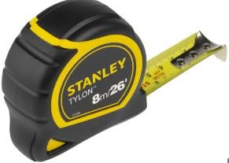
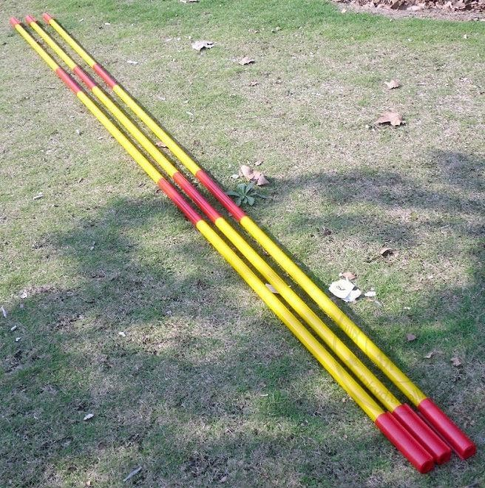
Tape measure cross bars

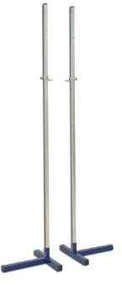
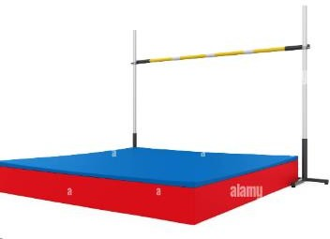
Upright bars Landing area.

High jump rules to observe:
- Do not touch the ground beyond the plane of the upright and the landing area before clearing the cross bar.
- Take off should be on one foot.
- Do not dislodge the bar during a jump.

Safety instructions in High jump.
 Make sure there is proper spacing during practice.
 Wear protective PHE attire during the training activity.
 Follow the instructions given.
 Make sure the runway is free from obstacles.
 Use a flat ground for practice.
 Jump one learner at a time.
 Make sure the materials used in the landing area is in place before attempting any jump.
 Perform the following warm up activities before participation.
  - Jumping jacks.
  - Skip and skip.
  - Press-ups.

Scissor technique in High jump.
This is a method of clearing the bar in high jump.
It involves the legs making a criss-cross action over the cross bar during flight. The criss-crossing is what gives the technique its name scissor technique.

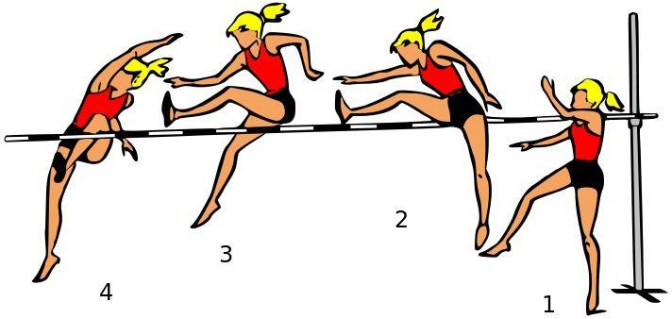
- Approach stage. - Approach the bar at comfortable speed.
- Take of stage- hold your shoulders high and flex your take off leg to launch a jump in the air.
- Flight stage – hold the leg nearer to the bar straight and swing it into the air to clear the bar. Once the lead leg is over the bar, kick the other foot to clear the bar.
- Landing stage – land on your feet to complete the jump.

Safety instructions
  - Make sure there is enough space.
  - Use proper PHE attires during the activity.
  - Follow the instructions given by the teacher.
  - Make sure the runway is free from obstacles.
  - Make sure that you land on the landing area.
  - In case the crossbar falls, place it back on the upright bars without throwing it back.
  - Perform the following warm up activities.

Long Jump.
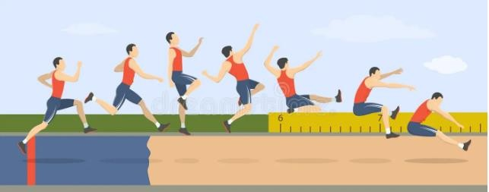

- Athletes combine speed, strength and ability to jump as far as possible from a take-off point.
- The following are the sections of the long jump facility.
  - Runway-the sprinting or approach area
  - Take- off board -the point you jump from.
  - Landing pit -a sand filled pit for safe landing
- Equipment used in long jump include:
  - 50 metres measuring tape.
  - A rake for levelling the sand pit.

Long Jump Techniques. Stages in long jump.
Approach -athlete runs along the runway using quick long strides.
Take-off – placing one foot next to the take-off board or line and then lift the body off the ground.
Flight –cycling action od the legs in the air to move the body.
Landing -contacting or touching down the landing pit area with both feet and knees bent.

Rules to observe for a good long jump.
    - Take off foot must not cross the takeoff board or line.
    - Use quick long strides, when tunning along the runway during approach.
    - Land on the pit with knees bent and head leaning forward with the hands in front.

Safety measures to observe as you participate in long jump technique activities.
- Ensure that the long jump facility is safe for use.
- When in groups, take turns to jump so as to avoid injuries.
- Follow your teacher’s instructions.
- Wear the right sports kit.

2.2 Descant Recorder.

Playing the scale of C major ascending and descending using the following musical notes C D E F G A B C D.
✰ Learn the fingering of the notes C-C’
✰ Practice notes G A B C’ as previously played in grade 6.
✰ Play gently when descending and add more air flow while ascending.’
✰ Include some of the elements of music already learnt such as playing softly, loudly, slowly and fast.
✰ Ensure that you cover the finger holes properly to enhance clarity of sounds.

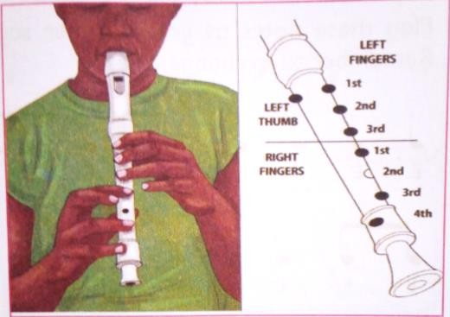
TO PLAY F
Left hand.
  - Cover the holes at the back with the thumb.
  - Cover holes 1,2 and 3 with index, middle and fourth fingers.

Right hand.
  - Cover holes 4,6 and 7 with index, fourth and fifth finger.

TO PLAY NOTE E.
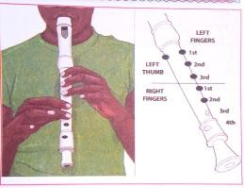
Left hand.
  - Cove the holes at the back with the thumb.
  - Cover holes 1,2 and 3 with index, middle and fourth fingers.

Right hand.
  - Cover holes 4 and 5 with index and middle finger,

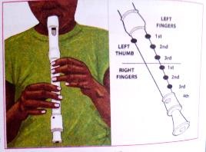
TO PLAY NOTE D.
Left hand.
✰ Cover the hole at the back with the thumb.
✰ Cover the holes 1, 2 and 3 with index, middle and fourth fingers

Right hand.
✰ Cover holes number 4,5 and 6 with index, middle and fourth fingers.

TO PLAY NOTE D.
Left hand
✰ Cover the hole at the back with the thumb.
✰ Cover holes number 1,2 and 3 with index, middle and fourth fingers.

Right hand.
✰ Cover holes number 4,5, 6 and 7 completely with index, middle, fourth and fifth finger.
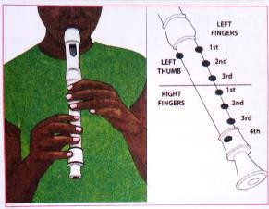

Appreciating a descant recorder.
When playing or listening to a descant recorder performance, always listen to the following:
🢖 Elements of music used such as dynamics, tempo, melody and rhythm.
🢖 Find out also if you are able to recognise the type of song such as lullaby, action song, sacred song, birthday song or patriotic songs.
🢖 Find out if you can name the title of the melody.

2.3 Swimming.

Inverted Breaststroke.
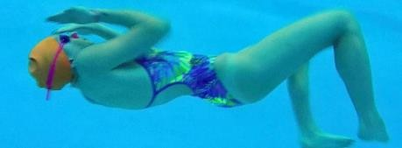
- Inverted breaststroke is a breaststroke upside down.
- It involves the arms and legs action similar to the breaststroke.
- A circular arm action and a whip leg actions.

Safety instructions.
  - Swim in appropriate swimming costumes.
  - Leave your shoes in the changing rooms.
  - Take a shower before entering the pool.
  - Tuck long hair and hold it tightly.
  - Visit the toilet before getting into the pool.
  - No pushing each other into the water or playing around the pool.
  - Do not dive in the shallow end of the pool.
  - Do not eat or chew gum within the poll area.

  - If you have an open wound or bruises, do not get in the pool.
  - Do not swim immediately after taking meals.
  - Ensure there is a life saver on standby around the pool.

Warm up activities.
🢒 Alternate arm circles.
🢒 Squats.
🢒 Knee to chest pose.
🢒 Toes touch.

Breathing action.
Breathing is natural as the face is out of water.
It is possible to exhale during propulsion as you kick the legs and pull the arms in the circular motions.
Inhale during the recovery as the legs come back to the straight position and the arms fully extend behind your head.

Timing and coordination action.
- From a glide start the arm and the leg push at the same time and finish with a glide.
- Maintain the streamlined glide position at the moment of the body decreases.
- Ensure you breath out as the arms pull in a circular movement outwards and downwards and breath in as the hands turn inwards and extend forward.
- Sequence and balance all the steps of the stroke. The steps are: stroke, breath, kick and glide.
- The stroke refers to the arm action which involves the circular outward, downward and
inward movement.

- Breathe refers to the breathing in of air.
- Kick refers to the power phase of the kick from the legs.
- Glide refers to the streamlined floating of the body.

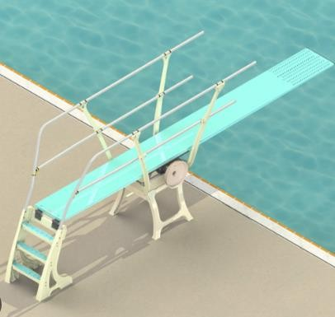
Tuck dive from an elevated position.

A tuck dive is a diving position where the dive bends his or her knees.
The diver tucks the knees and thighs closer to the chest and brings the heel towards the bottoms.

Safety instructions.
✗ Do not dive when no accompanied by a swimming teacher.
✗ Diving should be performed in pools with adequate water.
✗ Do not dive when there are swimmers in the diving area.
✗ Always observe pool and safety rules when swimming.
✗ Do not push one another from the diving board.

Warm up activities.
- Arm swings.
- Touch your toes.

Things to learn in tuck dive.
Starting position.
 Stand on the edge of the platform or springboard with your head and arms erect.
 Hold your body in a straight position.
 You can also take the staring position away from the edge of the platform or tip of the springboard. To take a few steps and build up forward momentum before take-off.
 The stages of tuck diving are as follows Take off-flight-entry into water.
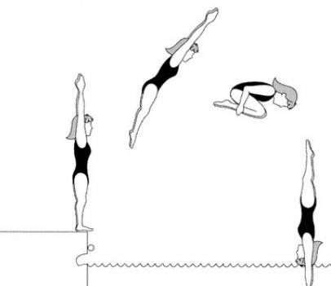

3.4 Kenya Indigenous Instrumental ensembles.

Categories of indigenous Kenyan Instrumental ensembles.
Percussion ensembles.
- Percussion instruments are instruments that are played by hitting or shaking.

They include
- Drums.
- Shakers.
- Jingles.
- Bells.
- Kayamba.
- Marimba.
- Adongo.

- There are two groups of percussion instruments:
✰ Non melodic percussion instruments- these are instruments that do not produce different pitches.
Examples are:
  - Drums.
  - Shakers.
  - Jingles.
  - Bells.
  - Kayamba.
✰ Melodic percussion instrument- these are instruments that can produce different pitches to make a tune or a melody.
Examples are:
  - Marimba.
  - Adongo.
- A percussion instrument can be identified by either listening to its sound or by looking at it.

Drums  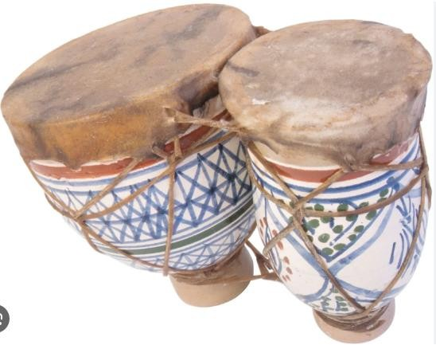 | Shakers | Kayamba

 | 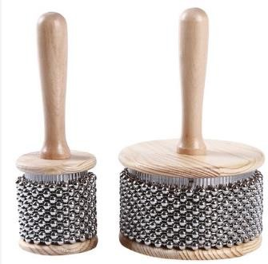 | 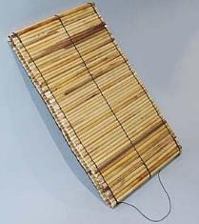
Jingles  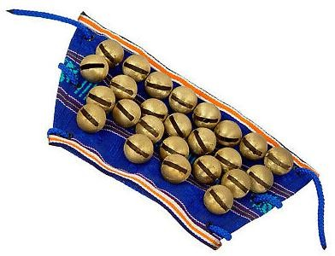 | Marimba  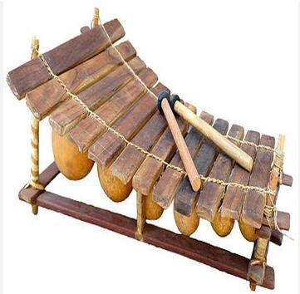

Parts of a percussion instrument.
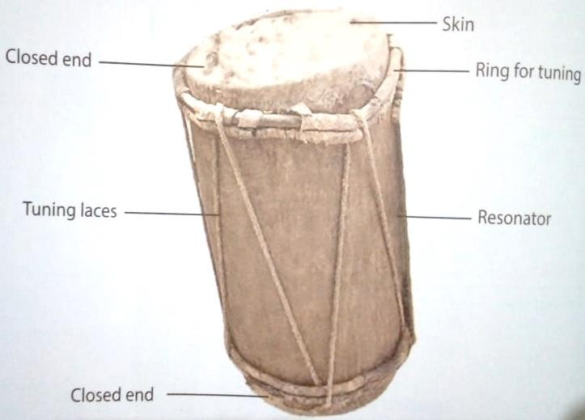

Skin -it is hit to vibrate and produce sound.
Pegs -fix the skin on the resonator.
Resonator- makes the sound louder.

Laces -use for tuning.
Sling -for holding the drum while playing.

Tools and materials used for making a percussion instrument.
Percussion instruments can be made from locally available materials such as:
- Rattles.
- Shakers.
- Drums.
- Gourds.

Methods of tuning drums.
- Warming in the sun.
- Shaking.
- Warming near fire.
- Rubbing with the palm of a hand.
- Playing a short tune.
- Tightening the membrane using laces.
- Beating/hitting the membrane.
- Hitting the tuning ring and tightening the ropes.
- Soaking the drum in arm water.
Wind ensembles.
- A wind instrument is a musical instrument which is played by blowing air into it.
- Wind instruments are found in most communities in Kenya.
- Different communities have indigenous names for their wind instruments.
- The instruments vary in shapes and sizes and materials used to make them. They include:

  - Chivoti.
  - Ndurerut.
  - Biring.
  - Biringi.
  - Muturiru.
  - Emborigo.
  - Bung’o.
  - Nzumari.
  - Abu.
  - Mulele.
  - Olwika.

Chivoti Ndurerut
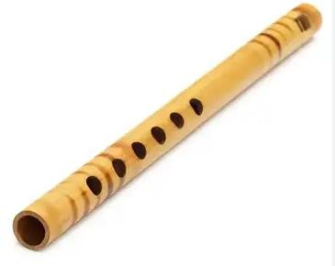
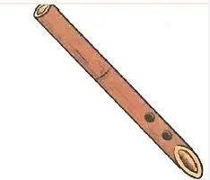
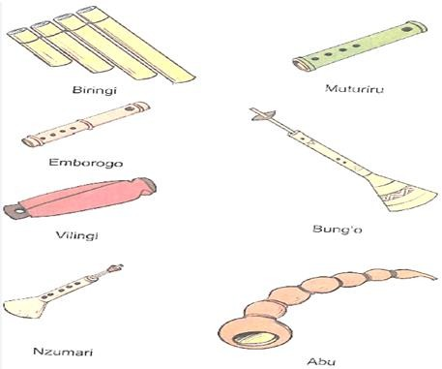

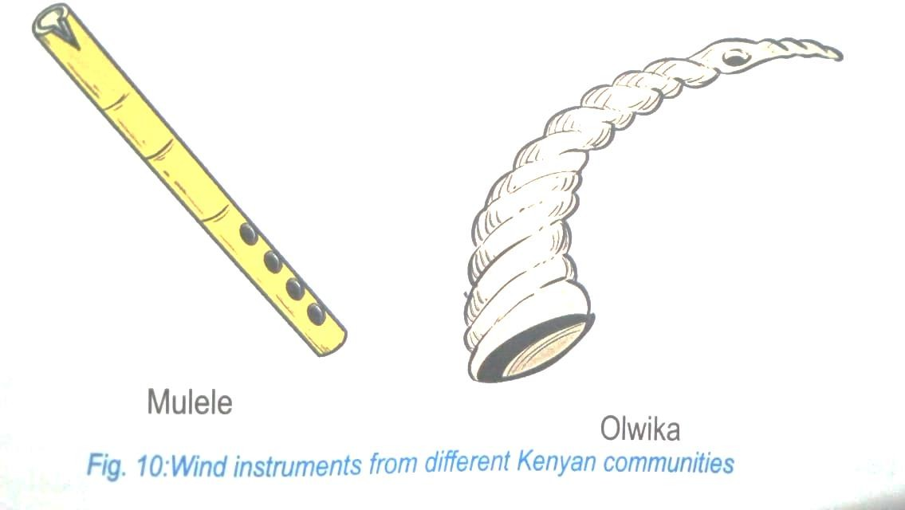

Parts of a wing instrument.
- Air is blown into wind instrument through a hole called the blowing hole or mouthpiece.
- A wind instrument has other holes used to produce different sounds or pitches when played.
- A wind instrument has an open end used to let out air when played.
- Some wind instruments have mouthpieces made of reeds.
- Wind instruments are made from different materials.
- Some instruments have a closed end to help air to pass in a particular direction.
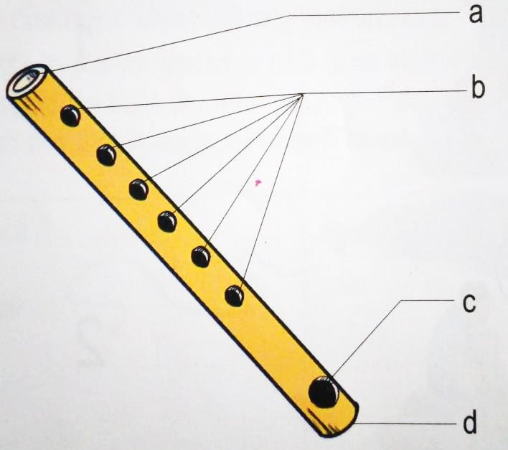
- Open end.

- Fingering holes.
- Mouthpiece.
- Closed end.

Steps in Making a wind Instrument.
⮎ Collect the materials needed in making a wind instrument such as:
⮎ Ensure the tube being used is hollow.
⮎ Mark and Cut holes as required.
⮎ Ensure you handle the knife carefully to avoid injuries.
⮎ Clean the place by collecting litter after making the wind instrument.

Care for A wind instrument.
⭧ Materials used for making most of the wind instruments are breakable, hence the instruments should be handled with care.
⭧ Some wind instruments have straps for hanging them for safe storage.
⭧ Use a clean piece of cloth to wipe the mouthpiece. This will reduce the risk of communicable diseases when sharing instruments.
⭧ Moisture collects in the air passage of a wind instrument as it is played. The air passage
should be kept dry after playing by passing a feather or a clean piece of cloth through the air passage.

Role of wind instruments in music making.
- Some are used to introduce the performance such as whistles and some flutes, for example, chivoti.
- Some may be played between parts of a song to bridge (fill the gaps or moments when the singers are silent).
- These instruments can also be played to respond to a soloist. For example, some flutes
such as chivoti.

- They provide accompaniment to songs and dances.
- Wind instrument also signals the start or change of a song.
- Other such as horns, for example Olwika of the Luhya is used to mark the climax of the performance.
- Solo wind instruments are used for music making during leisure time.
- Wind instruments that do not play melodies such as the Olwika of Luhya can be used to help in keeping the speed of the performance.
String ensembles.
These instruments produce sound through vibration of strings when plucked. They have man strings and others have only one or two strings.
They include:
  - Bukindit of the Kipsigis.
  - Wandindi of the kikuyu.
  - Adeudeu of the iteso.
  - Litungu of the luhya.
  - Nyatiti of the luo.
  - Shiriri of the Luhya.
  - Kimeng’enf of the Kalenjin.
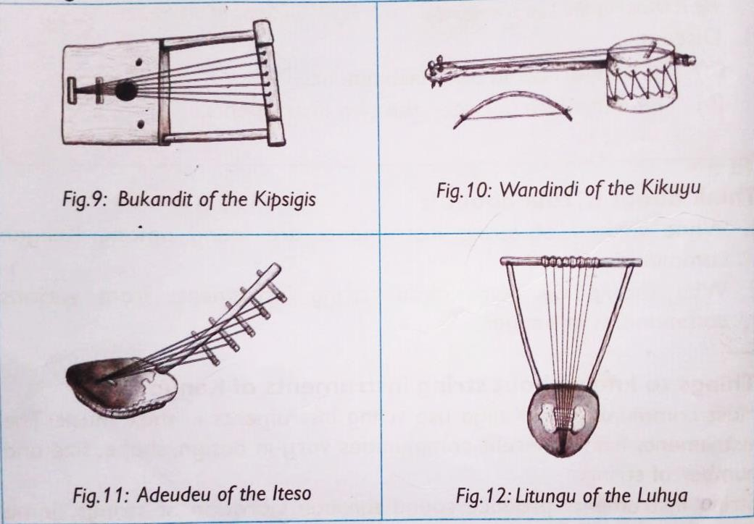
  - Zeze of the taita.

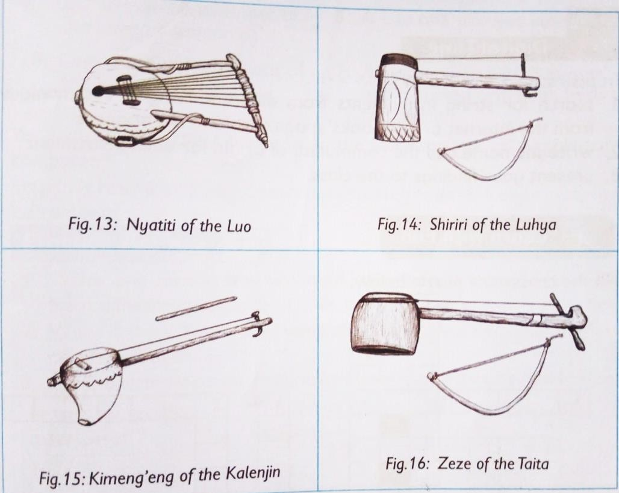

Factors to consider when playing in an instrumental ensemble.
  - Select an appropriate instrument-ensure you are able to use the instrument well in the right occasion.
  - Ensure the instrument is well tuned.
  - Ensure you apply the appropriate playing techniques.
  - Ensure you play your instrument in synchronization with other instruments.
  - Consider playing at the right tempo as the rest of the instruments.
  - Play with accuracy in melody and rhythm.
  - Improvisation of rhythms and melodies.

