

GRADE 6 CBC

SOCIAL STUDIES LESSON NOTES

STRAND 1.0 NATURAL AND THE BUILT ENVIRONMENT

Position and size of countries of eastern Africa
Eastern Africa consist of eleven countries namely.
- Kenya
- Uganda
- Ethiopia
- Sudan
- Somalia
- Burundi
- Djibouti
- Rwanda
- Eritrea
- Tanzania
- South Sudan

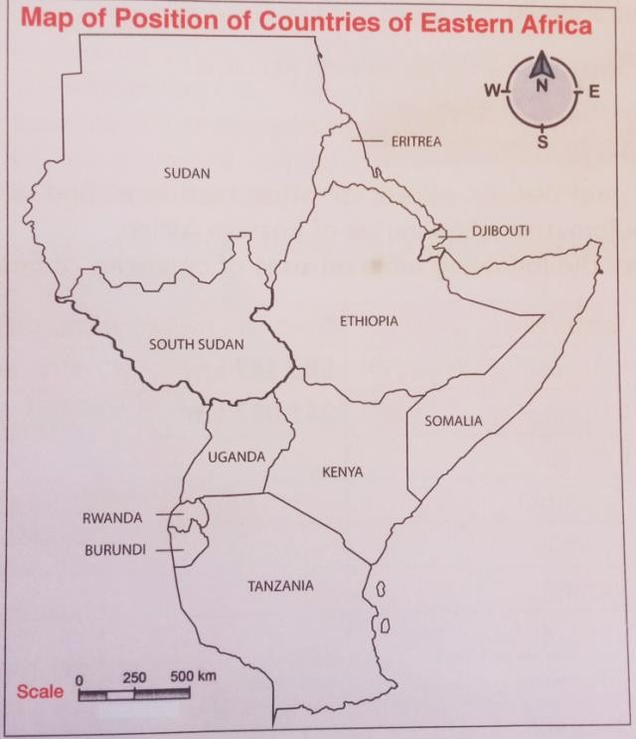

east.
- We can locate the position of the countries using latitudes and longitudes.
Latitudes – are imaginary lines drawn on a globe or a map running from west to

- They show how far how far the north or south a place is from the equator The main latitude is called Equator and it marks 0 degrees.

Longitude
  - These are imaginary lines drawn on a map from south to North.
  - The prime meridian is the most important line of longitude
  - It marks 0º.
  - Eastern Africa lies between latitude 23 ºN and 12 º and longitude 22º E and 51ºE
  - We can use latitude then longitude when locating a place.
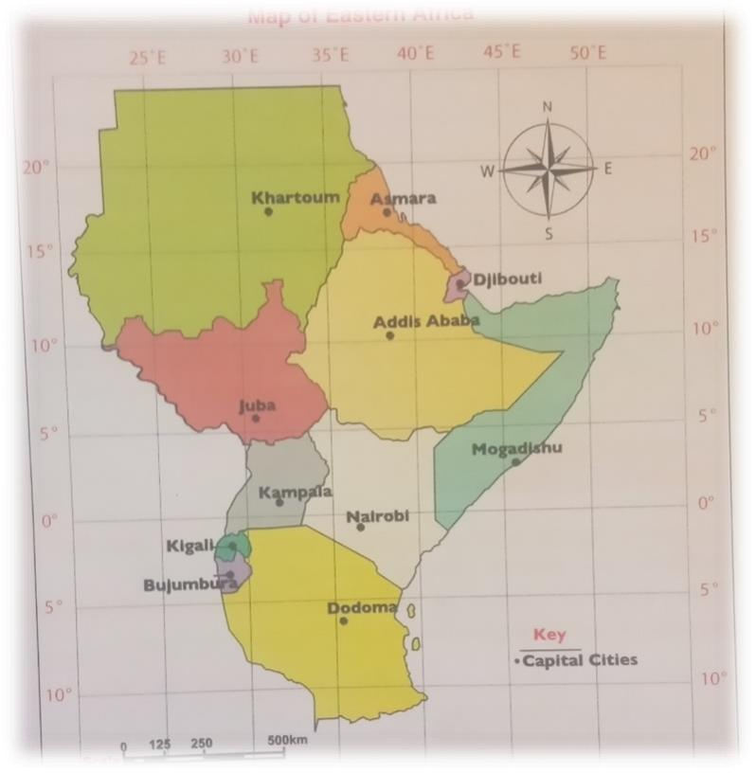

Activity: Learners in groups study the map of eastern Africa from the grade 6 K.L.B visionary learner’s book page 3 and identify the size of each countries.
The largest country in Eastern Africa is Sudan while the smallest country is

Djibouti.
Learners in group groups use digital devices to play games of the latitude and longitude through the link below https://youtu.be/SC_E2rc15f4

Main Physical Features in Eastern Africa
Physical features - are the natural things that are found on the surface of the earth
They include; mountains, valleys plains, lakes rivers, swamps and oceans

Mountains

The major mountains in Eastern Africa includes;
- Mt. Kilimanjaro
- Mt Elgon
- Mt Ruwenzori
- Danakil Apps
- Usambara
- Karisimbi
- Mt.Hehe
- Mt Marrah
- Mt.Kenya

A valley
A valley is a low lying are with steep slopes
In Easter Africa the rift Valley has two branches that stretch across several countries The two branches are:

Eastern Rift Valley
  - Western Rift Valley
Learners in groups discuss the eastern African countries crossed by rift Valley in Eastern Africa

Plains
Plains are low lying area that have a flat surface Examples of plains in eastern Africa includes:
  - Lotikipi plains in Kenya
  - Serengeti plains in Tanzania
  - Bilesha plains in Somalia

LAKES
A lake is a large water body of fresh or salty water occupying a depression.

Examples of lakes in eastern Africa includes;
  - Lake Turkana – Kenya
  - Lake Victoria- Kenya, Uganda and Tanzania
  - Lake tana - Ethiopia
  - Lake albert and kyoga in Uganda

Formation of main physical features in East Africa Formation of mountains

There are various types of mountain in Eastern Africa
  - Volcanic mountains
  - Block mountains
  - Fold mountains

Volcanic Mountains
Volcanic mountains are formed through volcanic eruption.
Magma is pushed up the vent and accumulates around forming volcanic mountains.

Examples of volcanic mountains are;
  - Mt Kenya
  - Mt Elgon
  - Mt. Longonot in Kenya
  - Mt Karisimbi in Rwanda
  - Mt Meru and Mount Kilimanjaro in Tanzania
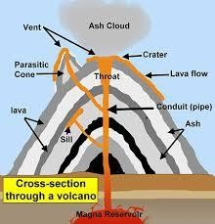
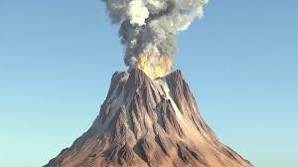
Activity: Learners in groups use digital devices to watch video clips of volcanic mountain mountains through the YouTube link below https://youtu.be/wO3R3iPCQ74 and discuss in class, where there I no network teacher to download the video via the above YouTube link

Block mountain formation
  - Block Mountains are also called horst blocks.
  - They are formed through a process called faulting.
  - When compressional force push rocks towards one another, faults form.
  - The land between the fault rises to form Block Mountains.

Examples of Block Mountains in Eastern Africa are:
- Danakil alps – border of Ethiopia and Eritrea
- Ruwenzori Mountain – Uganda
- Pare and Usambara Mountain in Tanzania

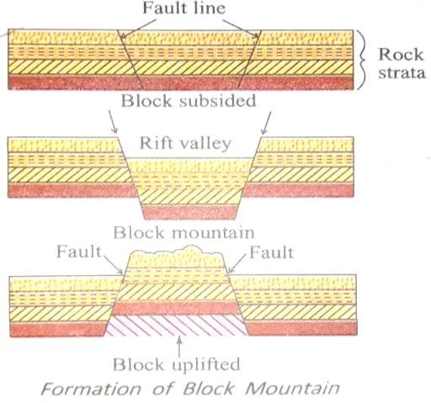

Formation of Lakes
  - The major lakes of Easter Africa were formed through river Deposition, faulting, down warping and deposition
  - ​

Rift valley lakes
During the formation of Rift valley, some parts of the land sunk deeper that others forming depression
The depression were filled with water to form lakes e.g. Lake Tanganyika
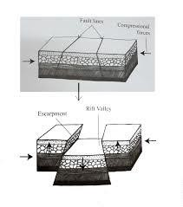
while some are fresh water lakes
Some of rift valley lakes are salty
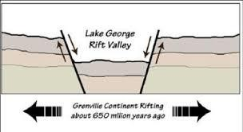

Lake formed as a result of down warping.
Down warping is a process by which the earth surface sinks inwards due to pressure forming a big basin.
Water fills this basin to form a lake
Examples of down warping lake is L. Victoria

Lakes formed as a result of volcanicity.
  - Lava dammed lakes.
Lava dammed lakes are formed when lava flows on the surface of the earth and come in contact with a river, blocking it.
This blockage leads to the formation of a lake.

Examples is Lake Kivu
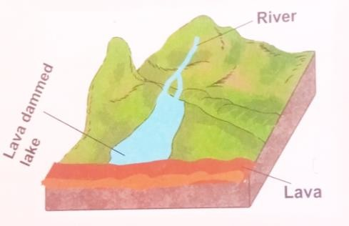

Crater lakes.
When volcanic eruption occurs, the top of the mountain may be blow off forming a hollow depression called crater.
Water fills the hollow depression forming a crater lake. Examples of crater lakes are;
    - Paradise in Kenya
    - Shalla in Ethiopia

- Plains
Plains are wide low lying areas of flat land.
Plains are formed as a result of erosions and deposition of the eroded materials.

Learners in groups locate the following physical features from on the map and discuss in class KLB visionary Grade 6 book page 23

CLIMATIC REGIONS IN EASTERN AFRICA
Climate – is the average weather condition of a given place for a very long period of time.
Climatic region – refers to a continuous geographic are with similar climatic characteristics.
Areas with similar climatic conditions are grouped together to form a climatic region. Differences in climatic conditions have impact on the type of farming activities and even the type of cloths we put on.
The dressing style depends of the climatic condition of a place

Climatic regions in eastern Africa
- Equatorial climate
- Tropical climate
- Sub- tropical
- Desert mountain climates
- Semi- desert climate
- Modified equatorial climate

Characteristics of main climatic regions in Eastern Africa
- Equatorial
- High rainfall throughout the year
- Experience high humidity
- No distinct dry season
- Receive convectional rainfall

Desert climate
  - Hot and dry in most months of the year.
  - Prolonged drought.
  - Cloudless sky throughout the year.
  - Less than 250mm rainfall throughout the year.

Semi-arid climate
- Long dry season
- High temperature
- Rainfall range between 250mm to 680mm per year.

Sub-tropical
Cool or moderate temperature between 18º and 23º. High rainfall between 1.100mm and 2500 mm per year Rainfall is throughout the year.

Modified Equatorial
- Some parts experience short dry season
- High rainfall over 1,100 mm per year.
- It has two main seasons of about 22 º c.
- High humidity throughout the year.
- It has two main dry seasons.

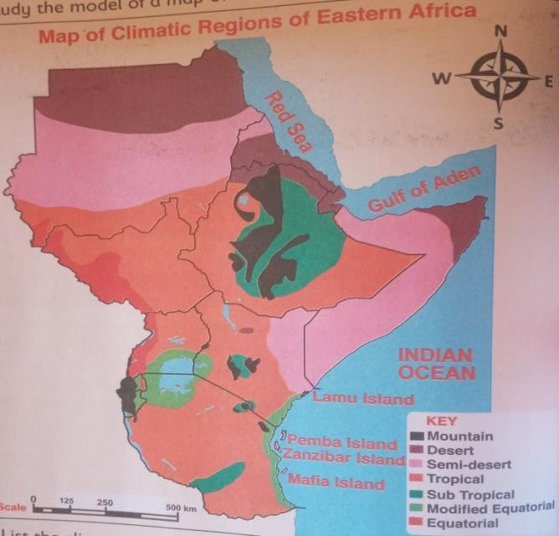

Influence of climate on Human Activities in Eastern Africa
In arid and semi-arid areas, pastoralism is the main economic activities.
- The area receive low rainfall that cannot support crop farming.
- In tropical areas where rainfall is reliable. Crop farming is the main economic activities because the climate favours the growth of crops and animals.
- Too much rainfall leads to flooding and destruction of crops and properties.
- Drought and famine leads to death of crops and animals

VEGETATION IN EASTERN AFRICA
Vegetation refers to plants that grow in a place. It consist of trees, bushes, grass and shrubs.
The vegetation that grows on its own is called natural vegetation.
The vegetation that is planted is called planted vegetation.

Types of vegetation in Eastern Africa
The main types of vegetation in Eastern Africa includes.
- Tropical rain forest vegetation.
- Savannah grassland.
- Desert vegetation.
- Papyrus swamp vegetation.
- Mangrove forest vegetation.
- Mountain forest vegetation.
- Semi- desert scrub.

Characteristics of the Main Types of Vegetation in Eastern Africa

Various types of vegetation has different characteristics

Savannah woodland vegetation
  - Provide enough sunlight to reach the ground
  - Trees of medium height cover large area

Mountain Vegetation
  - Mountain vegetation is mostly affected by the altitude
  - From the top mountain to bottom. The mountain ranges from
    - Rock,
    - Heath and moorland,
    - Bamboo,
    - Rain forest
    - Savannah
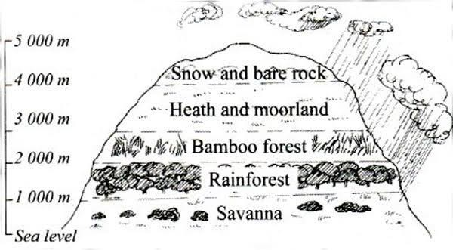

Historic Built Environment in Eastern Africa
Historic built environment - refer to features made by people. These features have a historic value.
They include museums, monuments and historical building.

The main Historic Built Environment in Eastern Africa
- Kigali Genocide Memorial Museum in Rwanda.
- Fort Jesus Museum in Kenya.
- Namugongo shrine in Uganda.
- Independent monument in Burundi.
- St. Francis of Asisi monument in Eritrea.

- John Garang Mausoleum South Sudan.
- Askari monument in Tanzania.
- Victoria monument in Ethiopia.

Importance of the main historic environment in Eastern Africa
  - It create a sense of belonging and connection with the past.
  - The historic built environment attract tourist and earn us foreign exchange
  - Many people are employed to work in the historic buildings e.g. museums and monuments.
  - They serve as source of learning centres.
  - They enable social interactions with family and friends.

Learners in groups compose poems of the important of historical environment and recite in class.
In groups learners use digital devices to Watch a video clip on historic built environment in Eastern Africa with the YouTube link below httpS://youtu.be/aPOUBgjeV2I

STRAND 2.0 PEOPLE, POPULATION AND SOCIAL ORGANIZATION

Language groups in Eastern Africa
A language groups – refers to the people or communities who speak the same or related language.
The people of Eastern Africa belong to different language groups. The language groups in Eastern Africa include;
- Nilotes
- Bantu
- Semites
Classification of communities in Eastern Africa According to Language Groups

Language group | Communities
Bantus | Chagga,hutu, baganda , abaluhya, tutsi, Sukuma, abakuria, Basoga,gogo, aembu, bagishu, hehe, akamba, banyore, zaramo pare, taita, nyamwzi,  Makonde,ngoni, agikuyu, batoro, Mijikenda
Nilotes | Luo, alur, lang’o, dinka, nuer,anuak, shiluk,  japadhola, lagbara, kipsigis,Nandi,tugen,sebei,keiyo,pokot,marakwet,

 | ogiek
Cushites | Borane, sanye, somali, somali, oromo,renndile,ogaden,beja,hawiya, galla, isaaq,  sandawa,burungu
Semites | Amhara, tigre,bagarra,falasha,Bagakko,kababish.  Girghe,arabs, Nubians and adere

Migration
Migration is the movement of people from one place to settle in another place People migrate from one place to another with various reasons

Bantus
The Bantu moved into the Eastern Africa from western Africa.
They later moved and first settled in Cameroon and later Congo before moving to eastern Africa
Bantus are divided into two groups which include
- Western Bantus
- Eastern Bantus
- Later some groups moved into Western Kenya.
- Eastern Bantus followed Lake Kivu and Lake Edward routes.
- They settled in Rwanda and Burundi and some moved into Northern and Central Tanzania.
- Some later moved into Kenya and settled in the highland of the coastal regions.

Reasons for migration of the Bantu
- They were looking for fertile land to grow crops.
- Drought and famine.
- They wanted to move away from their hostile neighbour.
- They were running away from outbreak of diseases.
- They wanted to avoid quarrelling amongst themselves.
- The population had increased and so they were looking for space to settle.

Nilotes
  - The Nilotic speaking groups into Eastern Africa along the River Nile from where they got their Name Nilotes.

  - They Nilotes are divided into three groups.
- Plain Nilotes.
- River Lake Nilotes.

- Highland Nilotes.

- The river Lake Nilotes moved into two groups, the first groups settled in South Sudan while the second groups moved southwards and settled in Uganda and some moved to western Kenya and settle near Lake Victoria.
- The highland Nilotes migrated from southern Sudan and settled around Mt Elgon in Kenya and Uganda.
- Later some moved and settled in highland west of rift valley in Kenya.
- The plain Nilotes moved from south Sudan into the Northern Uganda and around Lake Turkana in Kenya. Some moved further into southern part of kenya and entered northern Tanzania from Kenya.

Reasons for migration of the Nilotes
- They were looking for pasture for their livestock.
- They were running away from outbreak of diseases and pest.
- They were moving away from drought and famine.
- Population pressure in the community.
- Attack by the hostile neighbour communities.

CUSHITES
  - The cushites language group moved into eastern Africa from Arabia.
  - Some of the groups moved and settled towards Ethiopia, Somalia and Kenya.
  - The earlier Cushitic groups such as the Iraq settled in Tanzania.
  - The Semites are the mixed origin (African, Arabic and Jewish).
  - They intermarried with the African communities to form new language group.
  - The groups spread out and settled in Ethiopia, Djibouti, Eritrea and Sudan.

Reasons for migration of the cushites in Eastern Africa
- Looking water and pasture.
- Attack by hostile neighbour communities.
- Spirit of adventure.
- Outbreak and diseases and pest.
- Drought and famine.
- Population pressure.

Reasons for migration of the Semites
- They wanted trading partners .
- They wanted to spread Islamic education
- They wanted adventure.
- They wanted the spread of culture.

The Movement and settlement of language groups in eastern Africa

The different language groups in Eastern Africa migrated from their places of different language groups.

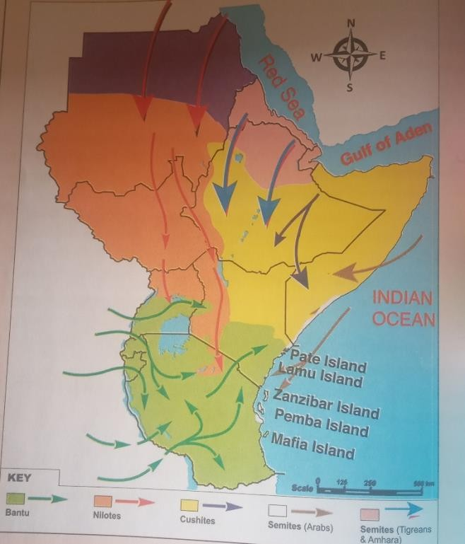
  - Leaners in groups in turns discuss the effect of migration and settlement of different Eastern Africa communities.

Effect of migration and settlement of selected language groups of eastern Africa
    - It led to intermarriage between different communities.
    - Adoption of different cultures.
    - Inter community trade.
    - Outbreak of wars, as some communities tried to displace other communities for settlement.
    - Promotion of trade.
    - Introduction of new farming methods .

POPULATION DISTRUBUTION IN EASTERN AFRICA
- Factors that influence population distribution in Eastern Africa Population - refers to the number of people living in a given place Population distribution - is how the people are spread out in a n area Population density - is the total number of people per square area Cities and towns have high population densities.

Areas that receive little rainfall, mountainous area, forests and swampy are have love population.

Effect of high population density in Eastern Africa
  - Poor living standard.
  - Unemployment.
  - Development of slums to control the rapid growing population.
  - Poor social amenities such as Hospitals.

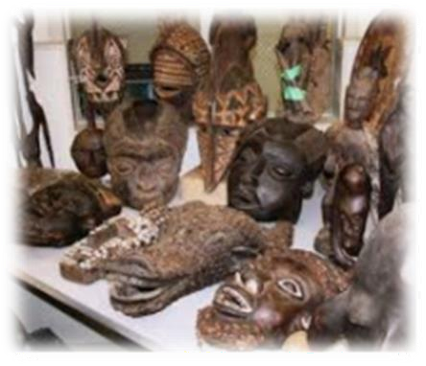
  - Traffic congestion in urban roads.

CULTURAL AND SOCIAL ORGANISATION
Culture – it is the people’s way of life The culture of people includes;
- Language
- Way of dressing
- The food they eat
- The way they worship
- Games and sports they play

Age group and Age set in the traditional Africa Society
An age set - is a social group consisting of people of similar age with a shared density. Members of the same age set maintain close ties over a long period of time.
An age group - is a social group consisting of people born during a particular period of time e.g people aged between 18 -25 form an age group.

CLAN
A clan is a group of people who originate from a common ancestor Many families that are related form a clan.
A clan perform many functions in a for the welfare of its members.

Function of clan in a society
  - Allocating lands to family members
  - Setting rules in a clan
  - Setting and maintaining moral values
  - Solving dispute

  - Protecting members from external attack
  - Punishing wrong doers
  - Deciding the religious practises and beliefs of the clan
  - Organising ceremonies and festivals

Aspect of African Tradition Culture that ought to be preserved
  - Tradition food
  - Traditional attire
  - Wrestling
  - Dance
  - Games
  - Worship ceremonies
  - Festival
  - Dances and language
Some of the aspects of African traditional culture include traditional food
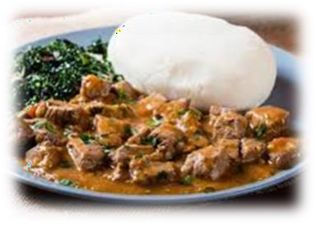
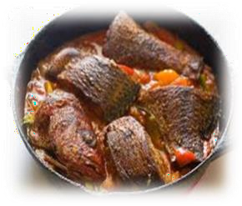
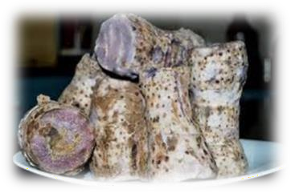
  - Traditional food
  - Traditional attire
  - Wrestling
  - Dance

- 
Learners in groups discuss various foods for different communities.

School and Community
A school is an educational institution designed to provide learning to learners with the support of the teachers
Community – is a groups of people living in a same place or having a particular characteristics in common

Ways in which the school collaborates with the community
  - The community donate books to a school
  - Learners clean market centres
  - Community appoint school representative for pupils
  - Help in in harambee for school building

RESOURCES AND ECONOMIC ACTIVITIES IN EASTERN AFRICA AGRICULTURE
It is the growing of crops and keeping of livestock Large scale farming is practised in large track of land
Farming involved large scale production which requires large amount of capital Types of farming methods

Large scale farming
It is the growing of crop and rearing of animals on a large piece of land Crops that are mainly grown in large scale farming include
  - Coffee
  - Wheat
  - Sugarcane
  - Tea
  - maize

Small scale farming
Is the growing of crops and rearing of animals in a small piece of land mainly subsistence farming.

Main Areas where large –Scale farming is practised in Easter Africa

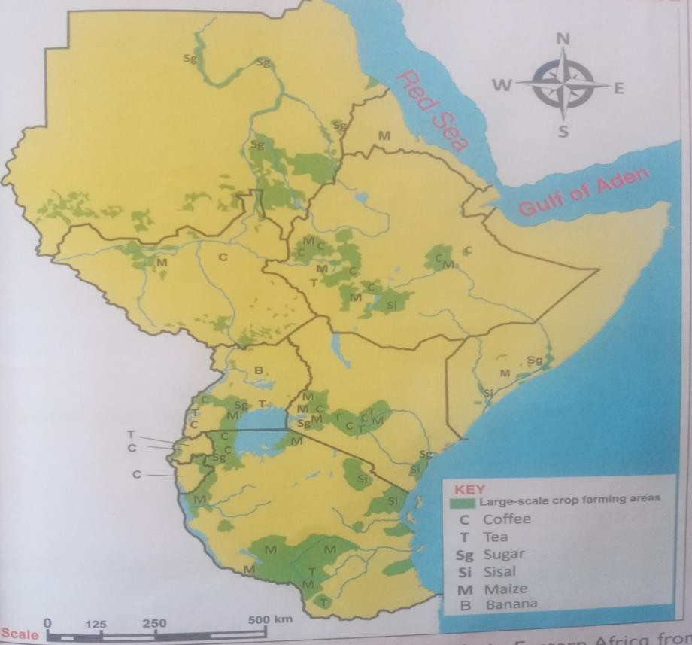

- large scale Livestock farming in Eastern Africa The animals kept I large scale farming
  - cattle
  - camels
  - sheep
  - goats

Contribution of Large Scale farming to the economy of Easter Africa
  - Source of raw material for agro- based industries
  - Source of employment
  - Source of food to people
  - Earns the country foreign exchange
  - Promote trade which stimulate economic development

Importance of contribution of Large scale Farming to the economy of Eastern Africa
  - Reduce cost of food
  - Improve the peoples living standard individuals
  - Development of good transport and communication network
  - Growth of towns
  - Improved social amenities such as schools and hospitals
  - Establishment of factories
  - Control rural – urban migration
Learners in groups discuss the contributions of available Farming methods in your locality and to the economic development.

BEEF FARMING
- It is an activity where farmers keep cattle to be sold for meat.
Beef farming is usually practise on a large - scale where cattle are kept on large farm. The farms are usually called ranches.
Beef farming is largely practised in areas where crop farming is not widely spread

Factors influencing beef farming in Easter Africa
- Climate
- Availability of large piece of land
- Demand for beef
- Capital availability

- Government policy

Area where beef farming is practised in Eastern Africa
  - .Kajiado in kenya
  - .machakos in kenya

Contribution of beef farming to the economy of East Africa
- Source of income
- Source of food
- Development of industries
- Earns the country foreign exchange
- Source of employment

FISHING IN EASTERN AFRICA
Fishing is the activity of catching fish for food or as a sport The fish is either consumed at home or sold in the market
In eastern Africa there is both inland and marine fishing ground
Inland fishing – is carried out in water bodies such as

Lakes
- Rivers
- Ponds
- Dams
Marine fishing is carried out in very large water bodies such as seas and oceans.

Methods of marine Fishing in Eastern Africa
  - Trawling
  - Purse seining
  - Drifting
  - Long line fishing Trawling method
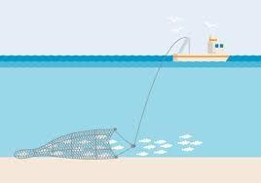
It is a method of marine fishing where fishing net is pulled by a boat to catch large amount of fish

Purse seining
Purse seining – is the use of the us of bag like nets that are spread on a lake assisted to float using weight in water
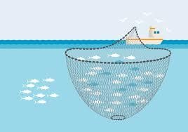

Long lining - it is a method where long lines with hooks containing baits are tied on a boat or a ship
The lines are thrown in the water to attract fish
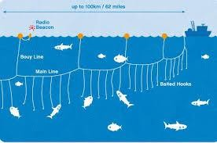

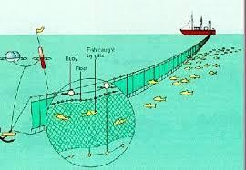
Net drifting
Drifting method – is a method where nets called drift nets are hanged vertically in water to trap fish.

Challenges affecting fish farming in Eastern Africa
- Lack of good fishing techniques

- Poor fish storage
- Water pollution
- Over fishing
- Demand for a particular type of fish
- Destruction of corals along the coast
- Lack of efficient means of transport
- Outbreak of water borne diseases that may led to closure of fishing beaches
- Government policies
- Over taxation by the government
- Inadequate fishing skills

Solutions to challenges facing fish farming in Eastern Africa
  - Allocating and sourcing for funds
  - Protecting fishing grounds from foreign vessels.
  - Provision of proper storage and preservation method.
  - Educating people on safe fishing method.
  - Protecting coral reefs from destructions.
  - Developing rules and regulations to guide the fishing industries
  - Improve good transport networks for easy transport of fish to the market
  - Government should loosen tight rules and regulations guiding fishing farming.

METHODS OF FISH PRESERVATION
  - Refrigeration
  - Sun drying
  - Canning

WILDLIFE AND TOURISM IN EASTERN AFRICA
- Wildlife includes plants , insects , bird and animals living on their own in the bushes or forest
- Tourism - is the act of travelling to visit things and places of interest for leisure

Factors promoting tourism in Eastern Africa
  - Wildlife
  - Beautiful sceneries
  - Rich cultural heritage
  - Historical sites
  - Good accommodations
  - Conference facilities

Learners in groups use digital devices to watch factors that promote tourism in Easter Africa and discuss with others in class.

Game reserves in Eastern Africa
  - Ruaha
  - Kitui south
  - Losai
  - Yabelo
  - Uwanda
  - Maasai
  - Rungwa

National parks in Eastern Africa
National park are controlled and managed by the national or federal government They are restricted area where settlement and human activities are not allowed

Game reserves
Game reserves are managed and controlled by local authorities such as counties, municipal council and district where they are located,
People are allowed to settle and carry out other human activities such as grazing of domestic animals

Leaners in groups locate game reserves and national park in the map of game reserves and National parks in grade 6 KLB Visionary social studies book page 105.

Challenges facing tourism in Eastern Africa
  - Poaching
  - Government policy
  - Drought and faming
  - Political instability
  - Insecurity
  - Threat by terrorism
  - Few local tourist
  - High entry charges in the game park
  - Expensive hotel charges
  - Poor road and air network

  - High cost of air transport

Solution to Challenges Facing Tourism in Eastern Africa
  - Improvised security in game park and game reserves, hotel, beaches and other recreational facilities
  - Improved hotel and conference facilities
  - Encourage local tourism
  - Reduce transport and park entry charges
  - Marketing Eastern Africa as a tourist destination in other parts of the world

Tourism as an Economic Activity
Wildlife is a major tourist attraction in Eastern Africa
It’s therefore important to participate in conserving environment

Outdoor practise
Learners to take a trip with their teacher to the nearby tourist attraction site, learners to engage the resource person in charge of the tourist attraction site by asking question.
Learners to take note on the various challenges, and important of tourist attractions site in the area.

TRANSPORT IN EASTERN AFRICA

Main Transport Networks in Eastern Africa
Transport - is the movement of people and good from one place to another The movement is made possible by established transport networks
The main transport network in Eastern Africa include;
- Road
- Railways
- Air transport
- Water
- Pipeline

Road transport Network in Eastern Africa
NOTE: Learners to look at the map of transport Network in Eastern Africa and locate major and minor roads, Grade 6 KLB visionary social studies book page 112
Most of the Eastern Africa road network is linked to the Great North road.

The great North road starts at Wadi Halfa in Northern Sudan to Tunduma in Southern Tanzania
The Tran African Highway enters Eastern Africa through Kisoro border at Uganda –
DRC border and extends to Mombasa in Kenya

Railway network in Eastern Africa
The railway networks in Eastern Africa was run down over the years due to poor maintenance,
Kenya –Uganda and Tanzania were linked by one railway network called the East African Railways
Sudan and south Sudan were linked by railway network which runs from Wadi Halfa ti Wau.
Ethiopia and Djibouti are linked by Ethiopia –Djibouti railway Somalia Rwanda and Burundi have no functioning railway network.

Air transport Network in Eastern Africa
Air transport involved the transport of Goods and people by means of ait The main item of trade here is plane
Air transport is not commonly means of transport In Eastern Africa due to high cost of living and lack of infrastructure.

Learners to discuss air lines in east Africa with reference to grade 6 KLB visionary book social studies page 114.

Water transport
Passage of good and people by means of water
The common means of water transport in Eastern Africa include
  - Boats
  - Canoes
  - Ferried
- Pipeline transport
The main pipelines in Eastern Africa are the oil pipeline from Mombasa to Kisumu and Eldoret in Kenya and the Greater Nile Oil Pipeline in Sudan
Other proposed pipelines being developed include the gas pipeline from Ethiopia to Djibouti, the crude oil pipeline from Uganda to Tanzania and the oil pipeline from Lamu , Kenya to South Sudan.
Learners us digital device stop watch transport networks in Easter Africa through youtube.

Challenges facing Transport in Eastern Africa
- Attach from terrorists

- Insecurity makes road transport difficult
- Numerous cases of accidents makes roads unsafe for use
- Lack of adequate capital to build new lines and expand existing ones
- Some railways are running on old locomotives
- Inadequate capitals to build ports and harbours
- Lack of moderns facilities for loading and unloading of cargo
- Poor management of airport resulting to huge losses and collapse

Solutions to the challenges facing transport Network in Eastern Africa
- Developing additional road capacity to accommodate a large number of motorist
, cyclist and pedestrians.
- Promoting public transport system that moves a large number of people as opposed to private cars.
- Establishing rapid rail transit system in urban.
- Encouraging walking from one place to another instead of using private cars.

Transport Network in Economic Development
- Create employment opportunities.
- Make movement of goods and people faster.
- Facilitate trade.
- Facilitate international co- operation .

Communication in Eastern Africa
Means of communication in Eastern Africa.
The common means of communication in Eastern Africa involves use of :
- Mobile phones
- Internet
- Radio
- Television
- Newspaper

Challenges facing Communication Networks in Eastern Africa
- Lack of technical skills
- Limited knowledge in the use of some means of communications
- Destruction and theft of communication
- Poor networks
- Bad weather

Solutions to challenges facing communication Networks in Eastern Africa
- Improvising security
- Introducing computer studies in th education system
- Training expert
- Allocating funds to improvise communication networks

Roles of communication Network in Eastern Africa
- Easy flow of information
- Source of employment e.g radio station
- Source of income for employed
- Radio and television stations provide source of entertainment

MINING IN EASTERN AFRICA
Mining- is the removal of mineral from where they are found
Minerals are precious stones or metal or gas dug from the ground or taken from the surface of the earth

Minerals found in Easter Africa
- Limestone
- Copper
- Diamond
- Gold

Locating the mineral found in Easter Africa
Learners in small groups locate the location of mineral sites found in Easter Africa in Grade 6 KLB maps of minerals found on page 127.
Learners highlight the use and contribution of different minerals found in Eastern Africa

Extractions of selected minerals in Eastern Africa
- Soda Ash mining in Kenya
- soda ash occurs naturally to form crystals
- the high temperature makes water to evaporate leaving a solid material known as

trona
- the trona is mined from the surface with a machine known as dredger
- the dredger floats on the lake where it troops the trona
- The materials now known as soda Ash is crushed into various sizes and packed.

GOLD MINING IN TANZANIA
- Gold is found underneath the earth crust
- In Tanzania some gold are is found in both open surface which is easy to extract and underground mines, to mine the gold underground, miners dig shaft into the ground along the veins.
- Using picks and small explosives
- They remove the gold ore from the surrounding

Kenya - soda ash Uganda - copper Tanzania - diamond Sudan - Zinc South Sudan – gold Somalia - uranium Djibouti – Limestone Burundi - tin Eritrea - gold

Limestone Mining in Uganda
- Limestone is mined through quarrying
- Bulldozers scoop it from the ground and load it on to the truck
- It is taken to factories where limestones is separated from other material

Effect of mining on the Environment in Eastern Africa
  - Causes air pollution
  - Causing water pollution
  - Wastage of agricultural land
  - Destroy the landscape and beauty of the land

Conservation of areas affected by mining Activities in Eastern Africa
    - Solution to problem associated with mining
    - Planting trees and grass to restore wasted land
    - Closing up the mines using environmental friendly measures
    - Controlling soil, water and air pollution that comes from mine

STRAND 4; POLITICAL SYSTEM AND GOVERNANCE
POLITICAL SYSTEM - are the ways in which people carry out their political affairs
Governance - is the process of overseeing the control and direction of a country or an organization

Traditional governance of the Buganda and Nyamwezi

Traditional form of Government of the Buganda
  - The Buganda kingdom was organized in a centralised form of government
  - The form of government was called centralized monarchy
  - The kabaka was the ruler of the kingdom
  - Symbol of national unity among the Buganda include
- Drums
- Shield
- Stool
- Royal fire
    - The kingdom had three arms of government namely
      - Executive form headed by the kabaka.
      - Judicial form headed by chief justice.
      - Parliament form called Lukiko.
    - It was made up of Ssaza chiefs and the kabaka.
    - It had 69 representatives except the kabaka.
    - All their other representative did not inherit their position except the kabaka
    - The main work was to make law.
Buganda was divided into smaller units or counties called amassaza which were appointed by the Kabaka.
Each Ssaza was under Ssaza chiefs, the chiefs were appointed by the Kabaka The ssazas were further sub divided into smaller units called GOMBOLOLA. These were headed by the gombolola chiefs
Bellow the gombolola was VITONGOLE headed by vitongola chiefs Below it were themiruka
The smallest administrative unit in the kingdom was at the village level These we called the Tabaka
They were made up of clans headed by Bataka. There were 54 clans. The bataka were led by a senior chief called Mugema.

Structure of the Buganda Governance
KABAKA

PRIME MINISTER (KATIKIRO)
CHIEF JUSTICE (OMULAMUZI
TREASURER (OMWANIKA)
Parliament (lukiko)
COUNTY CHIEFS (Ssaza)

Sub county chiefs (gombolola)

Parish chiefs (miruka

Sub parish chiefs (batongole

The traditional form of government of the Nyamwezi
The Nyamwezi are Bantu community who occupy the area of the South of L. Victoria and to the East of Lake Tanganyika in the central Tanzania
They are mostly found in Tabora and Shinyanga provinces The Nyamwezi had a well-organized system of Movement The lowest unit was the village,
Several villages were joined together to form a Gunguli headed by Ntemi The Ntemi was help to rule by a council of elders called Wanyamphala There were many officials e.g minule ho ensures that taxes are collected There was Mganwe in charge of the religious ceremonies
He was assisted by wanyikulu who was the religious officer
The was also kikoma the information officer who passed news to the chiefdom The nyamwezi had army headed by an officer known as Mtwale
The army was modernised by chief Mirambo who named it Ruga Ruga The mteko acted as a spy and was the head of the secret service
Each village also had a headman called Liunguli

GOVENENANCE STRUCTURE OF THE WANYAMWEZI

Gunguli
Ntemi

Wanyamphala
wanyikulu
mganwe
minule
Mteko
Liunguli (village)
kikoma
mtwale

SIMILARITIES BETWEEN THE BUGANDA AND NYAMWEZI TRADITIONAL FORM OF GOVERNMENT
Council of elder

No | Buganda
- Leadership was hereditary
- Power was centralised under the rule of the king
- The both had chiefs

Difference between Nyamwezi and Buganda traditional form of Governance
  - Buganda was rule by king while Nyamwezi chiefs
  - The tittle of the king was kabaka
  - They both had arm to defend the community from attack.

Good governance means that the institution or the society produces results that meet the needs and the expectation of the people.
Those in authority make the best use of the available resources for benefit of the society.

Aspects of good governance in traditional societies
  - Building consensus when making decisions.
  - Respecting the views and opinions of minority when making decisions.
  - Obeying laws of the land.
  - Being accountable for the actions or decision made.

REGIONAL CO- OPERATIONS IN EASTERN AFRICA
Countries in Eastern Africa have established various organizations to enable the co- operate.
This cooperation promote development and improve the lives of citizens This is what is called regional cooperation

a. The East African Community {EAC)
The East African Community was first in 1967 It consisted of Kenya, Uganda and Tanzania
By then it was known as East African Co- operations The East African Cooperation Revive in the 1988,
In 2001 it changes its name to East African Community with its headquarters in Arusha Tanzania

Members of EAC
- Kenya
- Uganda
- Tanzania
- Rwanda
- Burundi

- South Sudan
The head of states meet regularly to discuss how to improve the provision of services to the people.

Objective of E.A.C
- Promote trade among the member state.
- Provision of common services in area such as transport communication, education, health, security and legal affairs.
- Making the movement of people in the religion.
- Promote of science, research and technology and technology of the benefit of the people of the region.
- Establishment of wider common market in the region.
- The community has encouraged free movement of the people and goods.
- The community has promoted goods of member –states against unfair competition from other regions.

Challenges facing the East Africa Community
    - Lack of common currency
    - Lack of trust among member states
    - Poor infrastructure
    - Breakdown in diplomacy
    - Poor communication networks
    - Political instability among states
    - Production of similar goods

Solutions to challenges facing the Eastern African Community
- Member should diversify and produce different items of trade
- Promotion of good communication networks
- Development of commons currency
- Development of good road network system

CITIZENSHIP
Citizenship is the state of belonging to a particular country either by birth or registration.

Ways of becoming a Kenyan citizen
      - Birth
      - Registration

      - Naturalization

Right and responsibilities of a Kenya Citizen
      - Right to live I a clean environment
      - Right to life
      - Right to justice
      - Right to have a name and belong to a family
      - Right to security
      - Right to choose friends
      - Right to decent shelter
      - Right to movement
      - Right to education
      - Right to own property
      - Right to worship Responsibilities of a Kenya Citizen Kenyan citizens have a responsibility to:
- Obey the traffic law
- Conserve the environment
- Pay tax
- Observe guidelines of certain protocol e,g COVID 19 guidelines
- Respecting court orders
- Respect the constitution

Values of a Good Citizen
A value is something that people consider to be very important in their life In Kenya we have national values which all citizens are supposed to observe They include:
  - Patriotic
  - Honesty
  - Respect Patriotism as a Kenyan Citizen
Patriotism is the love for one county
A patriotic citizen is a citizen who loves his or her country and put the interest of the country ahead of his or her own.
We demonstrate patriotism as Kenya citizens by;
  - Obeying school rules and regulations
  - Taking part in school activities
  - Obeying our parents

Human rights
- Paying taxes
- Promoting peace at all times
- ​

Human rights are basic and freedom that belong to every person in the world from birth until death.

Classifications of human right
Human rights can be classified into three categories;
These are political, social and economic rights
- Political rights Freedom of worship Right to life
Right to equality Right to vote
Freedom of movement Freedom of association
- Social rights Right to privacy Right to education
Right to health care Right to food
Right to clean water
Right to shelter or improper housing
- Economic rights Right to own property Right to trade
Right to work
Right to fair wages and equal pay

Ways in which human rights are violated in the society
  - Child labour
  - Rape and defilement
  - Wrongful arrest
  - Torture
  - Discrimination
  - Favouritism
  - Denying people food
  - Outdated cultural practices
  - Female genital mutilation
  - Exposing children to drugs and substance use

Peace and Conflict Resolution Human beings conflicts from time to time Cause of conflict
- political differences
- tribalism
- religious difference
- unfair distribution of resources
- nepotism

Peaceful methods of conflict resolutions
  - mediation
  - through court
When conflicts are resolved in the society, people enjoy their rights and have good relationships among themselves
People are also able to carry out their activities without fear

GOVERNANCE IN KENYA
Revenue – refer to the income or money generated for an organization or an individual
Expenditure – refers to money spent by an organization or an individual
Revenue is money received by the government from taxes, custom duties, profit from state owned enterprise, capital markets and foreign aid

Sources of government revenue and expenditures
- loans and grants
- collection of fees and court fines
- profit made from parastatals
- taxes
- trade licenses
The national government gets its money from different sources.
The money that the government receives or spends is called revenue.

Ways in which the county and National government in Kenya spend their revenues.
Paying taxes help the government to raise many for
- Development
- Pay salaried
- Purchase goods and service for use
- Telephone bills
- Hospitals
- Electricity bills
- Water bills
- Transport cost for office work
The money spent of development is used on projects such as building schools, hospitals, roads, airports, seaport and also providing water services.

Participating in the generation of Government Revenue
- We can participate in the generation of government revenue by paying tax
- Paying land rates.
- Paying parking fees

The preamble of the constitution of Kenya
A constitution is a document containing sets of principles and laws of the nations, Key words in the preamble of the constitution.
  - Honouring
  - Recognising
  - Enactment
  - Respectfulness
  - Commits
  - Exercising
  - Proud
Acknowledging – the supremacy of the Almighty of all creation.
Respectful – of the environment which of our heritage and determined to sustain it for the benefit of future generation.
Honouring- those who are heroically struggled to bring freedom and justice to the land.
Proud – of our ethnic, cultural and religious diversity and determined to live in peace and unity as one indivisible sovereign nation.
Committed – the aspirations of all Kenyans for a governments based on the essential value of human rights, equality, freedom, democracy, social justice and rule of law.

Learners in small groups recite the meaning of preamble of the constitution of Kenya with in Grade 6 KLB VISIOANARY social studies book page 181.

Every Kenyan has a duty to obey the constitution. We can uphold the constitution of Kenya by:
  - Obeying the law
  - Protecting the environment
  - Participating in election
  - Paying taxes
  - Protecting the right of children.
  - ​

