

GRADE THREE HOMEWORK

ENVIRONMENTAL ACTIVITIES
- Match the unfavorable weather condition with its meaning.
- Flood long period without rain
- Drought too much rain
- Write true or false
- During drought crops dry up ……………….
- During drought there is a lot of food ……………..
- During floods houses are carried away ……………….
- People should move to highlands during floods………………
- Animal grow fat during drought …………………….. ( 5 marks)
- We boil water to kill …………………………….. ( 1 mark )
- Filtered water is …………………… for drinking ( safe, unsafe) 1mark
- Drinking dirty water can make us …………………………. ( 1 mark )
- Name three main types of soil
…………………………..
…………………………..
………………………….. (3 marks)
- ………………………….. soil feels rough ( clay, sand) 1mark
- Draw and name three edible plants
(3 marks)
- Name the products got from
- Hen ………………. …………………………
- Cow ………………. …………………… (2 marks )
- Name one animal that lives in water……………………. ( 1 mark )
- Write Yes for healthy habits and No for unhealthy habits
- Correct sitting posture …………….
- Drinking soda ………………
- Doing exercise regularly …………………
- Eating healthy food ……………………
- Poor sitting posture ………………….. ( 5 marks)

- Write two common teeth problem
- ………………………………………..
- ………………………………………… ( 2 marks )
- Name two ways of managing teeth problem
- …………………………………………………………………………….
- ………………………………………………………………………….. (2 marks )
- Boiled water is ………………………. For drinking ( safe, unsafe) 1 mark
- We brush our teeth ……………………………. a day. ( 1 mark)
- Give two reasons why we clean the classroom
- …………………………………………………………………………
- …………………………………………………………………………
- Draw the following items used to clean the classroom
broom | Dustbin | bucket
- The classroom should be cleaned……………………… (Once a week, daily) ( 1 MARK )

CHRISTIAN RELIGIOUS EDUCATION ACTIVITIES
- List four body parts God created
a)……………………………… b) ……………………………..
c) ……………………………… d) ……………………………. (4 marks)
20. ……………………………. Is a bad feeling. (anger, happiness) 1 mark
21. Adam and Eve ……………………….. God. (obeyed, disobeyed) 1 mark
22. The father of my father is my ………………………. (1 mark)
23. The Bible is divided into ……………….. parts. (1 mark)
24 Eve was created from Adam’s ……………………
25. Name two things created by God.
…………………………………….. ……………………………………

ISLAMIC RELIGIOUS EDUCATION ACTIVITIES
- We say ……………………. Before going to bed.
- The word Iman is the same as …………………….( Islam , faith )
- Surah Al-Fatima has………………(six, seven)
- We do not ……………………in masjid ( pray, play)
- ………………… means in the name of Allah.
- A muslim should eat using ………………. Hands (right, left)
- A muslim should enter the toilet using the …………… leg.
- Complete this dua “ Alhamdulillahi ladha ahyaana baada maa amaatana waileihin ……………………
- When I finish drinking water, I say …………………………….
- The Hindus worship in the …………………………

FRENCH.
1.Write down any five colours of the rainbow in French.
a.___________
b.___________
c.___________
d.___________
e.___________
2.Translate these members of the family in English.
a.un père____________
b.une soeur__________
c.une bèbé___________
d.une tante___________
e.un frère___________
3.Write these months of the year in French.
a.Mars_________
b.Août_________
c.Juin__________
d.Février________
e.Octobre________
4.Complete the sequence with the correct numbers.
Deux,__________,Quatre,_________,________,Sept,_________Neuf,_______.

UTATHMINI WA 003 MUHULA WA KWANZA MWAKA WA 2020
JINA ……………………………………………………………………………….
TAREHE……………………………………………………………………………
- Andika maneno mawili ukitumia sauti zifuatazo
- Fy…………….. ………………
- Bw…………… ………………
- Nd…………… ………………
- Kw………….. ……………..
- Mw…………. ……………… (Alama 10)
- Andika vifaa vitano vya shambani unavyovijua
a)…………………………………………..
b)…………………………………………..
c)……………………………………………
d)…………………………………………..
e)……………………………………………. (Alama 5)
Andika majina ya picha hizi
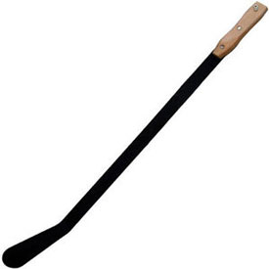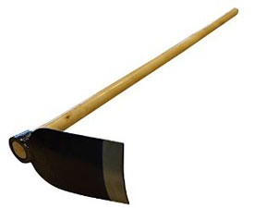
3) ………………………… 4)…………………..
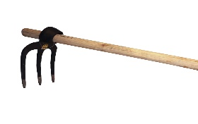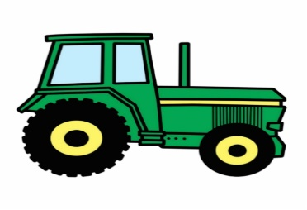
5)…………………………… 6)…………………………. (Alama 4)

(Trekta, fyekeo, machaku, jembe)

Tenganisha silabi zifuatazo
Mfano: ndogo = ndo go
7) Fyeka
8) Bwana
9) Machaku
10) Jembe
11) Ndoto
12) Somo (Alama 6)
Tumia yeye au wao kujaza pengo
13)…………………………………watalima shamba.
14)…………………………………watafyeka nyasi.
15)………………………………….ataenda shambani.
16)…………………………………watatutembelea.
17)………………………………… atanunua gari.
18)…………………………………atafundisha wanafunzi.
19………………………………… watafika mapema.
20)………………………………… atakula chakula. (Alama 8)
21) Chora na upake rangi bendera ya Kenya:

(Alama 8)
22) Andika sentesi tano kuhusu shule yetu
……………………………………………………………………………
……………………………………………………………………………
……………………………………………………………………………
……………………………………………………………………………
…………………………………………………………………………….. (Alama 5)
23) Andika vifaa vitatu vinavyo patikana darasani
……………………………………………………………
……………………………………………………………
…………………………………………………………… (Alama 3)
24) Mwalimu wetu anaitwa …………………………………….. (Alama 1)

CREATIVE ARTS
Through the help of your parent / guardian, kindly attempt all the following questions
- Write verses 1, 2 and 3 of the Kenya National Anthem in English.
- ………………………………………………………………………………………………………………………………………………………………………………………………………………………………………………………………………………………………………………………………………………………………………………………………………………………………………………………………………………………………………………………………………………………………………………………………
- ………………………………………………………………………………………………………………………………………………
………………………………………………………………………………………………………………………………………………………………………………………………………………………………………………………………………………………………………………………………………………………………………………………………………………………………………………
- ………………………………………………………………………………………………………………………………………………………………………………………………………………………………………………………………………………………………
………………………………………………………………………………………………………………………………………………………………………………………………………………………………………………………………………………………………
- Write verses 1, 2 and 3 of the East African Community Anthem.
- ………………………………………………………………………………………………………………………………………………………………………………………………………………………………………………………………………………………………………………………………………………………………………………………………………………………………………
Chorus: ……………………………………………………………………………………………………………………………………………………
…………………………………………………………………………………………………………………………………………………………………………………………………………………………………………………………………………………………………………
- ………………………………………………………………………………………………………………………………………………………………………………………………………………………………………………………………………………………………………………………………………………………………………………………………………………………………
- ………………………………………………………………………………………………………………………………………………………………………………………………………………………………………………………………………………………………………………………………………………………………………………………………………………………………
- Write verses 1, 2 and 3 of the Kenya National Anthem in Kiswahili.
- ………………………………………………………………………………………………………………………………………………………………………………………………………………………………………………………………………………………………………………………………………………………………………………………………………………………………………………………………………………………………………………………………………………………………………………………………
- ………………………………………………………………………………………………………………………………………………
………………………………………………………………………………………………………………………………………………………………………………………………………………………………………………………………………………………………………………………………………………………………………………………………………………………………………………
- ………………………………………………………………………………………………………………………………………………………………………………………………………………………………………………………………………………………………
………………………………………………………………………………………………………………………………………………………………………………………………………………………………………………………………………………………………
- Write 4 types of songs performed for different purposes in your community.
- ……………………………………………………………………………………………
- …………………………………………………………………………………………….
- …………………………………………………………………………………………….
- …………………………………………………………………………………………….
- Write the messages in each of the songs you have written above.
- …………………………………………………………………………………………………………………………………………………….
- …………………………………………………………………………………………………………………………………………………….
- …………………………………………………………………………………………………………………………………………………….
- …………………………………………………………………………………………………………………………………………………….
- Write the occasions in which the songs you have written above are performed.
- …………………………………………………………………………………………………………………………………………………….
- …………………………………………………………………………………………………………………………………………………….
- …………………………………………………………………………………………………………………………………………………….
- …………………………………………………………………………………………………………………………………………………….
- Write 4 body percussions that we use to accompany our singing. The first answer is given.
- Stamping.
- ………………………………………………………………….
- ………………………………………………………………….
- ………………………………………………………………….
- ………………………………………………………………….
- Patriotic songs are sung to praise our nation and leaders. Write 4 public holidays when these songs are performed.
- ……………………………………………………………………………………………
- …………………………………………………………………………………………….
- …………………………………………………………………………………………….
- …………………………………………………………………………………………….

- Write verses 1 and 2 of our school song / anthem.
- …………………………………………………………………………………………………………………………………………………………………………………………………………………………………………………………………………………………………………………………………………………………………………………………………………………………………………………………………………………………………………………………………………………………………………………………………………………..
- ……………………………………………………………………………………………………………………………………………………
………………………………………………………………………………………………………………………………………………………………………………………………………………………………………………………………………………………………………………………………………………………………………………………………………………………………………………………………
- Write 4 percussion instruments that we can use to accompany our singing. The first answer is given.
- A modern or traditional drum.
- ………………………………………………………………
- ………………………………………………………………
- ……………………………………………………………..
- ……………………………………………………………..
- A part from the instruments you have named above, write any other 4 instruments that you know or you have ever see.
- ……………………………………………………………..
- ……………………………………………………………..
- ………………………………………………………………
- ……………………………………………………………..
- A recorder is a wind instrument that produce sound through blowing. Name 4 things that you should not do to keep the recorder in a good condition. The first answer is given.
- Never drop the recorder.
- ……………………………………………………………..
- ……………………………………………………………..
- ……………………………………………………………..
- …………………………………………………………….
- Write 2 things that you should do after using the recorder.
- …………………………………………………………………………………………………………………..
- …………………………………………………………………………………………………………………..
- Write 2 things that we should do when singing the National Anthem.
- …………………………………………………………………………………………………………………
- ………………………………………………………………………………………………………………….
- Which messages are found in the following songs?
- Our school song……………………………………………………………………………………………………………………
……………………………………………………………………………………………………………………………………………..
- Our Kenya National Anthem…………………………………………………………………………………………………..
………………………………………………………………………………………………………………………………………………

Name 3 animals that hop.

- We hop for ______________ and coordination. (strength, happiness)
- We should observe____________ when playing any game. (safety, time)
Give 3 animals that moves by leaping

- I___________ over stream to avoid stepping in water. (leap, cross)
Name 3 body parts used in hopping

Name the following types of hop
- 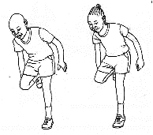

- 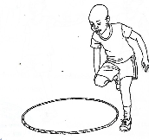

(hopping round a circle, hopping on one foot)
- We __________ over a log to avoid getting injured. (jump, walk)
- We__________ objects on the floor. (pull, push)
- ____________ makes the body fit. (Exercise, reading)
Name the body parts labelled.
18
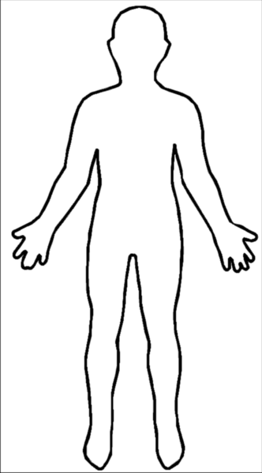
20
19

- We wear ______________uniform when playing. (sports, school)
- We skip using a ________________ (rope, log)
Name 3 body parts involved in skipping

- What shape can you make while skipping? __________________
- ______________ is a locomotor movement in which there is a combination of a step and a leap. (leaping, Galloping)
- Draw yourself skipping in a circle

- We use our _____________ to record video of our movement activities. (radio, tablets)
Study the picture below and answer questions that follow
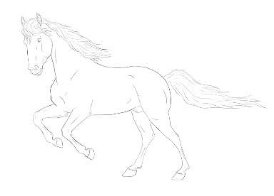
- What is the name of the animal

- What skill does the animal demonstrate?

(leaping, galloping)
- When do people use the skill?

(jumping over mud, walking)

Study the picture of the animal below and answer questions that follow.
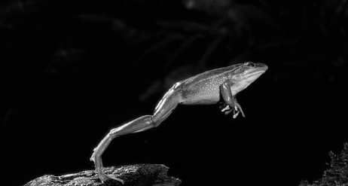

- Name the animal

- What skill does the animal show?

- We ____________ to avoid being hit by objects. (dodge, hop)

36. What local materials and tools are used to make kites?
a. ________________________.
b. ________________________.
c. ________________________. (3marks)
37. Name three materials used in painting.
1. ____________________________.
2. ____________________________.
3. ____________________________. (3marks)
38. Using a brush apply the paint on the underside of the leaf where the veins
show more clearly.
39. Carefully make leaf print on the space provided below.

(7marks)

40 Name three skills applied when playing different wind instruments.
1. ___________________________.
2. ___________________________.
3. ___________________________. (3marks)

MATHEMATICS ACTIVITIES

SECTION A
Task 1
Write the correct answer to the questions below
- If March is the 3rd month of the year, ________________ is the 10th month of the year.
- Add 38
+51

- Fill in the missing number in 10 12 14 ___ 18 20.
- Write in Symbols Sixty-Six _____
- ___ - 6 = 14
- 220 take away 110 = _____
- 15 divided by 5 = ____
- 10 shillings + 50 cents = ____
- Draw a clock face showing three o’clock
- Add 5/7 + 2/7 = _____ 10 marks
TASK 2
- What fraction is shaded?

= ___________

- 4 boys were each given five sweets. How many sweets did they have all together?
____________ sweets.
- Arrange the numbers below from the largest to the smallest.
15, 7, 29, 32, 11, 2. __________________________________
- Sally bought the items below, how much did she spend?
Sweets 5 shillings, Milk 50 shillings, a loaf of bread 50 shillings.
She spent _____________ shillings?
- Fifty Shillings note = ___________ ten shillings coins.
- Which digit in the number 382 lies in the place value of hundreds?
digit _____________
- Write 85 in words _____________
- How many days are there in three weeks? __________
- Fredrick had 129 goats, he bought 346 more goats. How many goats does he have altogether? _________________ goats.
- One cat has four legs, how many legs do four cats have? _________ legs. 10 marks

SECTION B (3 marks each)
TASK 3
Question | Working Space
Find the 5th number
18, 17, 15, 12, __________
Write the multiplication sentence and workout the answer
________ Multiplied by _________ = _____

Sally has five bottles. Each of the bottles holds 2 liters of water. If she pours all the water in a basin, how many liters are in the basin?
Janet has 24 sweets; she gives an 1/8 of the sweets to Alice. How many sweets does she give to Alice?
Count in Threes 3, __, 9, 12, ___, 18, ___
Draw three shapes you know

Write the place value of digit 4 in the numbers below. (4 marks)
- 534 ___________
- 4897 ___________
Expand: 83 = _________ hundreds ________ tens _______ ones
167 = __________ hundreds ________ tens _______ ones (4 marks)
Put the sign + or – to make it correct
13 __ 6 = 19
20 __ 5 = 15 (2 marks)
Color the shapes in the second and the fourth position

(2 marks)

Assessment Rubric
Exceeds  Expectations | Meets  Expectations | Approaching Expectations | Below  Expectations
48 -50 | 40 - 47 | 30 - 39 | 0 - 29

