
CBC

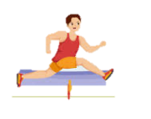
HOLIDAY ASSIGNMENT

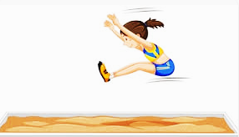

NAME: ____________________________________________________.
SCHOOL:________________________________________________.

MATHEMATICS ACTIVITIES
- Write the place value of 9 in the number 903456.

- Write in figures. Eight hundred and eighty thousand eight hundred and eight.

- The number of pupils in four schools was as follows. Arrange the numbers from the largest to the smallest.3033, 3003, 3303, 3330.

- Write 2³/₅ as a mixed fraction.

- 48 is a multiple of 8. Write the next two multiples of 8.

- Round off 809763 to the nearest thousand.

- A class has 42 pupils. Each pupil received sh 425 for buying stationery during the term. How much money did the class receive altogether?

- Identify the angle drawn below.
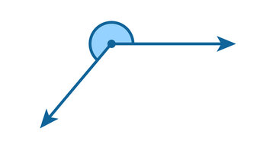
- Circle all the numbers divisible by 2,5 and 10.
(725, 130, 924,880, 470, 433)

- Find the HCF of 24 and 36.

- A farmer sold 3550 eggs in the month of June, 6252 in July and 2042 in August. How many eggs altogether were sold during the three months?

- Calculate area by counting the square.
- Work out:
834527
− 763756
________
- Sheila was depositing sh 4000 everytime she visited the bank. She has sh 16000 in the bank. Write the total amount in the book after every deposit fo five visits.
16000, ______, ______, _____, _____, _____
- Work out;
⁸/₁₀ − ⁵/₁₀ =

- Work out; 12 − 8 ÷ 4 =

- What is the time on the clock face?
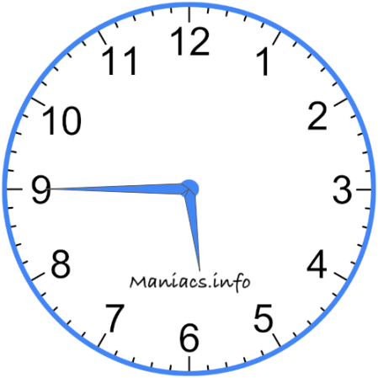

_________________________________

- How many ¼ kg are in 5¼kg of sugar?

_________
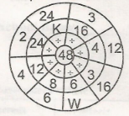
- Complete the division wheel.

K -
W –

- Find the LCM of 10 and

- Work out;
sh cts
8 5 6
× 5
___________

- Convert 5½ hours into minutes.

______________________
- Fill in the missing number
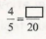

- Convert 0.33 into a fraction. ________________

- What is the quotient of 72 and 9 ____________________

- A chair costs sh 820. What is the cost of 5 such chairs? ________________

- Allan has 3n apples and Mary has 4f apples. What is the total number of apples they have altogether? _______________

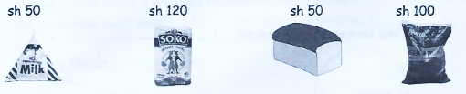
- The price of items in a shop is as follows:

Halama bought two packets of milk, a loaf of bread and 1 kg packet of sugar.
How much did she pay for the items? ___________________
- A piece of wood 31m 38 cm long was cut into 6 equal pieces. How long was each piece?

- Write the next number in the pattern below:
5,7, 11, 17, 25, _____________

CREATIVE ARTS
- A group of continuous dots form a ___________________________.
- Write three ways of making items in basketry.
  - ________________________
  - ________________________
  - ________________________
- The art of making and manipulating puppets in a performance is called ___________________________
- Write three available materials used to make a glove puppet.
  - ______________________________
  - ______________________________
  - ______________________________
- Which of the following is NOT useful when having a smudge technique lesson? ______________________________
(crayons, charcoal, dye)
- A person who operates puppets is called a _______________________________
- Write digital devices used to take photos of our artwork.
  - _____________________________
  - _____________________________
- Thonging technique is used in ____________________________
- List three primary colours.
  - ___________________________
  - ___________________________
  - ___________________________
- The art of putting artwork in frames before displaying them is called _________________________
- The art of making items from stones of a piece of wood is called ___________________________
- Which part of body is used to manipulate string puppets? ______________________________
- We add black colour to other colours to form _________________________________ effect.
- Draw the following tools.
Brush | Scissors
- Write two reasons which can make the national flag be hoisted half?
  - __________________________
  - __________________________
- List two non melodic percussion instruments.
  - __________________________
  - __________________________
- State three methods used to play percussion instruments.
  - __________________________
  - __________________________
  - __________________________
A group of men singing during worship in church form a ______________________________________
19. Pupils sang the song below.
Tuishangilie Kenya
Taifa letu tukufu
Kenya tunayoipenda
Daima
- The song sung by the pupils is a __________________________________ song.The song was sung to ______________________________ our country.
- Lullabies are sung in ____________ tempo. (slow, quick, high)
- Name two male voices in choir.
  - __________________________________
  - __________________________________
21. Draw the following musical instruments.
  - Kayamba
  - Flute

- Draw and colour two runners exchanging a relay baton (1mk)

- Study the spot below
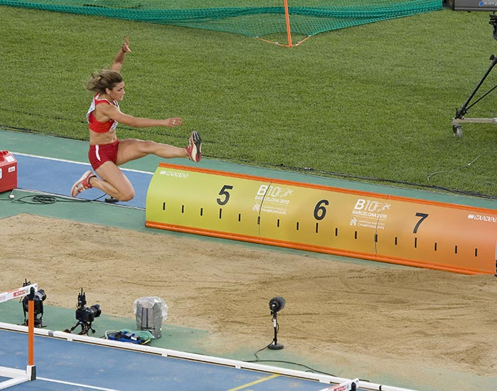

  - What is its name?
___________________________________________
  - Name the parts of a long jump
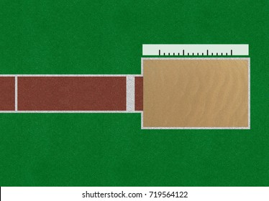

- Write down two importance of sliding when playing softball (2mks)
  - _______________________________________
  - _______________________________________
- What do you call the players that play the game of rounder’s? (2mks) _______________________ and _____________________
- List three basic equipment that are used in volleyball. (3mks)
  - __________________________________________
  - ___________________________________________
  - ___________________________________________
- Each team in the game of Kabaddi has ___________________________________________ players at the start of the game (1mk)
- There are ____________________________ phases used when performing standing discus technique. (3, 4, 6) (1mk)
- Below is a method used to start a race in athletics. How do we call this step? (1 mark)
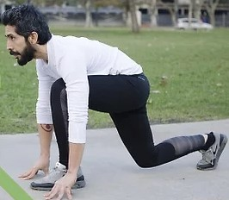 ____________________________________
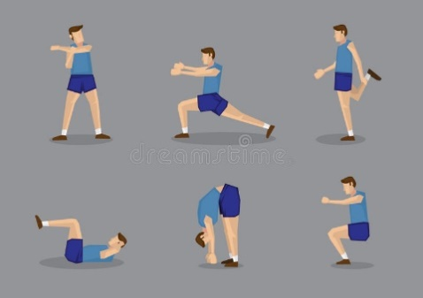
- Name the exercise being shown in the picture. (2 mark)
  - _____________________________________
  - ____________________________________

- The finishing technique in races where an athlete crosses the finish line with a lunge at full speed is called the_____________technique.
- Why do athletes wear correct sports attire? _______________
- List any 5 examples of improvising materials. (5 mks)
  - _____________________________________
  - ______________________________________
  - ______________________________________
  - ________________________________________
  - ______________________________________
- List materials we can use to improvise durable relay batons. (4 mks)
  - ___________________________________________
  - ___________________________________________
  - ___________________________________________
  - __________________________________________
- Why should a relay baton be smooth? Give 3 reasons. (3mks)
  - ___________________________________________
  - ___________________________________________
  - ___________________________________________
- List any 2 reasons why improvising is important. (2mks)
  - ___________________________________________
  - ___________________________________________
- List any 3 safety measures we observe while hurdling. (3mks)

  - ___________________________________________
  - ___________________________________________
  - ___________________________________________

- While participating in races, why should we keep our eyes focused on the ground? (3mks)
  - ___________________________________________
  - ___________________________________________
  - ___________________________________________

- List any suitable locally available materials we can use in a long jump landing area. (2 mks)
  - ___________________________________________
  - ___________________________________________

ENGLISH
TASK 1: LISTENING AND SPEAKING
Teacher says: I am going to read for you a story. Listen to it carefully and then answers the questions that follows.
Two children, Fatuma and Malewa, planned to attend a celebration the following day.
Malewa asked, "Tell me more about the celebration tomorrow?"
Fatuma answered, "We shall celebrate Jamhuri Day tomorrow, 12th of December. On this day, we remember the day our country gained independence.
Malewa said, "My teacher said there are more national celebrations in our country. He mentioned Madaraka Day on the 20th of October. I would like to be part of all these celebrations
Questions
- What celebration were the children planning to attend?
- Which other national celebration has been mentioned in the story?
- What are the names of the children in the story?
- Why was the celebration important according to the story?

TASK 2: READING ALOUD
"How does cholera spread?' Wawi asked the doctor. "Cholera is a waterborne disease. When water becomes dirty because of pollution, bacteria spread quickly. Unwashed raw fruits and vegetables might also carry germs. Sometimes, farmers may spread cholera when they use contaminated fertilizers," the doctor explained.
"It sounds healthy. Hygiene practices would help keep cholera away." Wawi explained.
"Sure," the doctor said. "All of us have a responsibility to keep diseases away. What do you think we can do to keep cholera away?"
"We should wash our hands frequently and clean the environment regularly," Wawi said. "I think we need to get the information to the community as soon as possible. Cholera can kill if it is not treated on time, we don't want an epidemic to break out Cholera con spread like wild fire!"

LANGUAGE
Comprehension
Read the following passage and answer the questions.
When the Director of Education visited Mutitu school, she was accomplanied by a few local leaders. She said that even though she had little time, she wanted to talk to the learners about occupations.
She began by asking about their future plans. Few learners raised their hands to answer. The Director said that anyone could become whatever they wanted. She told them that the country had few doctors and plumbers. She said that if they put alittle effort this could change. From the talk, each learner realised they had little knowledge about jobs and occupations.
- Who visited Mutito school? __________________
- The visitor wanted to talk to the learners about what? ___________________________________________
- Who had accompanied the visitor to the school? ___________________________________________
- The Director said that one could become ___________________________________________
- What made the learners realise they had little knowledge on jobs and occupations? ___________________________________________________
- The _____________________ had few doctors and plumbers.
GRAMMAR
- Complete the following sentences with possessive pronouns
  - The mobile phone belongs to me. It is ________________________.
  - The puppy belong to the white dog. It is ____________________________.
  - The pen I have belongs to Tonny. It is ___________________________
  - I think the car belongs to Mrs Kamau. It is _____________________________.
  - The house belongs to us. It is _______________________________
- Complete the sentences below with the correct order of adjectives.
  - The boys sat on a __________________ mat. (red, traditonal, big)
  - Katana drank soup from a ____________________________ bowl. (circular, tiny, new)
  - My father bought a ____________________________ table cloth. (triangular, brand new, huge)
  - I brought a ___________________________ plate. (big, round)
  - Mwangi found a ________________________ pan (round, large, old)
- Complete the sentence using the best occupations
  - A person who makes furniture from wood is called ________________________
  - A trader who sells vegetables in a market is called ________________________________
  - A person who writes books ________________________
  - A person who flies on aeroplane is _____________________________
  - A qualified person who treats sick animals is called _________________________
- Use degree of adjectives to complete the following questions
Adjective | Comparative | Superlative
Beautiful
 | sweeter
 |  | Eldest
Fat

- Construct accurate sentences using the following vocabulary.
  - Rescue _______________________
  - Violence _______________________
  - Adopt ________________________

ENGLISH COMPOSITION
Write a composition about;
A NATIONAL CELEBRATION I ATTENDED
_____________________________________________________________________________________________________________________________________________________________________________________________________________________________________________________________________________________________________________________________________________________________________________________________________________________________________________________________________________________________________________________________________________________________________________________________________________________________________________________________________________________________________________________________________________________________________________________________________________________________________________________________________________________________________________________________________________________________________________________________________________________________________________________________________________________________________________________________________________________________________________________________________________________________________________________________________________________________________________________________________________________________________________________________________________________________________________________________________________________________________________________________________________________________________________________________________________________________________________________________________________________________________________________________________________________________________________________________________________________________________________________________________________________________________________________________________________________________________________________________________________________________________________________________________________________________________________________________________________________________________________________________________________________________________________________________________________________________________________________________________________________________________________________________________________________________________________________________________________________________________________________________________________________________________________________________________________________________________________________________________________________________________________________________________________________________________________________________________________________________________________________________________________________________________________________________________________________________________________________________________________________________________________________________________________

SCIENCE AND TECHNOLOGY
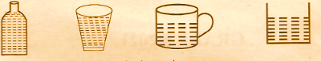
- Grade five pupils had put water in different containers as shown below.

They concluded that liquids do not have a __________________________________
- List two poor conductors of heat.
  - _______________________________
  - _______________________________
- Materials which do not allow any light to pass through them are called ______________________ materials.
- Write three diseases that affect the breathing system.
  - ________________________________
  - ________________________________
  - ________________________________
- List two green non-flowering plants.
  - ________________________________
  - ________________________________
- Importance of flowering plants.
  - ________________________________
  - ________________________________

- Name four water borne diseases.
  - _________________________________
  - _________________________________
  - _________________________________
  - _________________________________
- Write two laying mammals.
  - ________________________________
  - ________________________________
- Animals with varying body temperature are called ___________________________________
- Write three signs and symptoms of cholera.
  - _________________________________
  - _________________________________
  - _________________________________
- Muscles that hold the head up and move it in all directions are called ____________________________________
- The 3Rs means:
  - ______________________________________
  - ______________________________________
  - ______________________________________
- Name three internal body parasites.
  - ______________________________________
  - ______________________________________
  - ______________________________________
- Below is a human breathing system. (3 marks)
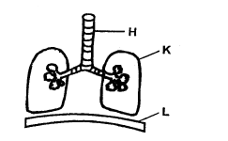
Name the labelled parts.
H - ____________________________________
K - ____________________________________
L - ____________________________________
- State the three states of matter. (3 marks)

- A grade five learner observed a burning candle through a bent pipe as shown below.
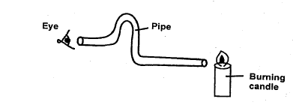
He was unable to see the light because (1 mark)
________________________________________________________________________________________________________
- Name the tooth drawn below. . (1 mark)
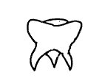________________________________
- List any 3 sense organs in a human being.(3 marks)
  - ____________________________________________
  - ____________________________________________
  - ____________________________________________

AGRICULTURE AND NUTRITION
- A ___________________________ is a place where mature plants grow and are taken care
- Write two reasons for using tools properly.
  - ____________________________________
  - ____________________________________
- List three materials which can be re-used for gardening in places with little space.
  - ____________________________________
  - ____________________________________
  - ____________________________________
- Write down three importance of compost manure in the farm.
  - __________________________________
  - __________________________________
  - __________________________________
- List three examples of climbing fruits.
  - ____________________________________
  - ____________________________________
  - _____________________________________
- Why is a nursery bed raised above the ground? ___________________________________________________________________________________________________________________________________________________________
- The process of collecting the deposited top fertile soil from deposition sites is called _____________________________
- List two organic wastes used in making compost manure.
  - ____________________________________
  - ____________________________________
- Write two farming practices that help to conserve water.
  - _____________________________________
  - _____________________________________
- Write the small animal controlled using the repellant crop below. Onions
- Grade five pupils collected the following crops Group them accordingly in the table below.
  - maize
  - rice
  - cowpeas
  - sukuma wiki
  - beans
  - pumpkin
Cereals | Vegetables
- Write two reasons why we cook food.
  - _____________________________________
  - ______________________________________
- Factors to consider when buying a button for a garment.
  - _____________________________________
  - _____________________________________
- To break the mucus in a handkerchief when washing we soak it in _____________________ water.
- The process of washing, ironing and storing clothes is called _________________ work.
- Write health measures that prevent common cummunicable diseases.
  - ________________________________
  - ________________________________
- List three physical changes that take place in both boys and girls during pre-teen stage.
  - ________________________________
  - ________________________________
- State three healthy eating habits practiced by pre-teens.
  - _________________________________________
  - _________________________________________

- Write the importance of dressing well by pre-teens.
  - _____________________________________
  - _____________________________________
- State three types of media used in advertisement.
  - _____________________________________
  - _____________________________________
- Name two diseases that can be caused by lack of exercise.
  - _______________________________________
  - _______________________________________
- Write two causes of communicable diseases.
  - _______________________________________
  - _______________________________________

KISWAHILI ACTIVITIES
KUSIKILIZA NA KUONGEA, KUSOMA KWA SAUTI
Sehemu ya A: Kusikiliza na kuongea
Ningependa tuzungumze kuhusu heshima na adabu. Wewe ni kiranja wa darasa lako una mazungumzo na mwalimu wako wa darasa.
- Anza mazungumzo kwa maamkizi yafuatayo.
(Mwanafunzi ajibu)
- Taja maneno ya adabu ambayo kama kiranja unawasisitizia wanafunzi kuyatumia darasani.
(Mwanafunzi ajibu)
- Eleza mwalimu umuhimu wa kuwa mwanafunzi mwenye heshima na adabu.
(Mwanafunzi ajibu)
- Toa maelezo mafupi vile utakavyoonyesha heshima na adabu kwa mgeni aliyealikwa nyumbani kwenu.
(Mwanafunzi ajibu)
- Taja maneno ya heshima na adabu badala ya maneno uliyopewa
  - Mtoto anahara _________________________
  - Fatuma ana mimba ___________________________
  - Halima amezaa ________________________

Sehemu ya B: Kusoma Kwa Sauti
Mama alikumbuka kuwa baba alisahau kumeza dawa. Aliingia chumbani na kutoka na vidonge viwili vya dawa akampa baba aweze kumeza kwa maji. Baba alikuwa na ugonjwa wa kisukari na shinikizo la damu.
Alikuwa anatueleza kuwa ugonjwa wake ulitokana na hali ya maisha katika harakati zake za biashara ambayo ilikuwa mara inapanda mara inashuka. Alikuwa akizinunua bidhaa kutoka Uchina na kuziuza humu nchini. Ingawa aliipenda biashara hiyo, aliichukia hali ile ya ugonjwa na hivyo akaamua kupunguza shughuli zake na kuongeza muda wa kupumzika nasi nyumbani.
Baba alipokata kauli kupunguza shughuli aliendelea kuwa na afya nzuri. Tuliendelea kuzungumza naye mambo aliyofurahia kusikiliza kama vile umilisi tuliokuwa tumepata shuleni. Hasa, alifurahi tulipomwambia tulijifunza kuhusu jinsi ya kuzuia magonjwa. Tulimweleza pia kuhusu magonjwa yanayotokana na hali za maisha kama vile kisukari na shinikizo la damu.

SEHEMU YA A: Ufahamu
Soma kifungu kifuatacho kisha ujibu maswali yanayofuata (alama 5)
Unapotembea mjini, chukua tahadhari kubwa sana. Kuna matapeli wanaohadaa watu mjini. Vile vile matapeli hao hujiweka katika makundi ili kungojea watembezi wanaoonekana wageni. Mara wanapowagundua, wao hunasa pesa, simu na vitu vingine na kukimbia navyo. Pia kuna wale hutumia maneno matamu. Wao hukuandama na ukifika kichorochoroni watakupora na kukimbia. Wengine watakupiga na kukuacha umeumia. Iwapo unataka msaada wowote, basi mtafute bawabu au askari akusaidie. Usijiingize kwenye shida tupu bure.
Maswali
- Kulingana na habari ni watu gani wanaoiba pesa? ___________________________________________________
- Mwandishi anatushauri tufanye nini tunapotembea mjini? ____________________________
- Kamilisha:
Maneno matamu humtoa __________________ pangoni.
(Samba nyoka sungura mdudu)
- Eleza maana ya neno wanaohadaa. _____________________________________________________________________________________________________________
- Andika maana ya neno 'matapeli ______________________________________________________________________________________________________________
- Unapofika vichochoroni huwa unafanyiwa nini? ____________________________________________________________________________________________________________
SEHEMU YA B; SARUFI
- Chagua maneno yaliyopo kwenye mabano kujaza mapengo
____1____.anapenda sana kuogelea majini. Yeye hutaga mayai makubwa makubwa. ____2____ yake ni tamu sana. Kuku pia hutaga _____3_____ japo madogo kushinda va bata. Nyama va kuku pia ni _____4_____ Kuna kuku wa kienveji na kuku wa ______5_______ . Kuku wa gredi huwa na mapato ya juu zaidi. Wao hukua kwa haraka na kutaga mayai ______6______.
( mayai, tamu, nyama, bata, gredi, hukiwa, mengi)

- Jaza pengo kwa kutumia viunganishi vifaavyo.
  - Juma alikula ______________________ hakushiba. (kwa sababu, lakini, pia)
  - Tulipita mtihani _____________ tulifanya bidii. (lakini, na, kwa sababu)
  - Halima ________________ Fatuma wanaosha vyombo. (na, lakini, kwa sababu)
  - Waliadhibiwa ______________________ walivunja sheria za shule. (pia, kwa sababu, na)
- Andika sentensi zifuatazo kwa umoja.
  - Miti ya mapera imekatwa.
_________________________________________________
  - Nguo zao ni chafu sana.
_________________________________________________
  - Viti vizuri vitauzwa.
_________________________________________________
  - Wakulima wanalima kwa bidii.
_________________________________________________
  - Maembe hayo ni matamu.
_________________________________________________
- Andika kinyume cha nomino hizi
  - Mzee ____________________________________
  - Mchana __________________________________
  - Maskini __________________________________
  - Rafiki ____________________________________
  - Mfalme ___________________________________
- Pigia mstari nomino za makundi katika sentensi zifuatazo
  - Barabarani kulikuwa na mlolongo wa magari.
  - Safu ya milima hupendeza.
  - kikosi cha askari kilikuwa kimesimama barabarani.
  - Fatuma alinunuliwa jozi ya viatu.
  - Mama alinunua pakacha la matunda kutoka sokoni.
- Kamilisha methali hizi
  - Mgagaa na Upwa. ___________________________
  - Achanikaye kwenye mpini ____________________________
  - Mtumai cha nduguye ___________________________
- Tunga sentensi ukitumia maneno yafuatayo.
  - Mlindalango_______________________________________
  - Vinasasauti_______________________________________
INSHA
Andika insha kuhusu;
JIRANI YANGU
___________________________________________________________________________________________________________________________________________________________________________________________________________________________________________________________________________________________________________________________________________________________________________________________________________________________________________________________________________________________________________________________________________________________________________________________________________________________________________________________________________________________________________________________________________________________________________________________________________________________________________________________________________________________________________________________________________________________________________________________________________________________________________________________________________________________________________________________________________________________________________________________________________________________________________________________________________________________________________________________________________________________________________________________________________________________________________________________________________________________________________________________________________________________________________________________________________________________________________________________________________________________________________________________________________________________________________________________________________________________________________________________________________________________________________________________________________________________________________________________________________________________________________________________________________________________________________________________________________________________________________________________________________________________________________________________________________________________________________________________________________________________________________________________________________________________________________________________________________________________________________________________________________________________________________________________________________________________________________________________________________________________________________________________________________________________________________________________________________________________________________________________________________________________________________________________________________________________________________________________________________________

SOCIAL STUDIES AND RE - GRADE 5 TERM 2 2023
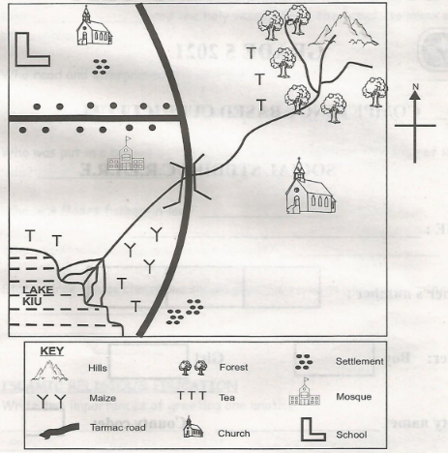
GITHIMA AREA

- What is the direction of the mosque from the school? _______________________________
- Which is the main religion practised in Githima area? ________________________________
- State one type of cash crop grown in Githima area. ________________________________
- State two economic activities carried out in the map.
  - _______________________________
  - _______________________________
- What is a resource? ___________________________
- Name four resources in Kenya.
  - _________________________________
  - _________________________________
  - _________________________________
  - _________________________________
- State four ways of caring for resources in Kenya.
  - _________________________________
  - _________________________________
  - _________________________________
  - _________________________________
- State three ways in which Kenya maintains good relations with her neighbours.
  - __________________________________
  - __________________________________
  - __________________________________
- Physical features are divided into ________________ and _______________ features.
- Name two uses of physical features.
____________________________
_____________________________
- State two ways of taking care of our physical features.
________________________________
________________________________
- Name four administrative leaders in the school.
_____________________________________
_____________________________________
_____________________________________
_____________________________________

- What is population density? ________________________________
- Write three methods of instruction used in African traditional education.
  - ______________________________________
  - ______________________________________
  - ______________________________________

CHRISTIAN RELIGIOUS EDUCATION
- Who baptised Jesus? ______________________________
- Jesus was baptised in River ____________________________
- When Jesus was being baptised the Holy Spirit came down inform of a ______________________________
- Who came to prepare for the coming of the Messiah? _________________________
- King ________________ used wisdom from God to solve the disagreement between two women.
- _________________________ saw his father's nakedness.
- King ________________________ used the holy vessels from the temple to drink wine and praise other gods.
- Who read and interpreted the writings on the wall? ________________________________
- Elijah contested the prophets of Baal at Mount ___________________________
- Who was put in a basket by his mother and was hidden at the edge of River Nile? ______________________________
- Who was Moses father-in-law? _________________________________
- Why was Moses told to remove his sandals? _________________________________
- State three values christians should practice towards the needy in the society
  - ____________________________________
  - ____________________________________
  - ____________________________________

ISLAMIC RELIGIOUS EDUCATION
- Write two importances of greeting one another.
  - ____________________________________
  - ____________________________________
- The Quran mentions ____________________________ prophets.
- Which pillar of Islam promotes sharing? ____________________________________
- The father of prophet Muhammad was called _________________________________
- Complete the verse below.
"Fajaalajum ka'asfin ___________________________________"
- Which is the second and fourth pillar of Iman? ___________________________ and ___________________________
- _____________________________ was the first prophet of Allah. (S.W) while ____________________ was the last prophet.
THE END

MARKING SCHEME
- Hundred thousands
- 880808
- 3330, 3303, 3033, 3003
- 4³/₅
- 56, 64
- 810000
- sh. 17850
- Obtuse angle
- 130, 880, 470
- 12
- 11844
- 42
- 70771
- 20000, 24000, 28000, 32000, 36000
- ³/₁₀
- 10
- 5:45/ Quarter to six/45 minutes past five
- 21
- K - 8
W - 2
- 30
- Sh 42 80cts
- 330min
- 16
- ³³/₁₀₀
- 8
- 4100
- 3n + 4f
- 250
- 5m 23cm
- 35

MARKING SCHEME
CREATIVE ARTS
- Line

  - Twining
  - Plaiting
  - Coiling
- Puppetry

  - Old clean socks
  - Glue
  - Buttons
  - Fibre
- Dye
- Puppeteer

  - Camera
  - Mobile phone
  - Tablet
  - Laptop

  - Red
  - Blue
  - Yellow
- Mounting
- Carving
- Hand
- darker

  - Brush
  - Scissors

  - Death of a president in another country
  - Death of current president in a country

  - Drums
  - Bells
  - Shakers
  - Jingles
  - Kayamba

  - Shaking
  - Hitting
  - Plucking
- Choir

  - Patriotic
  - Praise
- Slow

  - Bass
  - Tenor

  - m
  - s
  - t

  - kayamba
  - flute
- Picture of children exchanging a relay button

  - field, long jump
  - A-runway
B - take off board
C - Landing pit
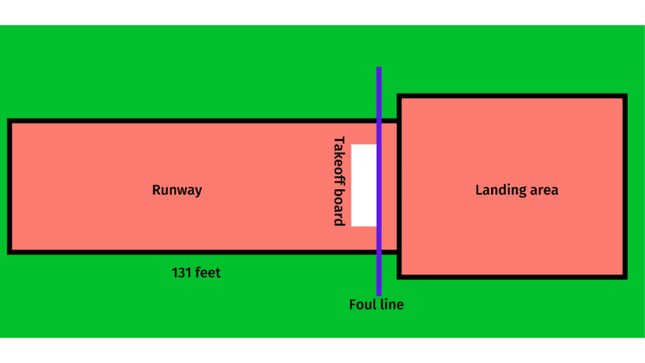
- prevent injury, avoid a tag, make a diversion, because it is the quickest way to the base
- fielders and battlers
- net, ball, posts
- 7
- 4
- 6. Crouch start
- a) flexibility exercise
b) make you flexible

- Run-through finish
- Correct sports attire protects athletes from injuries like cuts and scrapes. It also reduces the risk of serious injury.
- A) bamboo poles
B) Sharpened Sticks For Javelin
C) Rubber To Make Padding
D) Ropes
E) Nets For Table Tennis
- A) rolled newspapers or books
B) Manila
C) adhesive
D) sticks/bamboo
E) Sandpaper
- A) for safety
B) for efficient passing
C) to avoid wasting passing time
- A) it makes something real in a lesson
B) it gives a learner a chance to assess work through self and peer assessment
- A) check the track conditions, for wetness
B) hurdles/flights should be at the correct distance apart
C) hurdles/flights should be the correct height for different age groups
- A) it is a safer way to run
B) we can see what is coming and avoid falling
C) it is a proper running form
- A) sawdust
B) sand.

MARKING SCHEME
ENGLISH
- The Director of Education
- Occupations
- A few local leaders
- Whatever they wanted
- The talk
- Country
Grammar

  - Mine
  - it's
  - his
  - hers
  - ours

  - big, red, traditional
  - tiny, circular, new
  - huge, triangular, brand new
  - big, round
  - large, round, old

  - carpenter
  - Green grocers
  - author
  - pilot
  - veterinary office

  - more beautiful, most beautiful
  - sweet, sweetest
  - old, older
  - fatter, fattest

MARKING SCHEME

SCIENCE AND TECHNOLOGY
- Definite shape

  - Plastic
  - Wood
  - Glass
  - Feathers
  - Cloth
- Opaque

  - Cold
  - Asthma
  - Pneumonia
  - Tuberculosis
  - Covid-19
  - Coughs

  - Algae
  - Moss
  - Fern
  - Pine
  - Cedar
  - Liverworts

  - Source of food
  - Control soil erosion
  - Source of medicine
  - Source of firewood
  - Source of income
  - Beautify environment

  - Typhoid
  - Bilharzia
  - Cholera
  - Dysentery

  - Duck billed platypus
  - Spiny ant eaters
- Cold blooded

  - Body weaknesses
  - Fever
  - headache
  - Vomiting and watery Diarrhea
  - Loss of fluids and severe dehydration
- neck muscles

  - Reuse
  - Recycle
  - Reduce

  - Roundworms
  - Tapeworms
  - Hookworms
  - Pinworms
- H-trachea/windpipe
K-lungs
L-Diaphragm
- Solid,liquid,gas
- The pipe was not straight as light could not travel in a straight line
- Molar tooth
- Sense ofTouch,taste,hearing,smelling,sight

MARKING SCHEME
AGRICULTURE AND NUTRITION
- Garden

  - Safety measure
  - Long lasting

  - Plastic containers
  - Bottles

  - Reduces waste
  - Saves on fertilizer
  - Enhances soil quality and nutrients
- Passion fruits, grapes, blackberries, kiwi fruits, raspberry fruits and gooseberry fruits.

  - It is possible to provide favourable growth conditions
  - Easy weed control
- Soil recovery/restoration
- plants materials, animal waste, food remains or kitchen wastes
- mulching, shading, and cover cropping
- Aphids

Cereals | Vegetables
Rice  Maize  Cowpeas  Beans | Sukuma wiki  Pumpkin

  - Make it soft
  - have good taste
  - Make it easy to digest
  - To last longer
  - Kill germs
  - Make it easy to chew/eat

  - Shape of button
  - Colour of garments
  - Colour of button
- Salty
- laundry

  - Unblocking drainage systems
  - Clearing bushes
  - Proper use of toilets/latrine/urinal
  - Washing hands

  - Increase in weight and height
  - pubic hair grows
  - Pimples appear

  - Eating healthy foods
  - Eating a balanced diet
  - Avoid sugary foods
  - Eat right amount of food

  - One feels uncomfortable
  - Confidence
  - One looks smart
  - people respect a well dressed persoon

  - Radio
  - Television
  - Mobile Device
  - Window display

  - Heart disease
  - Obesity

  - Viruses
  - Fungi
  - bacteria
  - parasites

MARKING SCHEME

SOCIAL STUDIES
- North West
- Christianity
- Tea

  - Farming
  - Fishing
- A resource is something that we use to create wealth.

  - Minerals
  - Soil
  - Water
  - Forests

  - Keeping sources of water clean
  - Using minerals wisely
  - Planting trees
  - Planting cover crops

  - Trade
  - Games and Sports
  - Common language of Kiswahili
  - Free movement of people

  - Relief drainage

    - Fishing e.g lakes
    - Provide water- rivers
    - Tourist attraction- Mountains

    - Avoid dumping litter in lakes and rivers
    - providing security to such areas.

  - Head teacher
  - Deputy head teacher
  - Senior teacher
  - Teachers
  - The children's government
- The number of people living in an area.

  - Story telling
  - Narratives
  - Proverbs
  - Riddles
  - Songs
  - Dances
C.R.E
- John the Baptist
- Jordan
- Dove
- John the Baptist
- Solomon
- Ham
- Belshazzar
- Daniel
- Carmel
- Moses
- Jethro
- He was standing on a Holy Ground

  - Mercy
  - Love
  - Responsibility
  - Empathy
I.R.E

  - It promotes love and friendship among muslims
  - It is a form of due
  - When two people greet one another their sins are forgiven.
  - Allah rewards those who promote greetings.
- 25
- zakat
- Abdullah
- Maakul
- Believing in angels (S.W)
Believing in prophets of Allah (S.W)
- Nabii Adam (AS)
Nabii Muhammad

MWONGOZO WA KUSAHISHA

KISWAHILI
KUSIKILIZA NA KUONGEA
- Anaendesha
- Ni mjamzito
- Anejufungua
LUGHA
Sehemu ya A
- Matapeli
- Mtafute bawabu na askari
- Nyoka
- Wanaodanganya
- Wezi
- Kukupora
Sehemu ya B

  - Bata
  - Nyama
  - Mayai
  - Tamu
  - Gredi
  - Mengi

  - Lakini
  - Kwa sababu
  - Na
  - Kwa sababu

  - Mti wa mapera umekatwa
  - Nguo yake ni chafu sana
  - Kiti kizuri kitauzwa
  - Mkulima analima kwa bidii
  - Embe hilo ni tamu.

  - Kijana
  - Usiku
  - Tajiri
  - Adui
  - Malkia

  - Mlolongo wa magari
  - Safu ya milima
  - Kikosi cha askari
  - jozi la viatu.
  - pakacha la matunda

  - Hali wali mkavu
  - Halali njaa
  - hafi maskini

