TRAINER’s NAME: ESTHER AKHULE DEPARTMENT: ICT COURSE: DICT
CLASS: DICT II TERM: JANUARY to APRIL 2026
LEVEL: DIPLOMA MOD II SUBJECT: VISUAL BASIC PROGRAMMING PREPARATION DATE: 11/12/2025
REVISION DATE: ……………….
TERM 1I
Week | Topic/Sub-Topic | Objectives | Key Points | Activities | Reference & Aids | Remarks/  Date Taught
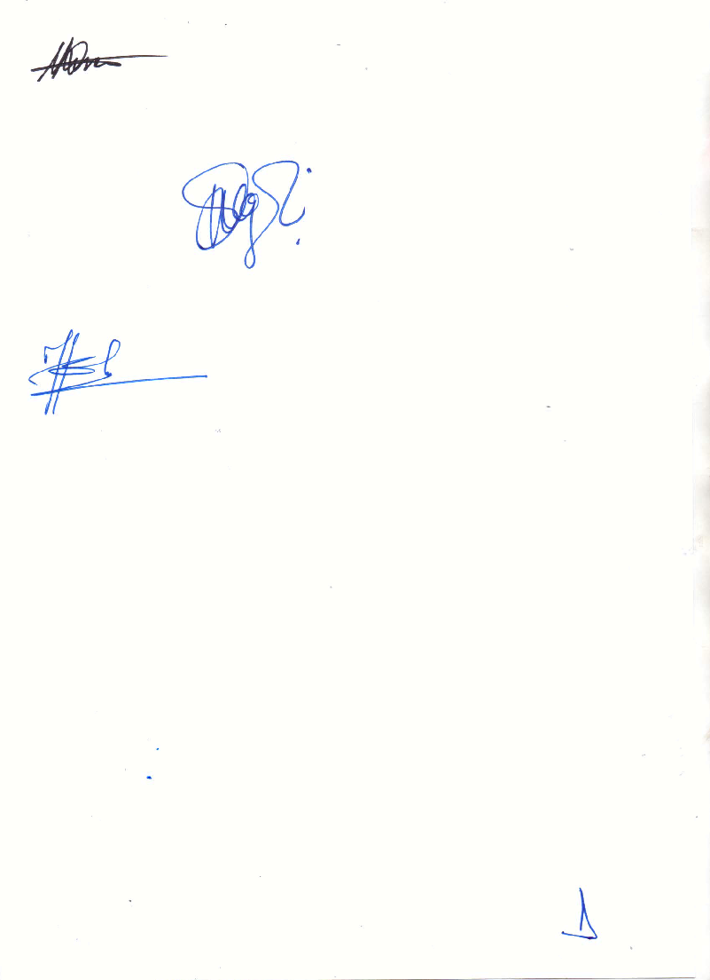
STUDENTS REPORTING , REGISTRATION, ORIENTATION,ISSUING OF COURSE STRUCTURE &OUTLINE
 | PROGRAM STRUCTURE | By the end of the lesson, the learner should be able to:  - Create a visual basic program  - Illustrate the naming convention of controls  - State variable declaration in visual basic | -Definition  -Importance  -create a VB program from form design to coding | The learner should:  - Take notes.  - Do assignments | -lecture notes  -online sites  (geeksforgeeks and W3 school)
 | CONTROL STRUCTURES | By the end of the lesson, the learner should be able to:  - Distinguish between if then, if then else, if else if else and case statements  - Differentiate between different loop structures i.e. Do while, while wend, do loop, do until, for next, for each and with end with | -Definition  -Importance  -When to use each and every control structure statement | The learner should:  - Take notes.  - Do assignments | -lecture notes  -online sites  (geeksforgeeks and W3 school)
 | DATA STRUCTURES | By the end of the lesson, the learner should be able to clearly define and create programs on:  - Arrays(fixed,dynamic,multidimensional)  - Searching and sorting algorithms in arrays  - Enums  - Strings(converting strings,the ASCII function,string manipulation sunctions)  - Date and time functions  - Data type conversion | -Types of data structures and their applications  Adventages and disadvantages of each data structure | The learner should:  - Take notes.  - Do assignments | -lecture notes  -online sites  (geeksforgeeks and W3 school)
 | SUB-PROGRAMS | By the end of the lesson the trainee should be able to:  - State types of sub procedures  - Function procedures  - Property procedures  - Arguments and parameters | -Types of supplies  - - State types of sub procedures  - Function procedures  - Property procedures  Arguments and parameters | The learner should:  - Take notes.  - Do assignments | -lecture notes  -online sites  (geeksforgeeks and W3 school)
 | ERROR HANDLING AND DEBUGGING | By the end of the lesson, the learner should be able to state and explain:  - Types of programming errors  - Run time error trapping and handling  - Eliminating logic errors  - Using the debugging toolbar | - i.Types of programming errors  ii.Run time error trapping and handling  iii.Eliminating logic errors  iv.Using the debugging toolbar  - | The learner should:  - . Take notes.  - Do assignments | -lecture notes  -online sites  (geeksforgeeks and W3 school)
 | C.A.T. | By the end of the lesson, the leaner should be able to:  - Attempt all the questions in the test  - Score at least 70% of the marks | Evaluation  -Silence | The learner should:  - Attempt all the questions in the test  - Score at least 70% of the marks | Past papers  Question paper  Marking scheme  Clock  Lesson notes
8&9 | SEQUENTIAL FILES | By the end of the lesson, the learner should be able to:  - Write to sequential file  - Read from sequential files  - Sequential file functions | -types of files  Advantages and disadvantages of each type  Reading and writing from and to files respectively | The learner should:  - Take notes.  - Do assignments | -lecture notes  -online sites  (geeksforgeeks and W3 school)
10 | LINKING TO DATABASE | By the end of the lesson, the learner should be able to:  - Define ADO Data Control, cursor types, lock types  - Work with Data manager in visual basic  - Create a Data report | -Working with Database  -Linking VB to a Database | The learner should:  - Take notes.  - Do assignments | -lecture notes  -online sites  (geeksforgeeks and W3 school)
11&12 | EXAMS | By the end of the lesson, the learner should be able to:  - Answer all the questions in the exam  - Score at least 70% in the exam | Evaluation | The learner should:  - Answer all the questions in the exam  - Score at least 70% in the exam | Question paper  -Answer sheet  -Marking scheme  -Lesson notes  -Clock
TERM III
Week | Topic/Sub-Topic | Objectives | Key Points | Activities | Reference & Aids | Remarks/  Date Taught
 | Revision | By the end of the lesson the learner should be able to  Answer last term’s exam paper by means of revision | Revision | The learner should:  Revise last term’s exam paper | Lesson notes  Question paper  Marking scheme
 | PROJECT DEVELOPMENT | By the end of the lesson, the learner should be able to:  - Apply VB concepts in real world projects  - System design and coding |  | Learner should be able to:  - Create projects | -lecture notes  -online sites  (geeksforgeeks and W3 school)
 | VISUAL ENVIRONMENT REVISION | By the end of the lesson, the learner should be able to: |  | Learner should be able to:  - Take notes  - Revise past KNEC papers | -lecture notes  -online sites  (geeksforgeeks and W3 school)
 | PROGRAM STRUCTURE REVISION | By the end of the lesson, the learner should be able to: | Home care to patients | Learner should be able to:  - Take notes  - Revise past KNEC papers | -lecture notes  -online sites  (geeksforgeeks and W3 school)
 | REVISION | By the end of the lesson, the learner should be able to:  - Tackle knec past paper | - | Learner should be able to:  - Revise past KNEC papers | -lecture notes  -past papers  -online sites  (geeksforgeeks and W3 school)
 | REVISION | By the end of the lesson, the learner should be able to:  - Tackle knec past paper | - | Learner should be able to:  - Revise past KNEC papers | -lecture notes  -past papers  -online sites  (geeksforgeeks and W3 school
 | REVISION | By the end of the lesson, the learner should be able to:  - Tackle knec past paper |  | Learner should be able to:  - Revise past KNEC papers
 | REVISION | By the end of the lesson, the learner should be able to:  - Tackle knec past paper | - | Learner should be able to:  - Revise past KNEC papers | -lecture notes  -past papers  -online sites  (geeksforgeeks and W3 school
 | REVISION | By the end of the lesson, the learner should be able to:  - Tackle knec past paper | -Equipment in the sick room | Learner should be able to:  - Revise past KNEC papers | -lecture notes  -past papers  -online sites  (geeksforgeeks and W3 school
10 | REVISION | By the end of the lesson, the learner should be able to:  - Tackle knec past paper | -Emerging trends | Learner should be able to:  - Take notes  - Revise past KNEC papers | -lecture notes  -past papers  -online sites  (geeksforgeeks and W3 school
11 | Revision | By the end of the lesson, the learner should be able to:  - Revise all the past KNEC papers  - Revise the lesson notes for the three terms |  | The learner should:  - Revise past KNEC papers  - Revise all the lesson notes | -lecture notes  -past papers  -online sites  (geeksforgeeks and W3 school
12 | KNEC EXAMS | By the end of the lesson, the learner should be able to:  - Answer all the questions in the KNEC exam  - Score at least 70% in the KNEC exam | -Evaluation | The learner should:  - Answer all the questions in the KNEC exam  - Score at least 70% in the KNEC exam | Question paper  -Answer sheet

Trainers name………………………….. Sign: ……….……Date………………

Principals Name: Rose Nthiga. Sign……………………… Date………………

